

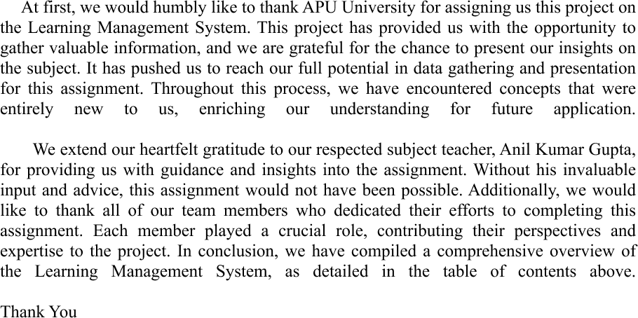

Table of Contents

1. Introduction: 5

1.1. Business Process: 6

1.1.2. Needs analysis: 6

1.1.3 Monitoring and Reporting: 6

1.1.3 Scalability Planning and maintenance: 6

1.2 Overview of Edusphere Proconnect: 7

1.3 Problem Statement, Causes and its Effects 8

1.3.1 Causes for the above mentioned problem: 8

1.3.2 Effects of the above mentioned problem: 9

1.4 Proposed Solutions: 10

2. System Development Life Cycle (SDLC): 11

2.1 Phases of SDLC 11

3. Feasibility study: 14

3.1 Operational Feasibility Analyses: 15

3.2 Technical Feasibility Analysis: 15

3.3 Economic Feasibility Analysis: 15

3.4 Schedule Feasibility Analysis: 16

3.5 PIECES Framework: 16

4. System Analysis 17

4.1 System Design 17

4.2 ERD life History 17

4.3Entity relation Diagram 18

4.5 Contest Diagram 19

4.6 Data Flow Diagram 19

4.7 Design data dictionary 20

5. Individual Component 21

5.1 Individual Component: Atul Dhital 21

5.2 Individual Component: Asmita Rawal 22

5.3 Individual Assignment: Khushi Kumari Das 23

5.4 Individual Assignment: Sajina Silwal 25

6. Conclusion 34

7. References 35

**Table Of Figure**

Figure 1: Edusphere Pro Connets 5

Figure 2 Phases of SDLC 11

Figure 3Grantt Chart 13

Figure 4 Work Load Matrix 14

Figure 5 Phases of Feasibility Study 15

Figure 6 Entity lifr History 17

Figure 7 ERD LMS 18

Figure 8 Contest Diagram 19

Figure 9 Edusphere Proconnect Flow 20

Figure 10 Home Page 27

Figure 11 Student Dashboard 28

Figure 12Teacher Dashboard 29

Figure 13 Sign Up Page 30

Figure 14 Contact Us page 31

Figure 15 ClassRoom 32

Figure 16 Recorded class 33

**Edusphere Proconnect**

# Introduction:

Edusphere Proconnect is an innovative business initiative with the aim of transforming the educational landscape, extending its impact beyond students to include business professionals and individuals seeking mentorship. Given the dynamic nature of educational systems and ongoing innovations globally, there has been an unprecedented demand for a groundbreaking learning management system. At its essence, Edusphere represents an optimistic approach dedicated to improving the scenario of future education. It serves as a concentrated learning platform where people from varied backgrounds can experience an exceptional user experience, engage in interactive study sessions, and explore practical and creative learning techniques, all while minimizing distractions. By integrating easily navigable features, a diverse array of classes, responsive design, and advanced privacy and data protection measures, our goal is to establish a modern and efficient learning management system (LMS).

Figure 1: Edusphere Pro Connets

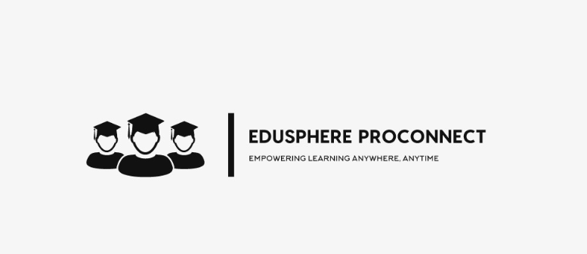

With our primary objectives focused on pioneering a simplified online learning initiative, ensuring an outstanding user experience, fostering flexibility, and encouraging the use of collaboration tools among both teachers and students to create a supportive learning environment, we anticipate that our efforts can revolutionize the market to meet the demand for high-quality learning. The prevalence of conventional learning methods, where students are expected to memorize course content and pass exams to move further in their education, constrains their ability to become well-rounded individuals and explore their areas of interest that the present world has to offer.

Due to the platform's dedication to creating a cohesive medium, the implementation process—ranging from developing a business model, initiating the development phase, and delivering the final product to the target audience—includes an open platform for suggestions. Introducing a transformation in a system that has existed for decades is a journey filled with obstructions and may require significant efforts, including securing supportive investors, marketing initiatives throughout schools and other potential users, user training for effective use of our tool, and recruiting developers who share a similar vision as well as skills for the project. Additionally, it involves extensive market and tools research for optimized efficiency and prompt results.

## **Business Process:**

### 1.1.2. Needs analysis:

Examining the market requirements and strategizing ways to disrupt the existing educational system is imperative. Without a thorough understanding of the current needs in the education sector, there is a risk of entering a market saturated with similar businesses where our presence might be redundant and our efforts might go in vain.

Establishing clear objectives for the system's success, including software requirements, features, target audience, and more, should be well-understood by all team members. This ensures the smooth operation of the venture with minimal conflicts in opinions and misunderstandings.

### 1.1.3 Monitoring and Reporting:

Commencing from the initial stages of the undertaking, it is crucial to maintain records and conduct thorough observations of the system. This involves capturing intricate details to draw insights from past mistakes and elevate approaches to overcome obstacles that come along the way.

Producing reports and using monitoring tools to precisely interpret data, including user engagement, completion rates, and progress, can emerge as an important procedure for identifying insightful areas in need of improvement. This helps in analysis through visuals and making strategic efforts for refinement.

### 1.1.3 Scalability Planning and maintenance:

Like any other enterprise, our Learning Management System (LMS) also requires regular updates to keep up with the expanding global requirements and advancements. Certain courses of action involve providing access to specialization courses worldwide, facilitating mentorships on subjects that extend beyond the course curriculum and also providing customizable features.

It is crucial to carefully consider scalability, as a venture that doesn't experience growth and unique ideas over time may struggle to compete with other businesses that gradually expand and build a brand of themselves.

## **1.2 Overview of Edusphere Proconnect:**

Edusphere Proconnect is a software with the aim to enhance, oversee, optimize efficiency for teachers providing study materials, ensure the organized delivery of education to students, and facilitate transparent communication among all users by tracking progress of each course. Keeping in mind the essential features that are required for the smooth functioning of a digital learning environment, we intend to use tools that are not only up-to-date with today's technological standards but are also user-friendly and efficient in comparison to current industry practices. Our concept has the potential to become an integral component of every educational institution.

**The following are our objectives:**

1. Providing a flexible learning environment that is accessible by all, enabling students to access their learning materials at their convenience regardless of their location or device.
2. Providing customizable features, such as setting meetings with mentors, calendars, study plan throughout the day, recommending missed assignments, and alert notifications for pending tests.
3. Enabling effective administration of educational assets, encompassing images, videos, externally sourced course materials, and a variety of multimedia elements, to enhance the overall learning experience.
4. Forming partnerships with various educational technology firms like Coursera and Udemy to supplement institutions with additional course materials, enabling students to access educational content and broaden their understanding of diverse developmental fields.
5. Implementing features that cater to individuals with diverse abilities and various forms of learning challenges to ensure the LMS is accessible and beneficial for everyone.
6. As we proceed with collecting data, prioritizing robust data security by employing advanced cyber security measures and maintaining strict data privacy protocols throughout the data collection process.
7. Assisting educators in organizing their course content over the duration of their classes, enabling students to take notes, and providing the option for them to review materials for an extended period to help in revision and catch up on missed lectures.
8. Establishing distinct sections for submitting assignments and coursework during the learning period, featuring options for editing and status indicators (marked, graded, late submission, etc.).
9. Facilitating straightforward scheduling of tests, quizzes, and examinations to monitor students’ progress throughout the course.
10. Enabling teachers to grade assessments with remarks, points for improvement, and identification of incorrect answers in tests like quizzes, promoting a learning experience that helps students understand and avoid repeating mistakes.

## **1.3** **Problem Statement, Causes and its Effects**

As we move on from a world pandemic, the need for online mediums of education has grown immensely. We have made studying from any part of the world possible. However, the traditional education system is still prevalent, where offline mode of teaching with physical presence limits people from all over the world to gain access to a basic necessity such as education. With the lifting of pandemic lockdowns, the world has partly gone back to its old methods in many ways. However, that should not be a cause of restriction for gaining education and having an efficient as well as unique way to increase skills of millions. Moreover, concerns for data leakage is an important issue to be addressed that has been a major drawback into implementing LMS globally. Portals ask for basic details of an individual that have been known to sell such details to other organizations for suggestions via email, text messages, and so on.

With this perspective, we believe that our LMS enables educators to concentrate on teaching and engaging with students, freeing them from the burden of manual tasks that consume considerable time, allowing for more planning for their course content, put effort on making the content innovative and understanding for all, and give personalized attention to each student. Additionally, students have access to a diverse range of innovative learning techniques, enhancing their skills across various developmental areas with full privacy of their details, learning capability, and progress made.

### 1.3.1 Causes for the above mentioned problem:

* Transitioning away from traditional methods is often a difficult journey for society, particularly when it comes to deeply rooted practices like the conventional teaching-learning approach found globally.
* In the technology sector, Nepal, being relatively new, has significantly less trained educators in terms of IT tools. Majority of teachers are more accustomed to traditional methods involving blackboards, rather than embracing digitalized teaching systems.
* The current global economic uncertainties, especially recession-induced layoffs, contribute to a significant issue of unemployment. Consequently, this poses a challenge for many teachers and creates a reluctance in the entire country to adopt Learning Management Systems (LMS) more proactively.
* Analyzing the country's market, investor hesitations, and limited mentorship are significant challenges, influencing institutions to follow the conventional teaching approaches. These hurdles hinder the exploration of innovative educational methods, preventing the students from broadening their learning capacity.

### 1.3.2 Effects of the above mentioned problem:

* The challenges posed by the prevalence of traditional education methods, concerns about data security, and a shortage of trained professionals primarily limit students' learning opportunities, restricting their access to resources and preventing them from realizing their full potential.
* It also hampers their exposure to digitalized systems, such as a straightforward and efficient Learning Management System (LMS), which could enhance their computer navigation skills.
* Difficulty in accessing classroom-taught resources directly impacts a student's adherence to the course syllabus, potentially leading to falling behind in class and, consequently, underperforming.
* The absence of such opportunities on a global scale may cause students to fall behind in international competition, limiting their personal development compared to others who have access to a broader range of educational resources, despite their immense potential for success in their chosen field.
* Ultimately, due to the lack of early-stage implementation of such technology, the nation will struggle to cultivate highly skilled individuals crucial for its development, individuals who can make significant contributions and represent the country on the global stage, eventually helping the country improve its standing in terms of technology, business, and IT.

The aforementioned reasons and issues carry considerable importance with long-term repercussions, requiring immediate implementations of solutions to eliminate significant effects on the country and its economy. We wholeheartedly believe that a highly sophisticated Learning Management System (LMS) such as Edusphere Proconnect serves as a modest yet impactful step in addressing the prevailing global challenges.

## **1.4 Proposed Solutions:**

Even though the causes and effects are hindering the motivation for skillful individuals to embark on a journey for developing a recognized and effective LMS, we believe that we possess the required solutions to eradicate them. The following are our thorough resolutions for the above-mentioned causes of our problem statement:

* **Awareness Campaigns:** The optimal approach to familiarize people with Edusphere Proconnect and its advantages involves organizing awareness programs, webinars, and numerous PR events. Executing these campaigns both physically and online, targeting institutions, course providers, and potential investors can be beneficial for the business to gain stakeholders and users at the same time. This method addresses any shortcomings and presents solutions, instilling confidence in our software for assured success.
* **User engagement:** The success of any software depends on user satisfaction with features like response time, personalization, inclusivity, ease of use, effectiveness, and most importantly, attention-grabbing methods. We plan to incorporate gamification, an interactive UI, and collaboration tools to grab the attention of our users to increase efficiency. These enhancements won't be confined to users but will extend to mentors as well, uplifting motivation and refining teaching and learning capabilities simultaneously. This results in active user engagement and also publicity of the software in the market.
* **Tailored learning paths:** It is no secret that there are individual differences when it comes to study preferences, pace, and timing. We acknowledge that a one-size-fits-all approach is ineffective. In response, we aim to utilize machine learning algorithms to recommend personalized learning routes. This system will suggest course materials suitable to each user's unique preferences and learning objectives, ensuring a more customized learning experience.
* **Regular updates:** In the rapidly evolving global innovation ecosystem, adapting to the swift pace is a must. Our commitment to determined business objectives aligns with providing users an exceptional learning experience. Regular updates and maintenance are essential to user satisfaction for both institutions as well as learners. Each update will involve extensive discussions and involvement of multiple departments to implement design or functional changes that our team believes enhance user experience and market appeal. This approach ensures continuous improvement, responsiveness to evolving needs, and sustained excellence in the ever-changing Educational environment.

# 2. System Development Life Cycle (SDLC):

The systematic method of creating, testing, releasing, deploying, and maintaining applications for software is referred to as the Software Development Life Cycle (SDLC). It provides an organized and controlled method of software development, assuring that the end result meets the goals, is of a superior quality, and arrives on time and under expense. Typically, the SDLC is separated into various phases, each having an own set of responsibilities, goods, and targets (stackify, n.d.)

## **2.1 Phases of SDLC**

Planning is the initial and vital phase in the SDLC. The procedure starts with an examination of the conditions and limitations of the work. After analyzing the firm and its past systems, receiving opinions from consumers, and calculating expenses and schedules, the company may decide either to modify or build the system. In the same time, major problems have been mentioned.

Figure 2 Phases of SDLC

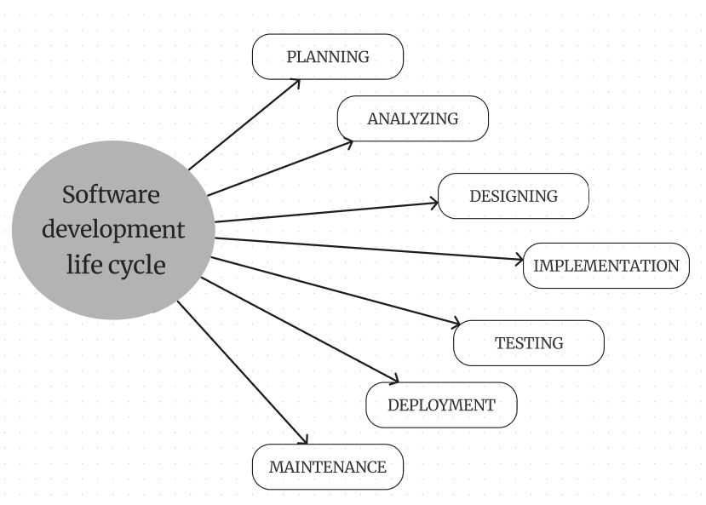

Planning:

The planning phase, referred to as the feasibility stage, is exactly the time when the designers of the project will develop decisions about a future effort. Defining the objectives for the new structures and identifying the issue and scope of any present ones are essential. They must be capable to recognize problems before they limit growth and develop a solid template for the next phase of progress. And help with getting the funding and resources needed to implement out the idea they propose (clouddefense.ai).

Analyzing:

In the analysis stage, every detail required to construct a fresh system is collected, and initial ideas for concepts are determined. Developers can provide the specifications for any prototype systems, assess substitutes for current prototypes, and conduct research and analysis to determine the needs of the customer. A program need standards, or SRS record, can be created by developers. This includes each element of the hardware, software, and networks that are required for developing the system they plan on creating. That will prevent individuals from misusing unnecessary money or assets while they work alongside other research team in a single location (clouddefense.ai).

Designing

Designers set the software details like interfaces for users, system connections, internet needs, or databases in the important designing phase of the creating cycle. They develop the design form to guide the SDLC, arrange the requirements specified in the Software Requirements Specification document into an orderly structure, and develop schedules for execution, instruction, and service (clouddefense.ai).

Implementation

In the development stage, developers construct applications and write program that complies with requirements & designs. During this stage, static application security testing (SAST) methods are used. Along with applying tools like translators, debuggers, & coders, programmers follow to coding standards. Programming languages like C++ & PHP are used, with proper code chosen to meet with the project's needs & criteria (clouddefense.ai).

Testing:

The creation of software is just one phase; to ensure that there is no errors or negative impacts for the user experience, it has to pass thorough testing. For ensuring that the program meets the standards and criteria stated in the SRS specification, designers actively observe, accurate & verify any issues that arise (intellectsoft.net).

Deployment

When the product is finished, it is deployed to an industrial setting for its final testing for being brought to consumers. Opportunities with unexpected events were vital, which includes using the use of micro services for easy function moving & many backup methods. The canary discharge is able to be used if needed (intellectsoft.net).

Maintenance

Customers use systems in the software development life cycle process's maintenance phase. Producers ought to fix any problems which weren't found in first evaluation, particularly for huge systems. Continuous tools for tracking, commonly called "instrumentation," are able to keep high standards by constantly evaluating speed & efficiency, identifying errors, & using changes for constant use (intellectsoft.net).

Gantt chart:

Figure 3Grantt Chart

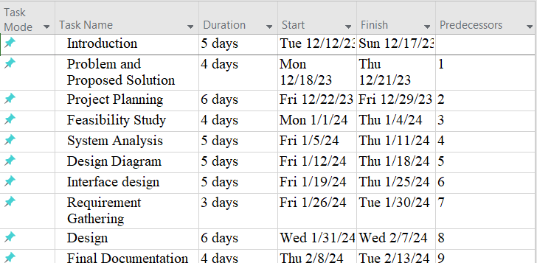

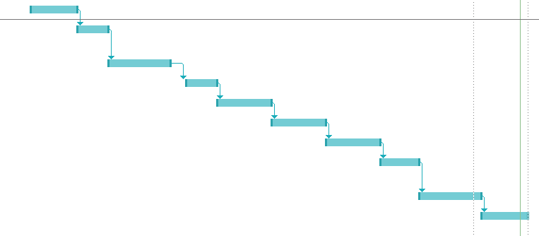

Workload matrix:

Figure 4 Work Load Matrix

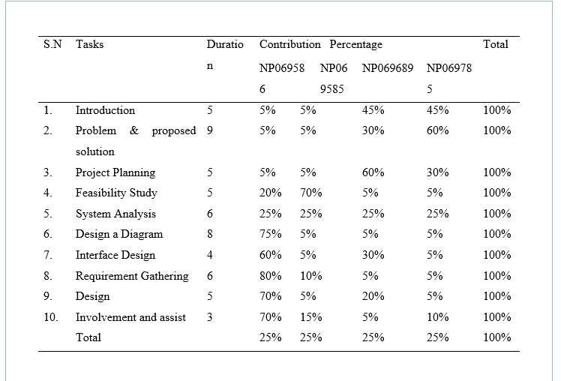

# 3. Feasibility study:

A feasibility study is an extensive evaluation of an idea, task, or products to evaluate its chances of effectiveness. The objective of the research aims to measure technological, economical, & ethical feasibility by examining demands of the project, finding possible challenges, evaluating costs, & estimating gain in investment. By checking these factors, the feasibility analysis gives an accurate picture on if the objective is feasible and worthy of seeking, helping leaders to determine its overall survival and potential for achievement of return on investment.

The action that should be done while conducting the feasibility study are explained below:

Figure 5 Phases of Feasibility Study

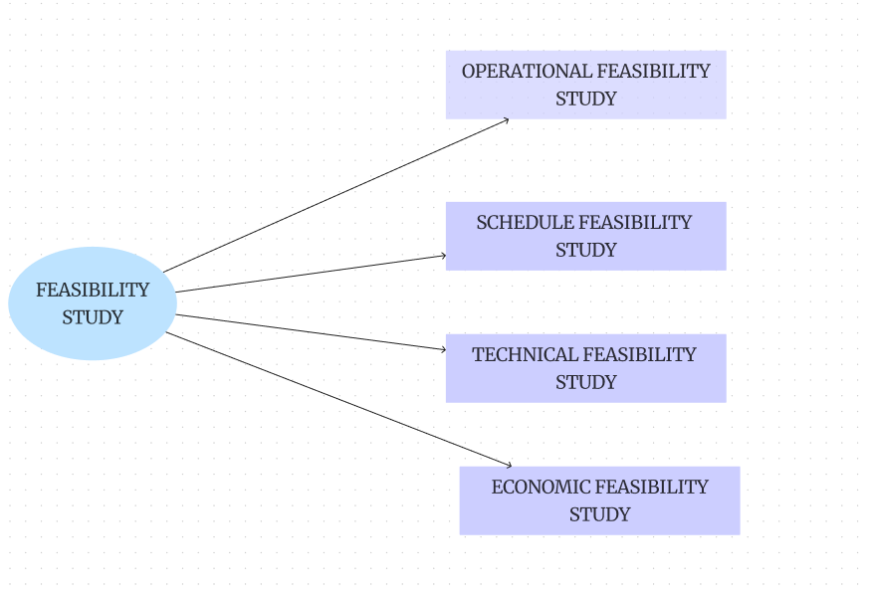

## **3.1 Operational Feasibility Analyses:**

A feasibility study examines the proposed a project's feasibility for business operations, while taking factors like person adjustment, required training, & potential disruptions. It analyses the task's impact on process, efficiency, & system reliability to guarantee its economic feasibility & value for the company, and to ensure easy integration in routine tasks.

## **3.2 Technical Feasibility Analysis:**

Technical feasibility utilizes an indicator of how an activity or systems will be efficiently developed and implemented form a technological point of view. It involves determining the task's technical needs, abilities, & boundaries.

## **3.3 Economic Feasibility Analysis:**

Economic feasibility is an essential part of feasibility studies in the management of projects. It analyses if a suggested concepts is economically feasible & reasonable. This kind of feasibility study involves an extensive examination of the project's estimated expenses as well as potential returns of investment.

**3.4 Schedule Feasibility Analysis:**

Schedule feasibility represents one of the aspects included in the project's feasibility study. It evaluates whether a task can be accomplished within an acceptable duration taking into consideration time frames, objectives, and time limits. The goal is to decide if the task is able to be accomplished during the stated time frame and if the schedule coincide with the goals of the company.

## **3.5 PIECES Framework:**

Pieces framework is the design used to examine the feasibility of information system. Every letter in an acronym which represents the vital aspects that need to be done while applying the operational

Feasibility analysis in the feasibility study. The overview of the PIECES framework are explained below:

1. Performance:

We need to evaluate the system's working status by considering the working speed, response done in

Estimated time, throughput and overall efficiency of the developed system. We also need to consider about the proposed system is able to meet the needs of the performance and capable to handle the pressure

2. Information:

We have to test the system's quality, accuracy, availability and relevant information. we have to evaluate the information and consider the user's requirement, accuracy of the data, and the capability of the system to provide the relevant and updated information.

3. Economy:

We need to focus on estimation of the cost-effectiveness with the consideration of the development and operational budget. Analysis of the budget, development cost, maintenance cost and effective return of the investment.

4. Control:

We have to maintain the security, integration of the data, controlling measures for the access of the system. System capability for maintaining data security, integrity and assure that effective control of access of the data need to evaluate.

5. Efficiency:

The resource should be utilize including time personnel and technology in efficient way. We should consider the resources used and efficiency of the organizational goals.

6. Service:

We need to focus on the quality of service provided through the system including the satisfaction of the user and support mechanism. Consideration of the user's thought, support mechanism and capability of the system to meet the user expectation towards the system that we developed.

Pieces framework helps to ensure the performance, efficiency, quality of services, economical status of the system, information that was included in the system,

# 4. System Analysis

System analysis may be defined as "the process of studying a procedure or business to identify its goal and purposes and create systems and procedures that will efficiently achieve them". Another perspective sees system analysis as a problem-solving approach that deconstructs a system into its constituent elements and assesses how well those parts function and interact to achieve their goals (wikipedia.org, 2017).

## **4.1 System Design**

System design is the process of developing a system's architecture, components, and interfaces to meet the demands of its end users. System design is a critical component to consider while conducting technical interviews! Almost every major IT company, including Facebook, Amazon, Google, Apple, and others, conducts interviews in which they ask questions on System Design concepts such as scalability, load balancing, caching, and so on. This System Design course is specifically designed to help you comprehend and grasp System Design ideas easily, from the fundamentals to the advanced level (https://www.geeksforgeeks.org/, n.d.).

### 4.2 ERD life History

Figure 6 Entity lifr History

Entity life histories are useful because they help you build the database forms and actions necessary to support each occurrence. For example, to add a new pupil record, you will need to develop an input form. If you want to produce a report that contains all students, you must use a query, and so on (theteacher.info, 2022).

### 4.3Entity relation Diagram

Figure 7 ERD LMS

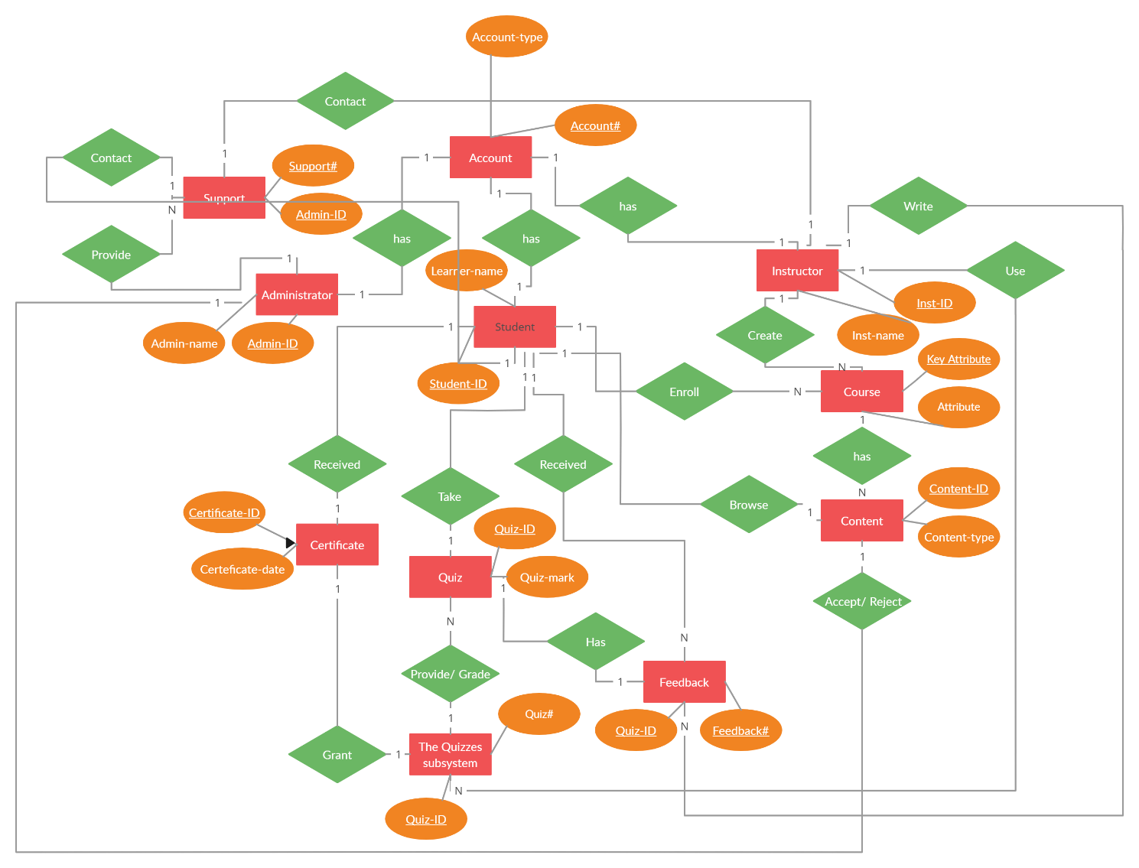

### 4.5 Contest Diagram

Figure 8 Contest Diagram

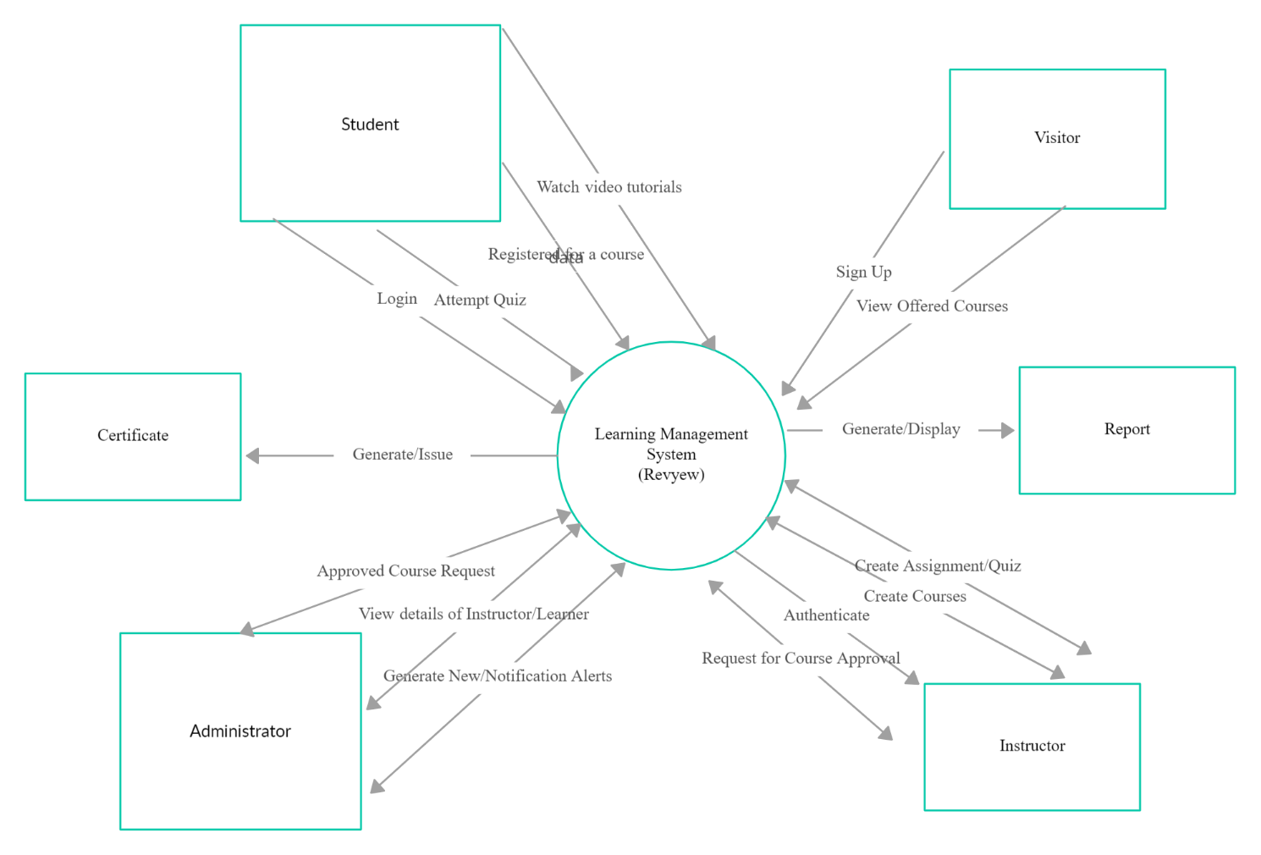

### 4.6 Data Flow Diagramhttps://documents.lucid.app/documents/59947273-f291-4af0-b885-a950947b7b21/pages/0_0?a=1006&x=-1362&y=-2309&w=4403&h=1268&store=1&accept=image%2F*&auth=LCA%20968ea5cdcb3b6b1baac694c40cd53350e92443d94da26fc814d972d7a61e3814-ts%3D1706350402

### 4.7 Design data dictionary

Figure 9 Edusphere Proconnect Flow

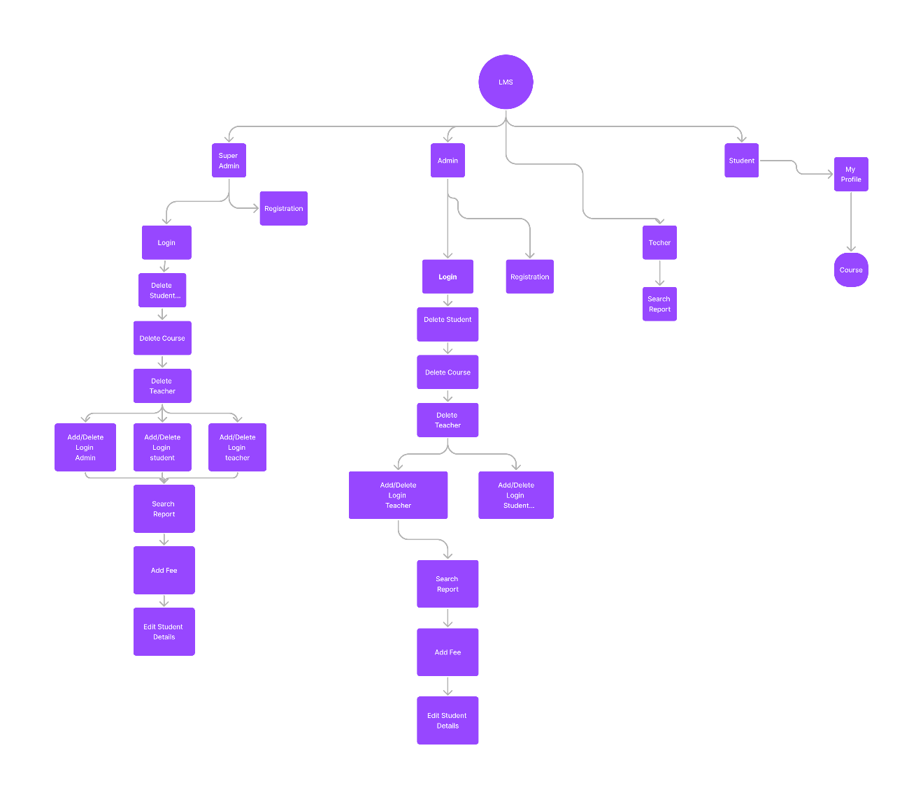

# 5. Individual Component

## **5.1 Individual Component: Atul Dhital**

**Implementation**:

To begin the implementation process, Edusphere Proconnect puts together a specialist project team comprised of HR representatives, IT professionals, training coordinators, and department managers. The team conducts a comprehensive needs assessment to establish the specific training requirements for each department and people's roles within the organization.

**1. Needs Assessment:** Begin by identifying our organization's specific training requirements and goals. Determine the types of courses and information we need to offer through Our LMS, as well as our target audience's specialized needs.

**2. Research and Selection:** Compare and rank the various LMS systems on the market based on functionality, scalability, ease of use, cost, and customer support.

**3. Planning and preparation:** Develop an explicit plan for execution such as the timing, responsibilities, and resources required for the implementation process. Assign an experienced project team to manage implementation and guarantee a seamless process.

**4. Configuration and customization:** Configure the LMS based on Our Company’s guidelines for branding and functional requirements. Customize the platform's training material and interface settings, such as creating user profiles, categorizing courses, and managing permissions.

**5. Content Migration:** Upload existing training assets including presentations, papers, videos, and exams to Our LMS. Ensure that all material is logically arranged and correctly categorized for easy navigation and search inside the platform.

**6. User Training and Support:** Provide thorough training for administrators, trainers, and learners on how to utilize the LMS efficiently. We offer continuing assistance and resources, such as user manuals, FAQs, and help desk services, to address any concerns or difficulties that may arise throughout our migration.

**7. Testing and Quality Assurance:** Thoroughly test the LMS to identify and resolve technical flaws, usability issues, and compatibility issues with various devices and browsers. Before releasing the platform to users, ensure that all capabilities perform as expected.

**8. Pilot Deployment:** Test the LMS with a small group of users or a pilot program to get feedback and identify areas for improvement. We will use our feedback to make any necessary modifications and improvements to the platform before it is officially released.

**9. Implementation and Evaluation:** Once the LMS has been properly constructed and tested, make it available to all intended users in our organization. Monitor use, learning engagement, and performance metrics to assess platform efficacy and identify areas for improvement.

**10. Continuous Improvement:** We regularly monitor and review the LMS's performance, collect user input, and implement changes and upgrades as needed to keep the platform current, user-friendly, and meeting Our organization's changing needs.

By taking these steps and including stakeholders throughout the process, we can ensure a successful learning management system implementation and maximize the benefits of online training for our Employees.

## **5.2 Individual Component: Asmita Rawal**

**Observation:**

Understanding and evaluating a variety of aspects of the learning procedure in a Learning Management System involves observation. It includes systematically gathering information of student achievement, involvement, and engagement while paying attention to incidents and interactions across the structure. Professors utilize their faculties and the LMS's characteristics to maintain updated on how students utilize the system, interact with the materials, and communicate with one another. In addition to qualitative analyses of student participation & instructive efficiency, evaluations involve statistical data like task fulfilment rates & access frequently. By using the technique of observation, professionals gain information which helps managers improve their techniques and the learning atmosphere for students (wikipedia)

**Advantage of observation:**

Very Accurate and reliability: As observation collects action or events immediately, with no depending upon participants' opinions or thoughts, it ensures the information gathered is both reliable and exact

Improved Research Results: By raising the accuracy of the study's results observation enables experts to make more knowledgeable choices and create accurate results using reliable direct information.  
   
Reduced Reliance on Users: By eliminating the demand to depend on responders' experiences or judgments of what happened, observation serves to minimize the chance of errors or inaccuracy that come from oneself and recollection shortcomings.

Enhanced Analysis of Stated Statements: Through immediate observation of the voice, setting, and nonverbal signals which follow the exchange, methods of observation assist in a more accurate analysis of stated replies, providing more insights about what has been noticed.  
  
Reduced Trouble and Bias: In comparison with other collection methods, observation can be less challenging and partial since it includes simply observing actions or events not seeking participants to recollect or understand things. The result minimizes capacity presumptions and assures accurate data collecting.

**Disadvantage of Observation:**

Restriction in Analyzing Historic areas: Since observational methods cannot enable for direct observation of previous incidents or actions, they can't be ideal for analyzing historic subjects. Because historic stories, treasures & records usually available or direct observation, study of history generally require these methods.

Depend on Relevant Paperwork: In the absence of observational information, historians must rely on verbal finances, records of history, & archive which are in their reach for the purpose to gain knowledge on past events, steps or opinions.

Failure to Study Ideas: Since methods of observation concentrate mainly on observing actions and behaviors instead of gathering opinion or ideas, they aren't suitable for research ideas or beliefs. Techniques including interviews, surveys, or content evaluation of documents typically occur while studying perspectives.

Insufficient Study on Views: Since views tend to be personal and unreliable, observations can fail to be enough for understanding issues. Recognizing views frequently means studying people's thoughts, feelings, & beliefs through methods that include surveys, interviews, or evaluations of psychology.   
  
Impossible to Employ Sample: The abundance of seen incidents or actions hinders the use of sampling methods in observational studies. Due to restrictions in seeing particular events, observations tend to lack a chance to carefully take a representative group, compared with survey studies whereby random selection may be utilized.

## **5.3 Individual Assignment: Khushi Kumari Das**

**Questionnaires:**

A questionnaire is a tool or method used to gather data and information from people or organizations who are a part of or impacted by a particular system. These tools assist analysts in compiling application details regarding the current system, its requirements, and user needs. Most questionnaires are self-administered, which means that respondents answer the questions on their own without speaking with an interviewer directly (Research, 2022).

**Sample questions:**

1. What part do you play in the edusphere? (Leader, Instructor, and Student)
2. Do you have any experience with learning management systems (LMS) or online learning platforms?
3. What are the main goals you want to accomplish with the LMS implementation?
4. What difficulties do you now have using the systems or training methods that are in place?
5. In what way do you see the course materials being arranged and maintained in the LMS?
6. How often do you plan to update the LMS or add new courses and resources?
7. How significant is it to you that the LMS be simple to use and intuitive?
8. Would you prefer to integrate any current tools or systems utilized by edusphere with the learning management system?
9. What factors need to be taken into account in order to guarantee compatibility with different platforms or systems?
10. To what extent does interoperability with tools or services from third parties matter to you?
11. What degree of assistance and training do you think you'll need to use the LMS effectively?
12. Do you think there are any particular LMS features or places that need further help or training?
13. Which kind of continuing assistance with the LMS would be most helpful to you?
14. How much do you worry about student data security and privacy in the LMS?
15. Which method would you want to use to offer criticism or recommendations for enhancing the LMS?
16. What measurements or indicators would you employ to assess the LMS's efficacy and success?
17. Do you think there are any particular LMS features or areas that need constant development or improvement?
18. What scalability factors need to be considered in order to support development and growth in the future?
19. Are there any long-term aims or purposes you would want to see the LMS pursue?
20. Would you like to offer any further feedback or comments regarding the Edusphere LMS implementation?

When determining whether a questionnaire is the best way to collect data for your project, weigh its benefits and drawbacks.

**Advantage:**

1. Quick Data Collection: By using questionnaires, it is possible to quickly get data from a sizable number of people.
2. Consistent Measurement: Data collection is made consistent by using standardized questionnaires.
3. Secrecy: Since their answers are kept private, respondents are more inclined to give honest criticism.
4. Statistical Analysis: It is simple to quantify responses and do statistical analysis on them.

**Disadvantages:**

1. Limited Insight: It is possible for questionnaires to miss certain important details or subtle insights from respondents.
2. Bias in Responses: Misconceptions or social desirability bias may lead respondents to give false information.
3. Poor Response Rates: It might be difficult to motivate participants to fill out and return questionnaires, which leads to poor response rates.
4. Rigidity: Once issued, questionnaires are difficult to amend or clarify as needed since they are rigid.

## **Individual Assignment: Sajina Silwal**

**Document Review** Document review is an important process of evaluation that includes several phases of assessments to ensure that the document is in compliance to the agreed upon criteria. The review is said to be successfully completed when the document is relevant to the objective, includes reasoning to support decision-making, has feedbacks for continuous improvement, and handles sensitive information with utmost responsibility. The goal is to improve the accuracy and quality of the written work, simultaneously guaranteeing clarity and shared understanding among all involved.

In practical terms, it is a difficult task that requires a thorough evaluation of all factors such as each word, heading, sentence, and paragraph to ensure logical consistency and information completeness. Ensuring transparency for the reader is essential as it should deliver comprehensible material to the readers. It should also provide a systematic and step-by-step explanation for the documented process. The process includes understanding the structure of the content, determining the intended audience, evaluating readability, and enlarging short phrases or sections. (Medium, n.d.)

The steps involved in documentation review are as follows:

1. **Defining objective:** Clearly stating the objective and scope of the document is crucial as it helps make a roadmap for subsequent steps. It is the step that helps reviewers establish guidelines and the parameters within which the contents of the document will be evaluated.
2. **Gathering documents:** Collecting all relevant documents that are to be assessed is a step that requires accuracy as leaving behind one document can lead to a gap in the review process affecting the effectiveness.
3. **Review:** After gathering all documents, the panel will now be reviewing the document based on criteria such as accuracy, consistency, clarity, and compliance of standard policies.
4. **Editing:** Almost no document is finalized after the first draft. Errors will persist during documentation which are then edited by the concerned department to follow suggestions made during the review process.
5. **Approval and distribution:** Upon conducting possibly multiple editing and reviews for the document to meet the required standards, the document is then approved and is finally distributed to the concerned participants and is stored for future reference.

**Advantages of document review:**

1. **Accuracy and compliance:** Making sure the document is accurate, includes all conducted steps, and is in compliance of the rules and regulations set beforehand is the first and foremost advantage of document review.
2. **Quality assurance:** In real-world situations, the document is meant to be shared not only with professionals who possess expertise in various fields but, most importantly, with clients. Having such importance, reviewing documents helps ensure there are no compromises when it comes to quality, eradicating grammatical errors, inconsistencies, and identifying areas of enhancement.
3. **Knowledge transfer:** Given that these documents are stored in the database, they will be applicable to be referenced later while working on various other projects. This helps in broadening the thought process and learning from past records for new members of the team.
4. **Risk management:** Keeping a thorough record of the processes involved in a document helps mitigate any potential legal and compliance issues that might be raised from external or internal factors.

**Disadvantages of document review:**

1. **Time-consuming:** Making sure that all steps of the process are included in the document and maintaining readability for everyone is a time-consuming task that involves working with a large volume of data.
2. **Cost:** Leveraging various technologies and tools is crucial for documentation and review, turning it into an incurred cost that requires specific allocation in the project budget.
3. **Complexity and errors:** Errors are inevitable in all documents since they are prepared by humans. One factor contributing to these errors is the complexity that comes during the review process, which involves collaborating with individuals from different departments and understanding their methods of execution.
4. **Resistance:** Resistance is applicable for stakeholders as well as reviewers is an issue that comes both after and during the document review process. The stakeholders and reviewers might have concerns or objections that need to be addressed continuously for a smooth review experience.

# 6. Design UI

Figure 10 Home Page

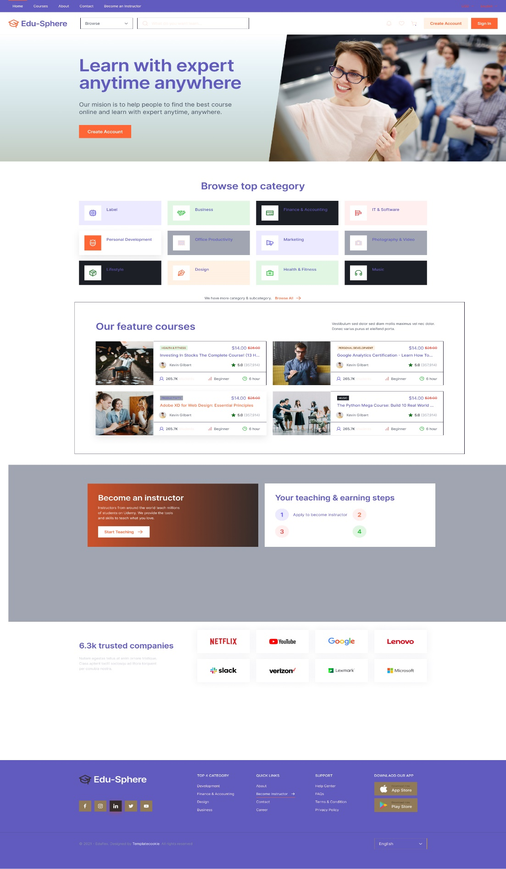

Figure 11 Student Dashboard

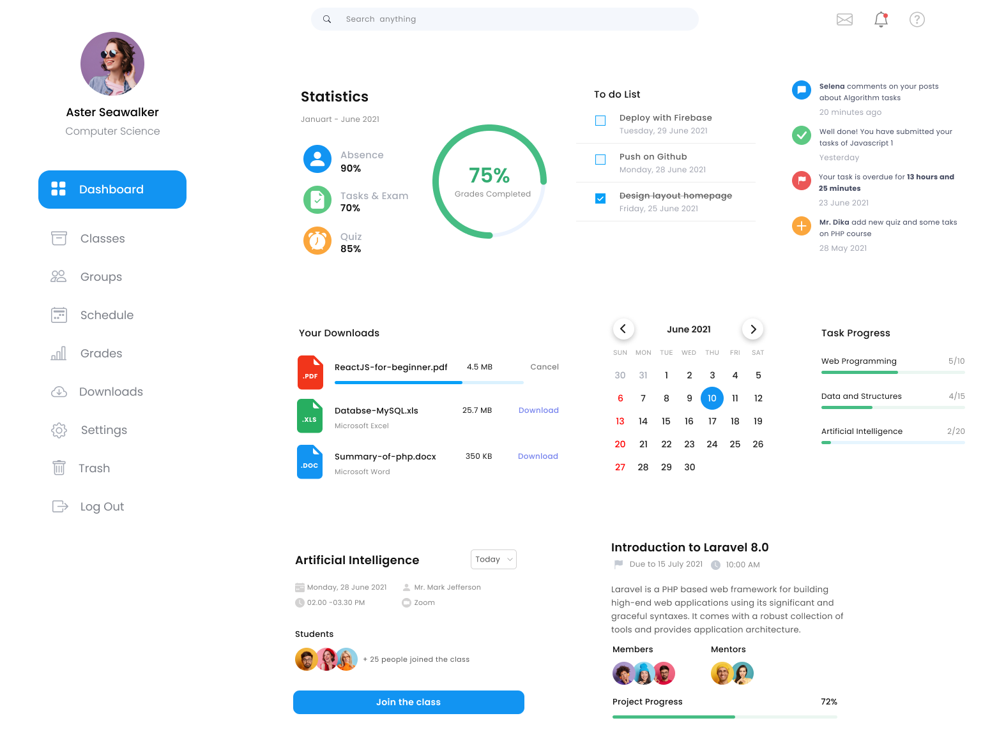

Figure 12Teacher Dashboard

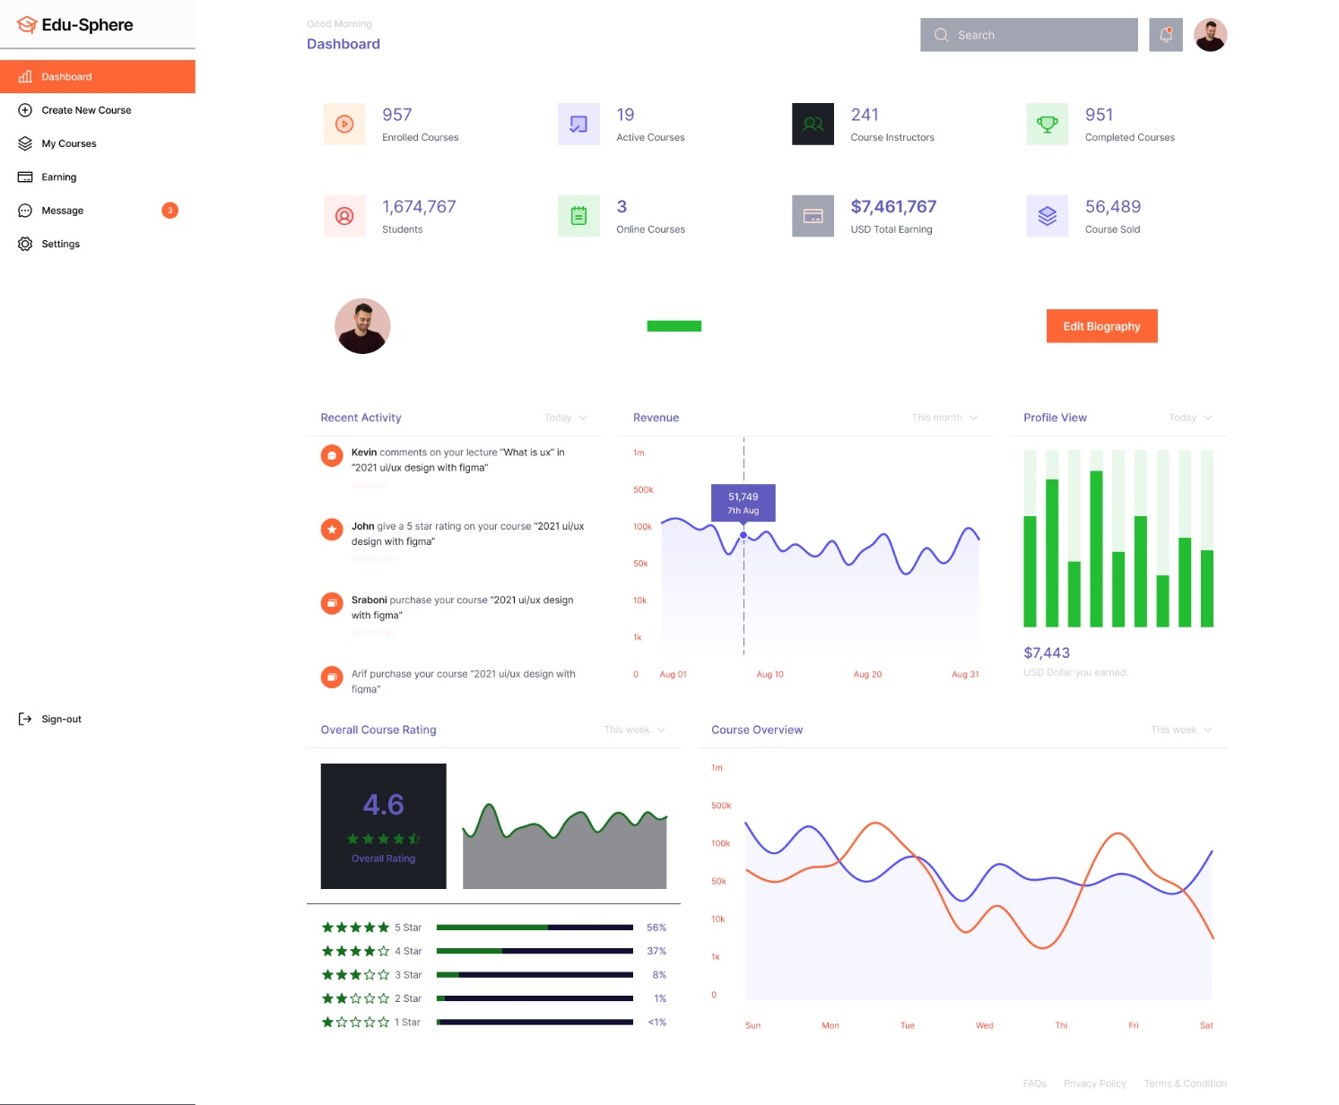

Figure 13 Sign Up Page

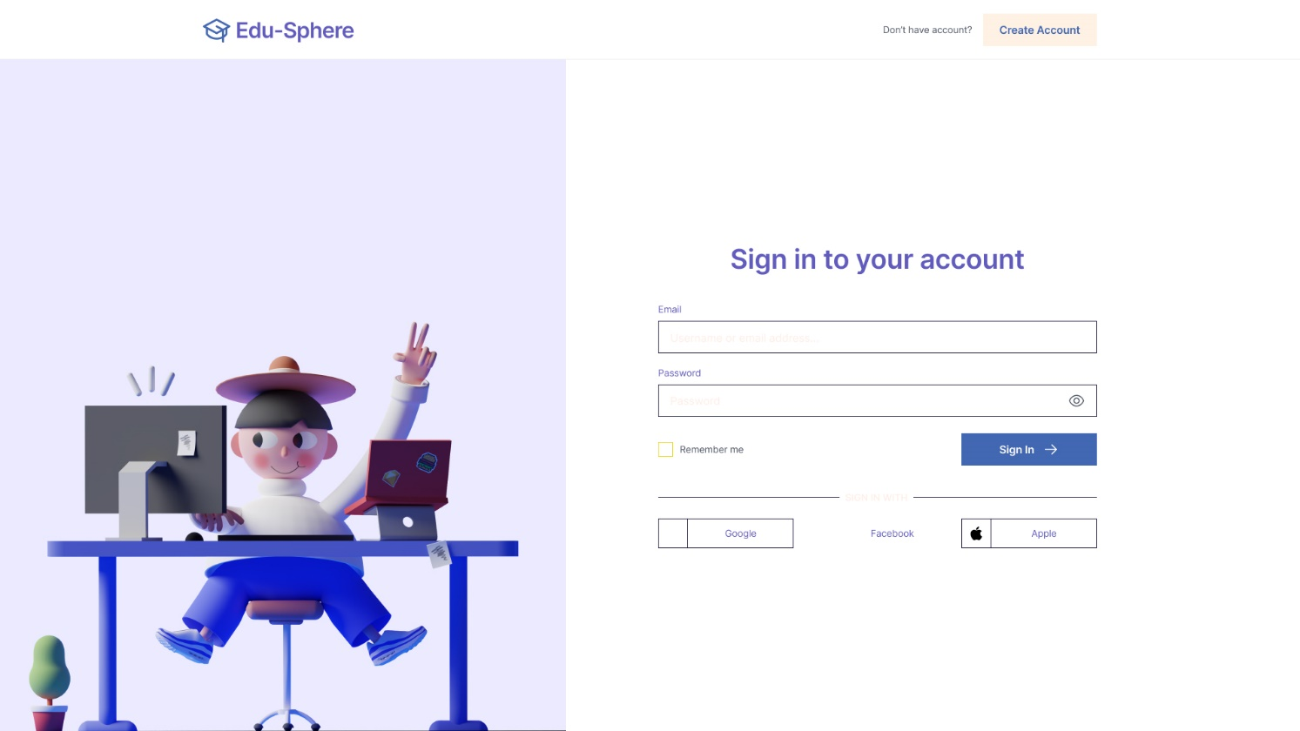

Figure 14 Contact Us page

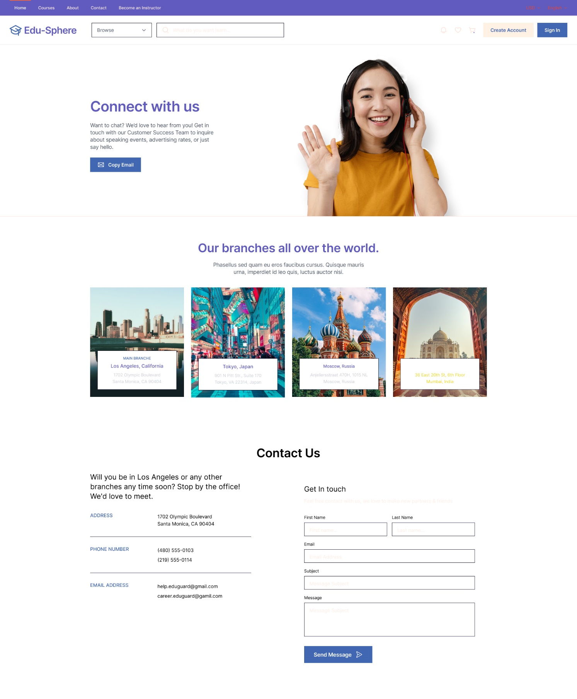

Figure 15 ClassRoom

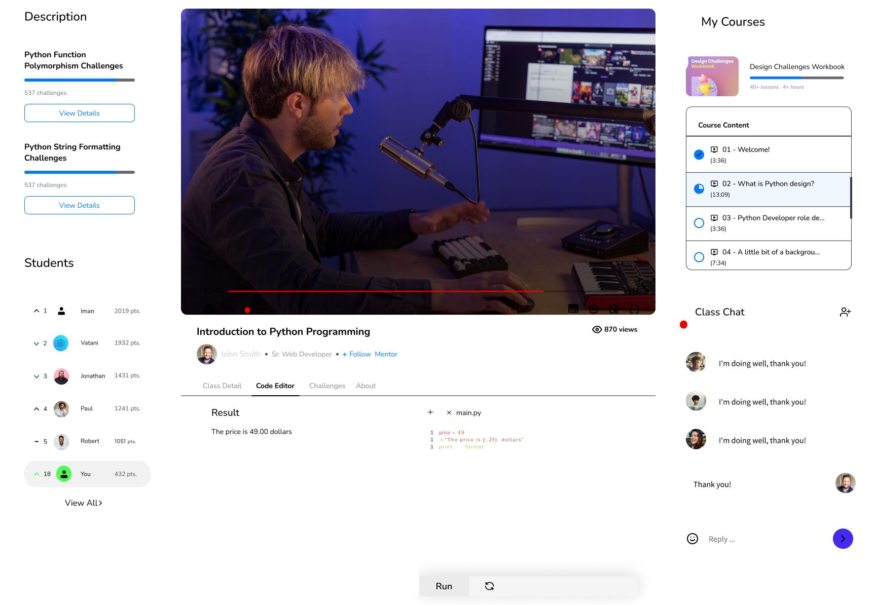

Figure 16 Recorded class



**7. Conclusion**

We appreciate APU University for requesting "e-learning." As part of this study, we thoroughly collected and analyzed data about learning management systems. We remained focused on issues that fulfilled our assignment requirements. We have carefully chosen material, including a description of the system and its operation. In our documentation, we established the system's aims and addressed current topics.   
  
In addition, we built a work matrix and continuously monitored project breakdown to ensure timely completion. Our feasibility research covered operational, technological, and economic elements, resulting in a complete evaluation. Despite having challenges in various areas, we were able to successfully handle them and complete the entire assignment. Furthermore, we addressed common user problems and provided viable solutions, so boosting the usability of our system. Finally, we developed a complex data dictionary to consolidate system information.

# 7. References

bartleby. (2023, 03 19). *Effects Of Lack Of Resource Materials For Students*. Retrieved from bartleby: https://www.bartleby.com/essay/Effects-Of-Lack-Of-Resource-Materials-For-PKVCHVEBHEF

bcisnotes. (2020, Feb 20). *PIECES Framework || The Context of System Analysis and Design || Bcis Notes*. Retrieved from bcisnotes: https://bcisnotes.com/thirdsemester/system-analysis-and-design/pieces-framework/

clouddefense.ai. (n.d.).

clouddefense.ai. (n.d.). 7 Phases of System Development Lifecycle. pp. https://www.clouddefense.ai/system-development-life-cycle/.

DeFranzo, S. E. (2023, March 19). *Advantages and Disadvantages of Surveys*. Retrieved from snapsurveys: https://www.snapsurveys.com/blog/advantages-disadvantages-surveys/

elearningindustry. (2023, 03 19). *Lack Of eLearning Materials In Secondary Schools*. Retrieved from elearningindustry: https://elearningindustry.com/lack-of-elearning-materials-secondary-schools#:~:text=Inadequate%20technology%20infrastructure.,Consideration%20of%20eLearning%20policies

https://www.geeksforgeeks.org/. (n.d.). *System Design Tutorial*. Retrieved from System Design Tutorial: https://www.geeksforgeeks.org/system-design-tutorial/

intellectsoft.net. (n.d.). 7 phases of System Development Lifecycle. pp. https://www.intellectsoft.net/blog/what-is-system-development-life-cycle/.

LISBDNETWORK. (2022, February 11). *Information Gathering*. Retrieved from lisedunetwork: https://www.lisedunetwork.com/information-gathering/

Medium. (n.d.). *Document Review Process: Guidelines & Best Practices | by HelpLook | Medium*. Retrieved from Medium: https://medium.com/@HelpLook/document-review-process-guidelines-best-practices-38850b5e9bf6

open. (2023, 03 19). *Purpose of teaching and learning materials*. Retrieved from open: https://www.open.edu/openlearncreate/mod/page/view.php?id=168509#:~:text=Learning%20materials%20can%20significantly%20increase,new%20skill%20gained%20in%20class

Research, M. (2022, June 29). *What Is a Questionnaire and How Is It Used in Research?* Retrieved from cint: https://www.cint.com/blog/what-is-a-questionnaire-and-how-is-it-used-in-research

Simplilearn. (2023, 2 3). *Feasibility Study and Its Importance in Project Management*. Retrieved from Simplilearn: https://www.simplilearn.com/feasibility-study-article

skfdjskdfjs. (n.d.). *sdfsdf*. Retrieved 2014

stackify. (n.d.). *SDLC*. Retrieved from stackify: https://stackify.com/what-is-sdlc/

theteacher.info. (2022). *Entity Life History (ELH)*. Retrieved from theteacher.info: https://theteacher.info/index.php/f453-advanced-theory/3-3-9-databases/notes/382-entity-life-history-elh-notes

wikipedia. (n.d.). observation. p. https://en.wikipedia.org/wiki/Observation.

wikipedia.org. (2017, February). *Systems analysis*. Retrieved from wikipedia.org: https://en.wikipedia.org/wiki/Systems_analysis

xgxdfd. (n.d.). *xxfdxd*. Retrieved 2010