# C:\Users\visha\OneDrive\Desktop\cover page .png

|  |
| --- |
|  |

# a.png

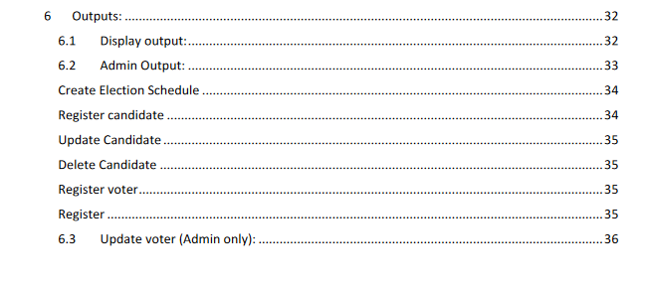

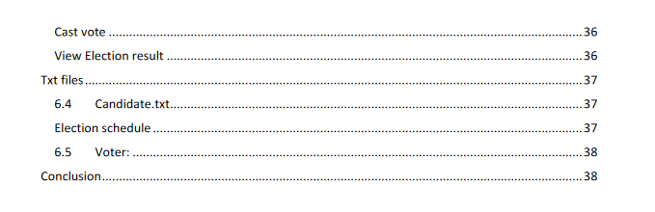

# Introduction:

C is a popular, easy-to-learn, and adaptable general-purpose programming language. It is a machine-independent structured programming language that is widely used to write applications, operating systems like Windows, and numerous complex programs like the Python interpreter, Oracle database, and Git. C is said to be the programming language of the gods. One could say that the programming is based on C. You can easily understand the other programming languages that use the C concept if you know C. (w3schools)

# Design:

The program is an Election Management System that allows users to perform various tasks related to elections. The main menu offers three options:

## Admin Login

## Voter Registration

## Cast Vote

## Exit

Once the user selects an option, the program will prompt them to provide further details.

If the user selects the Admin Login option, they will be prompted to enter their username and password. If the login is successful, the program will display a menu with the following options:

### Register candidate

### Update candidate

### Delete candidate

### List candidates

### Update voter

### Delete Voter

### Search voter

### Show vote results

### Logout

The user can select an option by entering a corresponding number. If they enter an invalid choice, the program will display an error message.

If the user selects the Voter Registration option, the program will prompt them to provide their details, including name, address, age, and voter ID. The details will be saved to a file.

If the user selects the Cast Vote option, they will be prompted to enter their username and password. If the login is successful, the program will display a list of candidates, and the user can select one to cast their vote. Once the vote is cast, the program will update the vote count for the selected candidate.

The program also includes various functions to perform tasks related to the election, such as creating the election schedule, saving voter details to a file, and reading voter details from a file.

Overall, the program is designed to provide a user-friendly interface for managing elections and ensuring that the process is fair and transparent.

Its also include the system flowchart and pseudocode.

# Pseudocode:

For better human comprehension, the informal programming style known as pseudocode can be found in C. Because it is written in straightforward English, the complex program is made simpler to comprehend. (geeksforgeeks, 2023)

It is impossible to compile or interpret pseudocode.It doesn't follow the syntax of the programming language; therefore, it is written in pseudocode to make it simple for both programmers and non-programmers to comprehend. (wikihow, 2023)

# Flowcharts:

Flowcharts are useful visual aids that allow programmers to visually represent algorithms or programs. Programmers can more easily comprehend and analyze intricate code structures thanks to flowcharts, which show the processes, information flow, and connections that take place within an algorithm or program. They are especially helpful when programmers need to visualize a program's logic and decision-making processes during the planning and debugging stages. (zenflowchart, 2022)

Flowcharts can help non-technical people understand how a program works in addition to their technical applications. Flowcharts make it simpler for non-programmers to comprehend the inner workings of a program by employing symbols and natural language. Various symbols, such as start and end points, decision points, process steps, and connectors, may be included in a basic flowchart. Combining these symbols allows for the representation of intricate decision trees, loops, and other program structures. (programiz, 2021)

Overall, flowcharts bridge the gap between technical and non-technical programming aspects in software development. They give a visual representation of the logic and structure of a program, making it simpler to find and fix mistakes and to explain programming concepts to a wider audience.

## Candidate register:

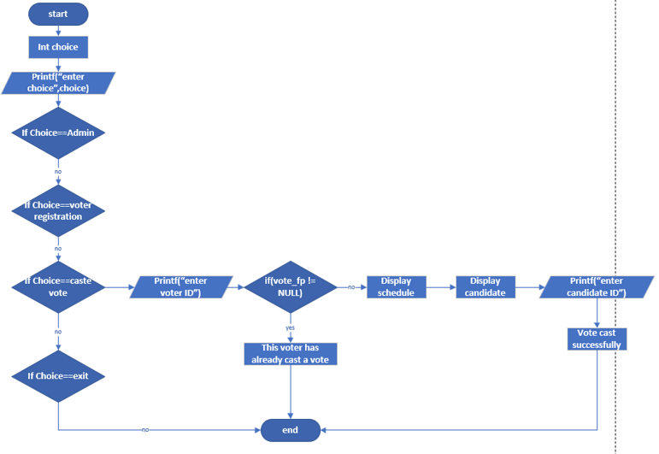

## Voter register:

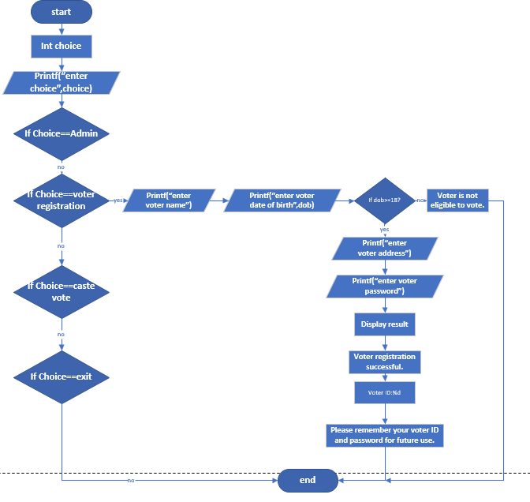

## Main function:

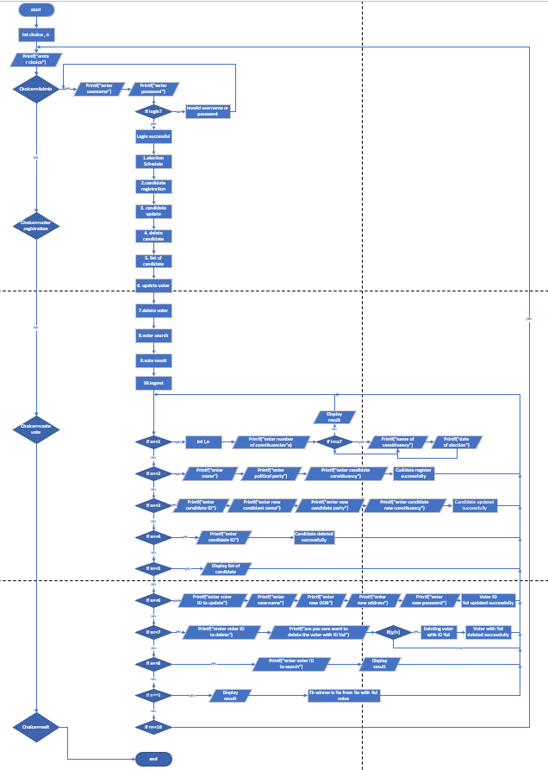

## Display panel:

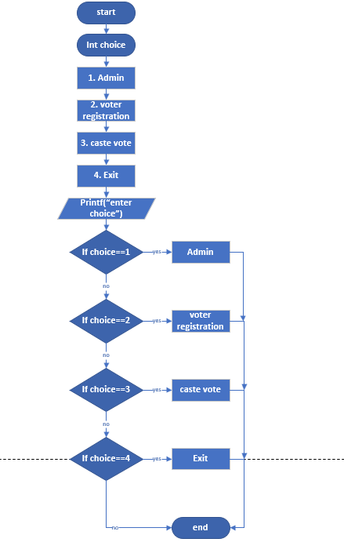

# Code:

# Outputs:

## Display output:

It will allow voter to register the voter and cast the vote. In admin he can add candidate register candidate, update and so on.where voter see the information about the register the vote caste vote and admin panel. Voter don’t have access to open admin panel.

## Admin Output:

Admin need to use Id and password to see the display.

Admin can register candidate, update, delete, list. and admin have right to update voter, delete, and see the voter result also admin can create election schedule.

Create Election Schedule:

Only admin have right to create the schedule.

Register candidate:only admin have right to register the candidate.

Update Candidate: Admin have right to to update candidate.

Register voter:

Voter need to register from the display panel where voter will get there ID and password. Voter need to keep the voter ID and password for future to cast the vote.

Register:

## Update voter (Admin only):

Admin have right to update voter from admin login.

Cast vote:

From the display panel voter can cast their vote. So they need to provide the voter ID which they get after registration. If there voter Id is not match to the database voter can’t go further to cast the vote. voter have right to caste the vote only once.

View Election result:

Only admin have right to the result.

Txt files:

The system should ensure the security of data stored in text files. It should be encrypted and secure from any unauthorized access.

## Candidate.txt

Election schedule:

## Voter:

Conclusion:

The system must be designed to facilitate the secure and efficient conduct of an election, incorporating essential features such as voter and candidate registration, online voting, and result generation. The system must also ensure that all data stored in text files is secure and protected from any potential breaches. In addition, the system should provide a reliable and trustworthy platform for conducting the election, with measures in place to prevent unauthorized access or tampering with the data. Overall, the system should prioritize the integrity and confidentiality of the election process to ensure a fair and accurate outcome.

# Bibliography

geeksforgeeks. (2023, march 15). *What is PseudoCode: A Complete Tutorial*. Retrieved from geeksforgeeks: https://www.geeksforgeeks.org/what-is-pseudocode-a-complete-tutorial/

programiz. (2021, april 5). *Flowchart In Programming*. Retrieved from programiz: https://www.programiz.com/article/flowchart-programming

w3schools. (n.d.). *w3schools*. Retrieved 04 15, 2023, from w3schools.com: https://www.w3schools.com/

wikihow. (2023, february 23). *Learn to Write Pseudocode: What It Is and Why You Need It*. Retrieved from wikihow: https://www.wikihow.com/Write-Pseudocode

zenflowchart. (2022, march 10). *Flowchart In C Programming: Guide & Example*. Retrieved from zenflowchart: https://www.zenflowchart.com/guides/flowchart-in-c-programming

# 