Assignment10_Report:

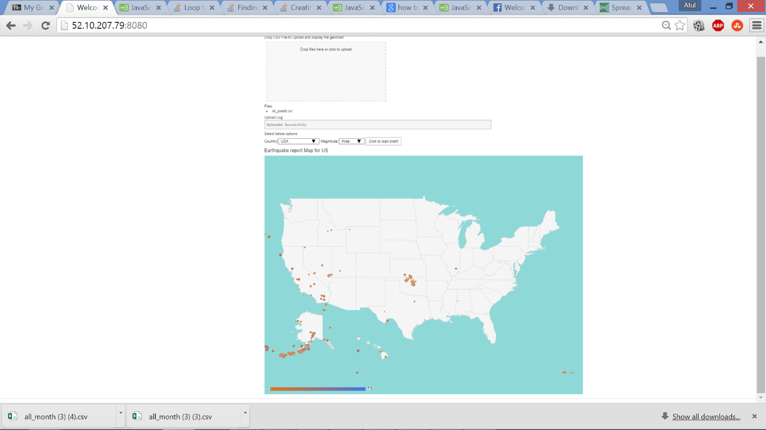Drop an earth quake csv file from [*http://earthquake.usgs.gov/earthquakes/feed/v1.0/csv.php*](http://earthquake.usgs.gov/earthquakes/feed/v1.0/csv.php)in the box. Geo chart with default as USA will appear  
You can choose the Country and magnitude from the options, and click load chart.

