**Assignment 7 Report:**

Have plotted the scatter plot for AirPassengers dataset having year and the number of passengers.

Click Load parameters to load the parameter list, to choose.

Enter the parameter for No of Cluster

**For 3 Clusters:**

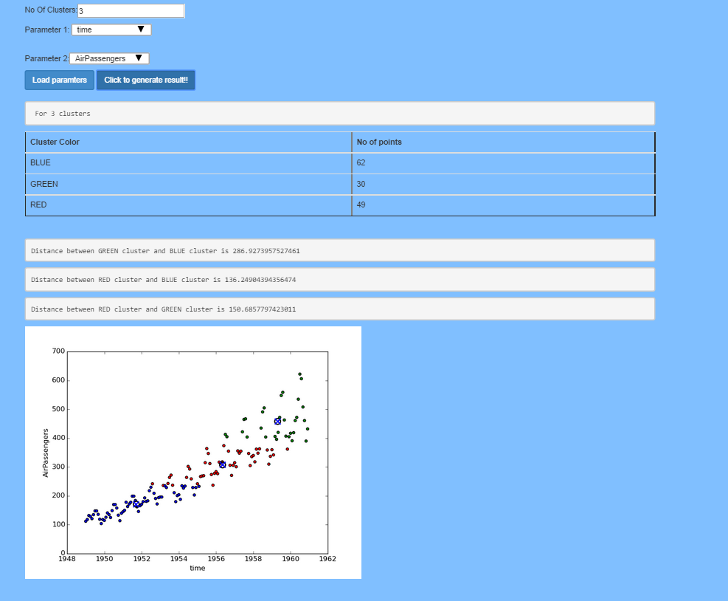

**For 2 Clusters:**

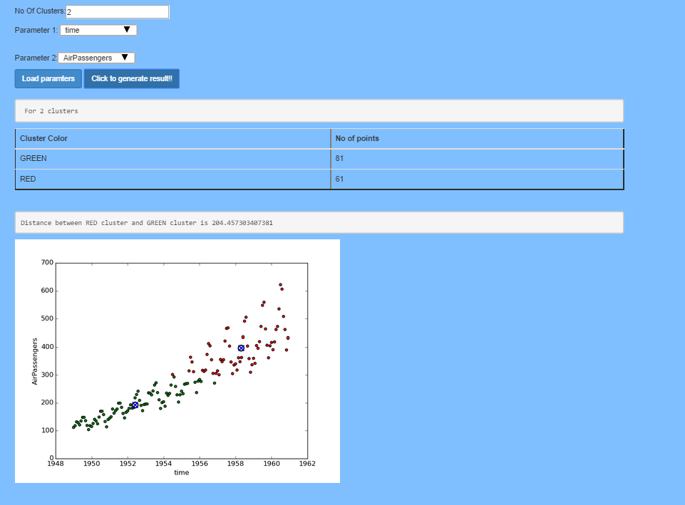

**For 4 Clusters:**

