
Project Report:
Mobile Information Management System Using C Programming.

Project No.: 05
Course title: Structured programming
Course code: CSE-103
Section: 03
Semester: Fall 24

Submitted to:
Dr. Maheen Islam
Chairperson, Associate Professor
Department of Computer Science & Engineering,
East West University.
Submitted By:
Saif Sarowar Atul
ID: 2024-3-60-203

Project Report on Mobile Information Management System Using C.

About the Project
This C program uses 2D arrays and functions to manage a mobile phone database, allowing users to enter phone specifications, view statistical data (including maximum, minimum, and average prices), and search for phones by brand name, with the goal of developing skills in array manipulation and function implementation.

Introduction
In the rapidly evolving world of technology, managing and organizing information efficiently is crucial. This project focuses on developing a simple yet effective Mobile Information Management System using the C programming language.
This project provides a basic implementation of mobile data storage, price analysis, and brand-based search using fundamental C programming concepts. The project helps in understanding how 2D arrays and functions can be used effectively to manage structured data.

Objective
The main objectives of this project are:
- To create a system for storing and managing mobile phone data.
- To analyze and display statistical information about mobile prices (min, max, and average price).
- To implement a search feature for finding mobile data based on brand.
- To demonstrate the use of arrays and functions in C programming.

Code Explanation
The program consists of three main functions:
• insertInfo(): This function takes input from the user and stores the details of multiple mobile phones in a 2D array, including brand, model, color, price, and storage capacity.
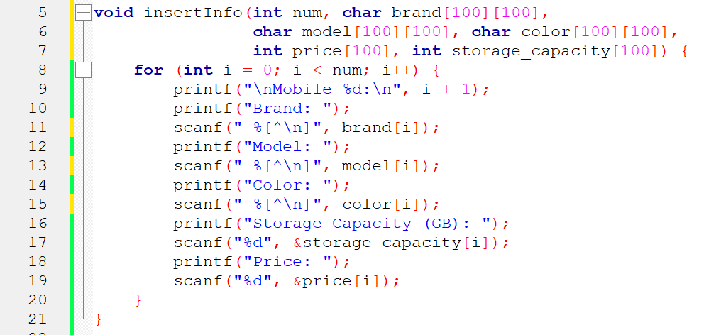
- showStats(): This function calculates and displays the total number of mobiles, the minimum and maximum price, and the average price of the stored mobile data.
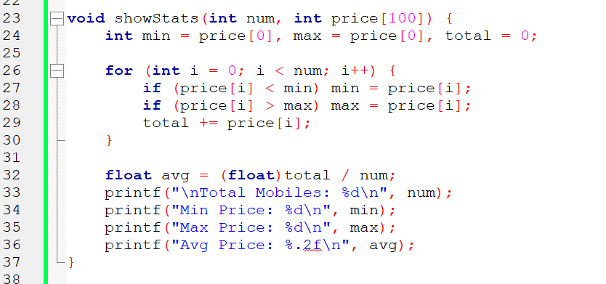
- searchMobile(): This function allows the user to enter a brand name and displays all available mobiles of that brand. If no match is found, it prints 'Not Available'.
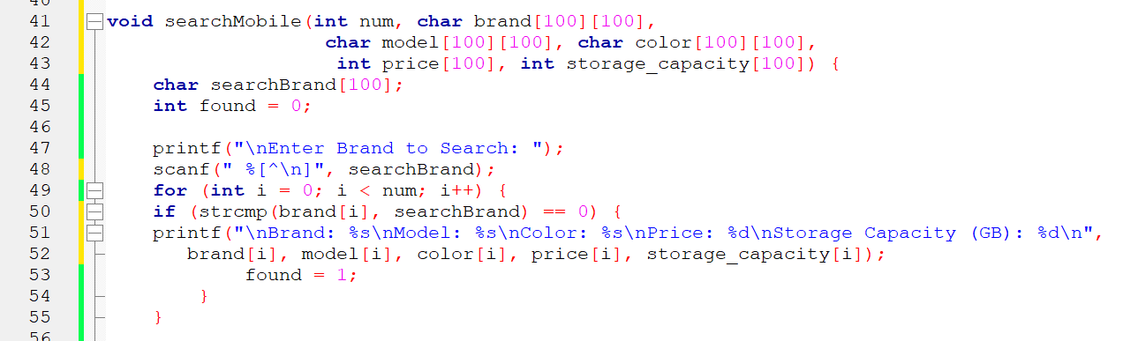

Output
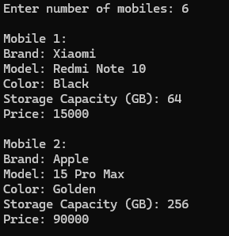
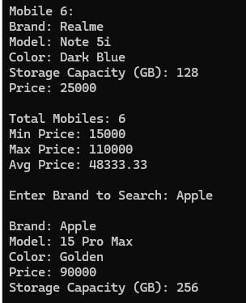
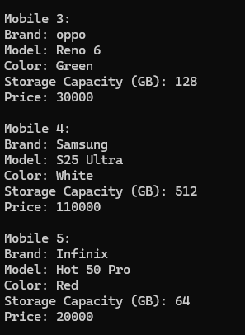
When executed, the program takes inputs such as brand name, model, color, price, and storage capacity. It then calculates statistical values and allows users to search for mobiles based on brand. A sample expected output is as follows:

Learning Points:
- Usage of 2D arrays to manage structured data.
- Implementing functions to organize code and promote reusability.
- Using loops and conditional statements to control the flow of the program.
- Computing minimum, maximum, and average values from an array of numbers.

Improving Points
- Enhance the user interface for better interaction.
- Add validation checks for input values.
- Improve memory efficiency by dynamically allocating arrays.
- Improve the search functionality to handle case-insensitive brand names.

Limitations:
  - The program uses a fixed array size, which limits scalability.
  - The search functionality only matches exact brand names.
  - No file handling for data persistence.

Achievements:
- Successfully implemented data storage using a 2D array.
- Implemented a functional search mechanism.
- Calculated and displayed price statistics efficiently.

Future Improvements:
- Implement a database or file storage system to save data permanently.
- Include features like updating and deleting mobile entries, sorting data, and advanced search options.
- By using structure, replace parallel arrays with structures to group related data more effectively.
- Use dynamic arrays to handle an unlimited number of mobiles.

Conclusion:
The Mobile Information Management System is a simple yet effective program that demonstrates the use of arrays and functions in C programming. It successfully achieves its objectives of storing mobile data, calculating price statistics, and searching for mobiles by brand. While the program has some limitations, it provides a solid foundation for future improvements and more advanced projects. This project has been a valuable learning experience in C programming and problem-solving.

