**MyBB Deployment Guide**

# 1) Using AWS CLI tool

**Steps**

1. Install the CLI tool (if not already installed)

Use this link on how to install the tool - <http://docs.aws.amazon.com/cli/latest/userguide/installing.html>

1. Configure the tool by giving below command

aws configure –profile user

You will be prompted for below inputs. Set the values as guided

AWS Access Key Id [None] : <your-access-key>

AWS Secret Access Key [None] : <your-secret-access-key>

Default regions name [None] : user-east-1

Default output format [None] : text

1. Go inside ./cloudify-mybb/code directory and give below commands sequentially
2. aws ec2 create-key-pair --key-name mybb –query “KeyMaterial” output text > ./mybb.pem
3. aws cloudformation create-stack --stack-name MyBBStack --template-body file://stack-template.json --cli-input-json file://stack-parameters.json

It takes around 15 – 20 minutes for the stack to be created

If stack is created successfully, you will get out as given below

{

"StackId": "arn:aws:cloudformation:us-east-1:694279810302:stack/mybb/cdb0a240-d619-21e6-2c5f-503aca4a5255"

}

1. **Using AWS Console**

Steps

1. Login to your AWS account (<https://console.aws.amazon.com/console/home>). Better login as root or account owner.
2. Click in services input box and start entering cloudformation.

Your will get cloudformatin service listed as you start typing, click that service

You will be taken to cloudformation dashboard

1. Click Create Stack button
2. Click Choose file button and select stack-template.json file from cloudify-mybb/code directory
3. Click the Next button in bottom right corner
4. Fill in the values in the UI as given. You can enter any password. Must be 8 chars long.

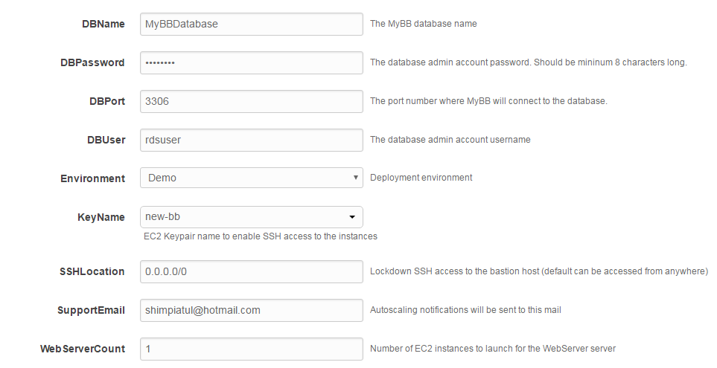

1. Click next button;
2. Confirm the default options for Tags and Permissions and click next Button;
3. Review the information and click “Create” button.

**You will see below ui. Observe the status value.**

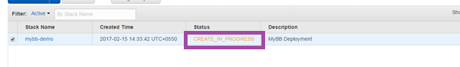

It will take 15 – 20 minutes for the deployment. After deployment is successful Status will change to CREATE_COMPLETE value.

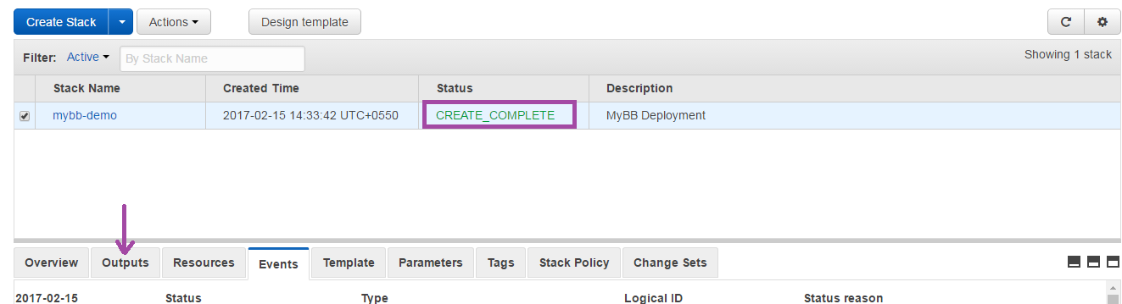

Click on Outputs tab. Click on value for key WebSite.

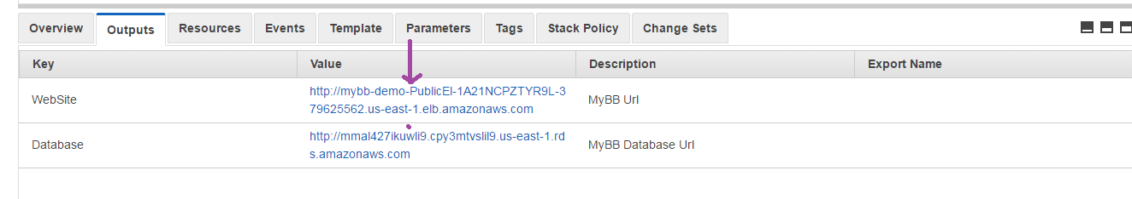

You will see deployed mybb application

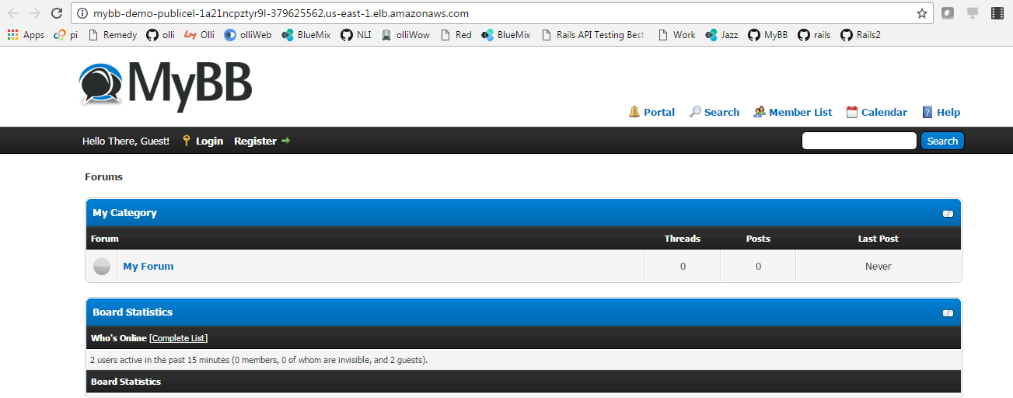

1. **Deleting the deployment.**

Once you are done you can delete the deployment using below steps

1. Select the stack. Click on checkbox before the stack name
2. Click Actions button and click Delete stack menu

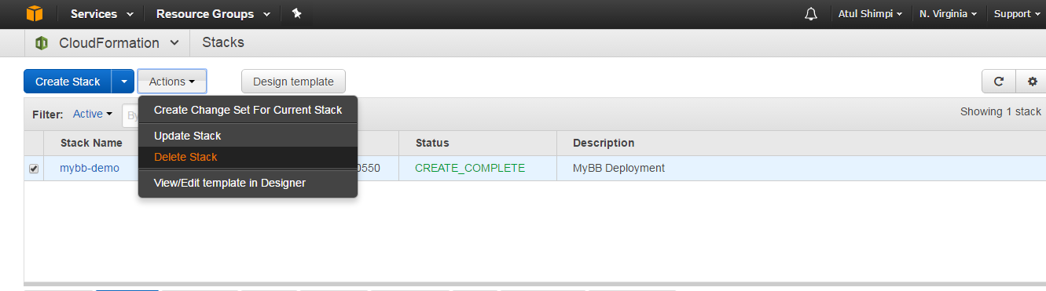

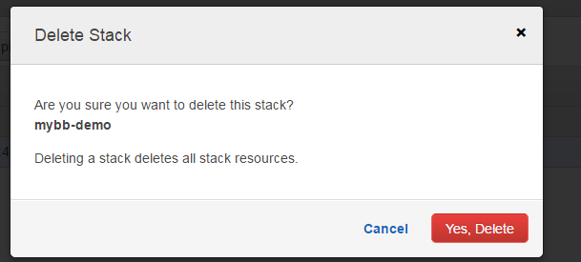

Click “Yes, Delete” button.

Status will change to DELETE_IN_PROGRESS. You can now log out from the aws account.

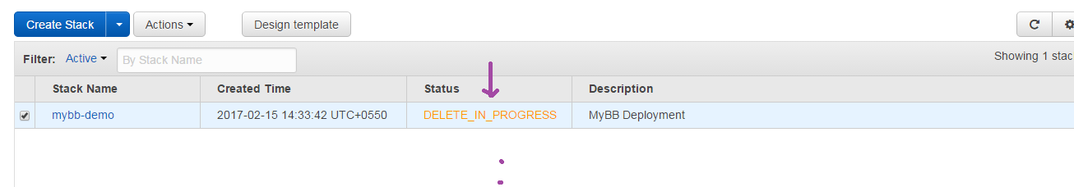

1. **Source code directory structure**

During launch configuration of autoscaling, user data script will clone <https://github.com/atul-shimpi/cloudify-mybb> and do the installation of mybb. Core file which come into picture during installation are explained

* **deploy-mybb.sh**

This script unzips the mybb_1810.zip and copies it to var/www/html. It then modified the mybb cofig files for database details and other things.

* **mybb_1810.zip, config.php, settings.php and mybb.sql:** Latest mybb version as of 14-Feb is 1810. So zip for it is downloaed
* **stack-template.json:** Cloudformation template
* **stack-parameters.json:** Used from AWS cli