README

TO RUN:
$ python3 nn.py train.csv test.csv

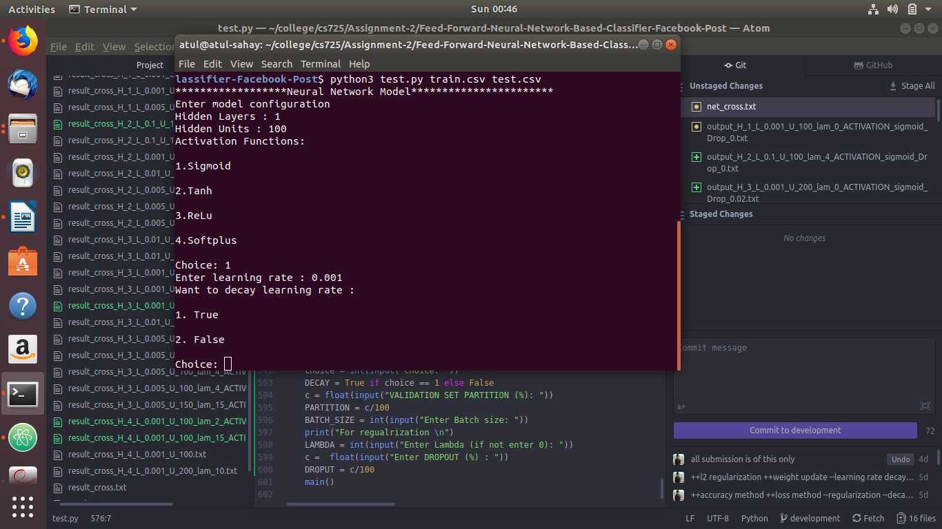
Fig 1: Interactive module of neural networks

- Model is made interactive, before running the train module will ask all the network configuration related queries, like number of layers and hidden units on each layer.
- For Task -2 : Just enter the network configuration accordingly and put lambda = 0 ( NO REGULARIZATION)
- For Task – 3 : when asked to whether you want to decayv learning rate, choose TRUE (See Fig1)
- For Task-3 : Tabel data , vary learning rate and lambda and also the network configuration accordingly to see the reported result.
- For Task-4 : choose from the different activation functions given. Put the choice as number given. (See Fig1)
- For Task-5 : Dropout method is implemented, for which dropout percentage should be provided.
NOTE: Choose Dropout percentage accordingly wisely as too much dropout can lead to poor result.

