README

The python program is saved as lr.py and at runtime train and test file (NOTE: either provide absolute path or just invoke the pyhton program from the submission itself) should be provided.

$ python3 lr.py train.csv test.csv

Note: Program is an interactive one just input necessary input at each stage for the needed output
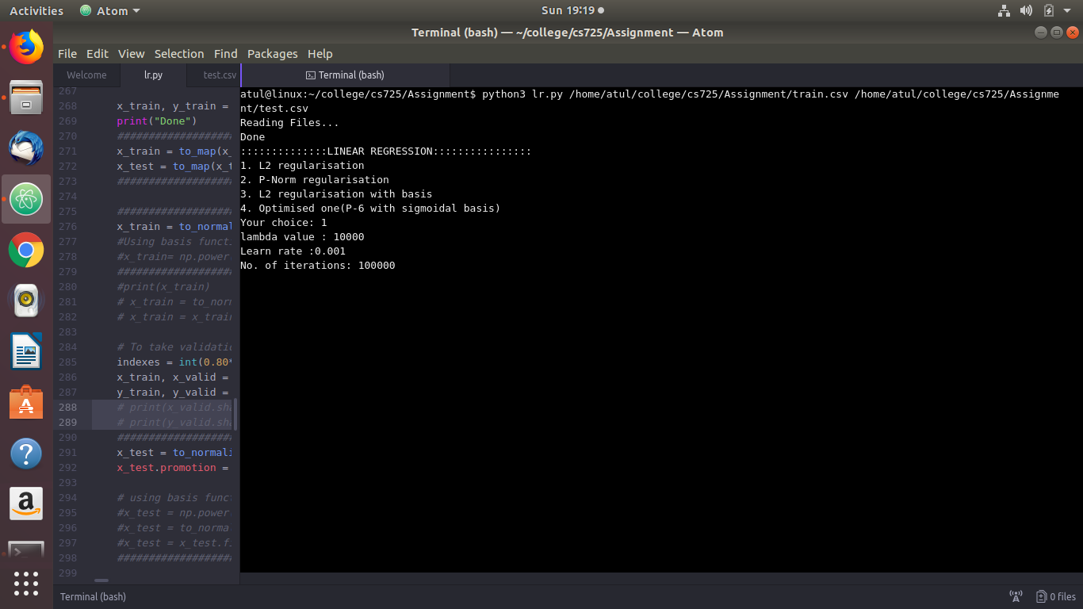
Figure 1: Interactive Console
The following model settings is common across all norms of regularisation and basis functions
applied:
- Min-Max Normalization is used.
- Held Out Validation is used, in proportion of 20 – 80, 20% for validation set and 80% validation for train set.
- Error rate = abs(cost of train-set atiteration - cost of train-set atiteration) is taken
- For the negative prediction, negative cutoff is used.

Hyperparameters used for given tasks are as follows:
(λ = Regularisation Factor, learn = Learning rate, Iterations = No. Of Iterations)
NOTE: FOR MSE and RMSE refer report.pdf
- Task -1:
First Select L2 regularisation option then enter the followings(see Figure1):
λ = 10000
learn = 0.001
Iterations = 100000

For unregularised :
λ = 0
learn = 0.03
Iterations = 100000
- Task -2:
To have the graphs, at last of the execution, you will be asked to whether you want to see the top features or not.[Press y]
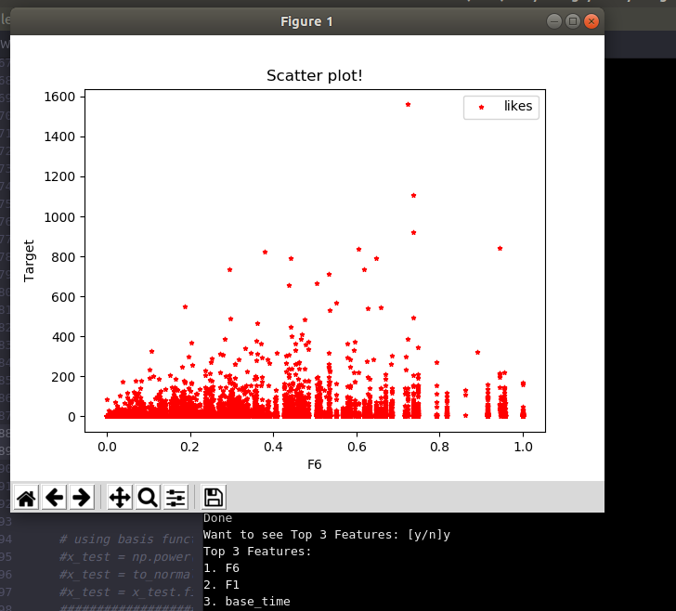
Figure 2: Scatter plot for top feature
- Task -3:
First select option -2 viz., P-Norm from the option.(see Figure1)
p = 4
λ = 109000
learn = 0.001
Iterations = 100000

For P-6 Norm:
p = 4
λ = 119000
learn = 0.001
Iterations = 100000

- Task -4
First select option-3 viz., L2 regularisation with basis function(see Figure1)
      - Inverse Sigmoidal
λ = 740
learn = 0.001
Iterations = 100000
      - Gaussian Function
λ = 13000
learn = 0.001
Iterations = 100000
- Task -5
First select option-4 Optimised(P6-Norm with Inverse sigmoid basis)
(see Figure1)
λ = 706
learn = 0.001
Iterations = 100000

