**The effects of carbonation conditions on the physical and microstructural properties of recycled concrete coarse aggregates**.

Asghar Gholizadeh-Vayghan , Annelie Bellinkx , Ruben Snellings , Bram Vandoren , Mieke Quaghebeur

https://doi.org/10.1016/j.conbuildmat.2020.119486

C&D

**Whole procedure of C&D :-**

1. A base concrete mixture is first produced, cast and cured inside sealed plastic buckets for production of RCA. After 28 days, the concrete is first crushed into hand-sized rubbles using a point press hydraulic jack.
2. The rubbles are dried to constant mass and then crushed using a laboratory jaw crusher.
3. The >3 mm fraction is tested for its apparent particle density and saturated surface-dry density, water absorption, micro-Deval (MDE) and freeze–thaw resistance.
4. Samples of this fraction are then subjected to different carbonation conditions where the RCA moisture condition, chamber relative humidity, CO2 pressure, temperature, and carbonation duration are studied in two to four levels in a sequential evolution ary design of experiments.
5. The carbonated RCA specimens are then tested for the same properties and the results of each experiment are used for deciding on the next carbonation conditions.
6. Satisfactory results are obtained after studying 16 different carbonation conditions.
7. A simple closed-form formula for determining aggregate porosity as a function of its apparent and oven-dried density is derived and the optimal combination of variable levels for maximum drop in porosity and water absorption is finally determined.
8. The products of outstanding carbonation conditions are studied for depth of carbonation via the phenolphthalein spraying technique.
9. The RCA microstructure and morphology are also studied using the scanning electron microscopy technique.
10. The MDE and freeze–thaw resistance of the RCA carbonated under optimal set tings is then measured and compared to those of fresh aggregates and non-carbonated RCA.

**Material required:-**

1. Neat Portland cement (CEM I 52,5N) is used as the primary (and only) cementitious material in making the base concrete.
2. 0/3 siliceous river sand, 2/7 and 7/14 crushed limestones are also used as the sources of fine aggregates, small and large coarse aggregates, respectively.
3. A high effective water-to-cement ratio of 0.57 is chosen to promote high water absorption by RCA.
4. water absorption of 2/7 and 7/14 aggregates are below 1.0% while that of the 0/3 sand is no more than 0.37%.

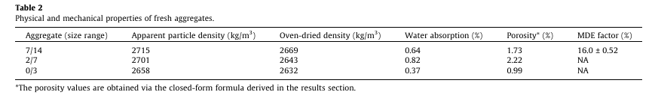

**Aggregate size used:-**

1. Upon completion of mixing, representative samples from the fresh base concrete mixture are taken and moist cured inside three 15*15*15cm 3cubicspecimensfor 28 days and tested for their compressive strength per EN 12390-3 (28-day compressive strength = 57.6 MPa).
2. However, due to lack of access to such types of crushers, the rubbles are crushed to aggregates only using a laboratory jaw crusher. The crusher opening is first set at 10 mm opening and all rubbles are passed through.
3. Resulting grains are crushed once more at 8.5 mm opening.
4. The obtained RCA is screened for the passing of 3 mm.
5. The experimental program is geared towards studying the effects of carbonation on the properties of the >3 mm fraction.
6. The grains are immediately washed after crushing, dried and stored for carbonation procedures.

**Different conditions for carbonation:-**

Five variables are defined and investigated in this research as follow.

1. RCA Moisture condition (‘‘Wet”, ‘‘Preconditioned”, ‘‘Air dried” and ‘‘Oven-dried”).
2. Relative humidity of the carbonation atmosphere (with or without boosting to saturation; referred to as ‘‘Boosted” or ‘‘Not boosted”).
3. CO2 pressure (1 bar or 5 bars).
4. Temperature (20 C or 60 C).
5. Carbonation Duration (1 h, 4 h or 24 h).

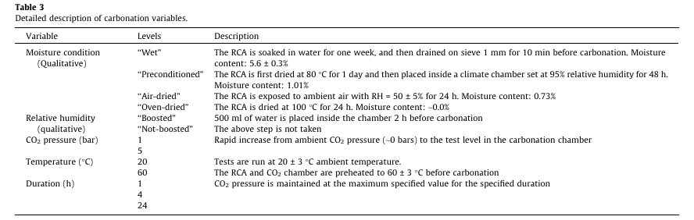

Carbonation procedure :-

Steps ;

1. Each recipe of carbonation is initiated by first adjusting the moisture condition.
2. The samples and the carbonation chamber are then brought to the test temperature two hours before the test.
3. Next, a nylon tray containing 500ml of water is placed inside the chamber in the case of ‘‘Boosted” experiments two hours in advance.
4. The samples are then placed inside the chamber and the carbonation is initiated by quickly injecting CO2 into the chamber to achieve the designated CO2pressure.
5. The pressure is preserved at that level for the specified duration and finally released and the chamber is flushed with nitrogen for 2min.
6. Upon completion of carbonation the samples are taken out and dried at 80 C in a ventilated oven for 24h to remove all the water trappedor generated during carbonation.