INTRODUCTION

1. INTRODUCTION

This chapter is intended to provide a brief introduction to the project along with the system and development process. This chapter also provides a brief overview of the objectives of the project.

1.1 BACKGROUND OF THE PROJECT

Nowadays, more and more departmental stores and supermarkets are being launched. They are being popular day by day due to the fact that they make the shopping experience easy by providing all the necessary stuffs under one roof. As per human nature everybody wants shopping experience easier and time saving.
Most departmental stores are run by manager. The manager needs to handle all the activities and needs quick decision to run the departmental store or shopping complex in an effective way. But because of the poor link between the manager and the customer, the works are not so much effective and the goals of supermarket or departmental stores are not met on time. So there is a need of a system that helps to manage such business organizations that can be accessed from any where and at any time for best performance.
These days large number of people are using internet. They use it for various purposes finding information to communication. Internet is now not only limited for entertainment purpose, it makes our life easy by performing our daily tasks in just a click. People prefer to do their shopping just sitting in a couch and surfing net rather than loitering around shop to shop. Moreover, web eases shopping, ascertains fixed price, and saves time & money. The web also provides whole new opportunities for businesses to expand in a new horizon. They get a wider audience and a larger market. Hence, an online store has lots of advantages as compared to the traditional brick and mortar business.
To fulfill the requirements, we have developed ePasal. The system handles the online shopping activities and gives detail information about products to customers. The system is designed in a way that is suited for every customer. The main features included in ePasal are different category of products and their sub category, products information, products add to cart, email, search, admin panel and many more.

1.2 OBJECTIVES

Due to rapid development in communication system, the world is getting smaller and smaller. The advancement of internet provides a platform for performing business, gathering information, transcending the traditional economic and geographical boundaries. The main objective of ePasal is to provide online solution for shopping. It changes the concept of localized shopping into global shopping so anybody in any part of world can purchase the products. The objectives of our sites can be pointed as
-to present online shopping system
-to provide detailed product information
-to provide customer for shopping wide range of products at reasonable price
-to provide complete set of administrative tools for managing accounts, categories and products and many more
-to store the data efficiently and effectively

1.3 PROBLEM STATEMENT

The problem of previous shopping technique is it is time consuming and required laborious work. But the online shopping eliminates all these drawbacks. People can get access to all those things they want in sip of coffee. Now, by using this online shopping system, people can save time and it doesn’t require to be physically present in the shopping mall and climbing upwards and downwards.

1.4 SCOPE AND APPLICATION AREA

The scope of the system can be listed as:
- The project saves time in shopping.
- The products are delivered at home.
- There is also a facility of advertisement.

1.5 DESCRIPTION OF SYSTEM

Online shopping is an online software package that facilitate the customers to buy the necessary items easily. It is easy to use our website with large range of products at reasonable price designed with an objective to ease shopping specially for those personals who are extremely busy and can’t afford to visit shopping centers and who wants their goods to be delivered at their doorstep. Online shopping is also interactive shopping with its network of technology specific websites, events and magazines.
This site can be successful to in simplifying the whole bargain-hunting madness. In addition to diverse range of products it emphasis its commitment to customer service with provision such as ‘fast find’ and ‘search’ which makes product discovery simple, customer information update to cart information update etc transaction. Its inventory or stock is diverse and constantly changing, continually expanding its product categories and hence launching new categories and products on the page of site. Its homepage also contains advertisements of various products. It is competent enough with the prevailing shopping sites.

  - TECHNOLOGICAL TOOLS

    - ASP.NET

ASP.NET is a web application framework developed and marketed by Microsoft to allow programmers to build dynamic web sites, web applications and web services. It was first released in January 2002 with version 1.0 of the .NET Framework, and is the successor to Microsoft's Active Server Pages (ASP) technology. ASP.NET is built on the Common Language Runtime (CLR), allowing programmers to write ASP.NET code using any supported .NET language. The ASP.NET SOAP extension framework allows ASP.NET components to process SOAP messages.

ASP.NET is a unified Web development model that includes the services necessary for you to build enterprise-class Web applications with a minimum of coding. ASP.NET is part of the .NET Framework, and when coding ASP.NET applications you have access to classes in the .NET Framework. You can code your applications in any language compatible with the common language runtime (CLR), including Microsoft Visual Basic, C#, JScript .NET, and J#. These languages enable you to develop ASP.NET applications that benefit from the common language runtime, type safety, inheritance, and so on.

    - SQL Server 2005

SQL Server 2005 (codenamed Yukon), released in October 2005, is the successor to SQL Server 2000. It included native support for managing XML data, in addition to relational data. For this purpose, it defined an xml data type that could be used either as a data type in database columns or as literals in queries. XML columns can be associated with XSD schemas; XML data being stored is verified against the schema. XML is converted to an internal binary data type before being stored in the database. Specialized indexing methods were made available for XML data. XML data is queried using XQuery; SQL Server 2005 added some extensions to the T-SQL language to allow embedding XQuery queries in T-SQL. In addition, it also defines a new extension to XQuery, called XML DML, that allows query-based modifications to XML data. SQL Server 2005 also allows a database server to be exposed over web services using TDS packets encapsulated within SOAP (protocol) requests. When the data is accessed over web services, results are returned as XM.
For relational data, T-SQL has been augmented with error handling features (try/catch) and support for recursive queries (Common Table Expressions). SQL Server 2005 has also been enhanced with new indexing algorithms and better error recovery systems. Data pages are check summed for better error resiliency, and optimistic concurrency support has been added for better performance. Permissions and access control have been made more granular and the query processor handles concurrent execution of queries in a more efficient way. Partitions on tables and indexes are supported natively, so scaling out a database onto a cluster is easier. SQL CLR was introduced with SQL Server 2005 to let it integrate with the .NET Framework.

SYSTEM ANALYSIS
SYSTEM DESCRIPTION

The system project originates for many reasons to achieve greater speed in processing data, faster information retrieval, reduce cost and better security. The development of a project takes place in a series of states that forms the system development life cycle. The general steps followed are:
- Preliminary investigation and feasibility study/feasibility analysis
- Specification of requirement/requirement analysis
- System design

2.1 PRELIMINARY INVESTIGATION AND FEASIBILITY STUDY

The purpose of the preliminary investigation is not to develop a system, but to verify that a problem of deficiency really exists, or to pass judgments on the new requirements.
If the feasibility analysis is not made beforehand, it will lead to a lot of wasted time, effort and capital as this project must be developed within the budgetary and time constraints.

2.1.1 Operational Feasibility

It is the process of accessing the degree to which a proposed system solves business problems or takes advantage of business opportunities. Projects are beneficial only if they can be turned on into system that will meet the requirements. Operational feasibility asks if the system will work when developed and installed.

2.1.2 Technical Feasibility

The purpose of accessing technical feasibility is to gain the understanding of the organization ability to construct the purposed system. The analysis should include an assessment of the development groups understanding of the possible target hardware, software and operating environment to be used.

2.1.3 Economic Feasibility

The purpose of accessing economic feasibility is to identify the financial benefit and costs associated with the development project. The study is done for the economic status that is required for the system.

2.1.4 Schedule Feasibility

The process of accessing the degree to which the potential time frame and completion dates for all the major activities within a project meet organizational deadlines and constraints for affecting change is the schedule feasibility.

2.2 REQUIREMENT ANALYSIS

2.2.1 Functional Requirement

Functional requirement are the requirements to build the software in an efficient and effective way. It includes all the necessity of the software to be built up that may be simple or complex. The detail of the software is stored in the database by the user.
The basic functional requirements of a system can be listed as follows:
- Provides the login feature for the user, administrator and supplier.
- Provides privilege to every system users.
- Provides adding, updating, deleting and viewing category and item information.
- Provides easy way to buy products.
- Providing facilities of shipping.
- Providing advertising facilities of supplier.
2.2.2 Non Functional Requirements

2.2.2.1 Software Requirement
- ASP.NET
- MS SQL

2.2.2.2 Hardware Requirement
- Operating system
- CPU
- Memory
- Windows 98 or above
- Pentium II or above
- 64 MB or above

2.3 COST ESTIMATION

The development process of any software starts from feasibility study, requirements analysis to testing and maintenance. Usually, software development involves various team members. In formal software development, system analyst is needed to analyze the overall system and other people involved such as programmer, designer etc.
Software cost estimation is the process of predicting the amount of effort required to build the software. Generally the cost of the system is estimated on the basis of the following factors:
- Complexity of the system
- Platform of the project
- Special features of the project
- Software quality
- According to demands of the software in the market
- Time taken to complete the project and number of people involved
- Type of the end user and fulfillment of the requirement
2.3.1 Cost Analysis

In this section we have estimated the cost on the basis of the manpower used in the development of the project. The cost of online shopping is evaluated as:
Task | Manpower | Number | Duration  (Month) | Rate /Manpower /Month | Cost
Analysis | System Analyst | 2 | 4 | 8,000 | 64,000
Design | System Designer | 2 | 2 | 7,000 | 28,000
Implementation | Programmer | 2 | 4 | 8,000 | 64,000
Documentation | System Analyst | 1 | 7 | 5,000 | 35,000
Testing | System Analyst | 2 | 2 | 8,000 | 32,000
Total Cost |  |  |  |  | 2,23,000
2.4 ENTITY RELATIONSHIP MODEL

The entity relationship data model is based on a perception of a real world. It consist a set of basic objects called entities, attributes and relationship among the objects.

2.4.1 Components of E-R Diagram

The E-R diagram consists of following components:
- Rectangle, which represents entity sets
- Ellipse, which represents attributes
- Diamond, which represents relationship sets
- Lines, which link attributes to entity sets to relationship sets
- Double ellipse, which represents multi valued attributes
- Dashed ellipse, which represents the derived attributes
- Double lines, which indicates total participation of an entity in a relationship sets

2.4.2 Keys

It is important to be able to specify how entities within a given entity set and relationship sets are distinguished. Conceptually, individual entities and relationship are distinct from a database perspective; however the differences among them must be expressed in terms of their attributes. The concept of key allows making such distinction. Types of keys are as follows:

Primary key
It is the field that uniquely identifies each record so it can be referenced from a related table. The primary key should meet the goals. Each record is unique within a table. For a record to be unique, all columns are necessary. The column that has completely unique data throughout the table is known as the primary key field.

Foreign key

A foreign key is a field in database that holds id values to relate record stored in another table. A foreign key field is a field that links one table to another table’s primary or foreign key. Foreign key is a key in table , normally a single field that directly references one or more fields in another table in order to enforce referential integrity.

2.4.3 Use Case Diagram

Use case diagram graphically shows the interaction between the system and the users of that system. In other words, use case diagram describe who will use the system and in what ways the user expects to interact with the system.
For the creation of use case, an analyst must first identify the different types of users that use the system or product. These users are actually the actors of the system that interact with the system in various manners. An actor is an external entity that interacts with the system while a use case represents a sequence of related actions initiated by an actor to accomplish a specific goal.

2.4.4 Class Diagram

A class diagram describes the static structure of the system. It shows how a system is structured rather than how it behaves. Class diagram is used to model the static structure of the system, in unified language using state diagram shows state transition. The main constituents of a class diagram are classes and their relationships. The relationships may be generalization, aggregation, association and various kinds of dependencies.

Representing a class

The simplest way of representing a class is to draw rectangle and place the name of the class inside the rectangle. UML suggests that class names began with capital letters. While making it more detailed, we draw rectangle and divide it into three horizontal compartments.
- In the top section, indicate the name of the class.
- In the second section, list of the attributes of the class.
- In the lower section, list the operation that the class can perform.

2.5 PROCESS MODELING

Process modeling involves the graphically representing the functions or processes which capture, manipulate, store and distribute data between a system and its environment and between components within a system. It is a technique of organizing and documenting the structure and data through a system process and logic, procedure and policies to be implemented by a system processes. A common form of processing modeling is a data flow diagram (DFD).

2.5.1 Data Flow Diagram

A data flow diagram is a graphical tool that allows analysts to depict the flow of data in an information system. The system can be physical or logical, manual or computer based. A DFD consists of data flow, data store, process and source/sink.
- A data flow can be best understood as the data that are in motion and moving as a unit from one place to another in the system. A data flow represents the result of query to the data base. Thus, the data flow is a data that move together. It is drawn as an arrow.

Figure 2.5.1 (a): Data Flow

- A data store is a logical repository of data. A data store depicts data at rest and it may represent data in file folder, computer based file etc.

Figure 2.5.1(b): Data Store

- A process is a unit of work that operates on data. Process depicts work or action performed on data so that they are transformed on data so that they are transformed, stored or distributed.

Figure 2.5.1(c): Process

- Source/Sink depicts the origin and the destination of data. It is sometimes referred to as an external entity and represented by rectangles.

Source sink
Figure 2.5.1(d) Source / Sink

SYSTEM DESIGN

3.1 DATABASE DESIGN

3.1.1 Database Concept

A Database is a collection of related files. A Database Management System (DBMS) is a computerized system for efficient management of data, their storage and retrieval.
Database design has five purposes:
- Structure the data in stable structures, called Normalized tables, that are not likely to change over time and that have minimized redundancy.
- Develop a logical database design that reflects the actual data requirement that exist in the forms and reports of an information system.
- Develop a logical database design from which we can do physical database design.
- Translate the relational database model into a technical file and database design that balances several performance factors.
- Choose data storage technologies that will efficiently, accurately, and securely that balances several performance factors.

3.1.2 Database Programming

Database programming is really the process of storing a variety of information in a standard way so the data can be easily accessed and maintained. Information stored within a database, unlike a word processing document, usually follows a standard format. The database programming is the process of constructing a database file to hold information in a standard format. When the actual database has been constructed, an ASP.NET application is then constructed to allow information stored in the database to be examined, modified and augmented.

3.1.3 Parts of the Database

- The database is actually overall file that can hold one or more formats. Although the term is often loosely, a database actually signifies the single file or structure that holds all the information for a process.

Record

A record is the primary data unit of information contained in a table.

Tables

Tables within the database are actually for holding the data, with each table defining structure. Table in a database are the most important things for holding the data in a systematic manner.

There are following tables in our system:
- Account Table
Accounts
AccountID
EmailAddress
PasswordHash
FirstName
LastName
Address
City
State
UpdatedBy
UpdatedDate
VerificationId
ForgotPasswordId
ForgotPasswordDate
EmailAlert
ClientIp
AccountCreatedDate
AccountBalance
LastLoginDate
UserType
DaytimePhoneNumber
EveningPhoneNumber
Status

- Category Table
Category
CategoryId
Name
Description
ParentCategoryId
PictureId
Status
CreatedDate
UpdatedDate
CategoryPage
SubCategoryFlag

- Current Statuses Table
CurrentStatuses
CurrentStatusId
CurrentStatusDesc

- Messages Table
Messages
MessageId
AccountId
MessageTo
Subject
Body
MessageStatus
SendDate
ProductOrderId

- Money Transaction Table
MoneyTransaction
MoneyTransactionId
AccountId
Amount
MoneyId
ClientIp
TransactionType
TransactionDate

- Product Table
Product
ProductId
CategoryId
ShortDescription
FullDescription
AllowCustomerReviews
RatingSum
TotalRatingVotes
AllowCustomerRatings
Status
CreatedDate
UpdatedDate
Name
Price

- Product Orders Table
ProductOrders
ProductOrderId
AccountId
ProductCount
StartBalance
EndBalance
SubTotal
ShippinCost
Tax
TotalAmount
ChargeFeeAmount
TransactionType
TransactionDate

- Product Quantities Table
ProductQuantities
ProductQuantitiyId
ProductId
QuantityInHand
QuantityInHold

- Product Rating Table
ProductRating
ProductRatingId
ProductId
CustomerId
Rating
RatedOn

- Product Transaction Table
ProductTransaction
ProductTransactionId
ProductId
Quantity
UpdatedBy
UpdatedDate

- Whole Transaction Histories Table
WholeTransactionHistories

WholeTransactionHistoryId
WholeTransactionId
CurrentStatusId
HistoryDate

- Whole Transactions Table
WholeTransaction
WholeTransactionId
ProductOrderId
ProductId
AccountId
CurrentStatusId
UpdatedBy
TransactionDate
ProductQty

Fields

A field is an element of a record.

3.1.4 Database Summary

The project in which we are involved is an integration of ASP.NET and the database. Here the database has the main role in the project. The more the secure database the more reliable would be the system. We had a lot of choice for maintaining the database like MS-Access, SQL Server, MS-SQL and so else. Among these we chose the MS-SQL Server as the database server. The reason behind this is MS-SQL is easily operable and has high security in comparison with other databases. A relational database utilizes two or more tables, containing data arranged in rows and columns, to cross-reference and define relationship between relationships between the data. In contrast, a flat-file database is limited only to a single file.

3.2 ALGORITHMS AND DESCRIPTION

There are two users in our system:
- User(Customer)
- Administrator

- User(Customer)
- All users register from the same page.
- They logon to their site.
- They can view items.
- They can check the state of the items through their mail.
- The items which are stored in cart but not brought can be viewed.
- The items which are bought can also be viewed.

- Administrator
- They can view, add and update category and product items.
- They can change product order status and system automatically sends the item status mail to the mail box.
- They can check the product item and there details.
- They can fill money in the database.
- They can search account.

3.3 FORMS AND INTERFACE DESIGN

3.3.1 Forms Design

A form is a business document that contains some predefined data and may include some areas where additional data are to be filled in. an instance of a form is typically based on one database record. Designing forms is a user-focused activity. Gaining an understanding of the requirements determination is a required first step in the creation of any forms. The design of forms should be such that each user understands it without difficulty as well as enough information should be provided to the user of the system.
In our system we have used ASP.NET for the forms design. We have also use CSS for giving better style to the designed forms.

3.3.2 Interface Design

Interface is a method by which users interact with the system. The design of interface is also a user-centered activity. Thus, the interface design should be the ease with which the users of the system use it. The system we have design has been designed according to users’ requirement. We have established menu interaction in our system. A menu interaction is a human-computer interaction method in which a list of system options is provided and a specific command is invoked by user selection of a menu option. For both interface as well as form design, we have implied ASP.NET and VB.NET. We have also used CSS for giving better style to the designed forms.

TESTING AND EVALUATION

4.1 SYSTEM IMPLEMENTATION

System implementation deals with the vital activities like coding, testing. The implementation phase is the most expensive and time consuming phase of entire life cycle.

4.2 CODING

Coding is the process whereby the physical design specification are turned oput into working computer code. Depending upon the size and complexity of the system, coding can be an involved, intensive activity.

4.3 TESTING

Testing is the process of debugging of the software, which is discovering the errors and bugs and consequently removing them. The main target for performing testing is to derive a test case for the system.

4.4 SOFTWARE TESTING

Software testing is the process of testing the code portion of the software. The main objective of software testing is to uncover errors in the logic and implementation of the software. There are mainly two types of testing strategies: white box testing and black box testing.

4.4.1 White Box Testing

White box testing uses the internal control structure of the procedural design to derive the test cases. To achieve required output, the software is carried through different stages where on each stage it is passed through various errors, which are debugged stepwise.

4.4.2 Black Box Testing

Black box testing enables set of input conditions to be derived that will fully exercise all functional requirements for a program. This testing basically focuses only on the input given and the output obtained. Black box testing is used to review module or program function from outside. It is based upon external design specification.

4.5 ACCEPTANCE TESTING

4.5.1 Alpha Testing

Alpha testing is simulated or actual operational testing by potential users/customers. Alpha testing is often employed for off the –shelf software as a form of internal acceptance testing, before the software goes to beta testing.

4.5.2 Beta Testing

Versions of the software, known as beta version are released to a limited audience outside of the company. The software is released to groups of people so that further testing can ensure the product has few faults or bugs.

4.6 VERIFICATION AND VALIDATION

Verification deals with the consistency, completeness and correctness check at each stage and between each stage of the development life cycle. Here, we check that the system meets its functional and non-functional properties.

Validation is the confirmation by examination and provision of objective evidence that software confirm to user needs and intended uses, and that particular requirements implemented through software can be consistently fulfilled. Validation is the determination of correctness of the final program and provides a guarantee that software works as advertised.

4.7 DOCUMENTATION

Documentation is the document prepared during the implementation process of any system. Documentation provides the users a lot of information regarding the new system. There are two types of documentation: system documentation and user documentation.
System documentation records the detailed information about the systems design specification, its internal working and its functionality. System documentation can be of two types: internal documentation and external documentation.
User documentation consists of written or visual information about an application system, how it works and how to uses the system.

IMPLEMENTATION
5.1 STATE TRANSITION DIAGRAM

State chart diagram describe the behavior of objects when an external entity initiates a task to be performed by the object. The diagrams also represents the life cycle of objects with respect to their states and transition.
The starting state is either with providing registration info or login into the system by user name and password. If the registration information is invalid then its state is ended if the information is valid the user type is checked and is forwarded to respective module.

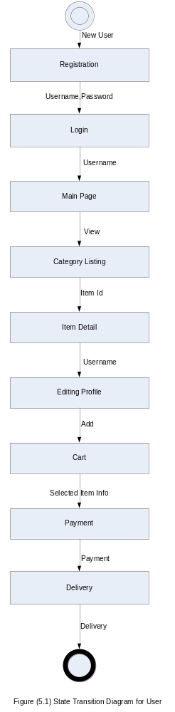
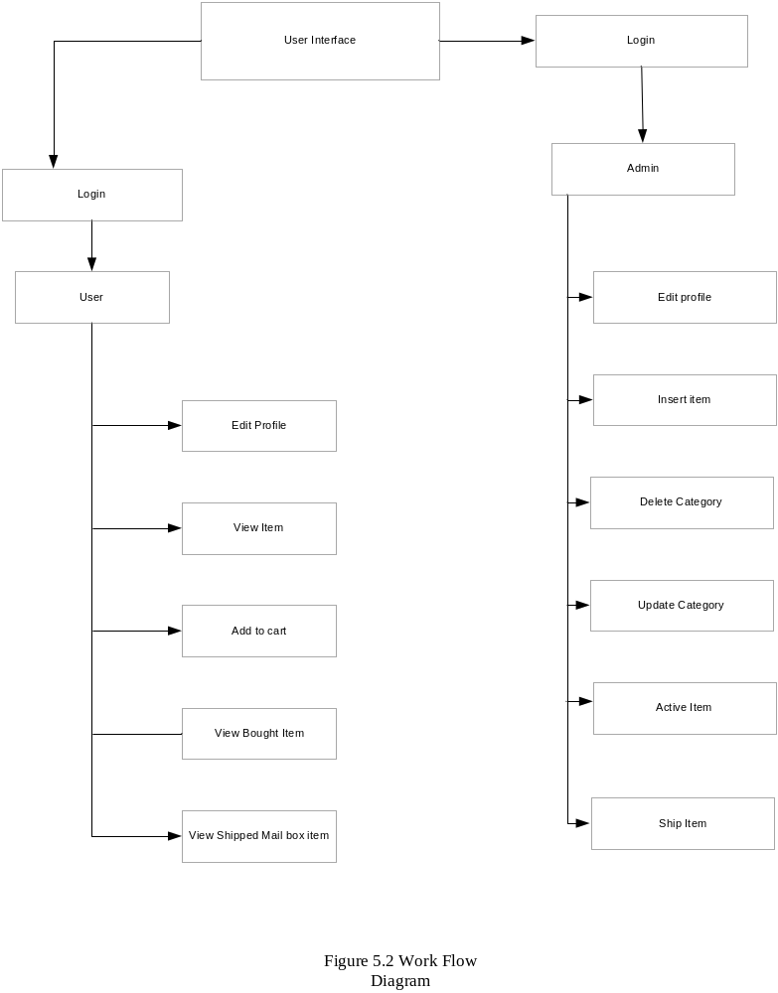

RECCOMENDATION
AND CONCLUSION

6.1 RECOMMENDATION

Our project “Online Shopping ePasal” can bring a new concept in the field of ecommerce. The project, indeed, has tried a lot to simplify the task in the shopping with the introduction of the computer. It is not the ending of the project but is the step towards that which in fact explores a lot of [projects with which we can overcome all the drawbacks of the existing system. This computer based system is a new project and there is a lot to perform in the field. There are a lot of factors due to which we can’t proceed a long way in the work. We are feeling much happy to work in such a challenging and happening area of database using all our concepts of vb.NET and Software Engineering.

We sincerely recommend our friends and colleagues to work in such field, which actually gives a lot of satisfaction while working. The project work in fact gives a lot of confidence to fight out in this challenging world. As one proceeds, one can’t believe how much knowledge he /she gains and the teamwork, which the project work teaches, really will be a new experience.

6.2 FURTHER ENHANCEMENTS

Online shopping is the vast scope. Whatever we do it is just nothing if we consider the world wide shopping. There are many things to add. When we think that we have finished our project new ideas keep on popping on our mind. Due to load shedding and time constraint we were unable to include all the features that we were thinking in the beginning of this project.

6.3 CONCLUSION

This project work has been quite beneficial for us as we learnt the practical applications about the software engineering process. We got familiarized with the practical knowledge of how software is designed prior to coding which was studied in theory and that make any software secured from crisis. Thus, it helps us to understand the technique of software analysis, designing, implementation, testing and maintenance. The essence of team work for completion of the project has been realized and we are built up with the confidence for software analysis, designing, implementations, debugging, testing and maintenance. We also feel very much privileged to work in such a challenging area.
REFERENCES
1. Roger S. Pressman “Software Engineering” Fifth Edition, Tata McGraw-Hill International Edition.
2. Jeffery A. Hoffer, Joey F. George, Joseph S. Valacich “System Analysis and Design” Third Edition, Pearson Education Asia.
3. Abraham Silberscatz, Henry R. North, S. Sudarshan “Database System Concepts”, Third Edition, The MacGraw-Hill Companies, Inc, New Delhi, 1997.

LIST OF FIGURES
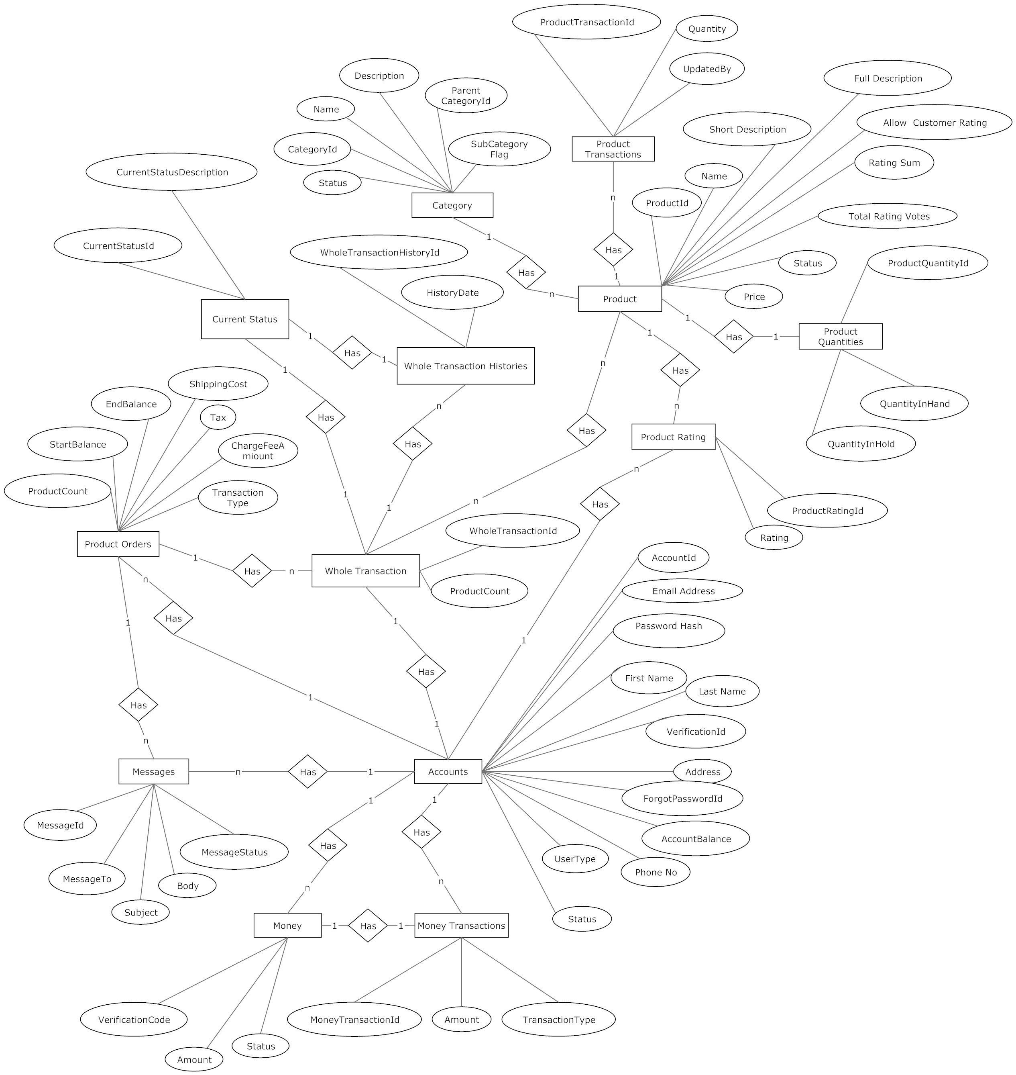

Figure 2.4 ER Diagram
  - DATA FLOW DIAGRAM

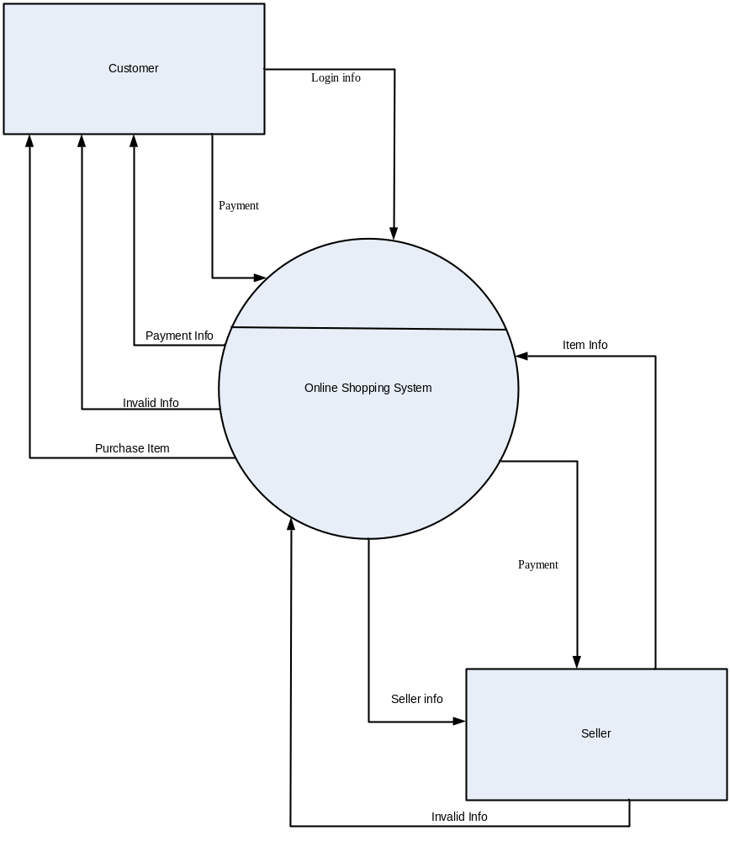

Figure 2.5.1 Data Flow Diagram (level 0)
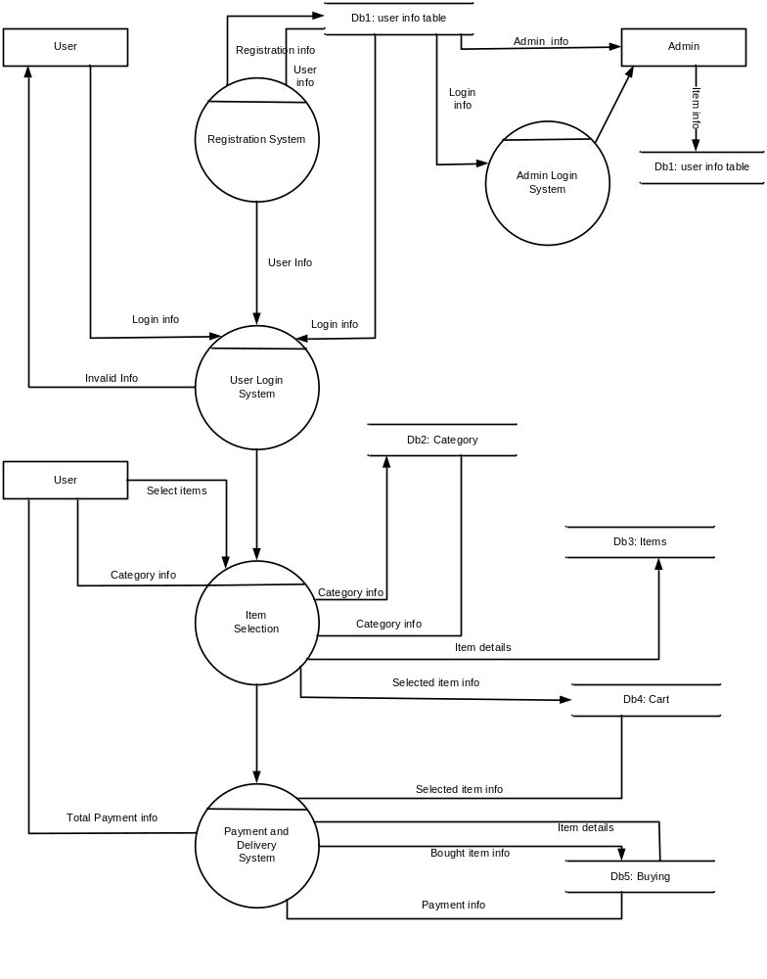
Figure 2.5.2 Data Flow Diagram (level 1)
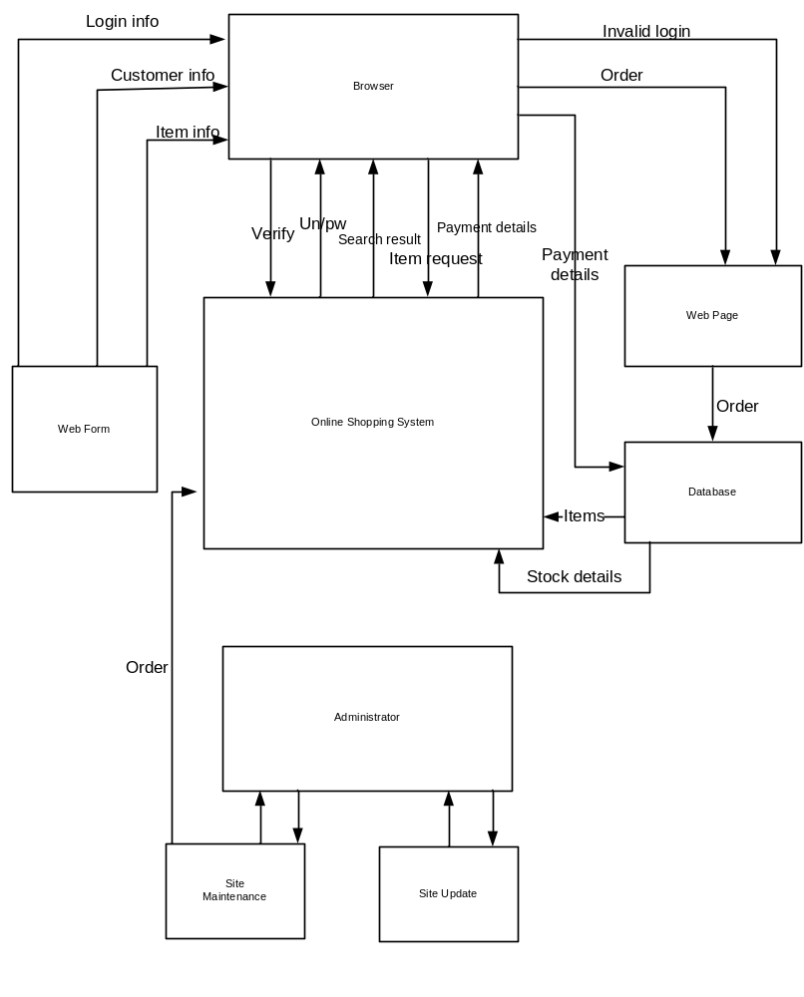
Figure A.1 Architecture Flow Diagram (level 1)
GANTT CHART
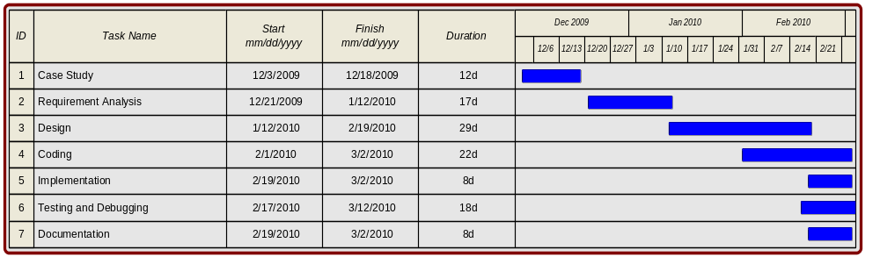

Figure A.2 Gantt Chart

SEQUENCE DIAGRAM FOR ADMINISTRATOR
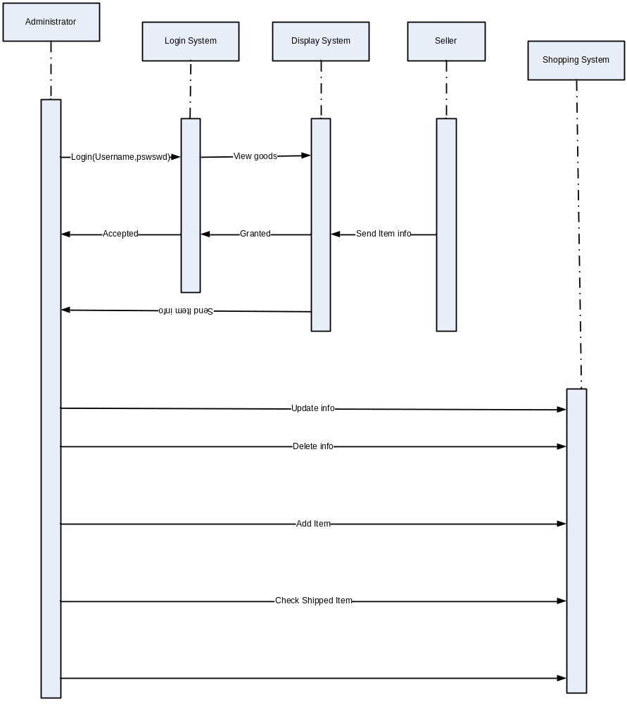

Figure A.3 Sequence Diagram for Administrator
SEQUENCE DIAGRAM FOR USER

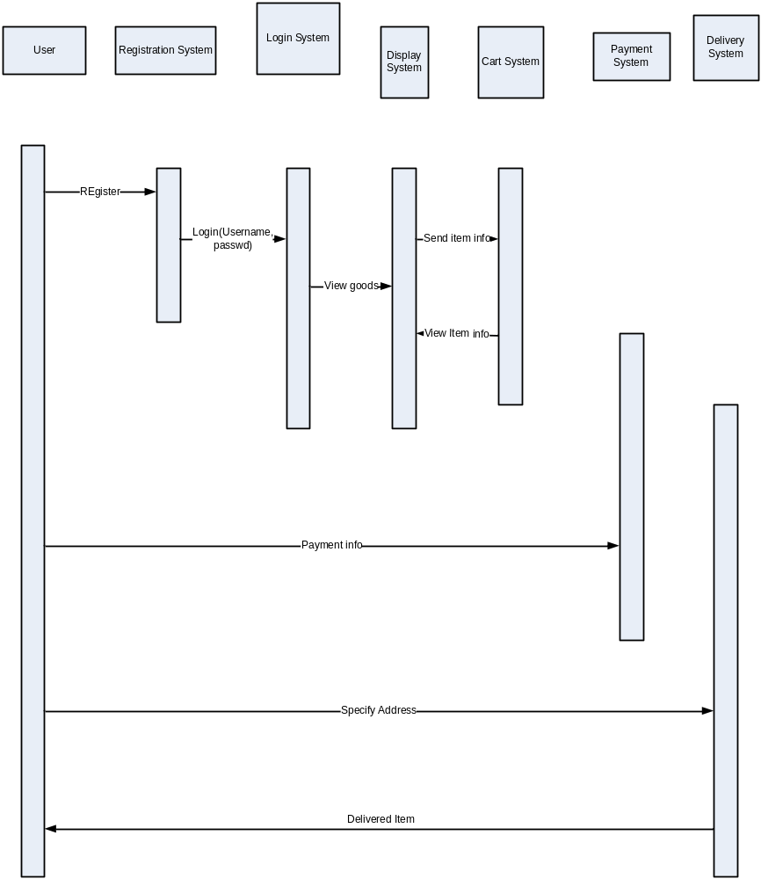
Figure A.4 Sequence Diagram for User
USE CASE DIAGRAM FOR ADMINISTRATOR

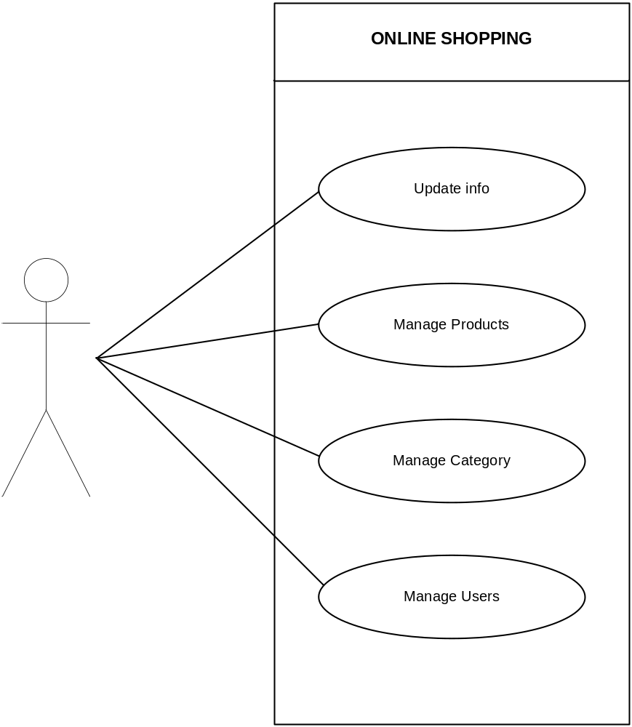
Figure A.5 Use Case Diagram for Administrator
USE CASE DIAGRAM FOR USER

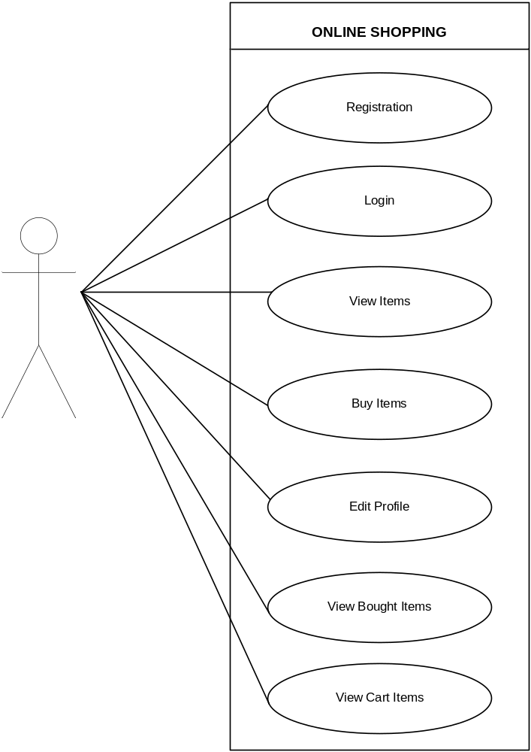

Figure A.6 Use Case Diagram for User

INTERFACES

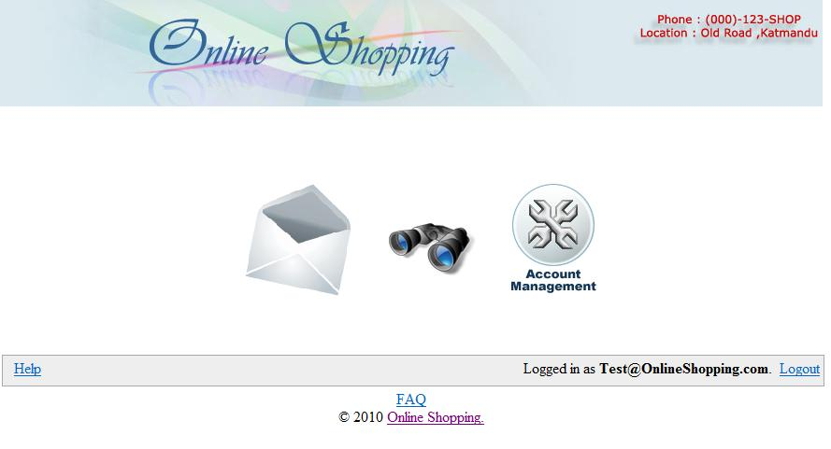
Figure 1: Default page for authenticated normal user
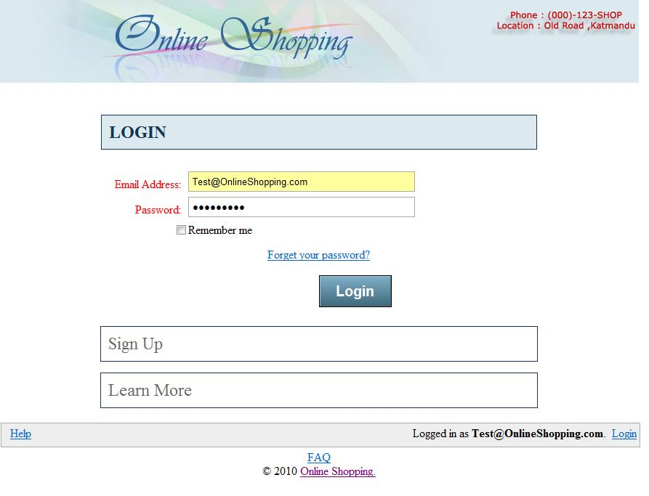
Figure 2: Login page

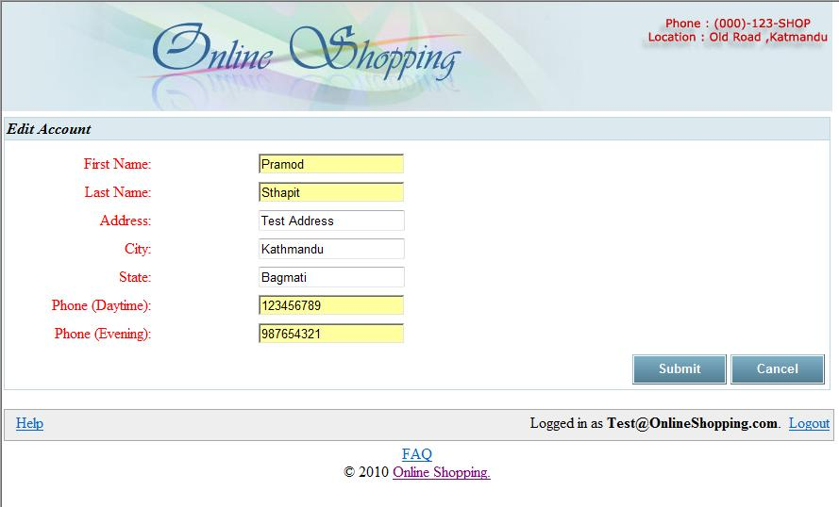
Figure 3: Edit account page

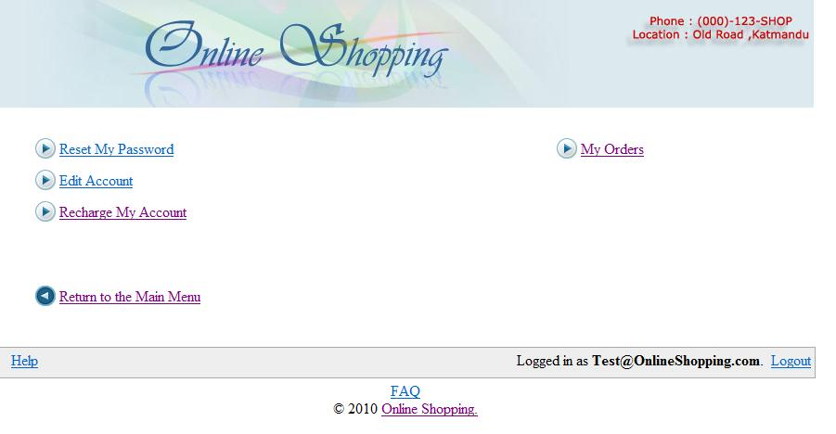
Figure 4: Normal user account management page

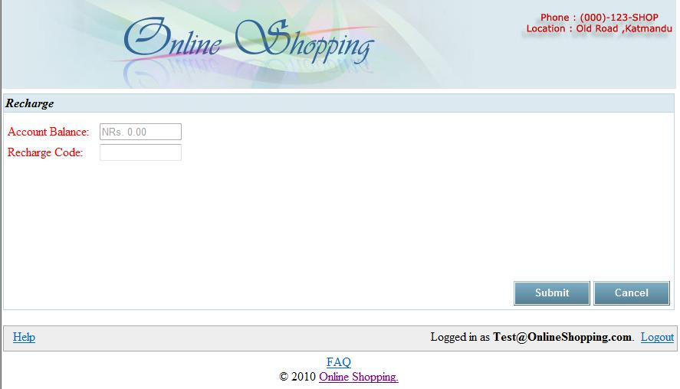

Figure 5: Recharge page

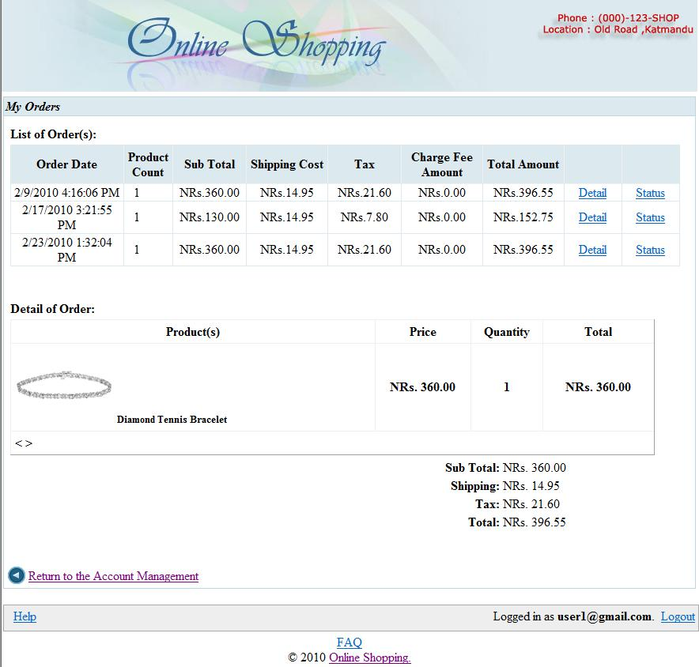

Figure 6: My order page with order detail

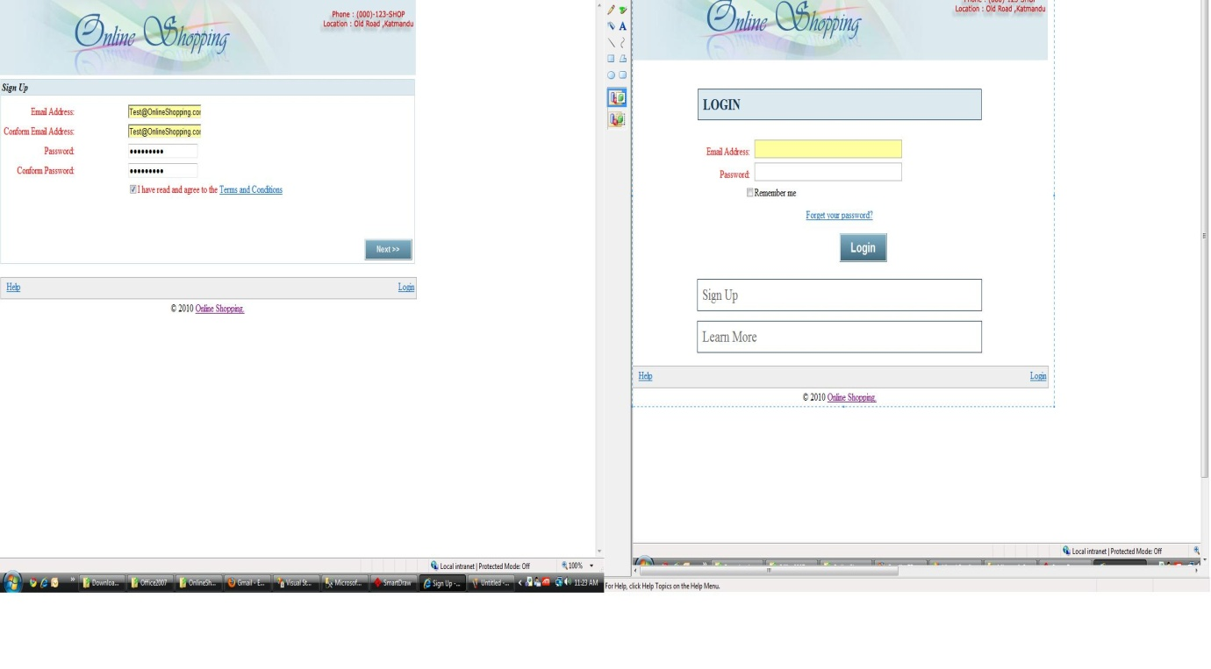

Figure 7: Sign up page 1

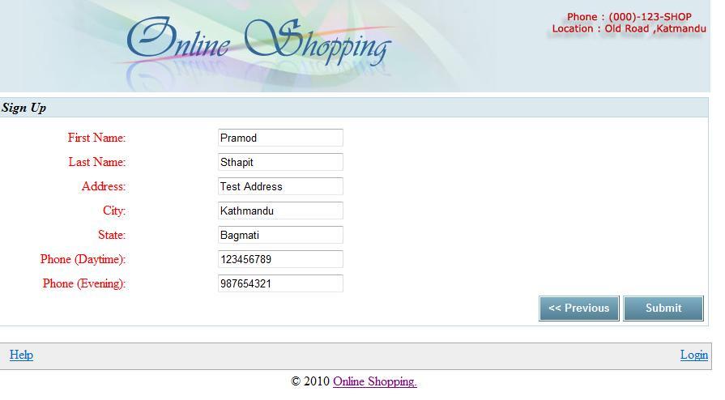

Figure 8: Sign up page 2

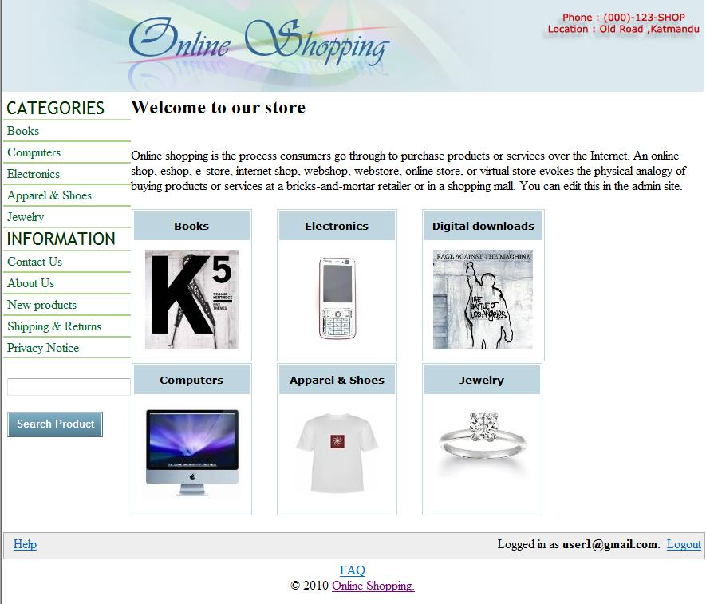

Figure 9: Online shopping default screen

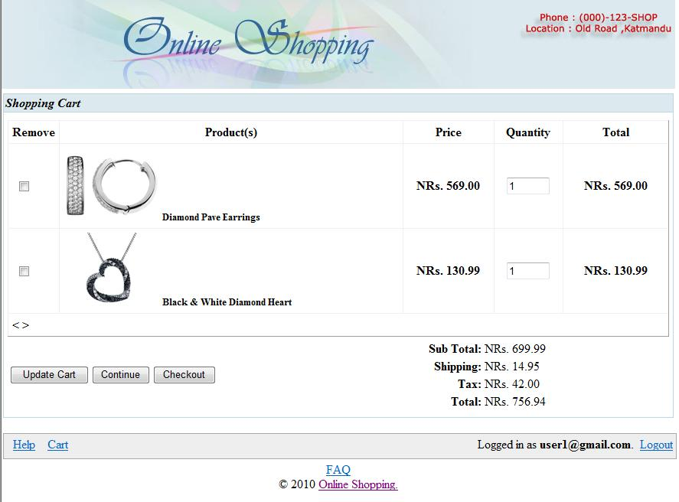

Figure 10: Online shopping shopping cart page

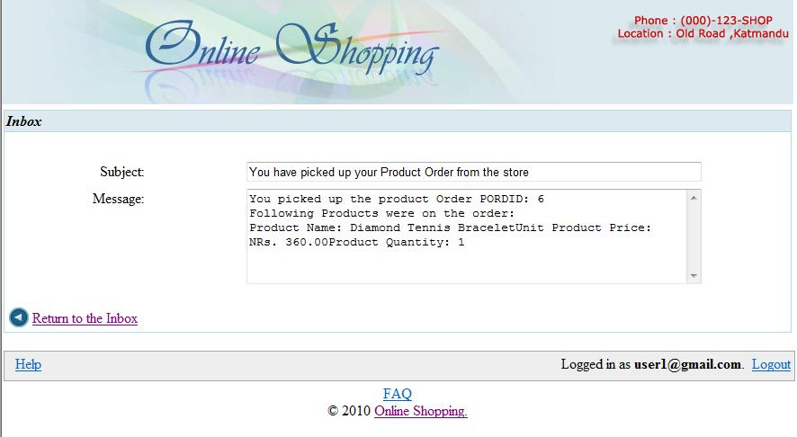

Figure 11: Inbox email page read

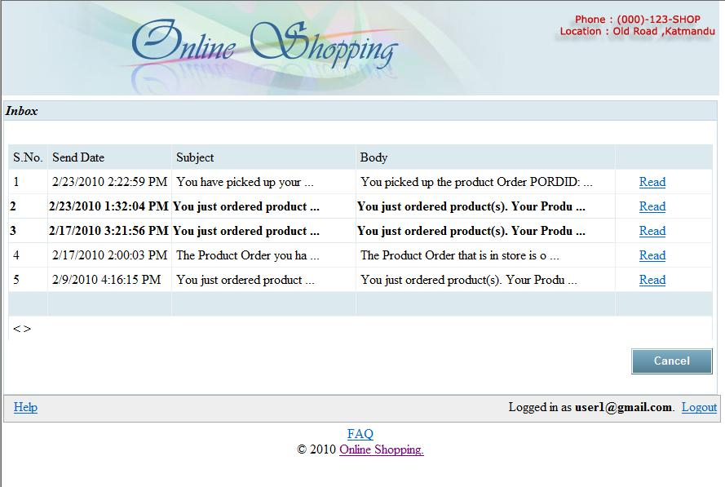

Figure 12: Inbox email page

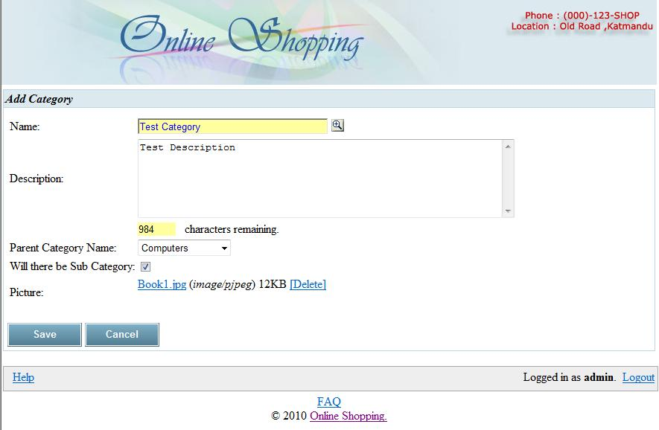

Figure 13: Admin add category page

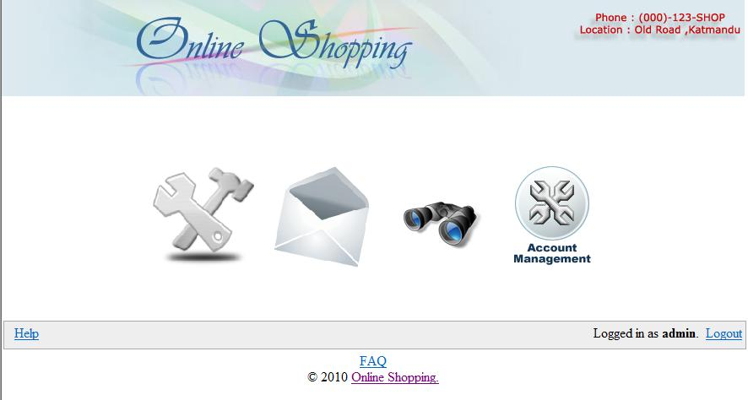

Figure 14: Admin default screen

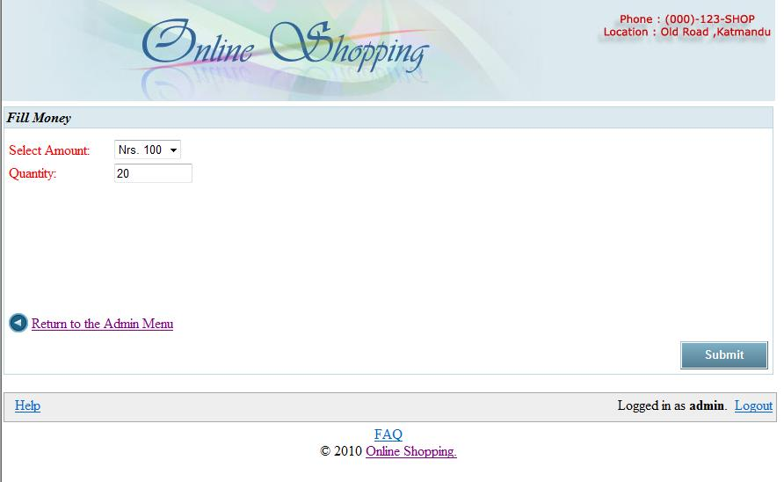

Figure 15: Admin fill money page

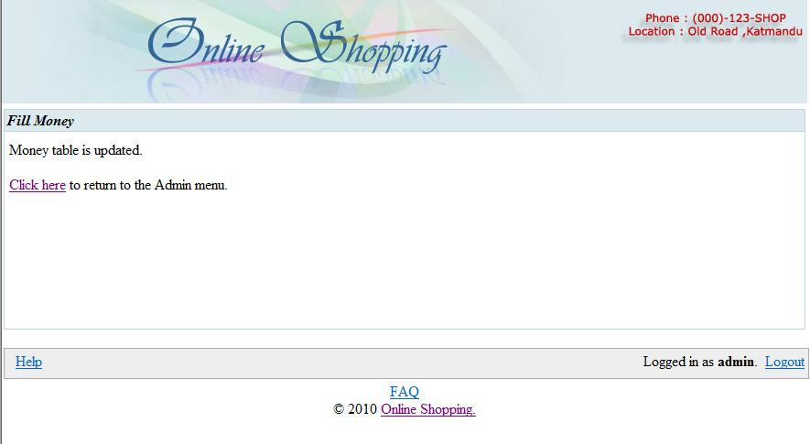

Figure 16: Admin fill money result page

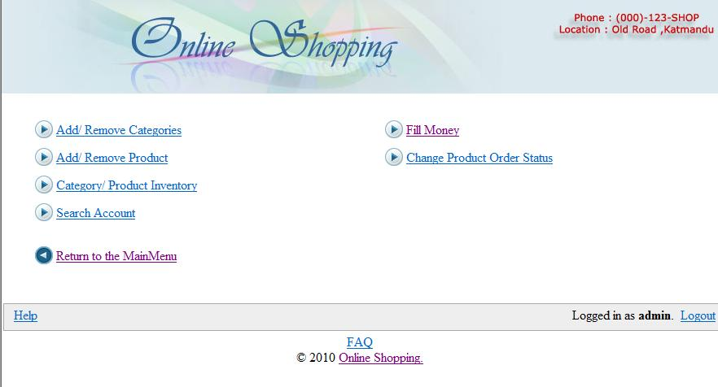

Figure 17: Admin function page

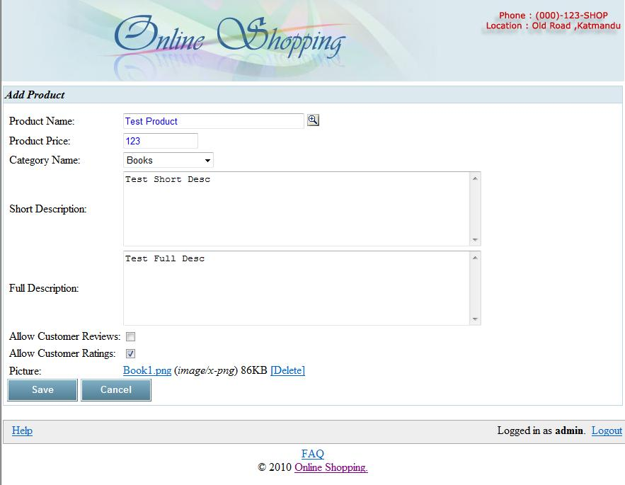

Figure 18: Admin add product page

