**Maven-TDD-Automation-Framework**

**Selenium based automation POM framework including Extent reports**

**This framework contains:**

* Excel Sheet and Config.properties file for data parameterization.
* Screen shots taken at every event for a test case through listeners and manually.
* Extent report for analyzing the output / results.
* TestNG.xml for running multiple tests at once.
* Test Utilities to take screenshots, Fetching data form Excel sheet and config file.

**Directory structure:**

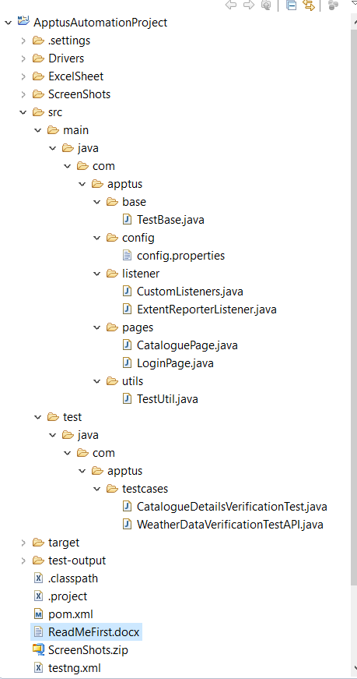

**Steps to run the Testcases:**

* Clone the repository using "git clone "
* Import as a maven project.
* Enter the data in the Excel sheet such as ( Email, pwd , Product’s details ).
* Run the TestNG.xml as a testNG file or Run the individual Tests as testNG.
* Include or Exclude the groups to run the Test Cases groupwise in TestNG.xml.

**Extent Reports:**

*Path of the Extent report*: “/ApptusAutomationProject/test-output/Extent.html”

As this is an HTML report just copy the path of the report and paste in any browser to see the results.

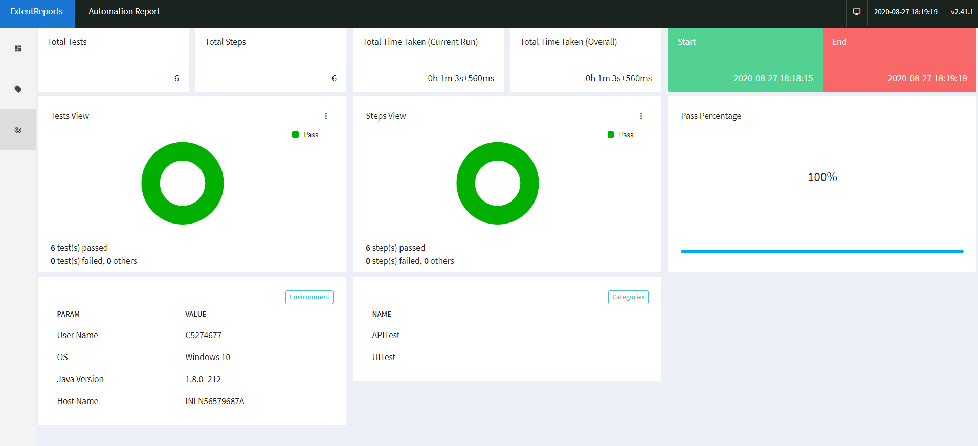

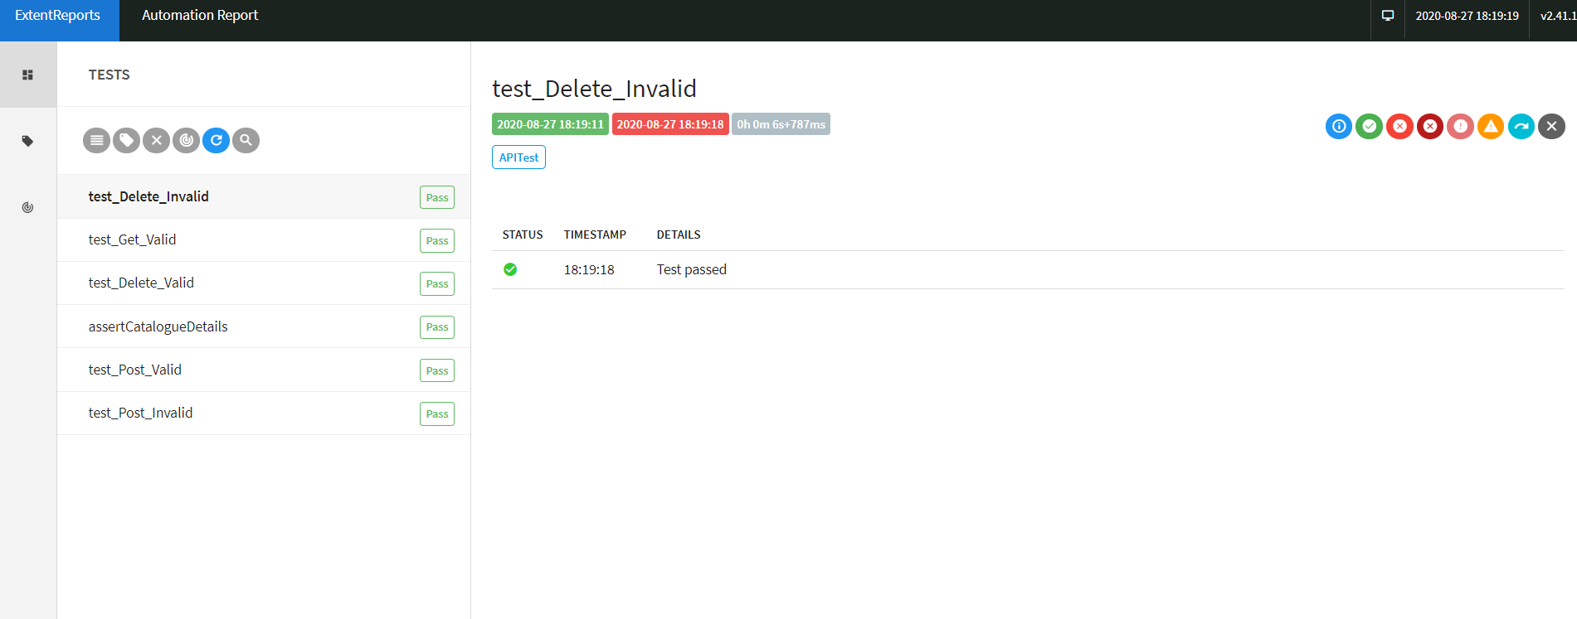

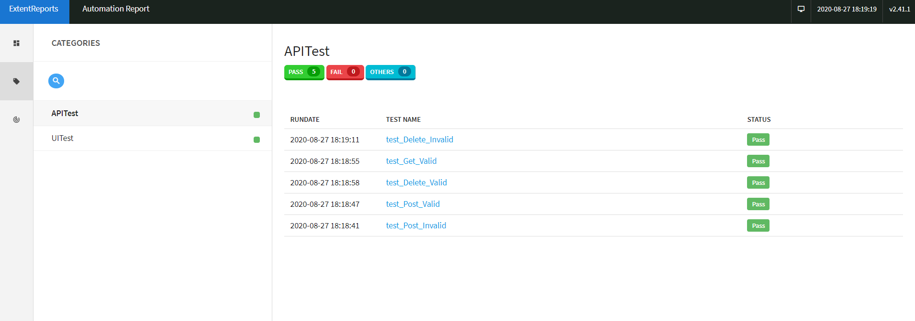

**Screenshots:**

Path of the Screenshots: “/ApptusAutomationProject/ScreenShots”

***Glimpse of Screenshots:***

