**Steps to execute the program**

The program submitted is written using Google Colab. As a result, it is highly recommended its run on the same platform. The steps below will illustrate how to run the code using Google Colabs.

1. Go to [Google Colab](https://colab.research.google.com/notebooks/welcome.ipynb) website.
2. Click on **File** and **Open** **Notebook**.

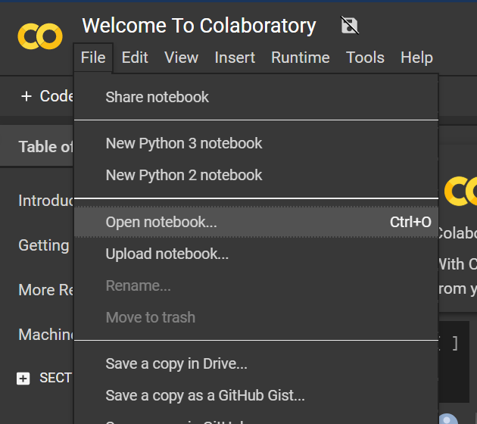

1. Select Github URL and enter path as provided here **atul1234anand/fastai**

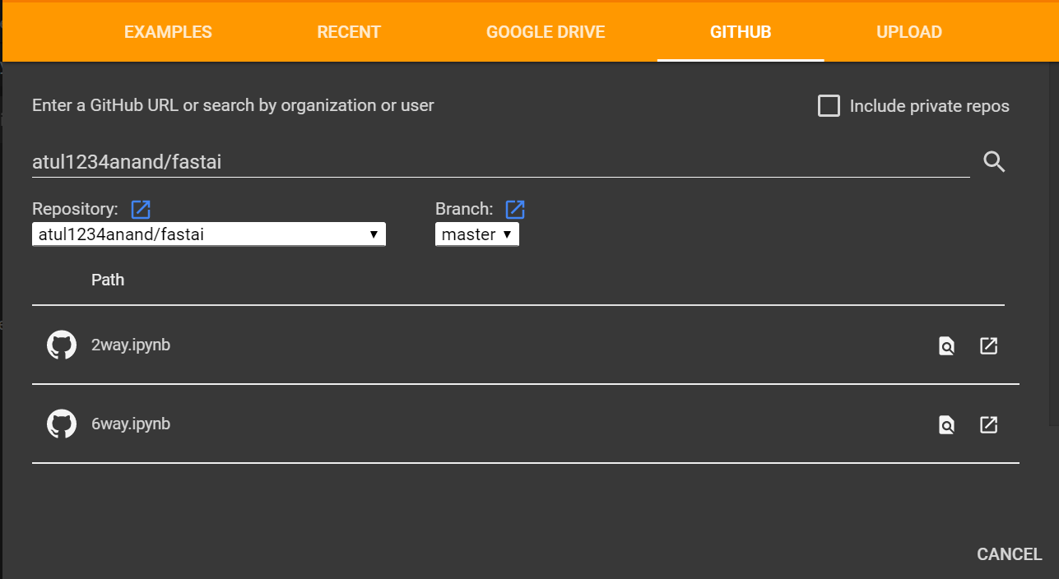

1. Open both 2way.ipynb and 6way.ipynb(one at a time)

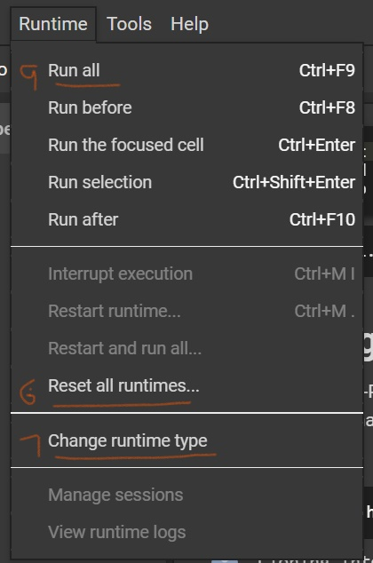

Steps 6, 7 and 9 are shown above

1. Go to **Runtime**
2. Click on **Reset all runtimes** and click **Yes** in the dialog box below

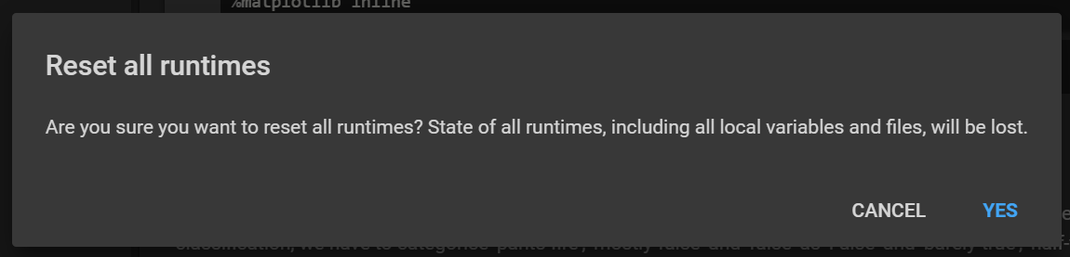

1. Click on **Change runtime type**

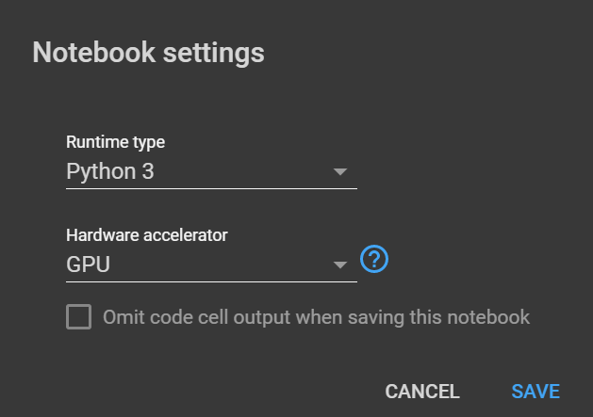

1. Change the **Runtime type** to Python3 and **Hardware accelerator** to GPU as shown above
2. Click on **Run All**