Assignment 3

CSE 527 Fall 2015

Atul Jha - 110350053

1. Matlab Code: 1/part1.m

1.1

Input size = W1×H1×D1

Number of filters = K

Filter size = F

Stride = S

Zero padding = P

Output size = W2×H2×D2 where:

W2 = (W1−F+2P)/S+1

H2 = (H1−F+2P)/S+1

D2 = K

Input Image used = 'peppers.png'

2 Sobel Filter used (one in x direction other in y)

Input size = 384x512x1

Number of filters = 2

Filter size = 3x3

Stride = 1

Zero padding = 0

Output size = W2×H2×D2 where:

W2 = (W1−F+2P)/S+1 = (384-3)/1 + 1 = 382

H2 = (H1−F+2P)/S+1 = (512-3)/1 + 1 = 510

D2 = 2

Output size(Using MathConvNet) = 382x510x2

Stride = 1

Zero padding = 1

Output size = W2×H2×D2 where:

W2 = (W1−F+2P)/S+1 = (384-3+2)/1 + 1 = 384

H2 = (H1−F+2P)/S+1 = (512-3+2)/1 + 1 = 512

D2 = 2

Output size(Using MathConvNet) = 384x512x2

Stride = 16

Zero padding = 4

Output size = W2×H2×D2 where:

W2 = (W1−F+2P)/S+1 = (384-3+8)/16 + 1 = 25

H2 = (H1−F+2P)/S+1 = (512-3+8)/16 + 1 = 33

D2 = 2

Output size(Using MathConvNet) = 25x33x2

Peppers image after running vl_nnconv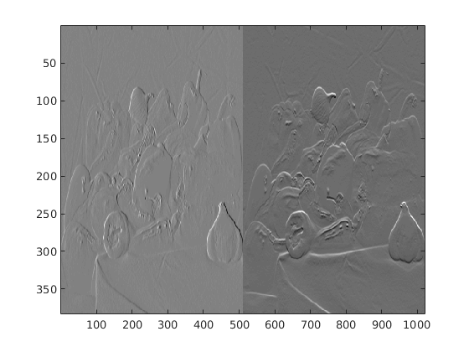

1.2

Peppers Image after relu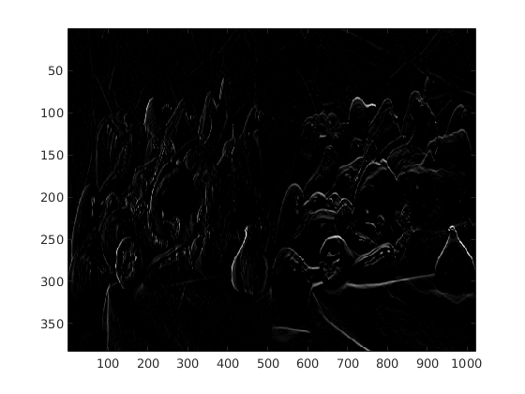

1.3

Pooling Layer reduces the spatial size of the output of convolution layers in order to reduce the number of parameters and computation in the network.

Peppers Image after Pooling Layer [Stride=1, Pad = 1, Pool = 4]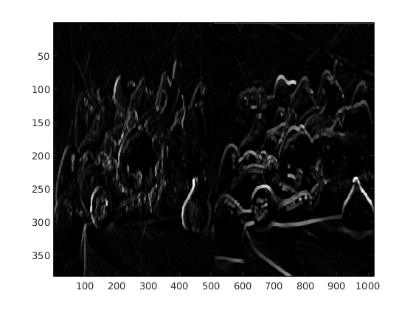

Peppers Image after Pooling Layer [Stride=1, Pad = 1, Pool = 8]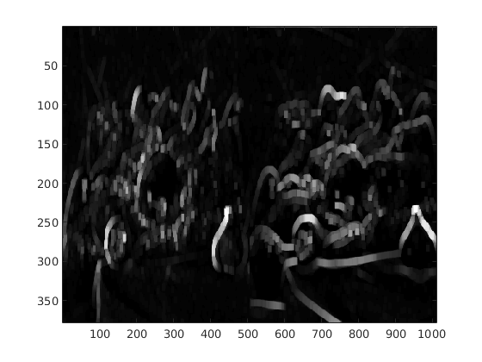

2.

2.1 Matlab Code: 2/part2.m

Hyper Parameters Used:

M1 = 20

M2 = 50

M3 = 500

batch size = 100

epoch = 10

learning rate = 0.001

weightDecay = 0.0005

momentum = 0.9

Error Curve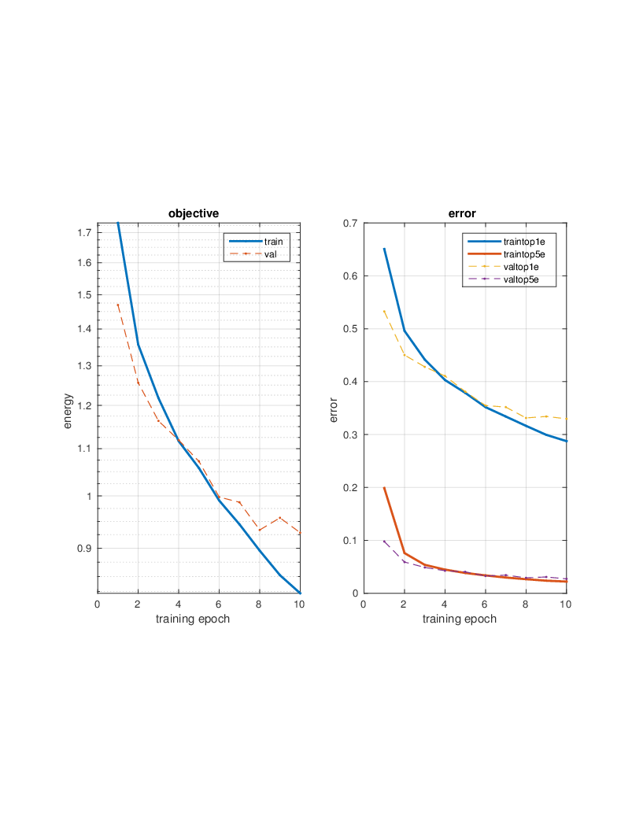

2.2 Matlab Code: 2/part22.m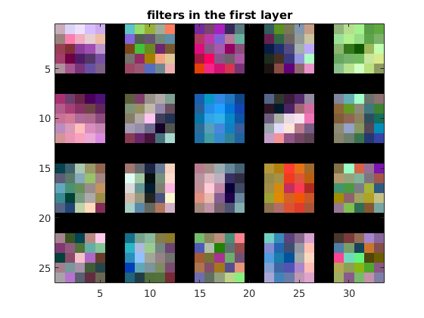

Accuracy Obtained on Training = 13.018%

Accuracy Obtained on Test = 13%

3. Matlab Code: 3/part3.m

Accuracy Obtained on Training = 5.14286%

Accuracy Obtained on Test = 5.21646%