Block Diagram:

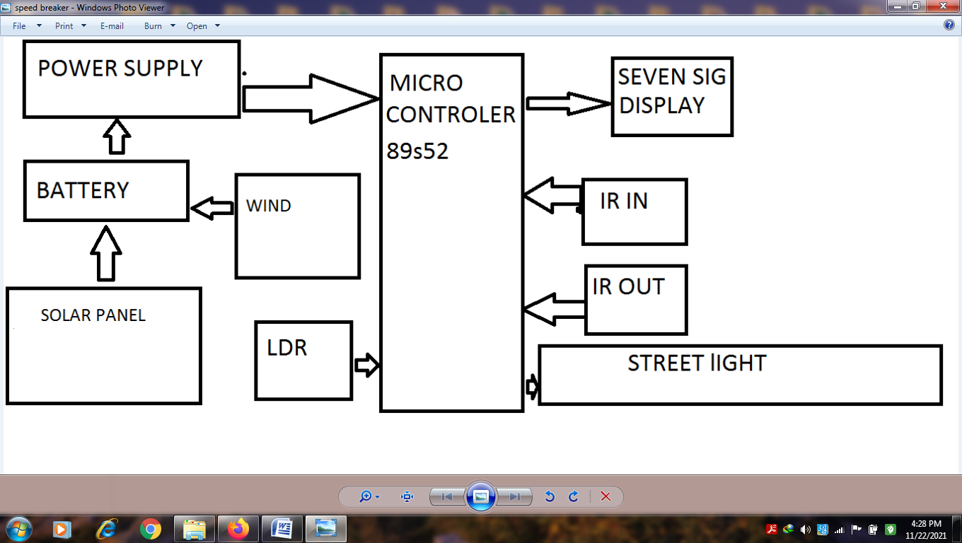

Hardware Specifications
- 8051 series Microcontroller
- Voltage Regulator
- Diodes
- LED
- Transistor
- Lamp
- Push Button
- IR LED’s

- IR Receivers
- 7- Segment Displays
- Motor
- Register
- Capister
- crystal

Software Specifications
- Keil µVision IDE
- MC Programming Language: Embedded C

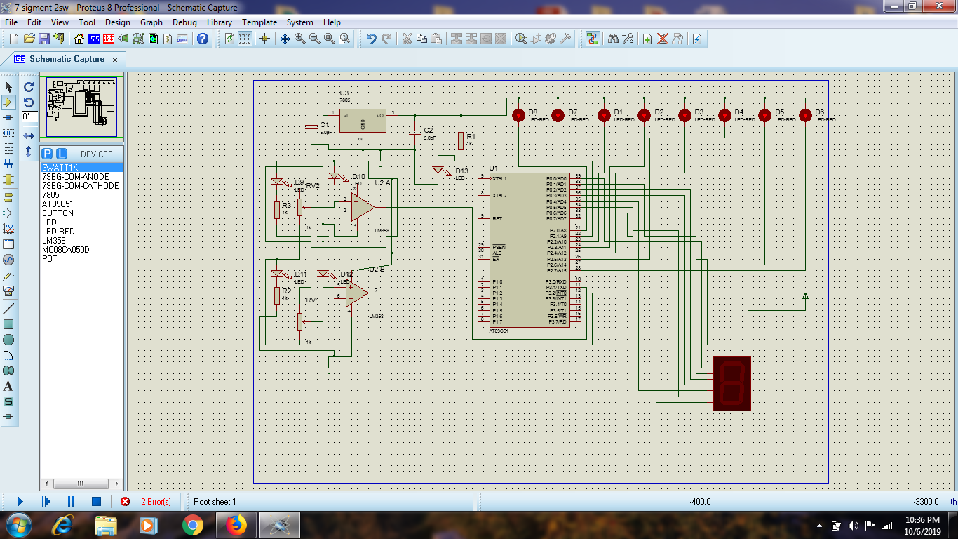

ode for 8051 Microcontroller
#include<reg51.h>

#define SEGMENT P0

sbit switch1=P3^0;

sbit switch2=P3^1;

sbit digit1=P2^0;

sbit digit2=P2^1;

void delay (int);

int x=0,y,z;

unsigned char ch[]={0xc0,0xf9,0xa4,0xb0,0x99,0x92,0x82,0xf8,0x80,0x98};

void delay (int d)

{

unsigned char i;

for(;d>0;d--)

{

for(i=250;i>0;i--);

for(i=248;i>0;i--);

}

}

void main()

{

switch1=1;

switch2=1;

digit1=1;

digit2=1;

while(1)

{

if(switch1==0)

{

x++;

delay(200);

}

else if(switch2==0)

{

x--;

delay(200);

}

y=x/10;

SEGMENT=ch[y];

digit1=0;

delay(10);

digit1=1;

z=x%10;

SEGMENT=ch[z];

digit2=0;

delay(10);

digit2=1;

}
}

