Date

**Your Company Name**

Your name • phone # • email address

Colleague name • phone # • email address

Colleague name • phone # • email address

**Logo of the Company You Are Launching Coverage On.**

**Disclosures:** Please refer to pages X-X.

**Company Valuation and Growth Metrics.**

|  |  |
| --- | --- |
| **Stock price**: $x | **Ticker**: ABC |
| **52 Week Low**: $x | **52 Week HIgh**: $x |
| **Market cap**: $xbn | **Average Vol**: 10k |
| 2016 P/E: Xx | 2016 EPS Growth: X% |
| 2017 P/E: Xx | 2017 EPS Growth: X% |
| 2016 P/R: Xx | 2016 Rev Growth: X% |
| 2017 P/R: Xx | 2017 Rev Growth: X% |
| 2016 P/B: Xx | Dividend per share |

**Exhibit Excerpt (example: misc. chart below)**

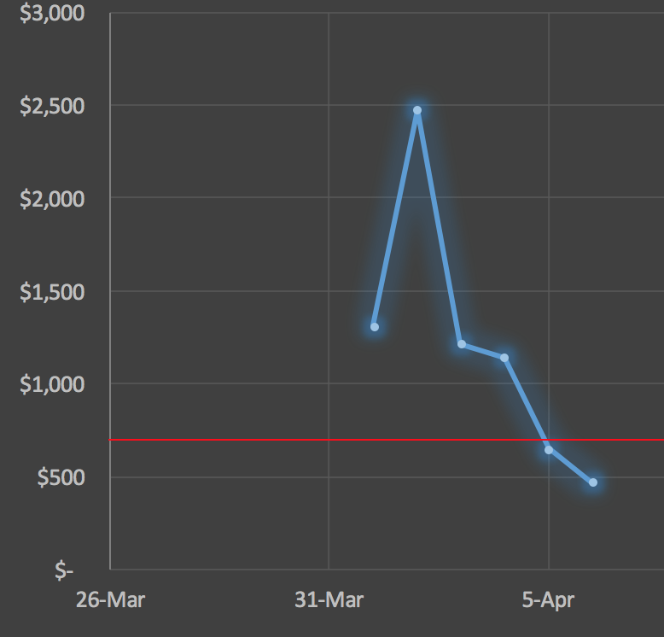

|  |
| --- |
| **Title of Your Report, Your Rating and Your Target Price**  **[example: Launching Coverage on Amazon with a Buy Rating and $1000 Target Price.]** |
| **Two sentence summary of this initiation report [many PMs will only read the first page].** |
| **Title of 1st bullish [if Buy Rating] reason to buy the stock.**  2 sentences with more detail.   * Mention the growth rate of the company in this paragraph and how your estimates compare with consensus (if Buy Rating, then above). * Mention how you justify your target price [example: Our target price is based on 20x our 2017 EPS estimate]. |
| **Title of 2nd bullish [if Buy Rating] reason to buy the stock.**  2 sentences with more detail.   * Mention the TAM in this paragraph. * Mention how this company compares to the competition and the quality of this company’s management team. |
| **Title of 3rd bullish [if Buy Rating] reason to buy the stock.**  2 sentenced with more detail.   * Mention upcoming catalysts [example, Microsoft is releasing the latest version of their flagship Windows product.]   **List a risk to your thesis here**  2 sentenced with more detail. |

**Contents**

Provide a 1-3 pages of detail on your 1st bullish [if Buy Rating] reason to buy the stock from the first page of this report. 4

Provide a 1-3 pages of detail on your 2nd bullish [if Buy Rating] reason to buy the stock from the first page of this report. 5

Provide a 1-3 pages of detail on your 3rd bullish [if Buy Rating] reason to buy the stock from the first page of this report. [Includes Catalyst]. 6

Risks: Provide a 1-3 pages of detail on the biggest risks that could challenge your investment thesis. 7

Qualitative Analysis 8

SWOT: Apply a framework to analyze the company. For example SWOT analysis. 8

Strengths: 8

Weaknesses: 8

Opportunities: 8

Threats: 8

BCG Matrix: Apply another framework to analyze the company. For example BCG Matrix analysis. 9

Product Portfolio Analysis: Cash Cows 9

Product Portfolio Analysis: Stars 9

Product Portfolio Analysis: Dogs 9

Product Portfolio Analysis: Question Marks 9

Porter 5 Forces: Apply another framework to analyze the company. For example Porter 5 Forces analysis. 10

Competition 10

Substitutes 10

New Entrants 10

Buyer Power 10

Supplier Power 10

Product Life Cycle (PLC): Apply another framework to analyze the company. For example PLC Analysis. 11

Introduction Phase 11

Growth Phase 11

Maturity Phase 11

Decline Phase 11

Quantitative Analysis 12

Income Statement [copy and paste from your Excel Model] 12

Balance Sheet [copy and paste from your Excel Model] 13

Cash Flow Statement Statement [copy and paste from your Excel Model] 14

Valuation: P/E Based Target Price [copy and paste from your Excel Model] 15

Valuation: P/R Based Target Price [copy and paste from your Excel Model] 16

Valuation: DCF Based Target Price [copy and paste from your Excel Model] 17

Valuation: Average of all 3 (or more) Valuation Scenarios 18

Probability Weighted Valuation Analysis (Bullish, Bearish and Neutral) 19

Competition’s Valuation Versus the Company We are Launching Coverage On 20

Additional Discussion of Any Relevant Data Provided by the Company in their SEC Filings/Analyst Day Events. 21

Disclosures 22

# Provide a 1-3 pages of detail on your 1st bullish [if Buy Rating] reason to buy the stock from the first page of this report.

Elaborate your thesis on:

* The growth rate of the company and how your estimates compare with consensus (if Buy Rating, then above).
* Mention how you justify your target price [example: Our target price is based on 20x our 2017 EPS estimate].

# Provide a 1-3 pages of detail on your 2nd bullish [if Buy Rating] reason to buy the stock from the first page of this report.

Elaborate your thesis on:

* The TAM
* Mention how this company compares to the competition and the quality of this company’s management team. [CITE GLASSDOOR.COM FOR FEEDBACK ON MANAGEMENT]
* Discuss the CEO, CFO and head of Sales.

# Provide a 1-3 pages of detail on your 3rd bullish [if Buy Rating] reason to buy the stock from the first page of this report. [Includes Catalyst].

Elaborate your thesis on:

* Mention upcoming catalysts [example, Microsoft is releasing the latest version of their flagship Windows product.]

# Risks: Provide a 1-3 pages of detail on the biggest risks that could challenge your investment thesis.

Elaborate on the risk you highlighted on the first page.

* Discuss at least 3-4 more significant risks to your thesis. [note: many risks can be found in the 10-K]

# Qualitative Analysis

## SWOT: Apply a framework to analyze the company. For example SWOT analysis.

### Strengths:

* A
* B
* C

### Weaknesses:

* A
* B
* C

### Opportunities:

* A
* B
* C

### Threats:

* A
* B
* C

## BCG Matrix: Apply another framework to analyze the company. For example BCG Matrix analysis.

### Product Portfolio Analysis: Cash Cows

* A
* B
* C

### Product Portfolio Analysis: Stars

* A
* B
* C

### Product Portfolio Analysis: Dogs

* A
* B
* C

### Product Portfolio Analysis: Question Marks

* A
* B
* C

## Porter 5 Forces: Apply another framework to analyze the company. For example Porter 5 Forces analysis.

### Competition

* A
* B
* C

### Substitutes

* A
* B
* C

### New Entrants

* A
* B
* C

### Buyer Power

* A
* B
* C

### Supplier Power

* A
* B
* C

## Product Life Cycle (PLC): Apply another framework to analyze the company. For example PLC Analysis.

### Introduction Phase

* A
* B
* C

### Growth Phase

* A
* B
* C

### Maturity Phase

* A
* B
* C

### Decline Phase

* A
* B
* C

# Quantitative Analysis

## Income Statement [copy and paste from your Excel Model]

Discuss trends in the historical data and any important forecast trends that you have in your model.

## Balance Sheet [copy and paste from your Excel Model]

Discuss trends in the historical data and any important forecast trends that you have in your model.

## Cash Flow Statement Statement [copy and paste from your Excel Model]

Discuss trends in the historical data and any important forecast trends that you have in your model.

## Valuation: P/E Based Target Price [copy and paste from your Excel Model]

## Valuation: P/R Based Target Price [copy and paste from your Excel Model]

## Valuation: DCF Based Target Price [copy and paste from your Excel Model]

## Valuation: Average of all 3 (or more) Valuation Scenarios

## Probability Weighted Valuation Analysis (Bullish, Bearish and Neutral)

## Competition’s Valuation Versus the Company We are Launching Coverage On

## Additional Discussion of Relevant Data Provided by the Company in their SEC Filings or Analyst Day Events.

# Disclosures

Get these from your compliance department.