MARKS ANALYSER
A Project Report submitted to Andhra University in partial fulfilment for the Award of the Degree of
MASTER OF COMPUTER APPLICATIONS

Submitted by
YAMALAVALASA SRINIVAS
Reg. No: [REGISTRATION NUMBER]

Under the Guidance of
CH. G. N. ALEKHYA RANI
(Assistant Professor)

NOBLE INSTITUTE OF SCIENCE & TECHNOLOGY
Affiliated to Andhra University, Visakhapatnam
Approved by AICTE, New Delhi, India
VISAKHAPATNAM
2024–2026

CERTIFICATE
This is to certify that the project work entitled “MARKS ANALYSER” is being submitted by YAMALAVALASA SRINIVAS (Reg. No: [REGISTRATION NUMBER]) to Noble Institute of Science & Technology, affiliated to Andhra University, Visakhapatnam, in partial fulfilment for the award of the Degree of Master of Computer Applications. This work has been carried out under my guidance and supervision during the academic period 2024–2026.
To the best of my knowledge, the work embodied in this project report is original and has not been submitted previously to this or any other university for the award of any degree or diploma.

Project Guide | Principal
CH. G. N. ALEKHYA RANI  Assistant Professor | ________________________  Noble Institute of Science & Technology

ACKNOWLEDGEMENT
I express my sincere gratitude to the Principal and all the faculty members of Noble Institute of Science & Technology for providing the facilities, infrastructure, and academic environment required to complete this project successfully.
I am especially thankful to my project guide, CH. G. N. Alekhya Rani, Assistant Professor, for valuable guidance, patient encouragement, constructive suggestions, and continuous support throughout the design and development of the Marks Analyser project.
I also thank the teaching and non-teaching staff, my classmates, friends, and family members for their cooperation, encouragement, and moral support during the course of this work.
YAMALAVALASA SRINIVAS
(Reg. No: [REGISTRATION NUMBER])

DECLARATION
I hereby declare that the project entitled “MARKS ANALYSER” submitted by me to the Department of Computer Science, Noble Institute of Science & Technology, affiliated to Andhra University, in partial fulfilment for the award of the Degree of Master of Computer Applications, is a record of original work carried out by me under the guidance of CH. G. N. Alekhya Rani. This project has not been submitted earlier to this or any other university for the award of any degree or diploma.

Date: ____________________
Place: Visakhapatnam
YAMALAVALASA SRINIVAS
(Reg. No: [REGISTRATION NUMBER])

ABSTRACT
Marks Analyser is a web-based examination response-sheet analysis system developed to reduce the manual effort involved in checking objective-type examinations. The application accepts a candidate response-sheet PDF, extracts candidate details and marked responses, validates the extracted information, compares it with the applicable answer key, and produces a clear score summary. It helps candidates and administrators obtain correct, incorrect, unattempted, and total-mark information quickly.
The system uses a modular three-tier architecture. A React and Vite frontend provides the upload, result, and administration screens. An Express.js backend validates requests, coordinates the scoring workflow, manages APIs, and stores results in MongoDB. A Flask-based Python parser service performs PDF text extraction and exam-specific response parsing. Redis and BullMQ support asynchronous processing for workloads where parsing should not block the user interface.
The current implementation supports NIMCET and contains extensible parser and scoring pipelines for CUET, RRB, and SSC-style examinations. Security and reliability measures include file-type and size validation, rate limiting, HTTP security headers, structured error handling, health checks, queue monitoring, and configurable deployment through Docker. The project demonstrates a practical, maintainable approach to automated result analysis and provides a foundation for richer reporting and additional examination formats.

TABLE OF CONTENTS

LIST OF TABLES
Table 1.1: Objectives of the system
Table 2.1: Functional requirements
Table 2.2: Non-functional requirements
Table 3.1: Hardware and software requirements
Table 3.2: Technology stack
Table 4.1: Module design
Table 4.2: Result data model
Table 5.1: API endpoints
Table 6.1: Test cases

LIST OF FIGURES
Figure 4.1: Component architecture diagram
Figure 4.2: Context data-flow diagram
Figure 4.3: Level-1 data-flow diagram
Figure 4.4: Use-case diagram
Figure 4.5: Entity-relationship diagram
Figure 4.6: Class diagram

4.6 Activity Flow
The activity diagram models the end-to-end validation, extraction, scoring, and result-storage workflow.
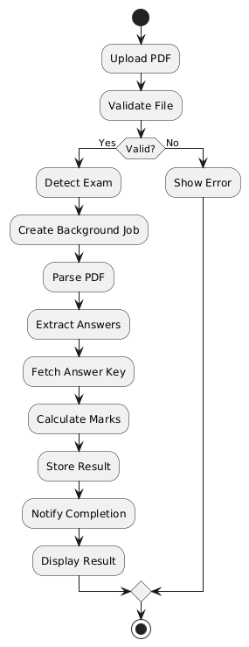
Figure 4.7: Activity diagram

4.7 Interaction Sequence
The sequence diagram shows how the user interface, backend, parser, scoring service, and database collaborate during analysis.
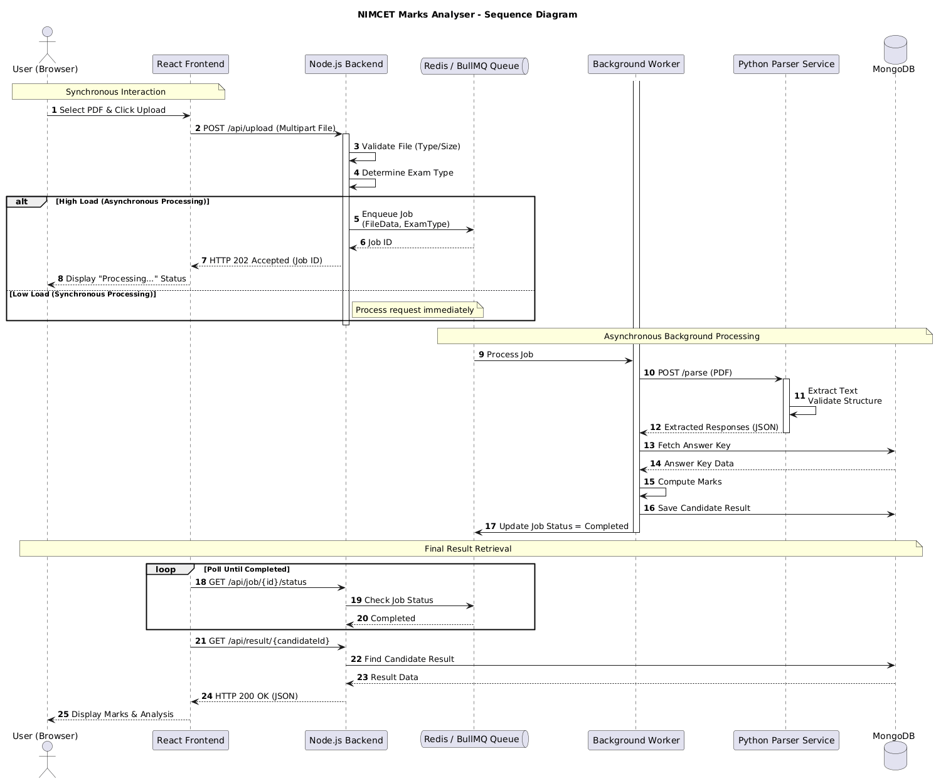
Figure 4.8: Sequence diagram

4.8 Processing States
The state diagram describes the lifecycle of a submitted response sheet from upload through completion or failure.
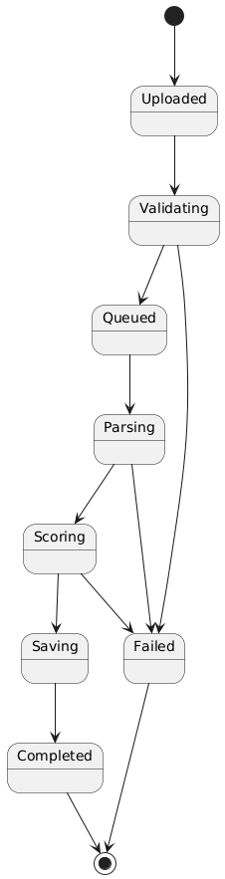
Figure 4.9: State diagram

4.9 Package Organisation
The package diagram groups the frontend, backend, parser, database, and supporting modules by responsibility.
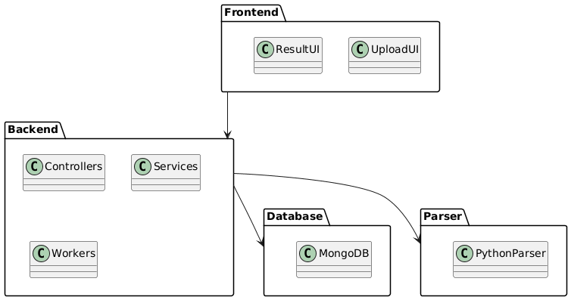
Figure 4.10: Package diagram

4.10 Deployment Design
The deployment diagram shows the runtime placement of the browser client, React frontend, backend and worker, parser, Redis, and MongoDB services.
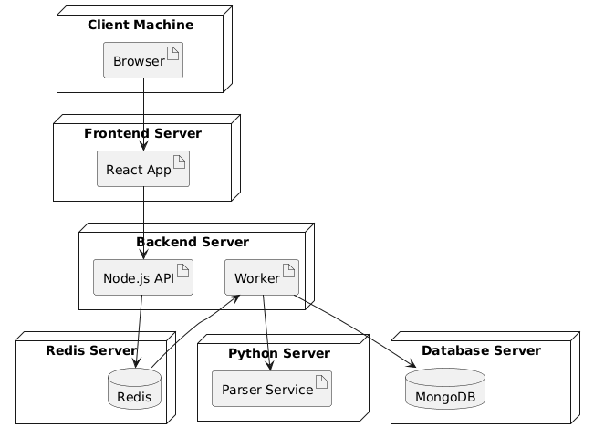
Figure 4.11: Deployment diagram
Figure 4.7: Activity diagram
Figure 4.8: Sequence diagram
Figure 4.9: State diagram
Figure 4.10: Package diagram
Figure 4.11: Deployment diagram
Figure 5.1: Application branding
Figure 8.1: Home page
Figure 8.2: Upload page
Figure 8.3: Result page
Figure 8.4: Admin dashboard
Figure 10.1–10.9: Output screenshots
Figure 11.1: Local service startup / deployment evidence

CHAPTER 1: INTRODUCTION

1.1 Introduction
Competitive and institutional examinations produce a large number of response sheets. Manual checking is slow, repetitive, and susceptible to transcription and calculation mistakes. Where response sheets are issued as PDFs, a useful solution must reliably extract answers, apply the correct marking scheme, and present the analysis in a form that is easy to verify.
Marks Analyser addresses this requirement through a browser-based workflow. A user uploads a PDF response sheet, selects the examination context when necessary, and receives a calculated result. The application separates user interface, business logic, and document parsing so that each part can be maintained or extended independently.

1.2 Problem Statement
Existing response-sheet evaluation often depends on manual inspection, spreadsheets, or isolated scripts. These approaches do not provide a unified path for validated PDF upload, answer extraction, score calculation, result storage, and retrieval. They are difficult to scale when many candidates submit response sheets in a short period.

1.3 Purpose and Scope
The purpose of the project is to automate objective-exam marks calculation from response-sheet PDFs. The present scope includes PDF upload, exam-aware parsing, response validation, answer-key comparison, score calculation, result persistence, result viewing, administrative monitoring, and asynchronous job handling. It is designed as an extensible platform rather than a parser restricted to one examination layout.

1.4 Objectives
No. | Objective
1 | Accept PDF response sheets through a simple web interface.
2 | Extract candidate details and marked answers from the uploaded document.
3 | Validate responses and calculate correct, incorrect, unattempted, and total marks.
4 | Store processed results for retrieval and administrative analysis.
5 | Support robust background processing and health monitoring.
6 | Provide a maintainable base for additional examination formats.

1.5 Organisation of the Report
The remaining chapters cover system analysis, requirements, design, implementation, testing, and conclusions with future scope.

CHAPTER 2: SYSTEM ANALYSIS

2.1 Existing System
In a manual workflow, an evaluator reads a response sheet, records each candidate answer, compares it with an answer key, performs calculations, and prepares the result. This consumes time and makes repeat checks cumbersome. Generic PDF readers also do not understand exam-specific response patterns or marking rules.

2.2 Proposed System
The proposed system introduces an automated and traceable workflow. It validates an uploaded PDF, invokes the appropriate parser, receives structured responses and candidate details, calculates marks using the selected answer key and marking scheme, stores the result, and renders an understandable score view. Queue-backed processing can be enabled for heavy workloads.

2.3 Feasibility Study
Type | Observation
Technical feasibility | The application uses widely supported technologies: React, Node.js, Python, MongoDB, Redis, and Docker. The modular services can run independently.
Operational feasibility | The browser-based upload and results flow requires minimal training. Administrators receive dedicated pages for results, jobs, analytics, and health.
Economic feasibility | The primary software stack is open source. Container deployment reduces environment setup effort and supports affordable cloud hosting.

2.4 Functional Requirements
ID | Requirement
FR-01 | Upload a PDF response sheet with file-type and size checks.
FR-02 | Receive an examination type and route it to the relevant parsing pipeline.
FR-03 | Extract responses, answer-key information where applicable, and candidate details.
FR-04 | Validate responses and compute the score according to the marking scheme.
FR-05 | Persist and retrieve result records.
FR-06 | Expose administration, job-status, recalculation, and health capabilities.

2.5 Non-functional Requirements
Attribute | Requirement
Performance | Use queue-based processing when synchronous parsing could delay the user experience.
Reliability | Use validation, explicit error handling, health endpoints, and circuit-breaker support.
Security | Restrict uploads to PDFs; apply headers, rate limiting, and admin authentication middleware.
Maintainability | Keep frontend, backend, parser, shared configuration, and deployment files separated.
Scalability | Allow independent deployment of services and Redis-backed workers.

CHAPTER 3: REQUIREMENT SPECIFICATION

3.1 Hardware Requirements
Component | Minimum | Recommended
Processor | Dual-core processor | Intel i5 or equivalent
Memory | 4 GB RAM | 8 GB RAM or more
Storage | 10 GB free | 50 GB free
Network | Internet/LAN access | Stable broadband connection

3.2 Software Requirements
Category | Requirement
Operating system | Linux, Windows, or macOS
Frontend runtime | Node.js 18 or later
Parser runtime | Python 3.10 or later
Database | MongoDB
Queue/cache | Redis
Deployment | Docker and Docker Compose (optional)
Browser | Current Chrome, Firefox, Edge, or Safari

3.3 Technology Stack
Layer | Technologies | Role
Frontend | React 19, Vite, Axios, Recharts | User interface, uploads, charts, and API communication
Backend | Node.js, Express, Mongoose, Multer | API, business rules, persistence, and secure uploads
Parser | Python, Flask, Flask-CORS | PDF text extraction and exam-specific parsing
Background jobs | Redis, BullMQ, Bull Board | Queue processing and job monitoring
Infrastructure | Docker, Nginx | Containerisation and reverse-proxy support

3.4 Development Methodology
The project follows an incremental development approach. Individual components were separated by responsibility, developed as modules, and connected through HTTP APIs and shared result structures. Exam-specific parser functions make it possible to add formats without rewriting the user interface or core scoring process.

CHAPTER 4: SYSTEM DESIGN

4.1 High-Level Architecture
The design has three principal service layers. The frontend receives a PDF and presents the result. The backend enforces input rules, calls the parser, runs the scoring pipeline, and saves the final data. The parser service extracts textual content from the PDF and applies a format-specific parser. MongoDB stores results, while Redis and BullMQ can decouple upload submission from processing.
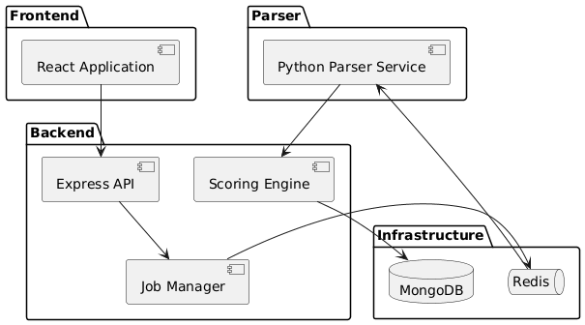
Component | Responsibility | Key Files/Modules
Frontend | Pages, upload form, score/result presentation, admin screens | frontend/src/pages, frontend/src/components
Backend | Routes, controllers, scoring, persistence, queues, middleware | backend/src/routes, controllers, services
Parser | PDF extraction, response validation, NIMCET/CUET/RRB parsers | parser/routes, parser/services
Data services | Result persistence and asynchronous jobs | MongoDB, Redis, BullMQ
Shared assets | Answer-key configuration | shared/nimcet_answer_key.json

Figure 4.1: Marks Analyser component architecture

4.2 Data Flow
1. The user selects a response-sheet PDF in the frontend. 2. The frontend sends a multipart request to the backend upload endpoint. 3. The backend validates the file and forwards the document to the parser service. 4. The parser extracts responses, answer-key data where required, candidate details, and a confidence value. 5. The scoring service normalises options A–D and determines correct, incorrect, and unattempted counts. 6. The result document is stored in MongoDB and returned to the result page.
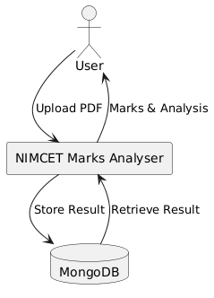
Figure 4.2: Context data-flow diagram
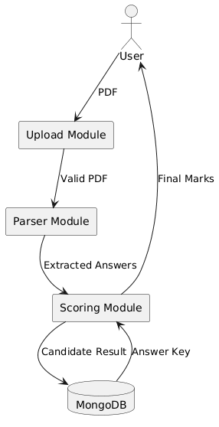
Figure 4.3: Level-1 data-flow diagram

4.3 Use Cases
The use-case diagram identifies the actions available to candidates, administrators, and the parser service.
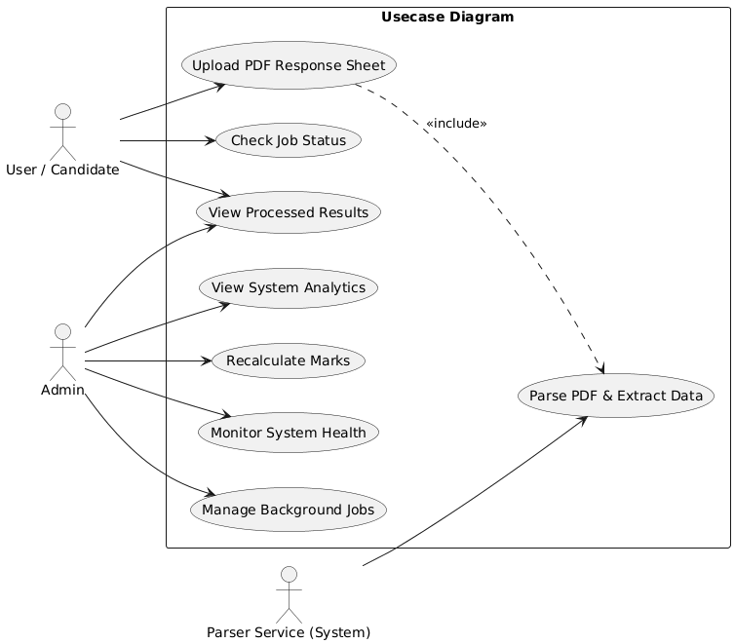
Figure 4.4: Use-case diagram
Actor | Use cases
Candidate/User | Upload response sheet, select examination, view marks and response analysis.
Administrator | View dashboards, results, jobs, health status, and initiate result-related operations.
System | Validate documents, parse responses, calculate scores, store and retrieve result data.

4.4 Database Design
Each result collection is selected by examination name. A result record includes examination name, candidate name, application and roll numbers, total marks, correct/incorrect/unattempted counts, responses, answer key, and timestamps.
The entity-relationship diagram shows the relationship between stored candidate results and answer keys.
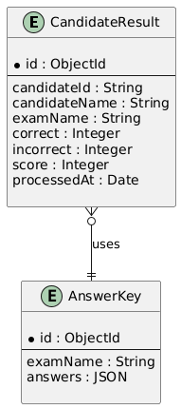
Figure 4.5: Entity-relationship diagram
Field | Type | Description
exam | String | Examination name; indexed.
name | String | Candidate name.
applicationNo | String | Candidate application number.
rollNo | String | Candidate roll number.
marks | Number | Calculated total marks.
correct / incorrect / unattempted | Number | Response summary counts.
responses | Object | Question-to-option mapping.
answerKey | Object | Question-to-correct-option mapping.
timestamps | Date | Created and updated timestamps.

4.5 Scoring Logic and Class Design
For every answer-key question, the scoring service normalises the candidate response and expected option to uppercase A, B, C, or D. Missing or invalid options are counted as unattempted. Matching options are counted as correct; remaining valid options are incorrect. Total marks are calculated as: Total Marks = (Correct × Correct Mark) + (Incorrect × Incorrect Mark). The marking scheme is supplied by the relevant examination pipeline.
The class diagram describes the core controller, service, parser, and result entities that support this scoring process.
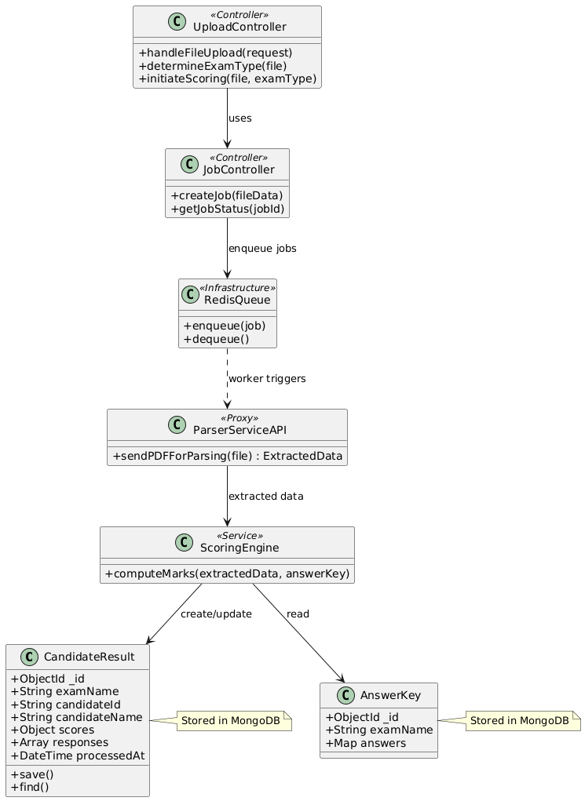
Figure 4.6: Class diagram

CHAPTER 5: IMPLEMENTATION

5.1 Frontend Implementation
The client application is built with React and Vite. It contains landing, home, upload, and result pages, along with administrative pages for dashboard, analytics, results, jobs, login, and health. Reusable components such as ProgressBar, StatCard, ConfidenceBadge, Spinner, and administrative data-table components improve consistency. Axios is used for API requests and Recharts supports visual analytics.
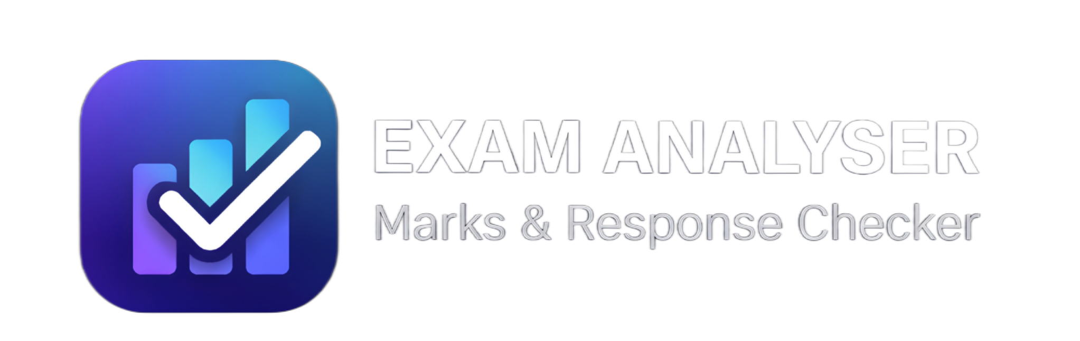
Figure 5.1: Marks Analyser application branding asset

5.2 Backend Implementation
The Express application configures Helmet, CORS, request logging, JSON parsing, and rate limiting before registering application routes. The upload route uses Multer memory storage and accepts PDF files only. The upload-size limit is controlled through the UPLOAD_MAX_MB environment setting. Controllers coordinate parser calls, scoring, persistence, result retrieval, recalculation, job status, and administration.

5.3 Parser Service
The Flask parser service exposes POST /parse and GET /health. The /parse route validates the uploaded document and selects a parser according to the exam field. NIMCET parsing verifies the document type and validates extracted responses. CUET accepts an answer-key PDF. RRB and SSC-related requests use the RRB parser pathway. The response includes responses, answerKey, candidateDetails, and a confidence value derived from detected questions versus expected questions.

5.4 API Specification
Method | Endpoint | Purpose
GET | /health | Backend health status.
GET | /health/parser | Parser circuit-breaker health information.
POST | /api/upload | Accept PDF files and start scoring workflow.
GET/POST | /api/result/* | Result retrieval functions.
GET/POST | /api/job/* | Job-status functions.
GET/POST | /api/admin/* | Administrative operations.
POST | Parser: /parse | Extract structured response data from a PDF.
GET | Parser: /health | Parser service health status.

5.5 Asynchronous Processing
For higher-volume deployments, uploads can enter a BullMQ queue backed by Redis. A worker processes the parsing and scoring operation separately from the request lifecycle. Bull Board integration is conditionally enabled to allow job inspection. This design improves responsiveness and gives administrators visibility into queued, active, completed, and failed tasks.

5.6 Deployment
The repository contains Dockerfiles for the frontend, backend, and parser service, plus a Docker Compose configuration and Nginx frontend configuration. Environment-based configuration keeps service URLs, database credentials, upload limits, and queue settings outside source code. This supports repeatable development and production deployment.

CHAPTER 6: TESTING AND VALIDATION

6.1 Testing Strategy
Testing is performed at module and workflow levels. Parser helper tests are used to inspect candidate-detail extraction and answer parsing. The most important integration scenario is the complete PDF upload-to-result workflow, because it verifies communication across frontend, backend, parser, scoring, and data storage components.

6.2 Test Cases
ID | Test scenario | Expected result
TC-01 | Upload a valid PDF response sheet | The file is accepted and the scoring workflow starts.
TC-02 | Upload a non-PDF file | The system rejects the request with an invalid-file-type error.
TC-03 | Submit without a file | The parser/API returns a missing-file error.
TC-04 | Select an unsupported examination | The parser reports an unsupported-exam error.
TC-05 | Upload an incorrect NIMCET document | The NIMCET detector reports an invalid exam type.
TC-06 | Response matches answer key | Correct count and marks increase according to the marking scheme.
TC-07 | Response is absent or invalid | The response is recorded as unattempted.
TC-08 | Check health endpoints | Services return an OK status when running.
TC-09 | Multiple queued uploads | Jobs can be observed and processed through the queue worker.

6.3 Validation and Error Handling
The backend and parser validate required file fields, empty uploads, MIME types, supported examination names, and expected document structure. Errors return structured JSON codes and messages. Central backend middleware handles unknown routes and unexpected exceptions. Parser exceptions are converted into JSON error responses so the frontend can present meaningful feedback.

6.4 Security Considerations
File uploads are restricted to PDFs and bounded by a configurable size limit. Helmet adds common HTTP security headers, while rate limiting reduces abusive request rates. Administrative routes use dedicated authentication middleware. Production deployments should use HTTPS, restricted CORS origins, secure secrets management, database access controls, malware scanning for user uploads, and regular dependency updates.

CHAPTER 7: CONCLUSION AND FUTURE SCOPE

7.1 Conclusion
Marks Analyser provides an effective solution for automated objective-exam response-sheet analysis. Its modular architecture links a responsive React frontend, Express business layer, Flask document parser, MongoDB storage, and optional Redis/BullMQ queue processing. The system automates the key stages of upload validation, answer extraction, score calculation, storage, and result presentation, reducing repetitive manual work and improving consistency.
The separation of examination-specific parsers and scoring pipelines makes the implementation easier to maintain and extend. Health monitoring, structured error handling, upload controls, and administration features provide a practical base for deployment in an academic or examination-support context.

7.2 Future Scope
- Add template-based OCR and image preprocessing for scanned or low-quality response sheets.
- Introduce role-based access control and stronger administrator authentication.
- Support more examinations, answer-sheet formats, and configurable marking schemes.
- Provide downloadable PDF/CSV result reports and bulk-upload processing.
- Add detailed analytics, performance trends, and institution-level dashboards.
- Use machine-learning-assisted anomaly detection and answer-pattern validation.
- Add automated test suites and continuous integration for dependable releases.

CHAPTER 8: USER MANUAL

8.1 Purpose of this Manual
This chapter explains the expected user journey through Marks Analyser. Replace each grey placeholder in this chapter with a clear, cropped screenshot from the running application. Use images at a readable size, add the caption already provided below each placeholder, and ensure that no personal candidate data is visible in the screenshots submitted to the college.
Before capturing screenshots, start the parser service, backend service, database, and frontend as described in the README file. The recommended order is parser, Redis where asynchronous processing is enabled, backend, and then frontend. Confirm the health endpoints before beginning a demonstration.
Step | Action | Expected evidence
1 | Open the application URL in a browser. | Landing page is displayed.
2 | Navigate to the upload page. | Upload form and examination choice are visible.
3 | Choose a PDF response sheet and submit it. | Upload/progress state is visible.
4 | Open the generated result. | Marks, response counts, and confidence are visible.
5 | Open the administration section if enabled. | Dashboard or job-monitoring information is visible.

8.2 Home / Landing Page
The landing page introduces the purpose of the system and guides a user to begin analysing a response sheet. It should communicate that the application supports automated marks calculation from uploaded PDF response sheets. Capture the page with the browser address bar hidden where possible and with the primary call-to-action clearly visible.
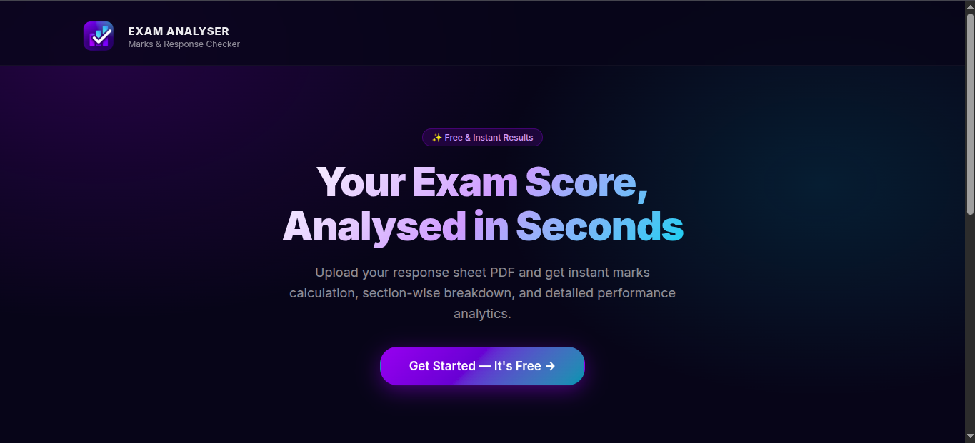
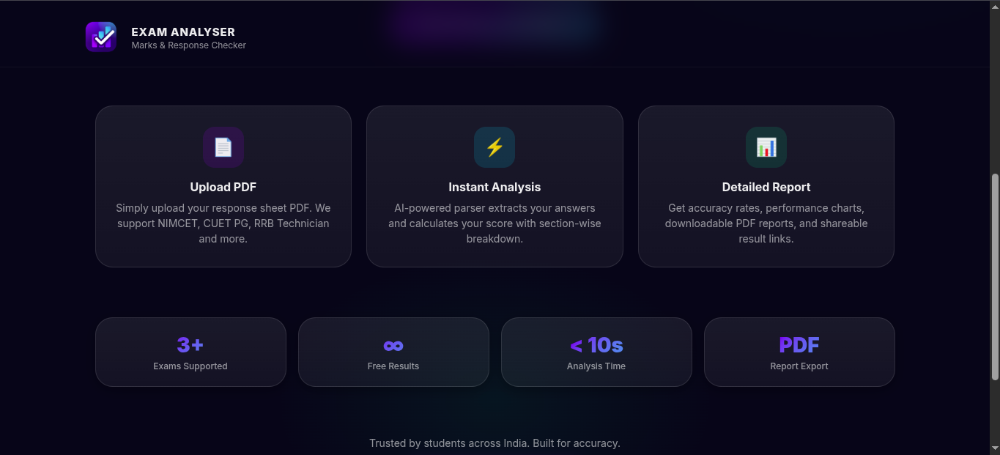

Figure 8.1: Marks Analyser landing page

8.3 Response-Sheet Upload
The upload page is the entry point for candidate documents. The user selects the examination type, attaches the response-sheet PDF, and submits the form. The server checks that the document is a PDF and enforces a configurable size limit before any parsing begins. For CUET, the workflow can also request an answer-key PDF.
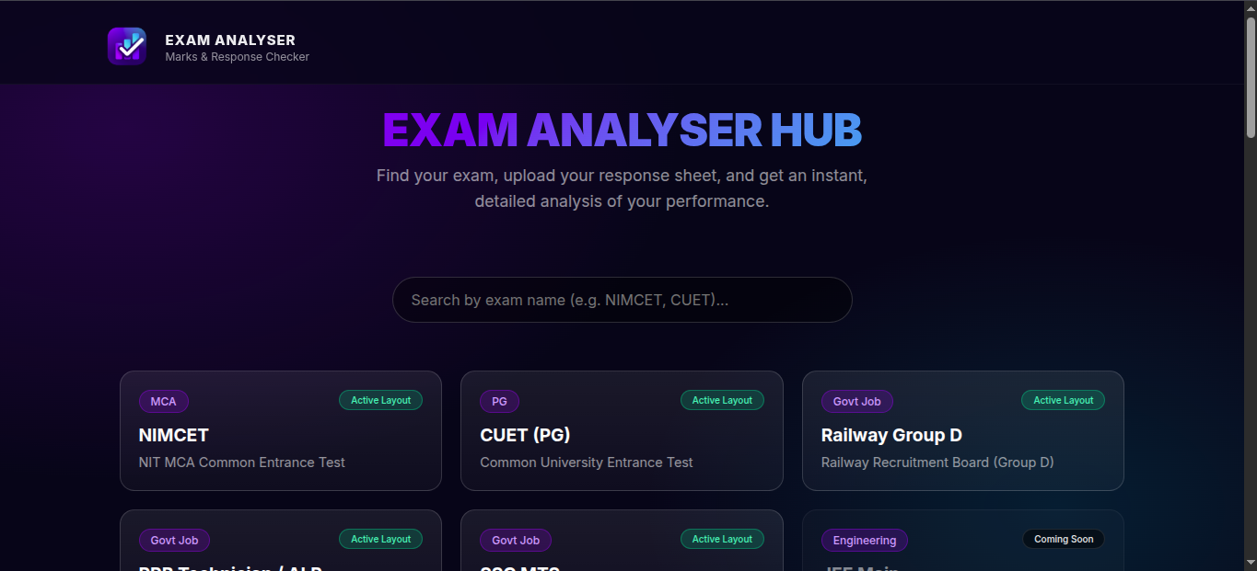

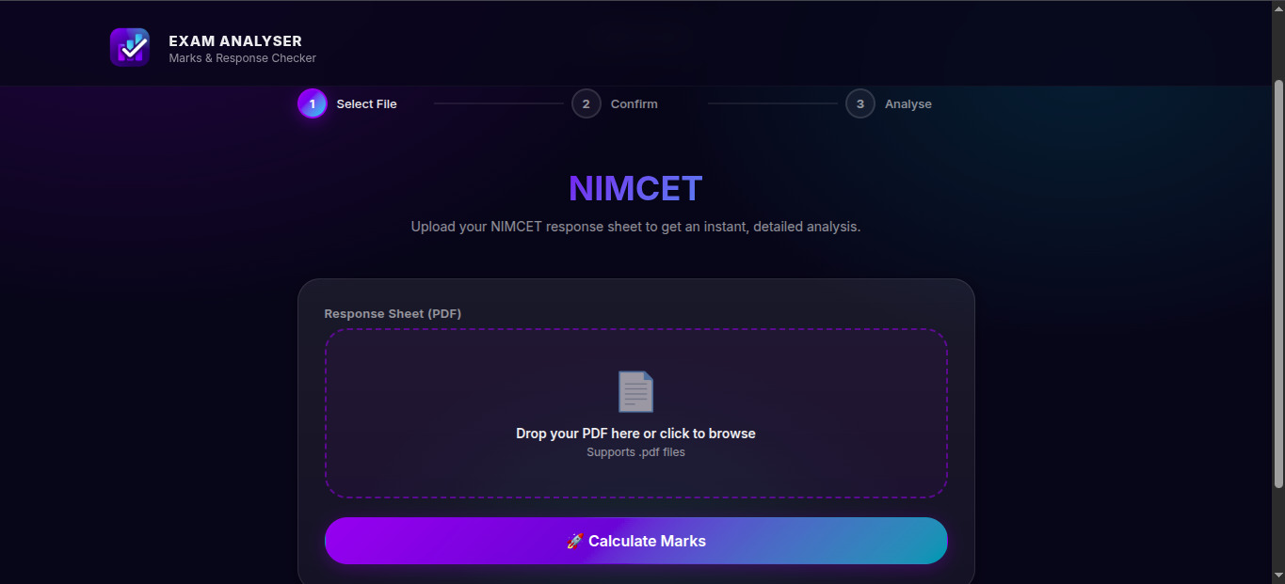

Figure 8.2: Response-sheet upload page

8.4 Result Analysis Page
After successful processing, the result page presents the calculated marks and an answer analysis. The report should demonstrate the correct, incorrect, and unattempted counts, candidate details where available, and the parser confidence indicator. Use an anonymised sample response sheet for the screenshot.
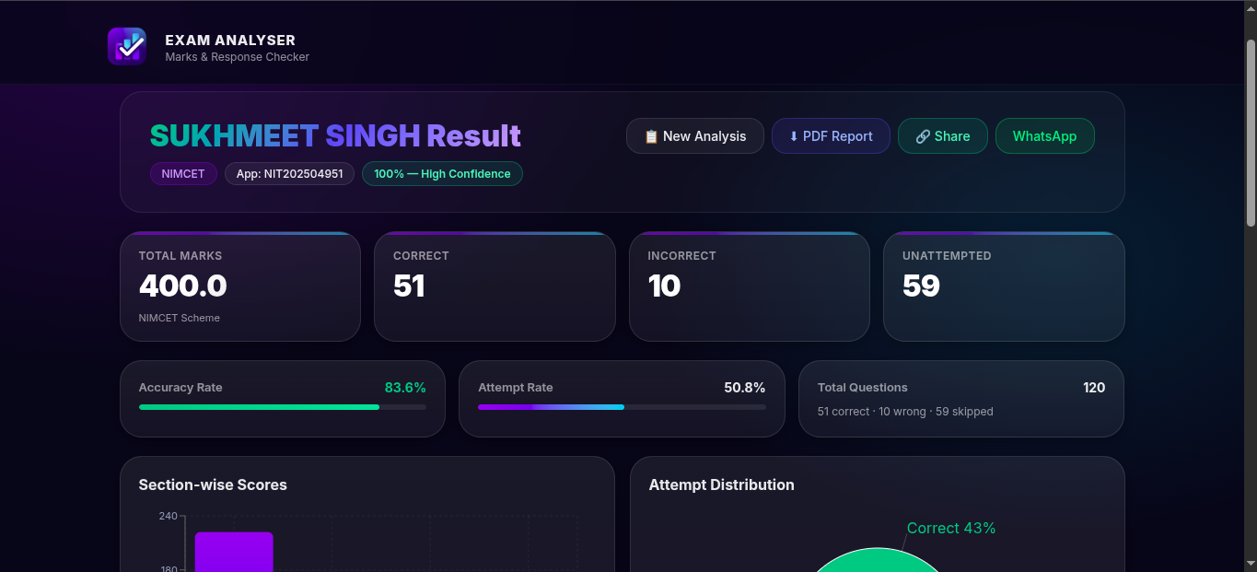
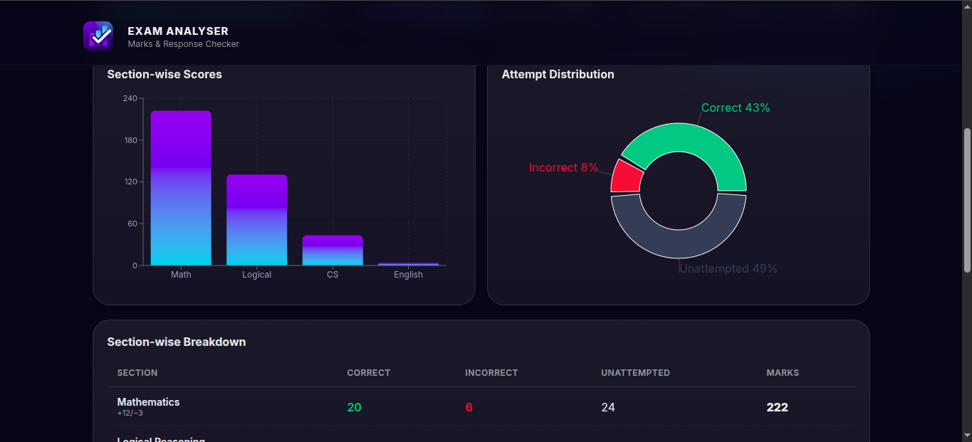
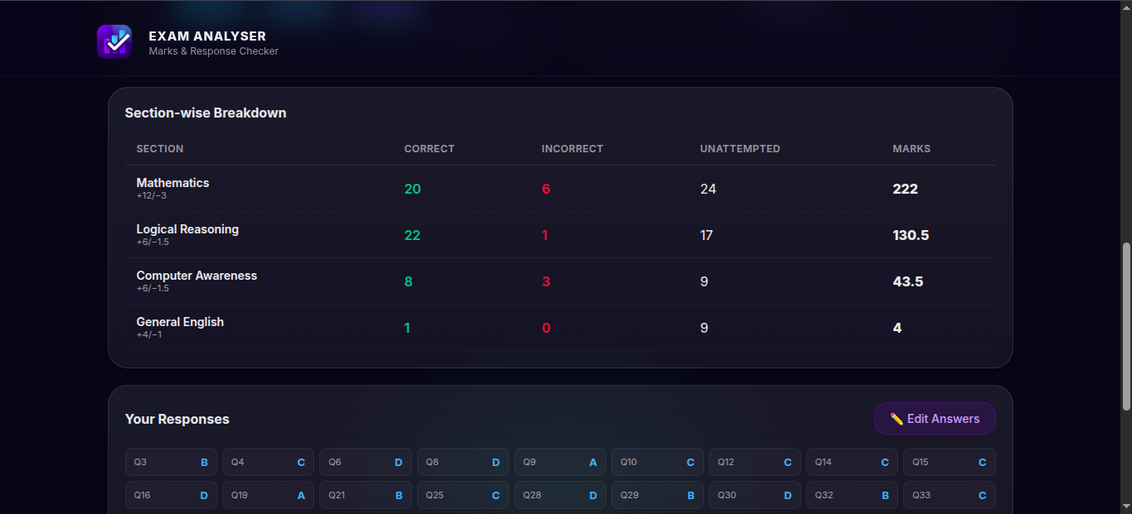

Figure 8.3: Result analysis screen

8.5 Administrator Dashboard
The administration area is intended for monitoring application activity. Depending on configuration, it provides dashboard statistics, results, job status, analytics, and service health. A professional demonstration screenshot should show only test data and must not expose passwords, database URLs, tokens, or personally identifiable candidate data.
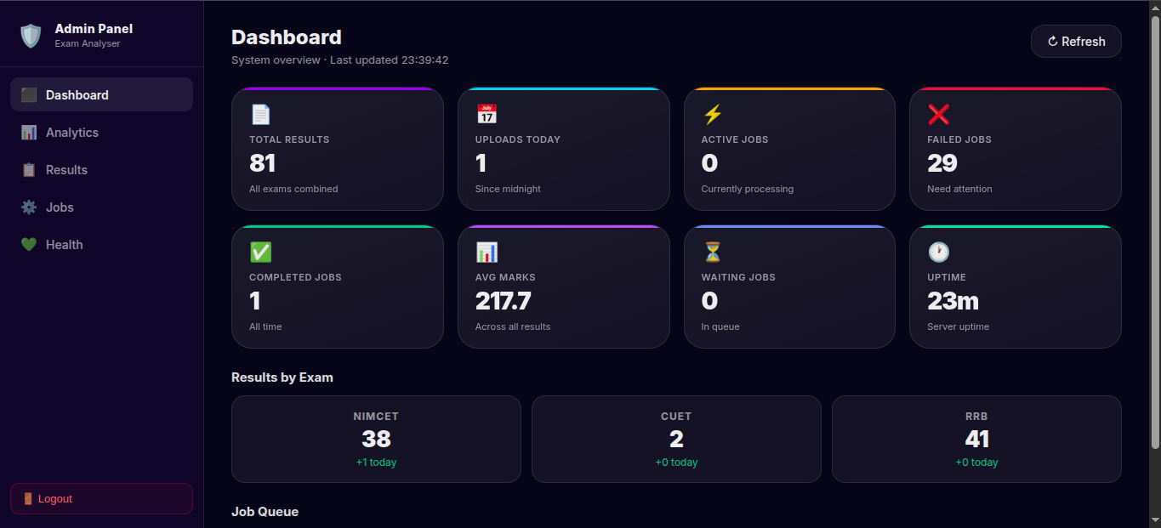

Figure 8.4: Administration dashboard

CHAPTER 9: SOURCE CODE DOCUMENTATION

9.0 Source Code Presentation Guidelines
Do not paste entire files into the final report. For every listing below, insert only the relevant 20–40 lines, use a monospaced font such as Consolas or Courier New at 9–10 points, and preserve indentation. Add a one-paragraph explanation before the listing and retain the listing title and file path. This approach keeps the project report readable while demonstrating the actual implementation.
Listing | What to insert | Why it matters
9.1 | Upload-page submit handler | Shows client-side file submission.
9.2 | Backend application setup | Shows middleware, routes, and security configuration.
9.3 | Upload route/controller code | Shows file validation and workflow entry.
9.4 | Scoring function | Shows correct/incorrect/unattempted calculation.
9.5 | Parser route | Shows examination-aware PDF parsing.
9.6 | MongoDB result model | Shows persistent result structure.
9.7 | Queue worker configuration | Shows asynchronous processing support.

9.1 Frontend Upload Handling
The frontend uses React components and an HTTP client to submit a multipart form request. Insert the function in UploadPage.jsx that creates the form data, attaches the selected PDF and examination value, and invokes the backend API. This code is evidence of client-side input collection and communication with the server.
import { useMemo, useState, useCallback } from "react";
import { api } from "../api/client";
import { Spinner } from "../components/Spinner";

export function UploadPage({ examConfig, onResult, onBack }) {
const exam = examConfig?.id || "nimcet";
const reqAnswerKey = examConfig?.reqAnswerKey || false;

const [file, setFile] = useState(null);
const [answerKeyFile, setAnswerKeyFile] = useState(null);
const [busy, setBusy] = useState(false);
const [error, setError] = useState("");
const [statusText, setStatusText] = useState("");
const [progress, setProgress] = useState(0);
const [dragOver, setDragOver] = useState(false);
const [akDragOver, setAkDragOver] = useState(false);

const currentStep = busy ? 3 : file ? 2 : 1;

const fileMeta = useMemo(() => {
if (!file) return null;
const mb = (file.size / (1024 * 1024)).toFixed(2);
return { name: file.name, size: `${mb} MB` };
}, [file]);

const akMeta = useMemo(() => {
if (!answerKeyFile) return null;
const mb = (answerKeyFile.size / (1024 * 1024)).toFixed(2);
return { name: answerKeyFile.name, size: `${mb} MB` };
}, [answerKeyFile]);

function handleDrop(e, setter, overSetter) {
e.preventDefault();
overSetter(false);
const f = e.dataTransfer?.files?.[0];
if (f && f.type === "application/pdf") setter(f);
else setError("Please drop a valid PDF file.");
}

function handleDragOver(e, overSetter) {
e.preventDefault();
overSetter(true);
}

async function onSubmit(e) {
e.preventDefault();
setError("");
if (!file) { setError("Please upload a Response PDF file."); return; }
if (reqAnswerKey && !answerKeyFile) { setError("Please upload the Official Answer Key PDF."); return; }

const form = new FormData();
form.append("exam", exam);
form.append("file", file);
if (reqAnswerKey && answerKeyFile) form.append("answerKeyFile", answerKeyFile);

try {
setBusy(true);
setStatusText("Uploading PDF...");
setProgress(0);
const resp = await api.post("/api/upload", form, { headers: { "Content-Type": "multipart/form-data" } });

// ── ASYNC mode: poll for job completion ─────────────────
if (resp.data.mode === "async" && resp.data.jobId) {
const jobId = resp.data.jobId;
setStatusText("Queued — waiting for worker...");

let pollCount = 0;
const maxPolls = 90;

const poll = async () => {
if (pollCount >= maxPolls) {
setError("Processing timed out. Please try again.");
setBusy(false);
return;
}
pollCount++;

try {
const jobResp = await api.get(`/api/job/${jobId}`);
const { status, result, error: jobError, progress: pct, eta, position } = jobResp.data;

if (status === "completed" && result) {
setProgress(100);
setStatusText("Done!");
setTimeout(() => onResult(result), 300);
return;
}

if (status === "failed") {
setError(jobError || "Processing failed. Please try again.");
setBusy(false);
return;
}

// Update progress
if (typeof pct === "number") setProgress(pct);

// Update status text with ETA
if (status === "queued") {
const pos = typeof position === "number" ? position : "?";
setStatusText(`In queue (position ${pos})${eta ? ` — ~${eta}s remaining` : ""}`);
} else if (status === "active") {
setStatusText(
`Analysing your PDF... ${pct || 0}%${eta ? ` — ~${eta}s remaining` : ""}`
);
}

// Adaptive polling: fast when progress > 80%, slower otherwise
let delay;
if (pct > 80) {
delay = 500; // almost done — poll fast
} else if (pollCount < 3) {
delay = 1500; // first few polls
} else {
delay = Math.min(1000 + pollCount * 500, 4000);
}
setTimeout(poll, delay);
} catch {
setTimeout(poll, 3000);
}
};

setTimeout(poll, 1500);
return;
}

// ── SYNC mode: result returned immediately ─────────────
onResult(resp.data);
} catch (err) {
setError(err?.response?.data?.message || err?.message || "Upload failed. Please try again.");
} finally {
setBusy(false);
}
}

return (
<div className="page animate-fade" style={{ maxWidth: "720px", margin: "0 auto" }}>
<button onClick={onBack} disabled={busy} className="button"
style={{ marginBottom: "1rem", border: "none", background: "transparent", color: "var(--muted)", cursor: "pointer" }}>
← Back to Exams
</button>

{/* ── Steps ──────────────────────────────────────────────── */}
<div className="steps">
<div className={`step ${currentStep >= 1 ? (currentStep > 1 ? "done" : "active") : ""}`}>
<div className="step-dot">{currentStep > 1 ? "✓" : "1"}</div>
<span className="step-label">Select File</span>
</div>
<div className={`step-line ${currentStep > 1 ? "done" : ""}`} />
<div className={`step ${currentStep >= 2 ? (currentStep > 2 ? "done" : "active") : ""}`}>
<div className="step-dot">{currentStep > 2 ? "✓" : "2"}</div>
<span className="step-label">Confirm</span>
</div>
<div className={`step-line ${currentStep > 2 ? "done" : ""}`} />
<div className={`step ${currentStep >= 3 ? "active" : ""}`}>
<div className="step-dot">3</div>
<span className="step-label">Analyse</span>
</div>
</div>

{/* ── Header ─────────────────────────────────────────────── */}
<section style={{ textAlign: "center", marginBottom: "1.5rem" }}>
<h1 style={{ background: "linear-gradient(135deg, var(--accent), var(--accent-2))", WebkitBackgroundClip: "text", WebkitTextFillColor: "transparent", fontSize: "clamp(24px, 4vw, 36px)" }}>
{examConfig?.title || "Exam Analyser"}
</h1>
<p className="muted" style={{ fontSize: "14px", maxWidth: "480px", margin: "8px auto 0" }}>
Upload your {examConfig?.title || "exam"} response sheet to get an instant, detailed analysis.
</p>
</section>

{/* ── Upload Form ────────────────────────────────────────── */}
<section className="card" style={{ padding: "28px", borderRadius: "var(--radius-lg)" }}>
<form className="form" onSubmit={onSubmit} style={{ gap: "20px" }}>
{/* Response sheet drop zone */}
<div className="field">
<label className="label">Response Sheet (PDF)</label>
<div
className={`drop-zone ${dragOver ? "drag-over" : ""} ${file ? "has-file" : ""}`}
onDrop={(e) => handleDrop(e, setFile, setDragOver)}
onDragOver={(e) => handleDragOver(e, setDragOver)}
onDragLeave={() => setDragOver(false)}
onClick={() => document.getElementById("file-input").click()}
>
{file ? (
<div style={{ display: "flex", alignItems: "center", justifyContent: "center", gap: "12px" }}>
<span style={{ fontSize: "28px" }}>📄</span>
<div style={{ textAlign: "left" }}>
<div style={{ fontWeight: 600, fontSize: "14px" }}>{fileMeta.name}</div>
<div style={{ color: "var(--green)", fontSize: "12px" }}>✓ {fileMeta.size}</div>
</div>
<button type="button" className="button" onClick={(e) => { e.stopPropagation(); setFile(null); }}
style={{ marginLeft: "12px", padding: "4px 10px", fontSize: "12px" }}>
Remove
</button>
</div>
) : (
<>
<div style={{ fontSize: "40px", marginBottom: "12px", opacity: 0.6 }}>📄</div>
<div style={{ fontWeight: 600, fontSize: "14px", marginBottom: "4px" }}>
Drop your PDF here or click to browse
</div>
<div style={{ color: "var(--muted)", fontSize: "12px" }}>Supports .pdf files</div>
</>
)}
<input id="file-input" type="file" accept="application/pdf"
onChange={(e) => setFile(e.target.files?.[0] || null)}
disabled={busy} style={{ display: "none" }} />
</div>
</div>

{/* Answer key drop zone (conditional) */}
{reqAnswerKey && (
<div className="field animate-slide">
<label className="label">Official Answer Key (PDF)</label>
<div
className={`drop-zone ${akDragOver ? "drag-over" : ""} ${answerKeyFile ? "has-file" : ""}`}
onDrop={(e) => handleDrop(e, setAnswerKeyFile, setAkDragOver)}
onDragOver={(e) => handleDragOver(e, setAkDragOver)}
onDragLeave={() => setAkDragOver(false)}
onClick={() => document.getElementById("ak-input").click()}
style={{ padding: "28px 24px" }}
>
{answerKeyFile ? (
<div style={{ display: "flex", alignItems: "center", justifyContent: "center", gap: "12px" }}>
<span style={{ fontSize: "24px" }}>🔑</span>
<div style={{ textAlign: "left" }}>
<div style={{ fontWeight: 600, fontSize: "14px" }}>{akMeta.name}</div>
<div style={{ color: "var(--green)", fontSize: "12px" }}>✓ {akMeta.size}</div>
</div>
<button type="button" className="button" onClick={(e) => { e.stopPropagation(); setAnswerKeyFile(null); }}
style={{ marginLeft: "12px", padding: "4px 10px", fontSize: "12px" }}>
Remove
</button>
</div>
) : (
<>
<div style={{ fontSize: "32px", marginBottom: "8px", opacity: 0.6 }}>🔑</div>
<div style={{ fontWeight: 600, fontSize: "14px" }}>Drop Answer Key PDF</div>
</>
)}
<input id="ak-input" type="file" accept="application/pdf"
onChange={(e) => setAnswerKeyFile(e.target.files?.[0] || null)}
disabled={busy} style={{ display: "none" }} />
</div>
</div>
)}

{error && (
<div className="alert">{error}</div>
)}

<button className="button primary button-lg" type="submit" disabled={busy}
style={{ width: "100%", fontSize: "16px" }}>
{busy ? "Analysing Document..." : "🚀 Calculate Marks"}
</button>

{busy && (
<div className="animate-slide" style={{ display: "grid", gap: "12px", justifyItems: "center" }}>
<Spinner label={statusText || "Processing..."} />
{progress > 0 && (
<div style={{ width: "100%", maxWidth: "320px" }}>
<div className="progress-bar" style={{ height: "8px" }}>
<div className="progress-bar-fill" style={{ width: `${progress}%`, transition: "width 0.4s ease" }} />
</div>
<div style={{ textAlign: "center", fontSize: "11px", color: "var(--muted)", marginTop: "6px" }}>
{progress}% complete
</div>
</div>
)}
</div>
)}
</form>
</section>
</div>
);
}

Listing 9.1: Frontend upload submission logic

9.2 Backend Application and Security Middleware
The backend application initialises the Express server and registers security-related middleware before exposing its business routes. The selected listing should show Helmet, CORS, JSON body parsing, rate limiting, and route registration. It demonstrates that the project applies standard web-server protections in addition to functional logic.
const express = require("express");
const cors = require("cors");
const helmet = require("helmet");
const morgan = require("morgan");
const rateLimit = require("express-rate-limit");

const uploadRoutes = require("./routes/upload");
const adminRoutes = require("./routes/admin");
const recalculateRoutes = require("./routes/recalculate");
const resultRoutes = require("./routes/result");
const jobRoutes = require("./routes/job");
const { notFound, errorHandler } = require("./middleware/errorHandler");
const { logger, requestLogger } = require("./utils/logger");

function createApp({ parserUrl, asyncUploadEnabled = false }) {
const app = express();

app.locals.parserUrl = parserUrl;
app.locals.asyncUploadEnabled = asyncUploadEnabled;

app.use(helmet());
app.use(requestLogger);
app.use(
morgan("combined", {
stream: {
write: (line) => logger.info("access", { line: String(line).trimEnd() }),
},
})
);
app.use(
cors({
origin: true,
credentials: false,
})
);

// ── JSON body parser ────────────────────────────────────
app.use(express.json({ limit: "2mb" }));

// ── Rate limiting: 100 requests per 15 minutes ─────────
app.use(
rateLimit({
windowMs: 15 * 60 * 1000,
max: 5000,
standardHeaders: true,
legacyHeaders: false,
message: { success: false, error: "TooManyRequests", message: "Too many requests, please try again later." },
})
);

app.get("/health", (req, res) => res.json({ ok: true }));

app.use("/api/admin", adminRoutes);
app.use("/api", uploadRoutes);
app.use("/api", recalculateRoutes);
app.use("/api", resultRoutes);
app.use("/api", jobRoutes);

// ── Bull Board dashboard ──────────────────────────────────
if (asyncUploadEnabled) {
try {
const { setupBullBoard } = require("./jobs/bullBoard");
setupBullBoard(app);
} catch (err) {
console.warn("[App] Bull Board not available:", err.message);
}
}

// ── Circuit breaker health ────────────────────────────────
app.get("/health/parser", (req, res) => {
try {
const { parserBreaker } = require("./utils/circuitBreaker");
res.json({ ok: true, circuit: parserBreaker.getStatus() });
} catch {
res.json({ ok: true, circuit: "not loaded" });
}
});

app.use(notFound);
app.use(errorHandler);

return app;
}

module.exports = { createApp };

Listing 9.2: Express application configuration

9.3 PDF Upload Validation
Multer is used with memory storage to accept uploaded response sheets. The code validates PDF MIME type and applies a file-size limit derived from an environment setting. Insert the route configuration that defines the upload middleware and POST endpoint. This listing provides direct evidence of server-side validation.
const express = require("express");
const multer = require("multer");
const { asyncHandler } = require("../utils/asyncHandler");
const { uploadAndScore } = require("../controllers/uploadController");

const router = express.Router();

const maxMb = Number(process.env.UPLOAD_MAX_MB || 10);

const upload = multer({
storage: multer.memoryStorage(),
limits: {
fileSize: Math.max(1, maxMb) * 1024 * 1024,
},
fileFilter: (req, file, cb) => {
if (file.mimetype !== "application/pdf") {
const err = new Error("Only PDF files are allowed.");
err.statusCode = 400;
err.code = "InvalidFileType";
return cb(err);
}
cb(null, true);
},
});

router.post("/upload", upload.fields([
{ name: "file", maxCount: 1 },
{ name: "answerKeyFile", maxCount: 1 }
]), asyncHandler(uploadAndScore));

module.exports = router;

Listing 9.3: PDF upload validation route

9.4 Marks Calculation Algorithm
The scoring service normalises answer options to A, B, C, or D. It iterates through the answer key, records unattempted answers where no valid option is available, and calculates total marks according to the marking scheme. This is the central algorithm of the project and should be included in the final report.
function normalizeOption(value) {
if (value == null) return null;
const v = String(value).trim().toUpperCase();
if (!v) return null;
// allow A/B/C/D only for now
if (!["A", "B", "C", "D"].includes(v)) return null;
return v;
}

function scoreResponses({ responses, answerKey, markingScheme }) {
const { correct: correctMarks, incorrect: incorrectMarks } = markingScheme;

let correct = 0;
let incorrect = 0;
let unattempted = 0;

const allQuestions = Object.keys(answerKey);

for (const q of allQuestions) {
const key = normalizeOption(answerKey[q]);
const ans = normalizeOption(responses?.[q]);

if (!ans) {
unattempted += 1;
continue;
}

if (ans === key) correct += 1;
else incorrect += 1;
}

const marks = correct * correctMarks + incorrect * incorrectMarks;

return {
marks,
correct,
incorrect,
unattempted,
totalQuestions: allQuestions.length,
};
}

module.exports = { scoreResponses };

Listing 9.4: Score calculation algorithm

9.5 Parser Service and Examination Routing
The parser service exposes a Flask endpoint for PDF documents. It validates the request, selects a parser by examination type, obtains structured responses, and returns candidate details with a confidence measure. This listing demonstrates how one project can support several response-sheet formats without mixing format-specific logic into the frontend.
from __future__ import annotations

from flask import Blueprint, request, jsonify

from services.extract_text import extract_text
from services.parse_nimcet import parse_nimcet, try_detect_exam as try_detect_nimcet
from services.parse_cuet import parse_cuet
from services.parse_rrb import parse_rrb
from services.validator import validate_responses
from utils.http_errors import HttpError

parse_bp = Blueprint("parse", __name__)

@parse_bp.post("/parse")
def parse_pdf():
if "file" not in request.files:
raise HttpError("Missing file field 'file'.", 400, "MissingFile")

f = request.files["file"]
if not f or not f.filename:
raise HttpError("Empty file upload.", 400, "EmptyFile")

if (f.mimetype or "").lower() not in ("application/pdf", "application/octet-stream"):
raise HttpError("Only PDF files are allowed.", 400, "InvalidFileType")

pdf_bytes = f.read()
text = extract_text(pdf_bytes)

exam = request.form.get("exam", "nimcet").strip().lower()

if exam == "nimcet":
detected = try_detect_nimcet(text)
if detected != "nimcet":
raise HttpError("This does not appear to be a NIMCET response sheet.", 400, "InvalidExamType")

raw, answer_key, candidate_details = parse_nimcet(pdf_bytes, text)
responses, extracted = validate_responses(raw)
elif exam == "cuet":
if "answer_key_file" not in request.files:
raise HttpError("Missing Answer Key PDF for CUET.", 400, "MissingAnswerKey")

ak_file = request.files["answer_key_file"]
if not ak_file or not ak_file.filename:
raise HttpError("Empty Answer Key file.", 400, "EmptyFile")

ak_bytes = ak_file.read()
ak_text = extract_text(ak_bytes)

# CUET answers are already mapped Q1->CorrectOptionID
responses, answer_key, candidate_details = parse_cuet(text, ak_text)
extracted = len(responses)
elif exam in ("rrb", "rrb-group-d", "rrb-technician", "ssc-mts"):
responses, answer_key, candidate_details = parse_rrb(pdf_bytes, text)
extracted = len(responses)
else:
raise HttpError(f"Unsupported exam type: {exam}", 400, "UnsupportedExam")

expected_raw = request.form.get("expected_questions", "").strip()
expected = 0
if expected_raw.isdigit():
expected = int(expected_raw)
if expected <= 0:
expected = 120 if exam == "nimcet" else len(answer_key) if answer_key else (100 if exam in ("rrb", "rrb-group-d", "rrb-technician", "ssc-mts") else 75)

detected_questions = len(answer_key) if answer_key else extracted
confidence = detected_questions / expected if expected > 0 else 0.0
confidence = max(0.0, min(1.0, float(confidence)))

return jsonify({
"responses": responses,
"answerKey": answer_key,
"candidateDetails": candidate_details,
"confidence": confidence
})

@parse_bp.errorhandler(HttpError)
def _handle_http_error(err: HttpError):
return jsonify({"error": err.code, "message": err.message}), err.status_code

@parse_bp.errorhandler(Exception)
def _handle_unexpected_error(err: Exception):
return jsonify({"error": "ParserError", "message": str(err)}), 500

Listing 9.5: Parser-service examination routing

9.6 Result Persistence Model
MongoDB stores a structured record of each processed result. The schema retains the examination name, candidate identity fields, score values, response map, answer key, and timestamps. Include the ResultSchema and getResultModel function to document the database design implemented by the project.
const mongoose = require("mongoose");

const ResultSchema = new mongoose.Schema(
{
exam: { type: String, required: true, index: true },
name: { type: String, default: "Unknown" },
applicationNo: { type: String, default: "Unknown" },
rollNo: { type: String, default: "Unknown" },
marks: { type: Number, required: true },
correct: { type: Number, required: true },
incorrect: { type: Number, required: true },
unattempted: { type: Number, required: true },
responses: { type: Object, required: true },
answerKey: { type: Object },
},
{ timestamps: true }
);

function getResultModel(examName) {
const collectionName = `${examName.toLowerCase()}_results`;

if (mongoose.models[collectionName]) {
return mongoose.models[collectionName];
}

return mongoose.model(collectionName, ResultSchema, collectionName);
}

module.exports = { getResultModel };

Listing 9.6: MongoDB result schema

9.7 Asynchronous Job Processing
The system has optional asynchronous upload processing using Redis and BullMQ. Include a short listing of the queue definition, worker processor, or job-state retrieval endpoint. This illustrates how the platform can remain responsive when several PDFs require parsing at the same time.
/**
* BullMQ Worker — production-hardened PDF parser.
*
* Improvements over v1:
* - Temp file storage (no base64 in Redis)
* - Circuit breaker for parser calls (fail fast when parser is down)
* - Job progress reporting (0–100)
* - Automatic temp file cleanup after processing
* - Stalled job detection
* - Structured logging
*/
const { Worker } = require("bullmq");
const { createRedisConnection } = require("../config/redis");
const { getResultModel } = require("../models/Result");
const { runNimcetPipeline } = require("../services/pipelines/nimcetPipeline");
const { runCuetPipeline } = require("../services/pipelines/cuetPipeline");
const { runRrbPipeline } = require("../services/pipelines/rrbPipeline");
const { runSscPipeline } = require("../services/pipelines/sscPipeline");
const { readTempFile, cleanupTempFile, cleanupOldTempFiles } = require("../utils/tempFiles");
const { parserBreaker } = require("../utils/circuitBreaker");
const mongoose = require("mongoose");

/**
* @param {{ parserUrl: string, concurrency?: number }} opts
*/
function startParseWorker({ parserUrl, concurrency = 2 }) {
const connection = createRedisConnection();

const worker = new Worker(
"parse-pdf",
async (job) => {
const { exam, filePath, answerKeyPath, fileName } = job.data;
const startTime = Date.now();

console.log(`[Worker] Job ${job.id} started — exam=${exam}, file=${fileName}`);
await job.updateProgress(5);

// ── 1. Read temp files ──────────────────────────────────
let file, answerKeyFile;
try {
file = readTempFile(filePath, fileName);
answerKeyFile = answerKeyPath ? readTempFile(answerKeyPath, "answer-key.pdf") : null;
} catch (err) {
throw new Error(`File read failed: ${err.message}`);
}

await job.updateProgress(15);

// ── 2. Run pipeline through circuit breaker ─────────────
let pipelineResult;

try {
pipelineResult = await parserBreaker.exec(async () => {
await job.updateProgress(25);

if (exam === "nimcet") {
return runNimcetPipeline({ parserUrl, file });
} else if (exam === "cuet") {
if (!answerKeyFile) throw new Error("Answer Key is required for CUET.");
return runCuetPipeline({ parserUrl, file, answerKeyFile });
} else if (exam === "rrb" || exam === "rrb-group-d" || exam === "rrb-technician") {
return runRrbPipeline({ parserUrl, file });
} else if (exam === "ssc-mts") {
return runSscPipeline({ parserUrl, file, exam });
} else {
throw new Error(`Unsupported exam: ${exam}`);
}
});
} catch (err) {
// Attach circuit breaker state to error for debugging
err.circuitState = parserBreaker.getStatus().state;
throw err;
}

await job.updateProgress(70);

// ── 3. Save to MongoDB ──────────────────────────────────
const { name, app_no, roll_no } = pipelineResult.candidateDetails || {};
const isIdentified =
app_no && app_no !== "Unknown" && roll_no && roll_no !== "Unknown";

const ResultModel = getResultModel(exam);

const query = isIdentified
? { applicationNo: app_no, rollNo: roll_no }
: { _id: new mongoose.Types.ObjectId() };

const doc = await ResultModel.findOneAndUpdate(
query,
{
exam,
name: name || "Unknown",
applicationNo: app_no || "Unknown",
rollNo: roll_no || "Unknown",
marks: pipelineResult.marks,
correct: pipelineResult.correct,
incorrect: pipelineResult.incorrect,
unattempted: pipelineResult.unattempted,
responses: pipelineResult.responses,
answerKey: pipelineResult.answerKey || {},
},
{ new: true, upsert: true, setDefaultsOnInsert: true }
);

await job.updateProgress(90);

// ── 4. Cleanup temp files ───────────────────────────────
cleanupTempFile(filePath);
cleanupTempFile(answerKeyPath);

const resultId = String(doc._id);
const elapsed = ((Date.now() - startTime) / 1000).toFixed(1);
console.log(`[Worker] Job ${job.id} done in ${elapsed}s — resultId=${resultId}`);

await job.updateProgress(100);

return {
resultId,
exam,
marks: pipelineResult.marks,
correct: pipelineResult.correct,
incorrect: pipelineResult.incorrect,
unattempted: pipelineResult.unattempted,
confidence: pipelineResult.confidence,
sections: pipelineResult.sections || null,
candidateDetails: pipelineResult.candidateDetails,
responses: pipelineResult.responses,
...(pipelineResult.warning ? { warning: pipelineResult.warning } : {}),
processingTimeMs: Date.now() - startTime,
};
},
{
connection,
concurrency,
limiter: {
max: 5,
duration: 10_000,
},
// Stalled job detection
stalledInterval: 30_000, // check every 30s
maxStalledCount: 2, // mark as failed after 2 stalls
lockDuration: 120_000, // job lock for 2 min (parser can be slow)
}
);

// ── Events ──────────────────────────────────────────────────
worker.on("completed", (job) => {
console.log(`[Worker] ✓ Job ${job.id} completed`);
});

worker.on("failed", (job, err) => {
console.error(
`[Worker] ✗ Job ${job?.id} failed (attempt ${job?.attemptsMade}/${job?.opts?.attempts}): ${err.message}`
);
// Cleanup temp files on failure too
if (job?.data?.filePath) cleanupTempFile(job.data.filePath);
if (job?.data?.answerKeyPath) cleanupTempFile(job.data.answerKeyPath);
});

worker.on("stalled", (jobId) => {
console.warn(`[Worker] ⚠ Job ${jobId} stalled`);
});

worker.on("error", (err) => {
console.error("[Worker] Error:", err.message);
});

// ── Periodic orphan cleanup (every 15 min) ─────────────────
setInterval(() => cleanupOldTempFiles(30 * 60 * 1000), 15 * 60 * 1000);

console.log(`[Worker] Started (concurrency=${concurrency}, stalledInterval=30s, lockDuration=120s)`);
return worker;
}

module.exports = { startParseWorker };

Listing 9.7: Asynchronous parsing job configuration

CHAPTER 10: OUTPUT SCREENS AND TEST EVIDENCE

10.0 Screenshot Instructions
This chapter is deliberately prepared as an evidence section for the final project demonstration. Replace every placeholder with a screenshot captured from your own running application. Do not leave any grey box in the submitted version. Use numbered captions and make sure the screenshot proves the stated function without showing secrets or personal data.

10.1 Application Home Screen
Evidence required: Capture the first page visible when the application opens.
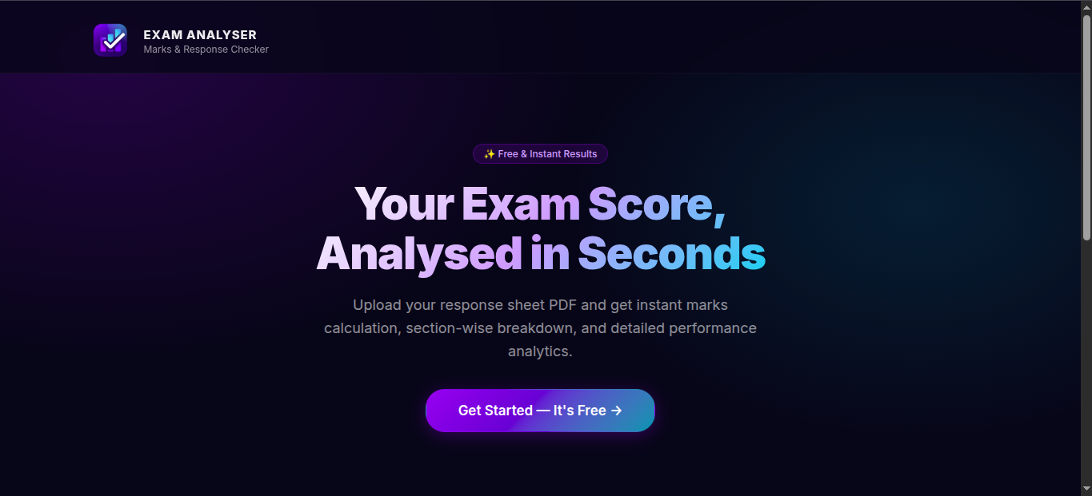

Figure 10.1: Application Home Screen

10.2 Upload Form with Exam Selection
Evidence required: Capture the form showing exam selection and PDF chooser.

Figure 10.2: Upload Form with Exam Selection

10.3 PDF Selected / Upload Progress
Evidence required: Capture the selected file state or progress indicator while processing.
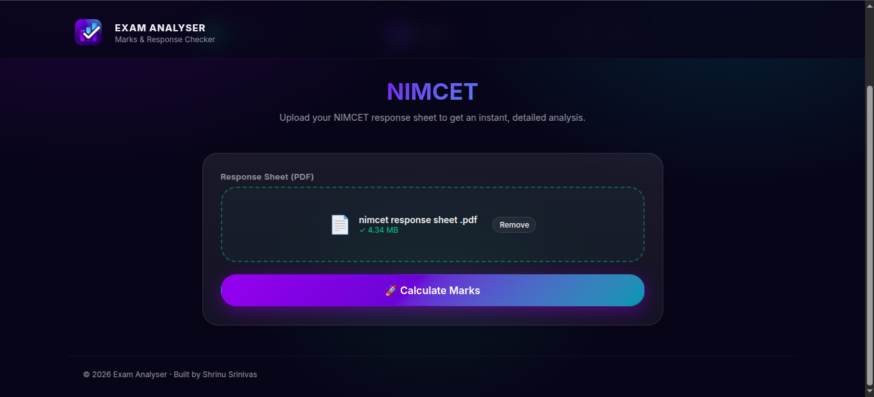

Figure 10.3: PDF Selected / Upload Progress

10.4 Successful Result Summary
Evidence required: Capture marks, correct, incorrect, and unattempted cards.
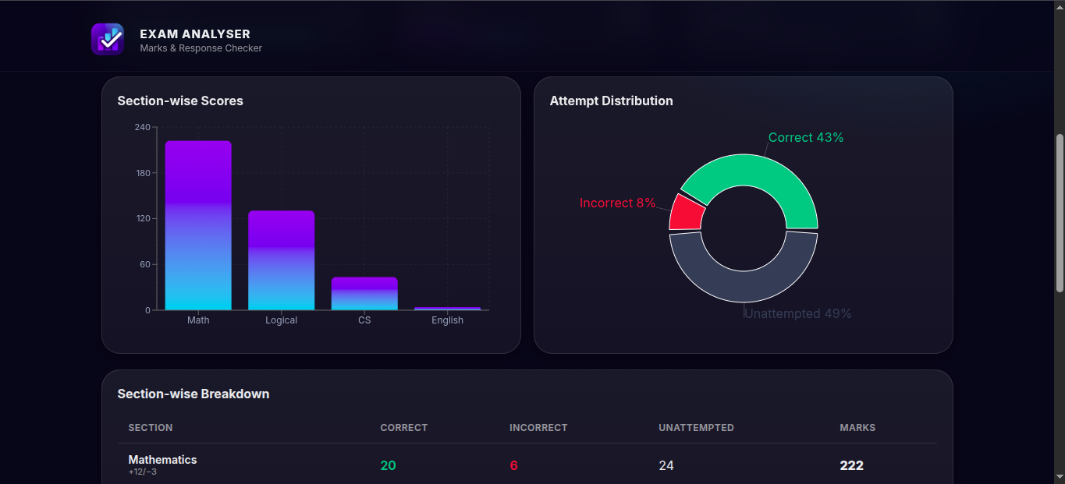
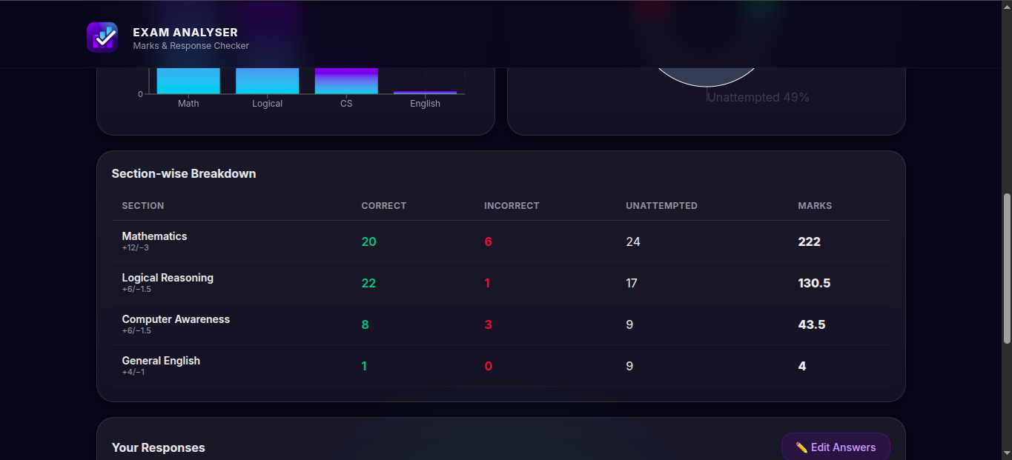

Figure 10.4: Successful Result Summary

10.5 Response-wise Analysis
Evidence required: Capture the question-by-question response view if displayed.
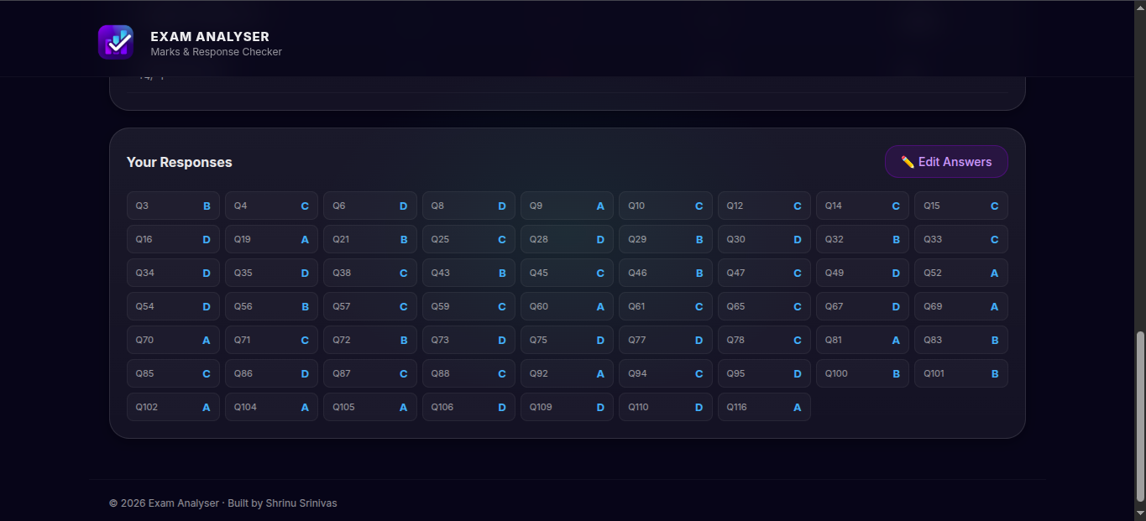

Figure 10.5: Response-wise Analysis

10.6 Confidence Indicator
Evidence required: Capture the extraction confidence badge with a test result.
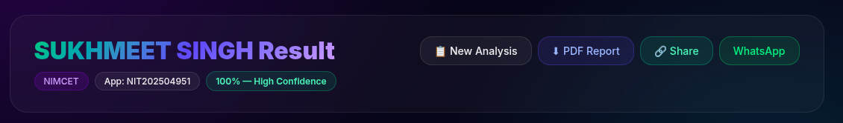

Figure 10.6: Confidence Indicator

10.7 Administrator Results View
Evidence required: Capture the admin result table with test data.
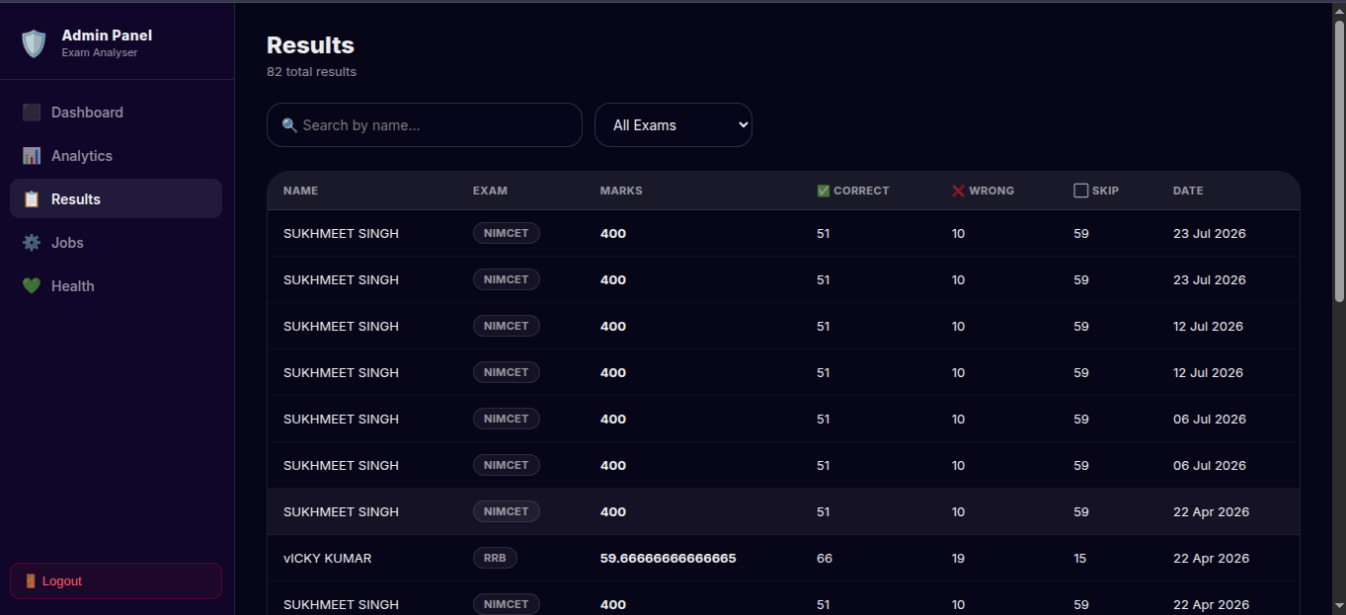

Figure 10.7: Administrator Results View

10.8 Job Monitoring / Queue Status
Evidence required: Capture admin jobs or Bull Board queue status when enabled.
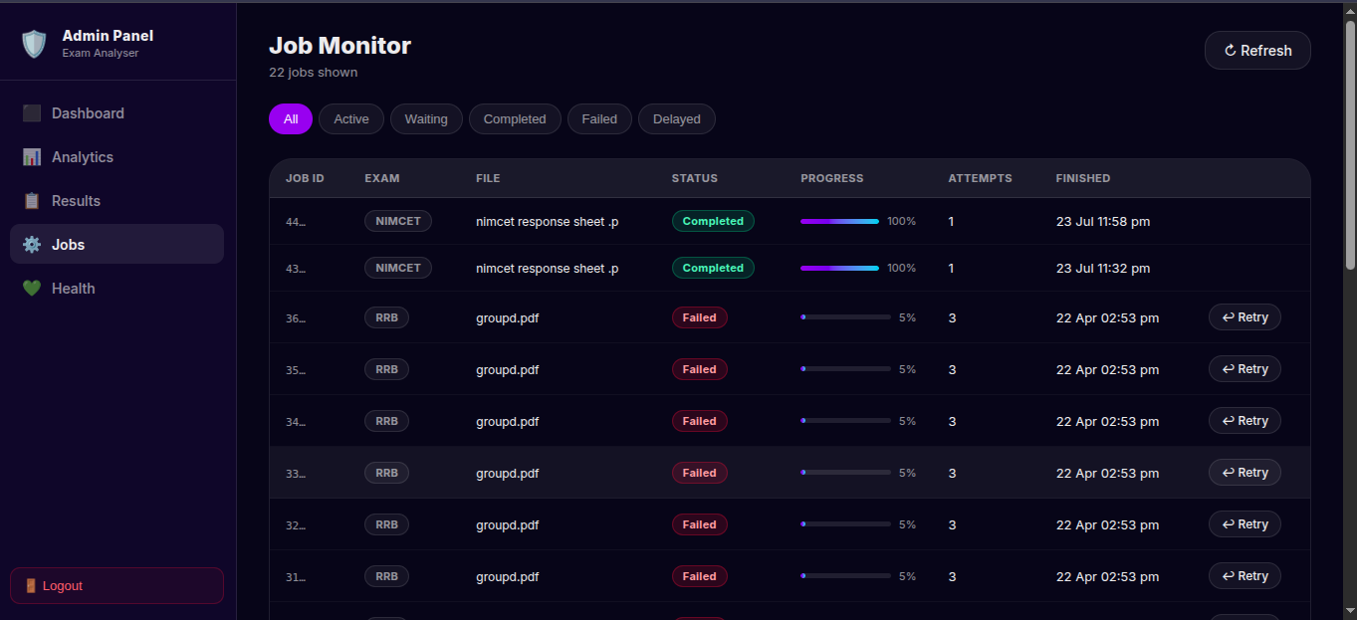

Figure 10.8: Job Monitoring / Queue Status

10.9 System Health Screen
Evidence required: Capture backend/parser health information.
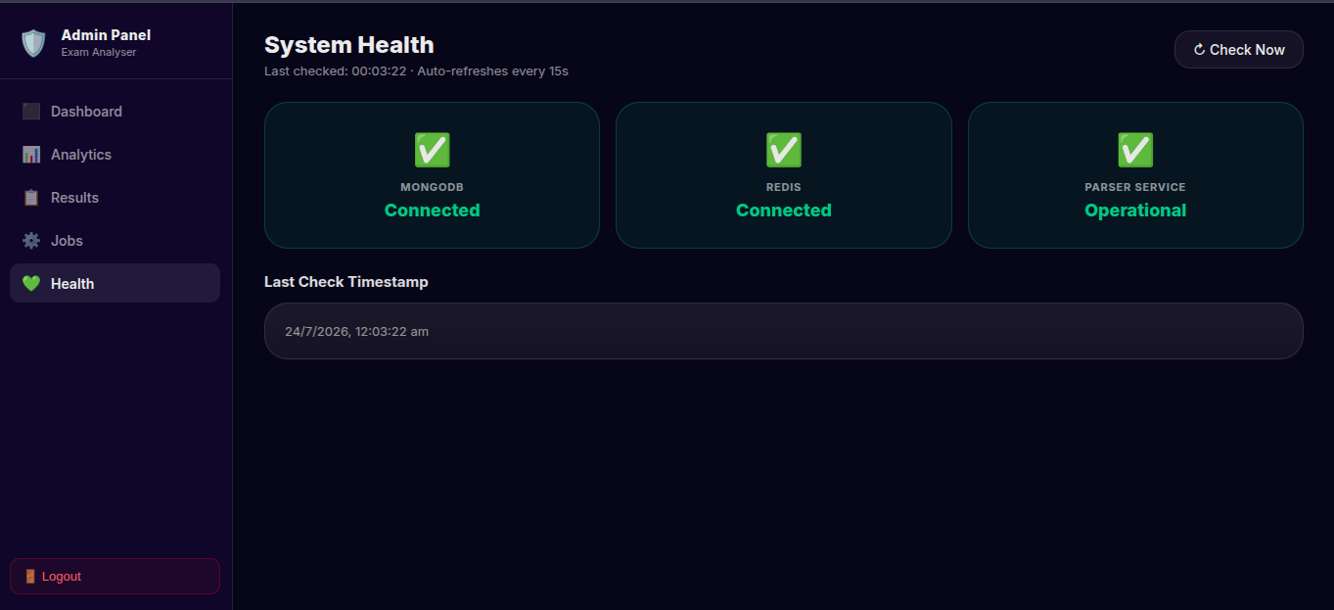

Figure 10.9: System Health Screen

CHAPTER 11: PROJECT MANAGEMENT AND DEPLOYMENT

11.1 Module-wise Work Allocation
The project is organised as a monorepo with clearly separated modules. This division helps testing, maintenance, and deployment because the user interface, API/service layer, and PDF parser can be developed and run independently. The following table can be retained as the module-delivery summary in the final report.
Module | Major responsibility | Evidence to attach
Frontend | User interface, uploads, results, administration | Screenshots from Chapter 10.
Backend | API, validation, scoring orchestration, persistence | Listings 9.2–9.4.
Parser | Text extraction and exam-specific parsing | Listing 9.5; parser test output.
Database | Result-document persistence | Listing 9.6; anonymised database record.
Queue/operations | Background jobs and health monitoring | Listing 9.7; job/health screenshot.

11.2 Deployment Procedure
For local deployment, install the required Node.js and Python versions, configure environment variables, start MongoDB and Redis if used, launch the parser service on its configured port, start the backend service, and finally run the Vite frontend. Dockerfiles and docker-compose.yml are available to support repeatable deployment. Never include actual MongoDB connection strings, passwords, API keys, or .env files in the project report.
SCREENSHOT 11.1 — INSERT HERE
Optional: Insert a terminal screenshot showing the frontend, backend, and parser services running successfully. Mask all secrets and personal file paths.
Project source: README.md; docker-compose.yml; Dockerfile.frontend; Dockerfile.backend; Dockerfile.parser

Figure 11.1: Local service startup / deployment evidence

11.3 Limitations
The quality of response extraction depends on the PDF layout and text clarity. Scanned response sheets, unusual formats, missing answer keys, and image-only PDFs may require stronger OCR or template-specific parsing. The exact examination marking scheme and correct answer key must be verified before publishing any result. These limitations do not reduce the value of the current system; rather, they identify the areas to be addressed in the next development cycle.

11.4 Maintenance Plan
Maintenance includes updating answer-key files, adding parser tests for new document layouts, checking dependency updates, backing up MongoDB data, monitoring failed queue jobs, and reviewing application logs. New examination support should be implemented through a separate parser and pipeline so existing behaviour remains stable.

APPENDIX A: SCREENSHOT AND CODE CHECKLIST
Use this checklist before printing or submitting the report. All grey placeholders in Chapters 8–11 should be replaced with your own evidence. This appendix helps ensure that the written report and demonstrated application remain consistent.
Item | Required evidence | Final check
8.1 | Landing page | [ ] Added [ ] Caption checked [ ] Sensitive data masked
8.2 | Upload page | [ ] Added [ ] Caption checked [ ] Sensitive data masked
8.3 | Result page | [ ] Added [ ] Caption checked [ ] Sensitive data masked
8.4 | Admin dashboard | [ ] Added [ ] Caption checked [ ] Sensitive data masked
9.1–9.7 | Seven source code listings | [ ] Added [ ] Caption checked [ ] Sensitive data masked
10.1–10.9 | Nine output/test screenshots | [ ] Added [ ] Caption checked [ ] Sensitive data masked
11.1 | Service-startup evidence | [ ] Added [ ] Caption checked [ ] Sensitive data masked

APPENDIX B: FILE-TO-REPORT MAPPING
The following mapping tells exactly where a project file can be cited in the report. It prevents copying unrelated code into the documentation and makes the project viva easier, because the submitted report is traceable to the implementation.
Report Section | Primary source file(s)
User interface | frontend/src/pages/ and frontend/src/components/
Backend configuration | backend/src/app.js
Upload API | backend/src/routes/upload.js and backend/src/controllers/uploadController.js
Scoring | backend/src/services/scoring.js
Result database model | backend/src/models/Result.js
Parser API | parser/routes/parse.py and parser/app.py
Exam parsers | parser/services/parse_nimcet.py, parse_cuet.py, parse_rrb.py
Queue processing | backend/src/jobs/queues.js and parseWorker.js
Deployment | README.md, docker-compose.yml, Dockerfile.*

REFERENCES
1. React Documentation. https://react.dev/
2. Vite Documentation. https://vite.dev/
3. Express Documentation. https://expressjs.com/
4. MongoDB Documentation. https://www.mongodb.com/docs/
5. Flask Documentation. https://flask.palletsprojects.com/
6. Redis Documentation. https://redis.io/docs/
7. BullMQ Documentation. https://docs.bullmq.io/
8. Docker Documentation. https://docs.docker.com/
9. Project source code: Marks Analyser repository, inspected for this report.

