Marketing campaign analytics: project workflow
This document explains how the supplied customer CSV becomes the notebook analysis, SQL database, dashboard, and business report. Run commands from the project root, where app.py and requirements.txt are located.

1. Data flow
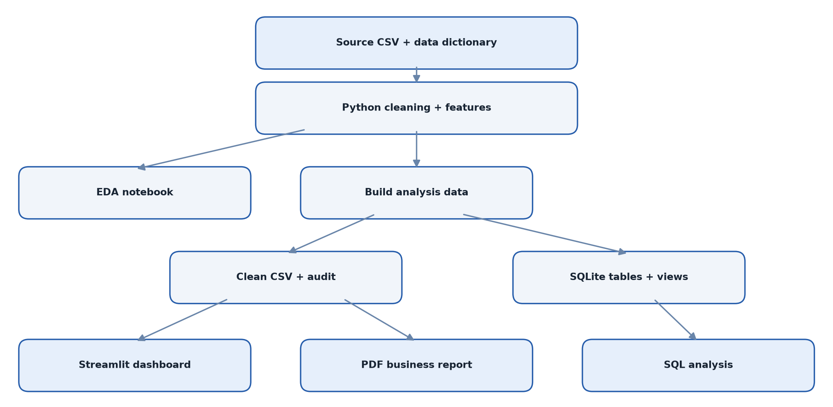
Figure 1. From source data to analysis deliverables
The dashboard reads the cleaned CSV. If that file is absent, it runs load_and_clean() directly against the raw CSV. The notebook also calls the same cleaning function, so its feature rules match the dashboard and database.

2. Set up the environment
Use Python 3.10 or newer. On Windows PowerShell:
python -m venv .venv
.\.venv\Scripts\Activate.ps1
python -m pip install -r requirements.txt
On macOS or Linux, activate with source .venv/bin/activate. The required libraries are listed in requirements.txt. If your IDE runs app.py as a normal Python script, use the Streamlit command in step 6 instead.

3. Inspect and clean the source
Inputs: marketing_campaign_data.csv and marketing_data_dictionary.csv.
src/marketing.py checks required columns, removes duplicate IDs, parses Dt_Customer, validates numeric and binary fields, and checks ages. Rows with unknown spend, purchase, or campaign values are excluded because an unknown value should not be counted as zero. Missing income, if a future file contains it, is imputed with a country median and then the overall median; an Income_Imputed flag records this. Unusually high income is retained with an Income_Outlier flag.
The age and customer tenure reference date is the latest enrollment date in the file (2014-06-29). This keeps results stable when the project is rerun in a later year. The source dictionary does not identify a currency, so all monetary results use source units.
The pipeline then calculates:
Feature | Rule
Age | Reference year minus Year_Birth
Customer_Tenure_Days | Reference date minus Dt_Customer
Children | Kidhome + Teenhome
Total_Spend | Sum of the six product spending columns
Total_Purchases | Web + catalog + store purchases
Campaign_Acceptances | Sum of Campaigns 1–5 and latest Response
Any_Campaign_Response | 1 if at least one campaign was accepted
Age_Band, Income_Band | Fixed bands for dashboard and SQL comparisons

NumDealsPurchases is a count of discounted purchases, not a separate purchase channel; it is not added to Total_Purchases.

4. Apply business segments
The same cleaned table contains the six segments requested by the assignment:
Segment flag | Membership rule
High_Income | Income > 75000
Young_Customer | Age < 30
Campaign_Responder | Latest Response = 1
High_Web_Engagement | NumWebVisitsMonth > 5
Family_Customer | Children > 0
High_Spender | Total_Spend above the full cleaned data's 90th percentile

Customers may belong to several segments. Under_Served is a separate diagnostic flag: below-median spend, more than five monthly web visits, and no latest-campaign response. Campaign_Responder and Under_Served both use Response in their definitions, so their response rates must not be interpreted as independent evidence of campaign effectiveness.

5. Build the analysis data and SQL layer
python -m src.build_data
This command writes data/cleaned_marketing.csv and data/cleaning_audit.json, creates the customers table and indexes from sql/schema.sql, loads the clean rows into data/marketing.db, and recreates the views in sql/views.sql. It is safe to rerun: the customer table is refreshed from the CSV rather than appended with duplicate records.
The SQL views provide one row per customer per campaign (campaign_responses), rule-based customer memberships (customer_segments), and segment KPIs (segment_kpis). sql/analytic_queries.sql contains overall KPIs, campaign rates, demographic profiles, product mix, channel behavior, underserved groups, and ranked prospective target cohorts. Execute these statements in any SQLite client connected to data/marketing.db.
Expected audit for the supplied CSV: 56,000 source and retained rows, zero duplicate IDs, zero incomplete/invalid rows, zero implausible ages, zero income imputations, and 14 flagged high incomes. The high-spender cutoff is 1,564 source units.

6. Explore the notebook and dashboard
Open notebooks/marketing_eda.ipynb in VS Code or Jupyter and run all cells. Its sections cover source profiling, cleaning, univariate distributions, campaign response by customer profile, product/channel comparisons, rule-based segments, target hypotheses, and an income-outlier sensitivity check. notebooks/build_notebook.py regenerates the notebook file; run it only when you intend to replace edits made inside the notebook.
Start the interactive dashboard:
python -m streamlit run app.py
Open the Local URL printed in the terminal, normally http://localhost:8501. Keep the terminal running while using the dashboard. If port 8501 is already in use, Streamlit may print a different port; use the URL it shows.
The sidebar filters all five tabs by country, education, marital status, age band, and income band. The tabs cover overview KPIs, campaigns and segments, product/channel behavior, opportunities, and data quality. The Data quality tab can download the filtered clean rows.

7. Create the business report
python -m src.create_report
This rebuilds report/marketing_campaign_report.pdf from the clean CSV and audit. The report presents the problem, data handling, major patterns, a campaign chart, six testable recommendations, and limits of the evidence.

8. Verify a complete run
Check | Expected result with the supplied data
Cleaning audit | 56,000 retained customers; 14 income outliers flagged
SQL customers table | 56,000 rows
SQL campaign_responses view | 336,000 rows (56,000 customers × 6 campaigns)
Dashboard overall KPIs | 56,000 customers; 14.8% latest response; 36.4% any-campaign response
Dashboard Country = India | 4,814 customers; 18.8% latest response
Report output | report/marketing_campaign_report.pdf opens as a three-page PDF

For a quick SQL row check:
python -c "import sqlite3; c=sqlite3.connect('data/marketing.db'); print(c.execute('SELECT COUNT(*) FROM customers').fetchone()[0])"

9. Refresh with updated data
- Replace marketing_campaign_data.csv with a file using the same field names and meanings.
- Run python -m src.build_data to regenerate the clean CSV, audit, and database.
- Run the notebook and inspect its charts and audit; investigate new exclusions or outlier spikes.
- Run python -m src.create_report so the PDF reflects the refreshed data.
- Restart or rerun Streamlit to clear its cached data and review dashboard filters and KPIs.
The analysis describes associations in historical customer records. Campaign exposure, offer details, campaign costs, and assignment rules are unavailable, so the output cannot establish causal lift or return on investment. Test promising target groups with a controlled campaign before rollout.

