## Mini Project Report On

**ELECTRICITY BILL SYSTEM**

## *Submitted By: Atul(1911985038)*

**CERTIFICATE**

*Certified that this is a bonafide record of the project work titled “***ELECTRICITY BILLING SYSTEM”**

*Done by*

# Atul

**Id:1911985038**

**Virtusa 2019 Batch**

# ACKNOWLEDGEMENT

We take this occasion to thank God, almighty for blessing us with his grace and taking our endeavor to a successful culmination. We extend our sincere and heartfelt thanks to our esteemed guide, Mr. Mukesh sir and Mr. Mananjay Sir , for providing us with the right guidance and advice at the crucial junctures and for showing me the right way. We also take this opportunity to express a deep sense of gratitude to our class coordinators, Dr. Neha Kumra, Mr. Manik Gupta and for their cordial support, valuable suggestions and guidance. We extend our sincere thanks to our respected **Head of the division Dr. Kuldeep** , for allowing us to use the facilities available. We would like to thank the other faculty members also, at this occasion. Last but not the least, we would like to thank our friends and family for the support and encouragement they have given us during the course of our work.

## TABLE OF CONTENTS

ABSTRACT 5

1. INTRODUCTION 6
   1. PROJECT AIMS AND OBJECTIVES 6
   2. BACKGROUND OF PROJECT 7
   3. OPERATION ENVIRONMENT 8
2. SYSTEM ANALYSIS 9
   1. SOFTWARE REQUIREMENT SPECIFICATION 9
   2. EXISTING VS PROPOSED 13
   3. SOFTWARE TOOL USED 13
3. SYSTEM DESIGN 14
   1. TABLE DESIGN 14
   2. DATA FLOW DIAGRAM’S 17
4. SYSTEM IMPLEMENTATION 23
   1. MODULE DESCRIPTION 23
   2. SCREEN SHOTS 28

4.3 MODULE 32

1. SYSTEM TESTING 85
   1. UNIT TESTING 85
   2. INTEGRATION TESTING 87
2. CONCLUSION & FUTURE SCOPE 88
3. REFERENCES 89

#### ABSTRACT

The purpose of Electricity billing system is to automate the existing manual system by the help of computerized equipments and full-fledged computer software, fufuling their requirements , so that their valuable data /information can be stored for a longer period with easy accessing and manipulation of the same. The required software and hardware are easily available and easy to work with.

Electricity Billing system, as described above, can lead to error free, secure, reliable and fast

**CHAPTER 1 INTRODUCTION**

This chapter gives an overview about the aim , objectives ,background and operation environment of the system.

#### PROJECT AIMS AND OBJECTIVES

The project aims and objectives that will be achieved after completion of this project are discussed in this subchapter. The aims and objectives are as follows:

* + - Online billing issue
    - Manage the information of Bill.
    - It tracks all the information of Unit of Energy.
    - Manage the information of Electricity.
    - Integration of all records of Electricity Board.
    - Editing, adding and updating of Records is improved.

#### BACKGROUND OF PROJECT

The purpose of Electricity Billing System is to automate the existing manual system by the help of computerized equipments and full fledge computer software, fulfilling their requirements so that their valuable data/information can be stored for a longer period with easy accessing and manipulating of the same . The required software and hardware are easily available and easy to work with.

Electricity Billing System , as described above , can lead to error free, secure, reliable and fast management system. It can assist the user to concentrate on their other activities rather to concentrate on the record keeping. Thus it will help organization in better utilization of resources. The organization can maintain computerized records without reduntant entries.

#### OPERATION ENVIRONMENT

|  |  |
| --- | --- |
| PROCESSOR | INTEL CORE PROCESSOR OR BETTER PERFORMANCE |
| OPERATING SYSTEM | WINDOWS VISTA ,WINDOWS 8 OR MORE, UBUNTU |
| MEMORY | 4GB RAM OR MORE |
| HARD DISK SPACE | MINIMUM 3 GB FOR DATABASE USAGE FOR FUTURE |
| DATABASE | MY SQL |

**CHAPTER 2**

**SYSTEM ANALYSIS**

In this chapter, we will discuss and analyze about the developing process of Electricity Billing System including software requirement specification (SRS) and comparison between existing and proposed system . The functional and non functional requirements are included in SRS part to provide complete description and overview of system requirement before the developing process is carried out. Besides that, existing vs proposed provides a view of how the proposed system will be more efficient than the existing one.

#### SOFTWARE REQUIREMENT SPECIFICATION

* + 1. **GENERAL DESCRIPTION**

PRODUCT DESCRIPTION:

Electricity Billing System is a computerized system which helps user to manage the bill of electricity daily activity in electronic format. It reduces the risk of paper work such as file lost, file damaged and time consuming.

It can help user to manage the transaction or record more effectively and time- saving.

PROBLEM STATEMENT:

The problem occurred before having computerized system includes:

* + - File lost

When computerized system is not implemented file is always lost because of human environment.Some times due to some human error there may be a loss of records.

* + - File damaged When a computerized system is not there file is always lost due to some accdent like spilling of water by some member on file accidentally.Besides some natural disaster like floods or fires may also damage the files.
    - Difficult to search record

When there is no computerized system there is always a difficulty in searching of records if the records are large in number .

* + - Space consuming

After the number of records become large the space for physical storage of file and records also increases if no computerized system is implemented.

* + - Cost consuming

As there is no computerized system the to add each record paper will be needed which will increase the cost for the management of library.

#### SYSTEM OBJECTIVES

* + - Improvement in control and performance
    - Save cost
    - Save time
    - Manage the information of Store Record.
    - It deals with monitoring the information and transaction of Store record.
    - Have a Good user interface.

#### SYSTEM REQUIREMENTS

* + - 1. NON FUNCTIONAL REQUIREMENTS
         * Product Requirements EFFICIENCY REQUIREMENT

RELIABILITY REQUIREMENT

The system should accurately performs member registration ,member validation .

USABILITY REQUIREMENT

The system is designed for a user friendly environment so that user and admin of system can perform the various tasks easily and in an effective way.

ORGANIZATIONAL REQUIREMENT IMPLEMENTATION REQUIREMNTS

**In implementing whole system it uses react in front-end spring boot as backend which will be used the backend ie the database part is developed using mysql.**

* + - 1. FUNCTIONAL REQUIREMENTS

1. NORMAL USER
   1. USER LOGIN Description of feature

This feature used by the user to login into system. They are required to enter user id and password before they are allowed to enter the system .The user id and password will be verified and if invalid id is there user is allowed to not enter the system.

Functional requirements

-user id is provided when they register

-The system must only allow user with valid id and password to enter the system

-The system performs authorization process which decides what user level can acess to.

-The user must be able to logout after they finished using system.

* 1. REGISTER NEW USER

Description of feature

This feature can be performed by all users to register new user to create account.

Functional requirements

-System must be able to verify information

-System must be able to delete information if information is wrong

#### SOFTWARE AND HARDWARE REQUIREMENTS

This section describes the software and hardware requirements of the system

* + - 1. SOFTWARE REQUIREMENTS
         * Operating system- Windows 7 and more is used as the operating system as it is stable and supports more features and is more user friendly
         * Database MYSQL-MYSQL is used as database as it easy to maintain and retrieve records by simple queries which are in English language which are easy to understand and easy to write.
         * Development tools and Programming language- HTML , CSS and JS in Recat is used to write the whole code and develop webpages
      2. HARDWARE REQUIREMENTS
* Intel core i3 7th generation is used as a processor because it is fast than other processors an provide reliable and stable and we can run our pc for longtime. By using this processor we can keep on developing our project without any worries.
* Ram 4 gb is used as it will provide fast reading and writing capabilities and will in turn support in processing

#### EXISTING VS PROPOSED SYSTEM

* + 1. Existing system does not have any facility of users login or where as proposed system will have a facility of login .
    2. Existing system does not have a facility of online payment whereas proposed system has a facility of Payment.
    3. Existing system does not has any option of information of Unit of Energy whereas proposed system will have this facility.
    4. Existing system does not have any facility to store the record of bill whereas proposed system provides this facility.

#### SOFTWARE TOOLS USED

* For Front-End we use React Software.
* For Back-End we use IntelliJ software.
* For Database we use MY SQL software.

**System Design**

E Bill:

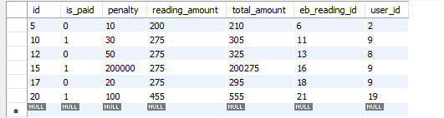

* E RERADING

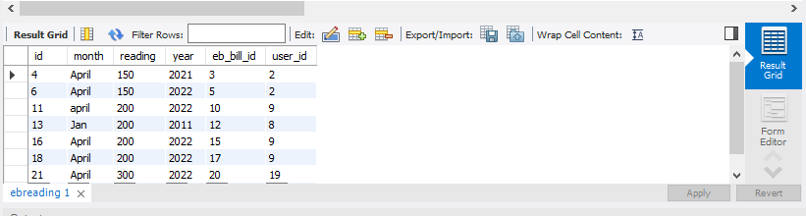

ROLE:

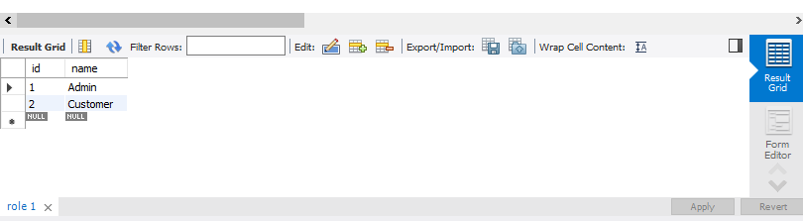

USER:

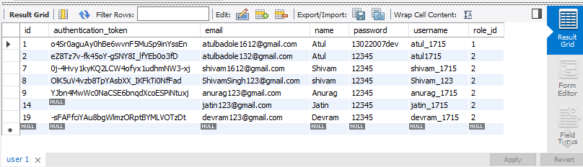

#### DATA FLOW DIAGRAMS

**0 LEVEL DIAGRAM**

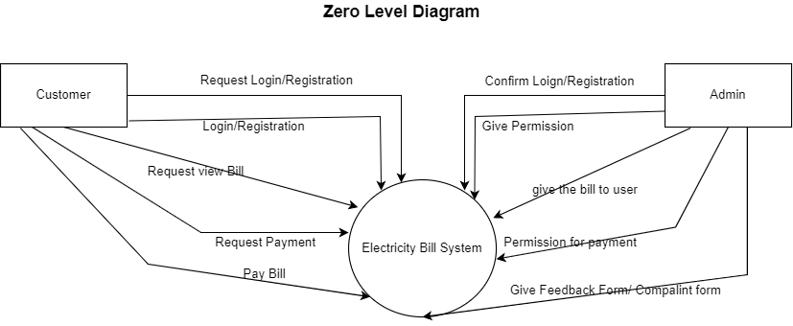

**ONE LEVEL DIAGRAM**

STUDENT

DATABASE

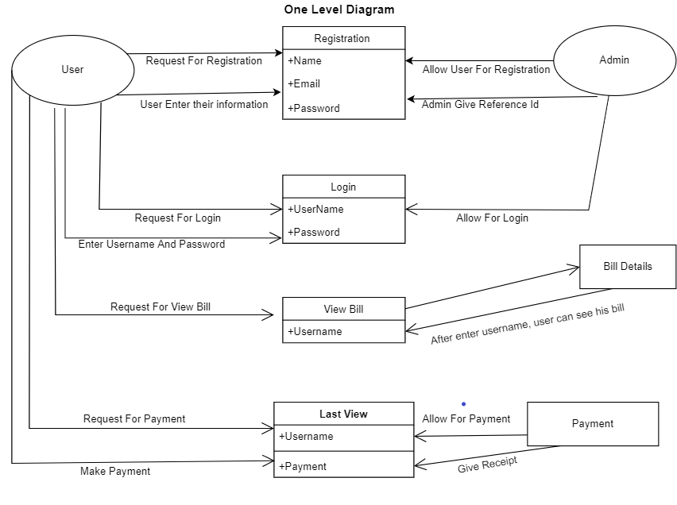

After entering to the services page of the website , admin can choose the ADMIN LOGIN option where they are asked to enter username & password , and if he/she is a valid user then a admin tasks will be displayed.

**UML CLASS DIAGRAM**

LOGIN

DATABASE

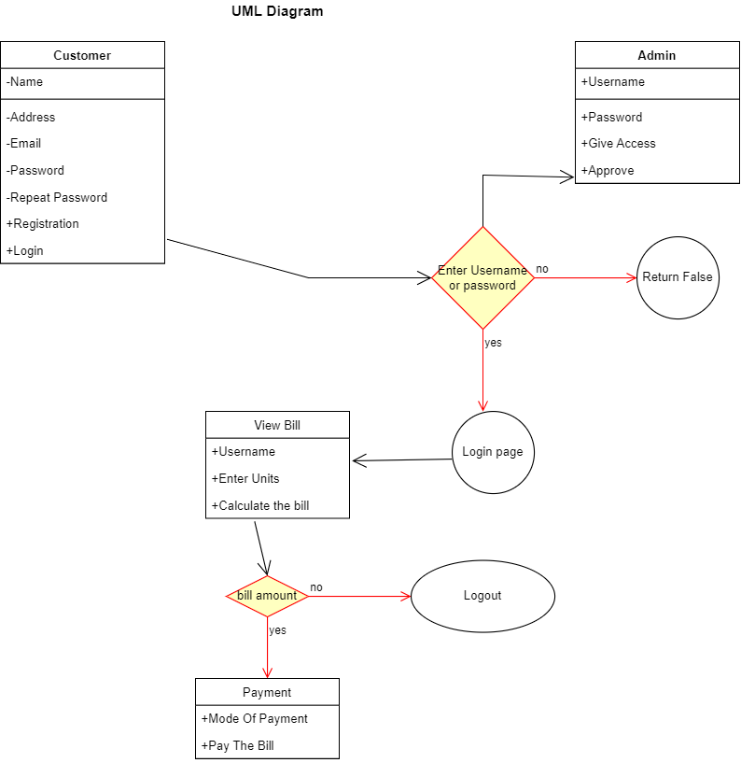

## CHAPTER 4

**SYSTEM IMPLEMENTATION**

###### 1.1 Screenshot for homepage

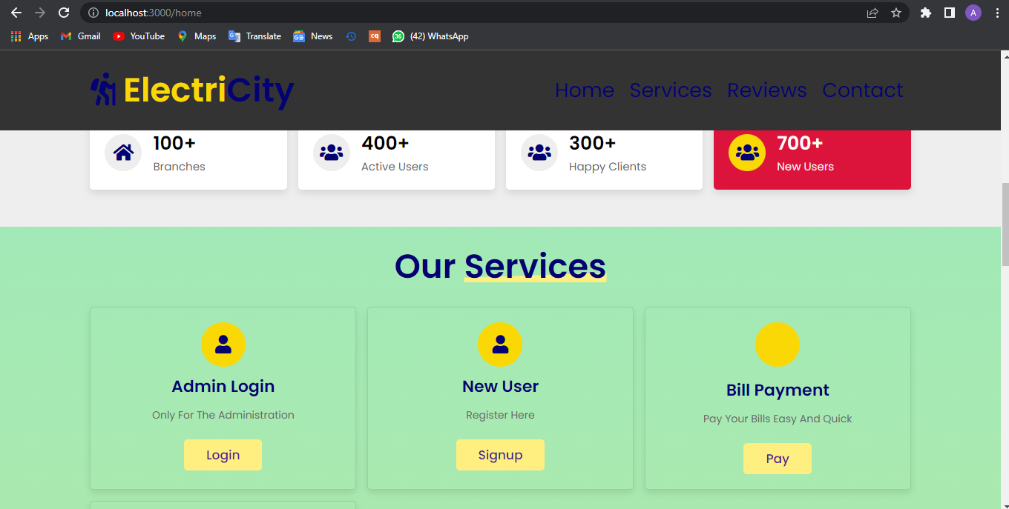

#### 

**1.2 Sign Up page**

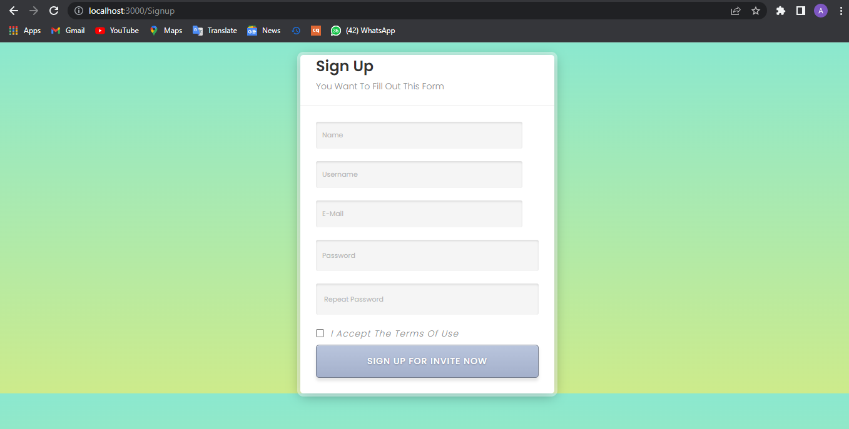

* 1. **Login Page**

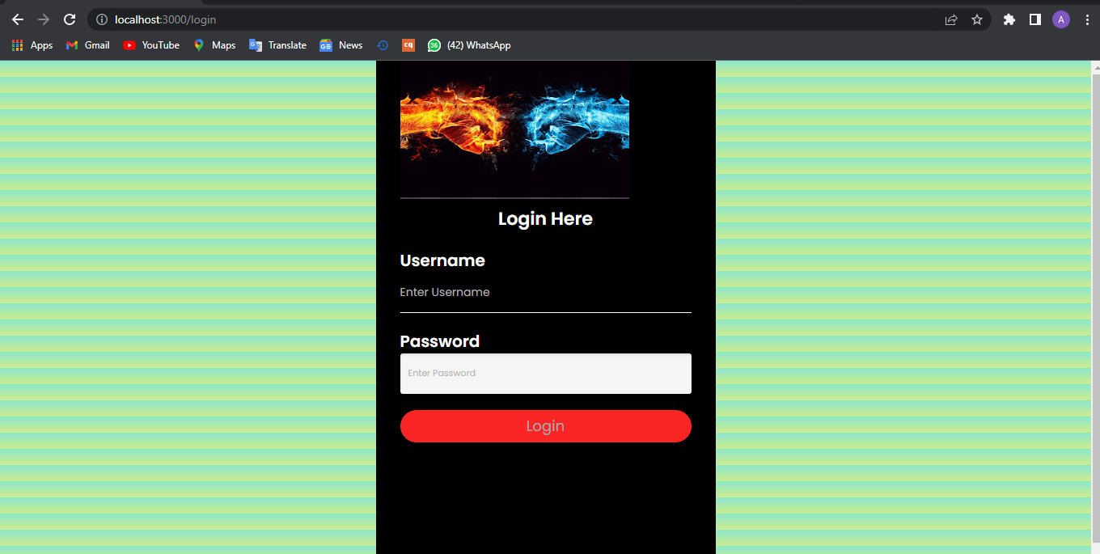

* 1. **List of Users**

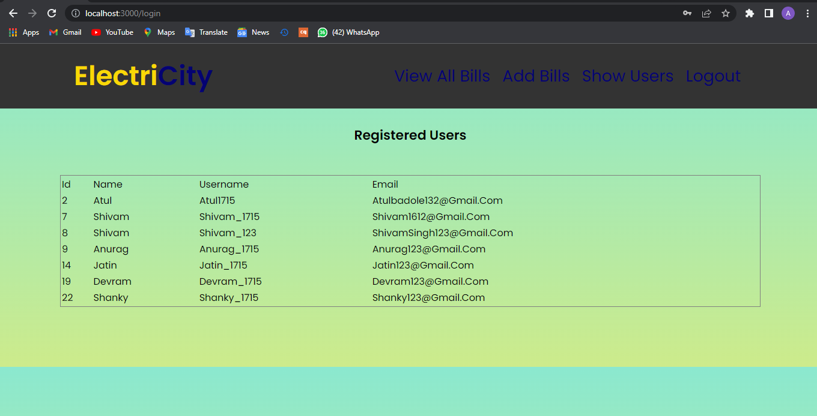

* 1. **Bill generated**

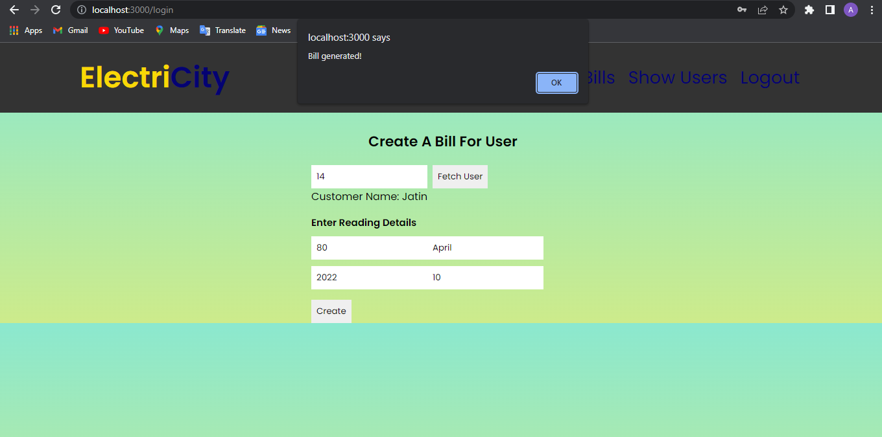

* 1. **View All Bill**

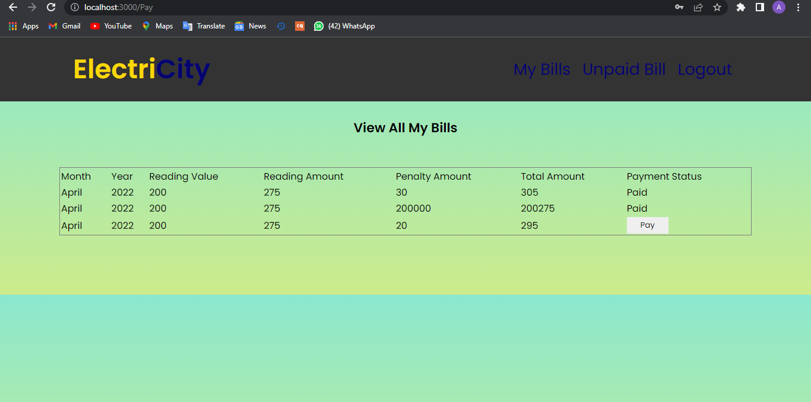

#### Bill Paid

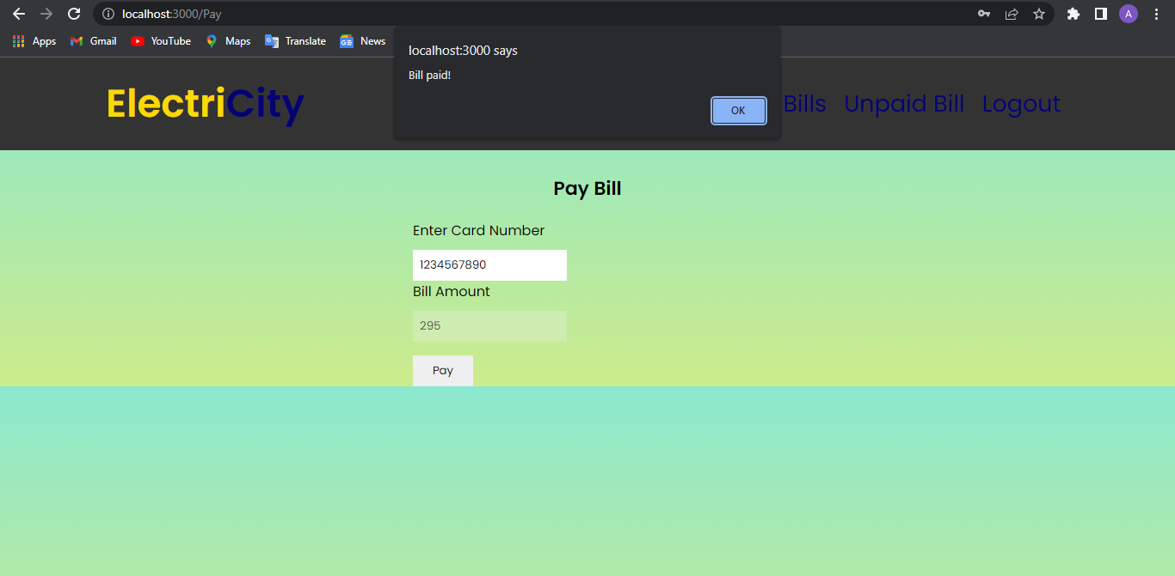

For Library Management System it is divided into the following Modules:

* + 1. **Admin Module**

ADD USERS

ADMIN

GENERATE BILL

LOGIN

The following module contains various facilities like student validation, teacher registration, book addition, and report generation.

PASSWORD

**NEW USER Module:**

NEW

USERNAME OF USER

CHECKBOX

REPEAT PASSWORD

EMAIL OF USER

NAME OF USER

**4.1.3 USER Module**

LOGOUT

CHECK OWN BILLS

LOGIN

USER LOGIN

PAY THE BILL

CHECK UNPAID BILLS

#### 4.1.5 Bill Transaction Module

ADD BILL

PAY BILL

BILL GENERATE

BILL MODULE

The following module contains various facilities like add bill, generate the bill and pay the bill.

# CHAPTER 5 SYSTEM TESTING

The aim of the system testing process was to determine all defects in our project .The program was subjected to a set of test inputs and various observations were made and based on these observations it will be decided whether the program behaves as expected or not.

Our Project went through two levels of testing 1.Unit testing

1. integration testing

## UNIT TESTING

Unit testing is undertaken when a module has been created and succesfully reviewed .In order to test a single module we need to provide a complete environment ie besides the module we would require

* + The procedures belonging to other modules that the module under test calls
  + Non local data structures that module accesses
  + A procedure to call the functions of the module under test with appropriate parameters

Unit testing was done on each and every module that is described under module description of chapter 4

1. Test For the admin module
   * Testing admin login form-This form is used for log in of administrator of the system.In this we enter the username and password if both are correct administration page will open other wise if any of data is wrong it will get redirected back to the login page and again ask for username and password
   * User account addition- In this section the admin can verify user details from user record info and then only add user details to database it contains add and delete buttons if user click add button data will be added
2. Test for User login module
   * Test for User login Form-This form is used for log in of User .In this we enter the user id, username and password if all these are correct user login page will open other wise if any of data is wrong it will get redirected back to the login page and again ask .
   * Test for account creation- This form is used for new account creation when new user it does not fill the form completely it asks again to fill the whole form when he fill the form fully it gets redirected to page which show waiting for conformation message as his data will be only added by administrator after verification.
3. Test for admin login module-
   * Test for teacher login form- This form is used for logg in of teacher .In this we enter the username and password if all these are correct admin login page will open other wise if any of data is wrong it will get redirected back to the login page and again ask for username and password.

## INTEGRATION TESTING

In this type of testing we test various integration of the project module by providing the input

.The primary objective is to test the module interfaces in order to ensure that no errors are occurring when one module invokes the other module.

# CHAPTER 6 CONCLUSION & FUTURE SCOPE

This website provides a computerized version of electricity management system which will benefit the students as well as the staff of the system.

It makes entire process online where student can search bills, staff can generate bills and check user and their transactions. It also has a facility for bill payment where users can login and can see status of bills issued as well as pay there bills

There is a future scope of this facility that many more features such as online payment gateway, a feature of editing the users details and fetching older readings to customize the human efforts for reading calculations and many more can be added.

# CHAPTER 7 REFERENCES

* <http://www.w3schools.com/html/html_intro.asp>
* <http://www.w3schools.com/css/css_background.asp>
* <http://www.w3schools.com/js/js_datatypes.asp>
* <http://www.w3schools.com/sql/sql_insert.asp>
* <http://www.w3schools.com/sql/sql_update.asp>
* <http://www.w3schools.com/php/php_forms.asp>
* Web development and application development by Ivan Byross BPB publication.
* GitHub Link: https://github.com/atulbadole/Electricity