**Ajinkya Shinde (Roll No. 183109007)**

**Atul Belekar (Roll No, 183109001)**

**Title:** A CFD study on the interaction between free-stream turbulence and a wing-tip vortex in the near-field of NACA 0015 aero foil.

**Description:**

The effect of external free-stream turbulence will be investigated in the near-field of a wing-tip vortex using simulations. This study has been previously done using experiments by Mojtaba A-B et.al. The purpose of this project is do numerical simulations of this problem and compare the results with the experimental data that they have published in the paper. I have attached the paper along with this proposal for more information.

**Model:**

Following figure shows the model that was used during the experiments. We propose to use the same model during the simulations along with all the dimensions.

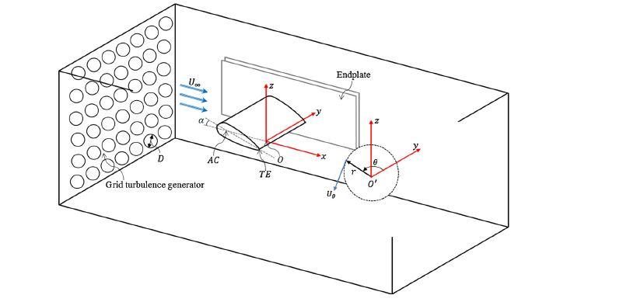

Fig. 1. Sketch of the experimental arrangement in the wind tunnel test section showing the coordinate system.

**Objectives:**

1. Variation of lift and drag coefficients with angle of attack of the aero foil.
2. Contours of cross flow velocity normalized by the free stream velocity for Tu=0.5% and 4.6% at four streamwise measurement planes.
3. The effect of free stream turbulence on the circumferential velocity variation.

**Approach to the problem:**

A geometric model similar to the on mentioned in the description will be created with a modelling software. We propose to do the simulation of the problem using Open FOAM. But in case of the difficulty we may switch to Ansys FLUENT. The decision to do so will be taken after

your permission. In the geometric model mentioned in the description a grid is present to produce turbulence. But during simulation we don’t need that grid as we can directly input the turbulence intensity in the software. A short literature survey is needed to be done to understand the type of boundary conditions to be used and to create appropriate mesh geometry. The results presented in the experimental study will be compared with the simulation results.