**T2 2020: ICT272 Web Design and Development**

**Assignment 2 – Part B**

Introduction

This assignment has been completed with the help of jQuery mobile framework. It’s a complete responsive site which works well across all the devices with different screen size. The website or the web application looks absolutely amazing in the smartphones.

The web application contains following pages which are referenced from the Assignment1.

# Home Page

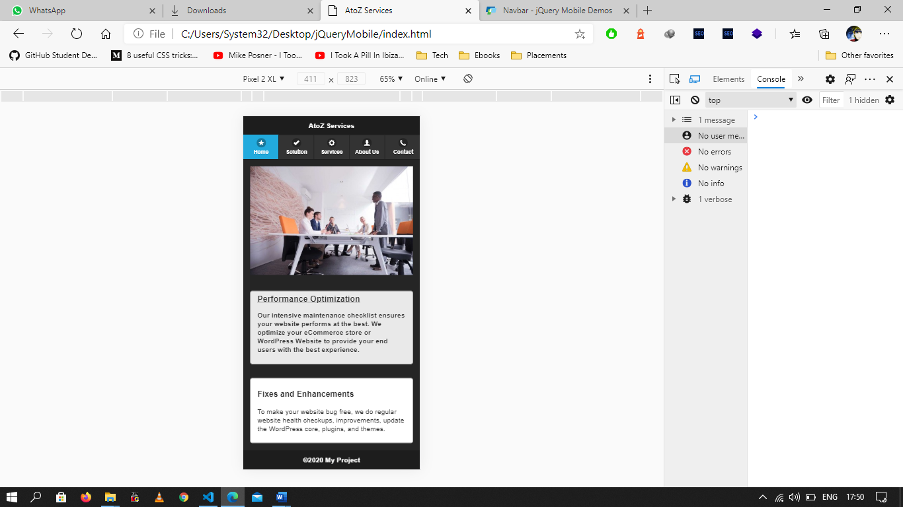

This page includes introductory information about the website. Other than there are details about the services that they are providing. In which there is various service option present a user can select the service he/she requires once the on the action button present on that service block the user is redirected to the requested service page. Once the user redirected to the service page, he/she can get the solution that they have issues with.

There is a brief description of all the service options that are provided by the company. Users can click on the service details and can read about the details of that particular service. It has the list of maintenance provided or completed by the company.

# Solution page

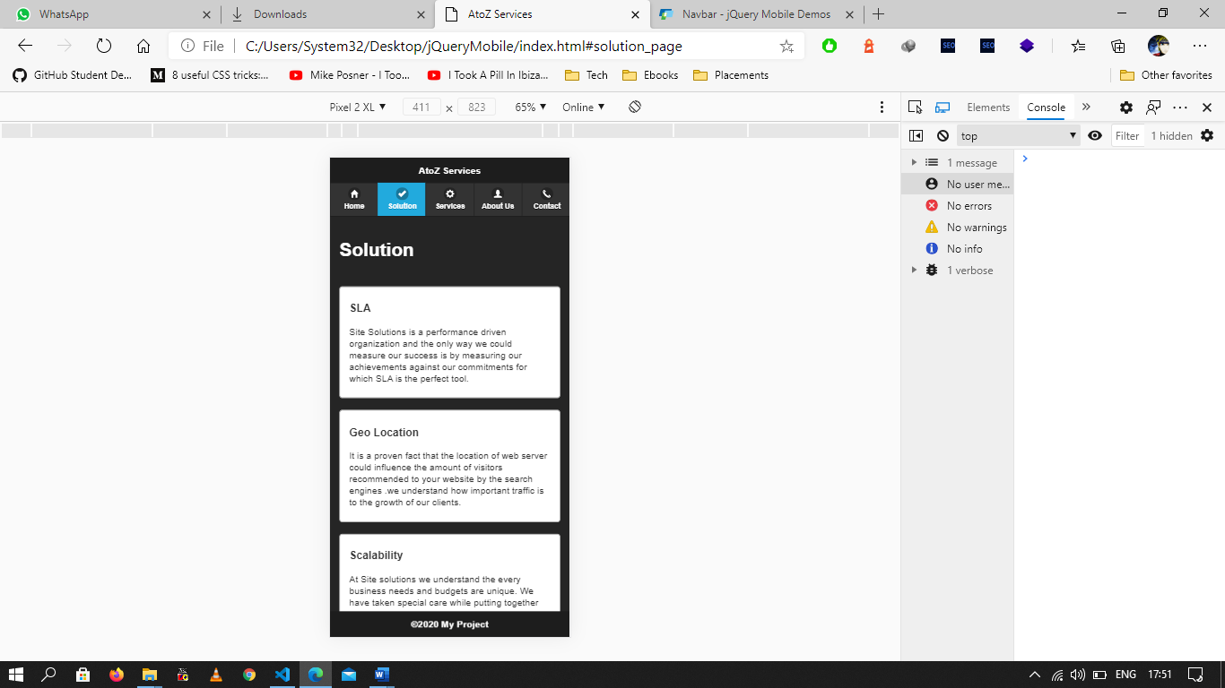

Once the user selects the services that he/she requires then the user is redirected to the service page. In the solution, there are details about the solution that a user will receive like if there is any sort of bug in the user’s website than i.e. in the website code of the user website, they will remove it so that the user website can be functional again. That is, they are providing fixes and enhancement for the websites. Other than this there are services like full functionality check of the website i.e. the response is received by the user or not. And they also check if there are any link breaks like when a user clicks on the button or the link provided and it shows some sort of error, they rectify this problem.

They keep the website hack free and virus free by applying SSL protection to the website. The most important part of a website is the server. And it is the major factor for having good traffic on the website. Also, each user or client gets the budget requirement of their website according to the requirements provided by the user or client.

# Services

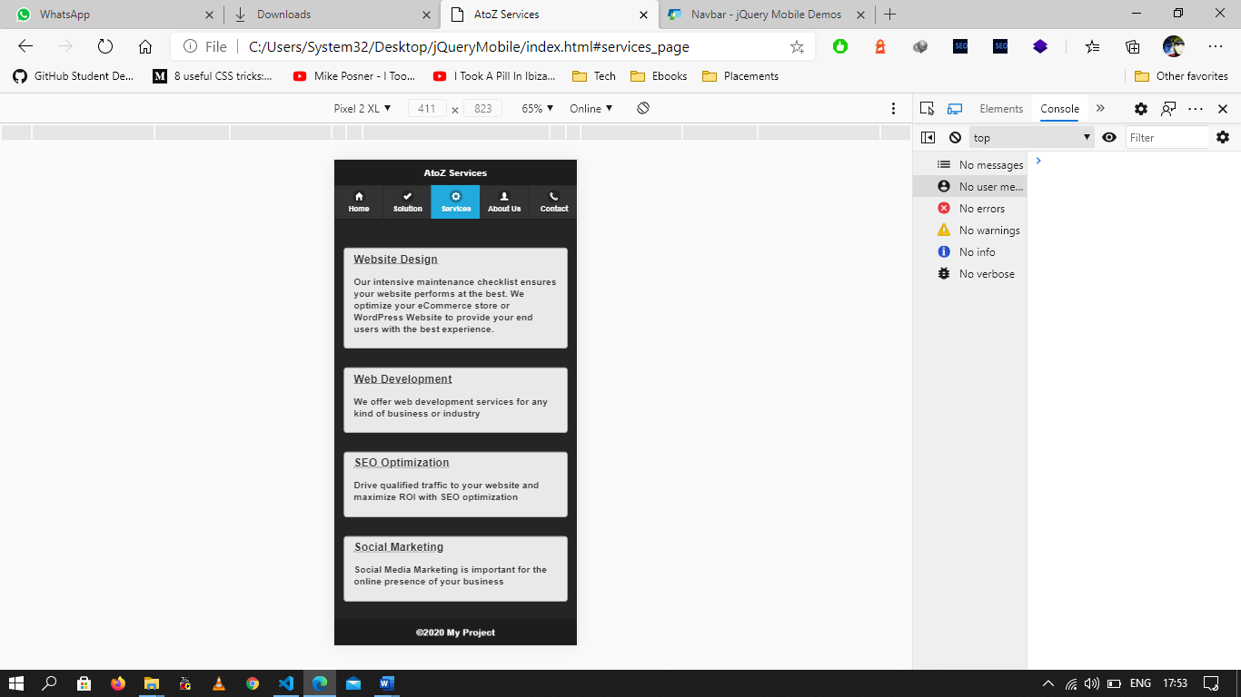

The services provided by the company are:

Website designing in this they design the layout of the website like the designing of all the pages, styling that is to be applied on the page. These tasks are completed by using HTML and CSS with JS. They take the requirements of the user that he/she needs on the website. Once all the requirements are noted by the designer. Then they design the website according to these requirements. This complete process is the front-end part of the user website. Then the second part is the database of the website. Back-end can be designed for other services like Django, Mongo dB SQL, etc.

Web development is the service that the user wants his website to be a single page website or each time the website is redirected to a new page. The user can have a single static page website or a plain text website depending upon there usage or requirements i.e. the website can be an e-commerce website, business website, portfolio website, or any sort of social networking website. So basically, it is the work that makes the website looks good and presentable to a user. Each website requires different types of features to be added to it. And have different types of traffic requirements.

SEO optimization helps is getting a good amount of traffic on a website. Basically, SEO optimization increases quality traffic on the user website and it helps in increasing the visualization of the website when someone search related to that website or the work done by that website. ROI is also calculated and maximum return is obtained.

# About Us

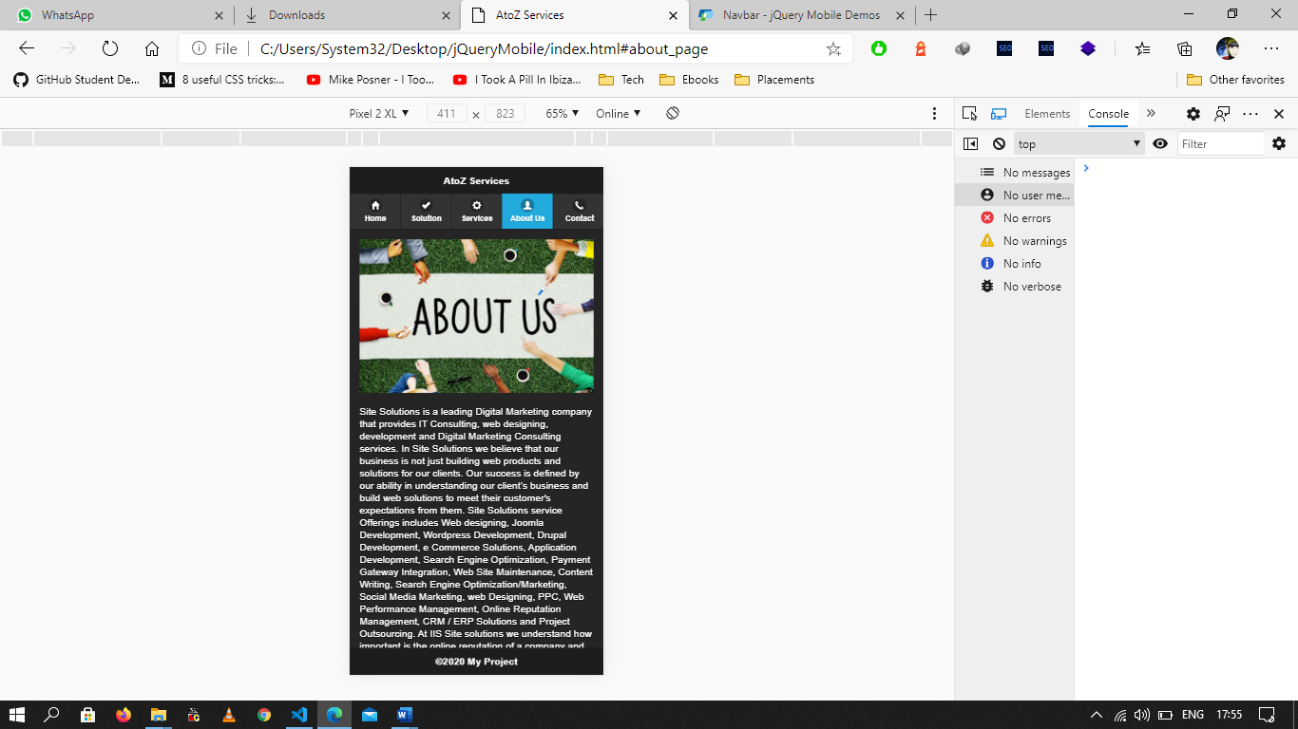

This page includes the details about the company like the address of the company where it is situated, the contact details of the company, details about the employees in that company, the project they have worked on or will be working on. Other than this the services provided by them, some websites have the feedback also in which the user gives feedback about the companies or the quality of services that they have received from the company. The vision of the company, the mission of the company, and the value of the company. Users can access these details to know about the company.

# Contact Us

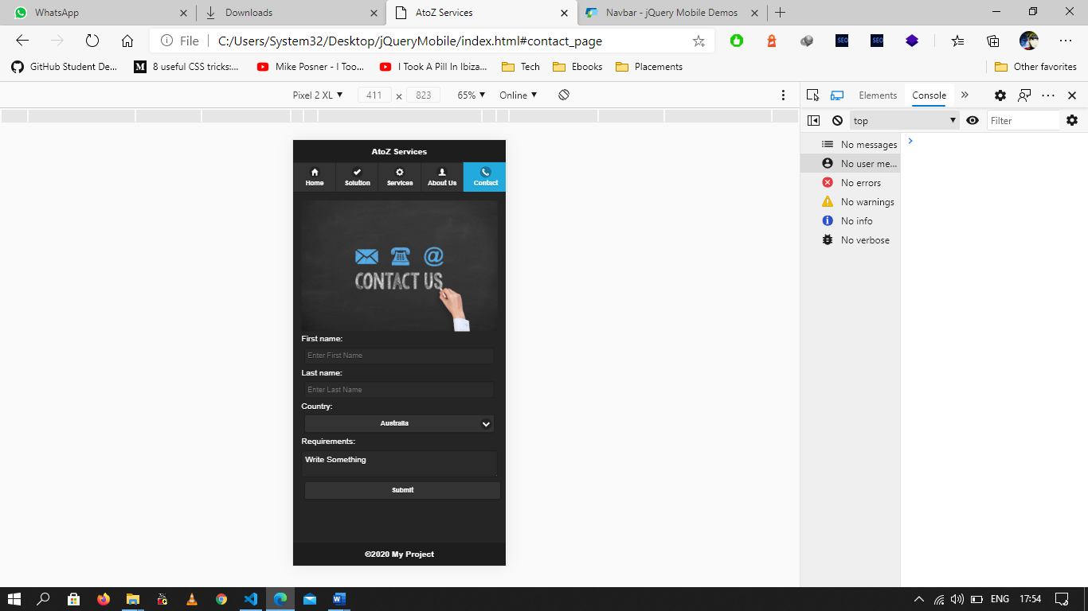

On this page, there is an entry form in which any client can fill the service he/she requires. In the form of the contact us form the user has to fill his/her full name, country they are from, and a brief description of the issue they are facing. Each and every requirement should be detailed while submitting the request so that it will be easy to understand the issue and provide the required solution to it. Even if a user requires the demo of the website, they can click on the request demo button and fill their details once the request is received users will receive the demo of the website they want.

Explanation

* **RESPONSIVE DESIGN CONCEPT**

Responsive Design Concept states that the layout of our website or our app should respond to the layout of the device. It should not look out of place when switching from one device to another or simply changing the orientation of the device. It should be responsive with respect the device it has to be viewed on.

**Wikipedia:** Responsive web design is an approach to web design that makes web pages render well on a variety of devices and window or screen sizes.

* **JQUERY MOBILE TO IMPLEMENT THE RESPONSIVE DESIGN**

**Steps are:**

1. Imported jQuery Mobile to head section of the HTML file along with the required jQuery file.

<head>

    <title>AtoZ services</title>

    <meta name="viewport" content="width=device-width, initial-scale=1">

    <meta name = "viewport" content = "width = device-width, initial-scale = 1">

    <link rel = "stylesheet" href = "https://code.jquery.com/mobile/1.4.5/jquery.mobile-1.4.5.min.css">

    <script src = "https://code.jquery.com/jquery-1.11.3.min.js"></script>

    <script src = "https://code.jquery.com/mobile/1.4.5/jquery.mobile-1.4.5.min.js"></script>

</head>

1. Read the documentation and started applying jQuery mobile elements to my HTML page.
2. Started with creating home page, followed by other pages.
3. jQuery mobile was used in following ways:

<div data-role="page" id = "solution_page" data-theme = "b">

<div data-role="header">

<div data-role="navbar" class="nav-glyphish-example" data-grid="d">

<div data-role="page" id = "solution_page" data-theme = "b">

<div role="main" class="ui-content">

<div class="ui-body ui-body-a ui-corner-all" style = "margin-bottom: 20px;">

<div data-role="footer" data-position="fixed">

data-role attribute was used to describe the each div has to play. This way the jQuery mobile was embedded in the HTML page.

* **CONSIDERATIONS OR TECHNIQUES USED FOR SPECIFIC DESIGN ISSUES**

Styling was done in few places to adjust the content so that it won’t disturb the responsiveness of the web application.

The main issue faced was with images used so to tackle with this problem the height and width of the images were fixed.

Apart from this <meta> tag was also used to achieve the responsiveness.

<meta name="viewport" content="width=device-width, initial-scale=1">