AI Gateway

- High level Architecture -
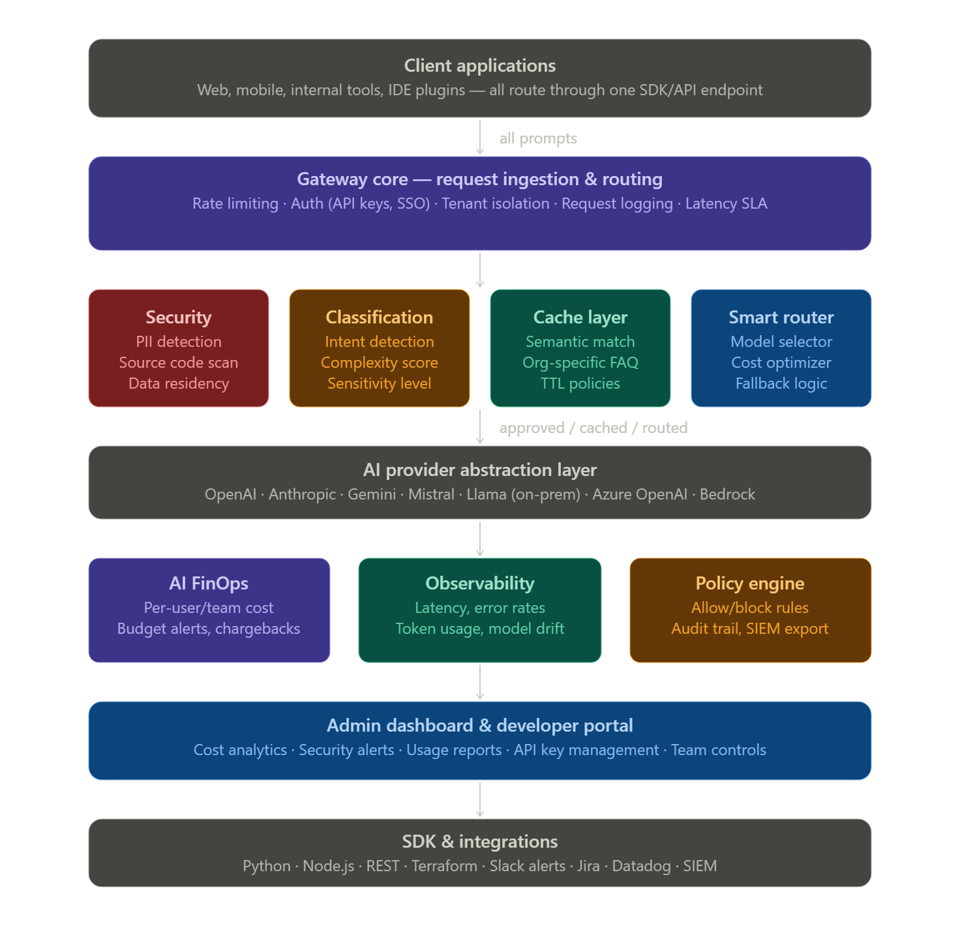
Core feature modules
1. Security & Compliance layer — this is the highest-value wedge for enterprise sales
- PII detection (names, emails, Aadhaar/SSN, phone numbers) before prompts leave the org
- Source code detection — flag when developers paste proprietary code into prompts
- Sensitive prompt detection — contracts, financials, trade secrets
- Data residency enforcement — block prompts from routing to providers in disallowed geographies.
- GDPR/HIPAA/SOC2 audit trail export.
2. Smart prompt router — the cost-saving engine
- Classify prompt complexity (simple Q&A → cheap model, complex reasoning → premium model)
- Auto-downgrade: "is this a GPT-4 task or a GPT-3.5 task?" decided programmatically
- Fallback chains: if primary model is down/slow, reroute automatically
- A/B testing between models for quality benchmarking
3. Semantic cache layer — instant ROI demo for customers
- Vector-embed every prompt; on cache hit, return stored response without calling any model
- Org-specific FAQ cache: common HR, IT, policy questions answered from cache
- Configurable TTL per topic type
- This alone can cut 30–60% of API spend for repetitive enterprise use
4. AI FinOps — CFOs love this
- Per-user, per-team, per-project cost attribution
- Budget caps with hard/soft limits (block or warn when limit hit)
- Chargeback reports by department
- Token cost forecasting and trend alerts
- Model cost comparison dashboards
5. Observability & Governance
- Full prompt/response logging with redaction options
- Policy engine: define allow/block rules (e.g. "engineering team cannot use GPT-4 for non-prod tasks")
- Real-time anomaly detection (sudden spike in tokens, unusual hours)
- SIEM/SOC integration (Splunk, Datadog, Sentinel)

Tech stack recommendation
For a solo founder or small team:
- Gateway core: Python (FastAPI) or Node.js — low latency proxy
- Cache: Redis + pgvector (PostgreSQL with vector extension) for semantic matching
- Queue/async: Celery or BullMQ for non-blocking classification
- PII detection: Microsoft Presidio (open source, battle-tested)
- Dashboard: Next.js + Tailwind
- Infra: Deploy on Railway or Render to start; move to Kubernetes as you scale
- Multi-tenancy: Postgres row-level security from day one

Build order (what to ship first)
- Proxy + logging — the boring plumbing that makes everything else possible
- PII/source code detection — fastest enterprise sale (compliance teams have budget)
- Cost dashboard — CFOs/CTOs can immediately see ROI
- Semantic cache — show a live demo where you cut spend in real time
- Smart routing — more complex, but huge cost savings story
- Policy engine — enterprise deal-closer for regulated industries

Build roadmap — 5 phases
- Foundation – Proxy core and Observability - Completed
- Features -
  - Build the HTTP proxy — intercept prompts, forward to any AI provider (OpenAI, Anthropic, Gemini), return responses transparently
  - API key management — issue org-scoped keys, per-user keys, track usage per key
  - Full request/response logging — store prompts, responses, token counts, latency, model used, timestamp
  - Basic admin dashboard — table view of logs, token usage chart, simple cost calculation
  - SDK stub — Python + Node.js drop-in that replaces OpenAI client and routes through your gateway
- Milestone - A working proxy an org can point their apps at. Every prompt is logged. Basic cost dashboard is live. This alone has sales value.
- Technology – FastAPI, PostgreSQL, Redis, Next.js dashboard Docker

- Security layer – PII, Source Code & Data residency - Completed
- Features –
- PII detection using Microsoft Presidio — detect names, emails, phone numbers, Aadhaar, PAN, SSN, credit cards before prompts leave the org
- Source code detection — regex + AST heuristics to flag code snippets (function defs, imports, variable assignments) in prompts
- Sensitive prompt classifier — ML or keyword-based model to flag financial, legal, or contractual content
- Data residency enforcement — block prompts from routing to providers in disallowed regions (e.g. EU data stays in EU-hosted models)
- Policy engine v1 — admin can set allow/block rules, configure actions (block, warn, redact, allow with audit)
- Security alerts dashboard — real-time view of flagged prompts, violation types, trend over time
- Milestone - Demo-able security product. Walk into any enterprise and show live PII/code detection in action. This is your door-opener for compliance-heavy sectors (BFSI, healthcare, legal).
- Technology – Presidio, spaCy, fasttext, GeoIP, Celery

- AI Finops – Cost attribution, budgets & Chargebacks – partially completed
- Features –
- Cost attribution engine — tag every request with user, team, project, environment; aggregate spend by any dimension
- Budget system — set soft limits (alert at 80%) and hard limits (block at 100%) per user, team, or project
- Chargeback reports — monthly CSV/PDF export showing AI cost by department for internal billing
- Model cost comparison — show side-by-side: "this team spent $800 on GPT-4, same tasks could run on Claude Haiku for $120"
- Spend forecasting — project next month's cost based on usage trend, alert when on track to exceed budget
- Slack/email alerts — notify team leads and finance when budget thresholds are hit
- Milestone - Full FinOps product. Average enterprise can see immediate ROI — typically 20–40% spend reduction just from visibility. This is your upsell from security-only deals.
- Technology – TimescaleDB, Recharts, Pandas, Celery beat, Sendgrid

- Smart routing & Semantic cache – cost optimizer - partially completed
- Features –
- Prompt classifier — categorize prompts as simple (Q&A, summarize), medium (code gen, analysis), complex (multi-step reasoning) and route to cheapest model that can handle it
- Smart router — configurable routing rules: "engineering team's test prompts → Haiku; production → Sonnet; complex analysis → Opus"
- Semantic cache — embed every prompt with a lightweight model; on >0.92 similarity hit, return cached response instantly (zero API cost)
- Org FAQ cache — let admins seed common questions (HR policy, IT helpdesk) that are always answered from cache
- Fallback chains — if primary model is slow/down, auto-failover to secondary with configurable SLA thresholds
- A/B testing — route X% of traffic to model A, Y% to model B; track quality score + cost to help orgs find the right model
- Milestone - This is your wow demo. Show a live dashboard where cache hits are saving money in real time. Typical savings: 30–60% of AI spend.
- Technology –pgvector, sentence-transformers, Redis cache, LiteLLM, scikit-learn

- Enterprise-grade – multi-tenancy, integrations & compliance
- Features –
- Multi-tenancy hardening — full org isolation, row-level security, custom domains per tenant
- SSO integration — SAML/OIDC (Okta, Azure AD, Google Workspace) so enterprise IT can onboard in one click
- RBAC — admin, analyst, dev, viewer roles with granular permissions per feature
- SIEM/SOC integrations — export audit logs to Splunk, Datadog, Microsoft Sentinel, Elastic
- Terraform provider & Kubernetes helm chart — so DevOps teams can deploy your product via IaC
- Self-hosted option — Docker Compose + Helm chart so data-sensitive orgs can run it on-prem
- Compliance reports — SOC2-ready audit trail export, GDPR data processing records, data retention policies
- Billing & subscription — Stripe integration, usage-based metering, plan upgrades in-dashboard
- Milestone - Production SaaS ready to sell. Self-serve onboarding, enterprise contracts, self-hosted option. Start outbound sales and apply to YC / raise a seed round with traction.
- Technology –Auth0 / Keycloak, Stripe, Kubernetes, Helm, Terraform, OpenTelemetry

Phase 1( Implemented) –

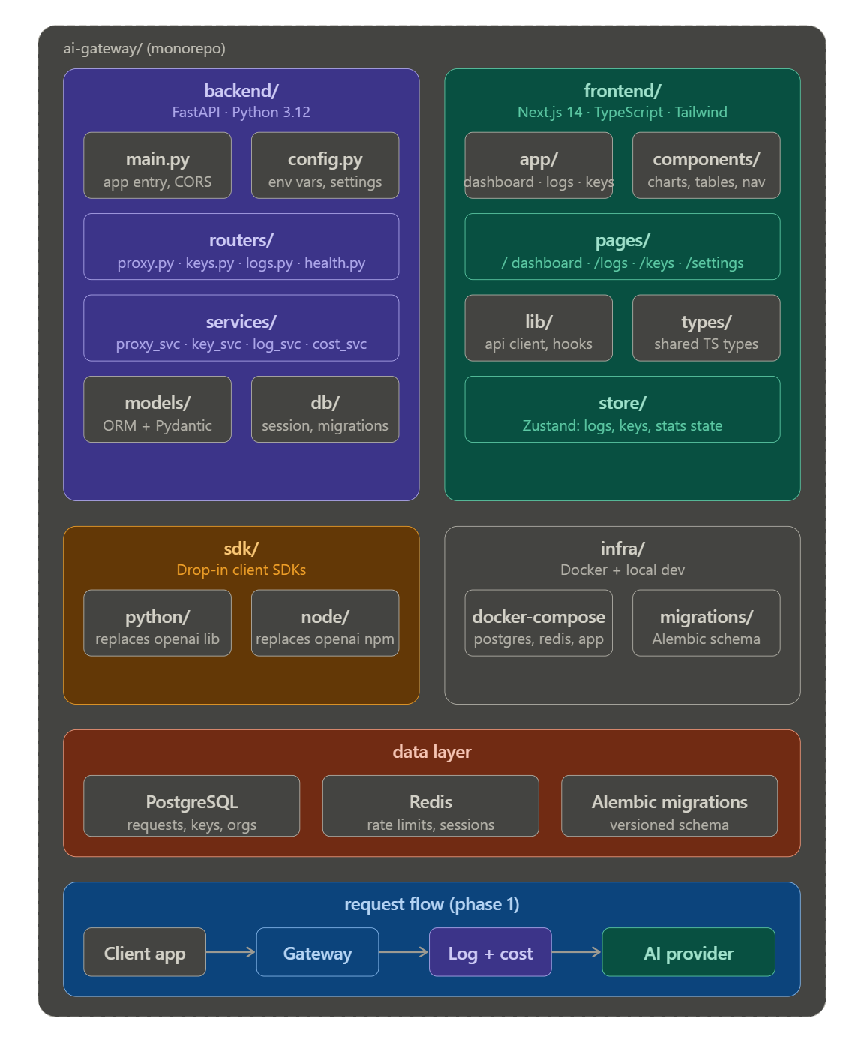

Phase 2( Implemented) –
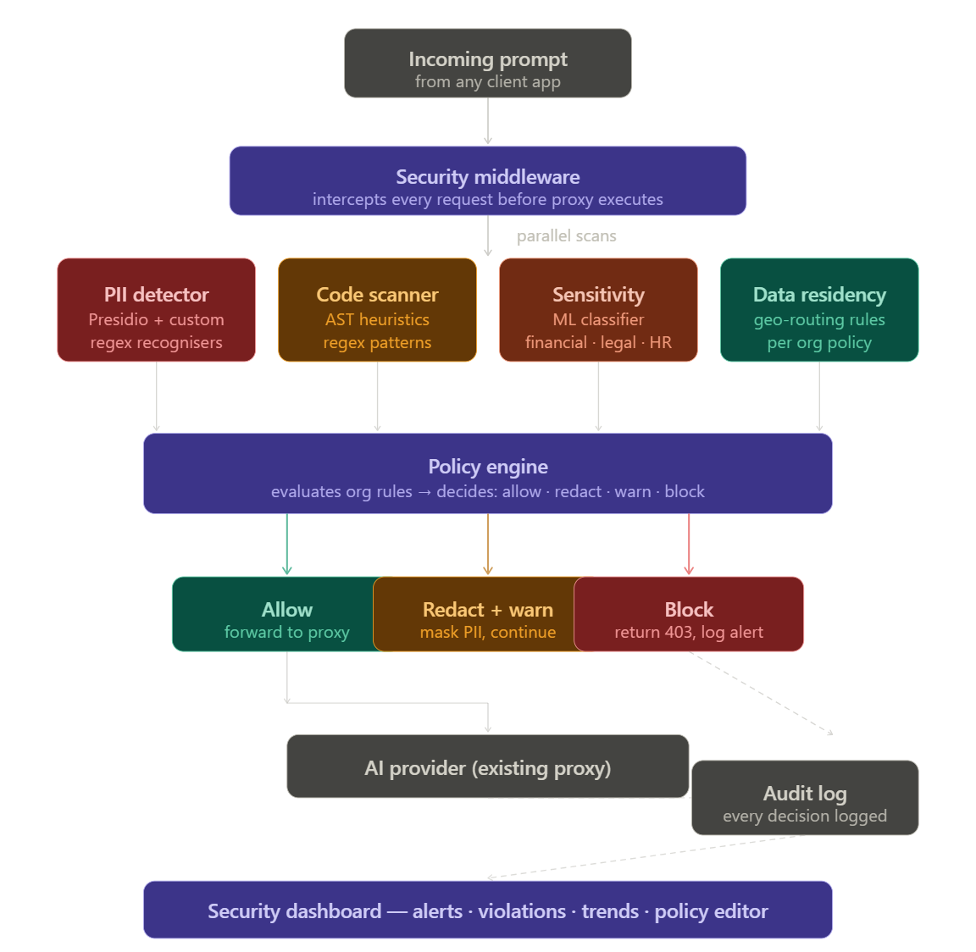

Phase 3( Implemented )

