Figure 14.3.2
Kaplan–Meier Plot of Overall Survival
Full Analysis Set

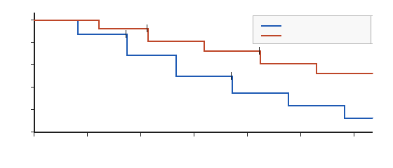
Number at risk
Placebo xx xx xx xx xx xx xx
Drug X 10 mg xx xx xx xx xx xx xx

Censoring is marked with a vertical tick. Landmark rates at 12 and 24 months are xx%.
Source: ADTTE Program: tfl_14_3_2_km.R

