Keep in mind Docker is different from docker swarm

We are using a docker swarm to implement load balancing and application scaling.
We have previously containerized our application with all its dependency.
By default traffic is routed using the ingress routing mesh and internal load balancing to handle the income requests. The load balacing default implementation is a round robin approach using the container DNS records eg,
App1>App2>App3>App1>App2> and so on
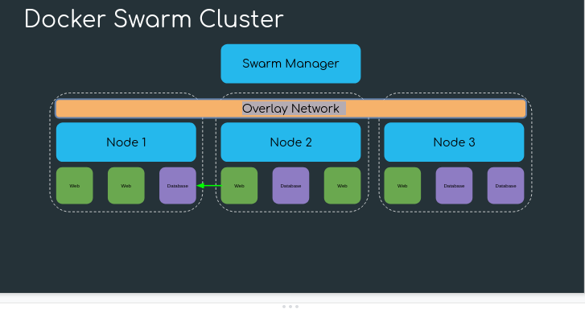

Step1:

This is the Docker Image that we craeted before and kept in the docker hub.
It contain all our resources
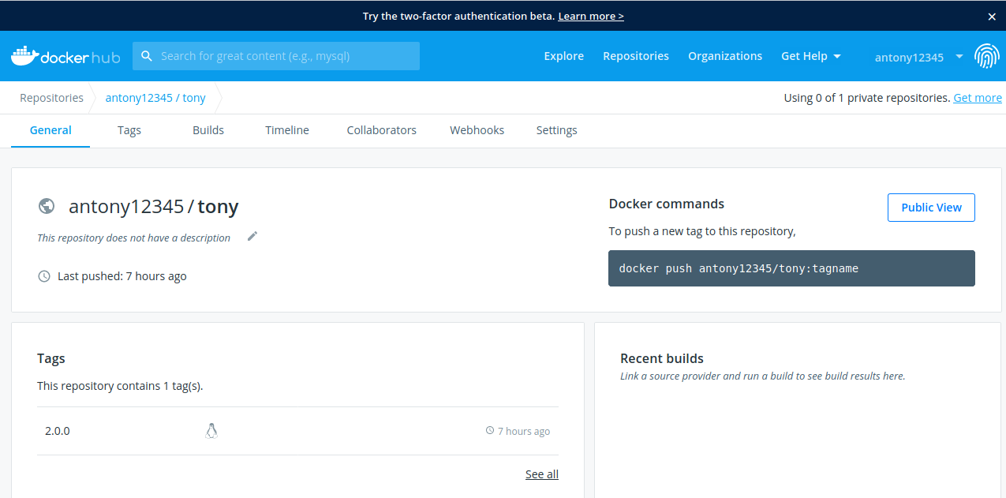

Step 2:
We are going to create a cluster with 1 manager and 2 worker nodes for LB.

CODE:
sudo docker-machine create --driver virtualbox --virtualbox-boot2docker-url https://github.com/boot2docker/boot2docker/releases/download/v18.06.1-ce/boot2docker.iso nodemanager

similarly we do for worker 1 and worker 2
sudo docker-machine create --driver virtualbox --virtualbox-boot2docker-url https://github.com/boot2docker/boot2docker/releases/download/v18.06.1-ce/boot2docker.iso nodeworker1

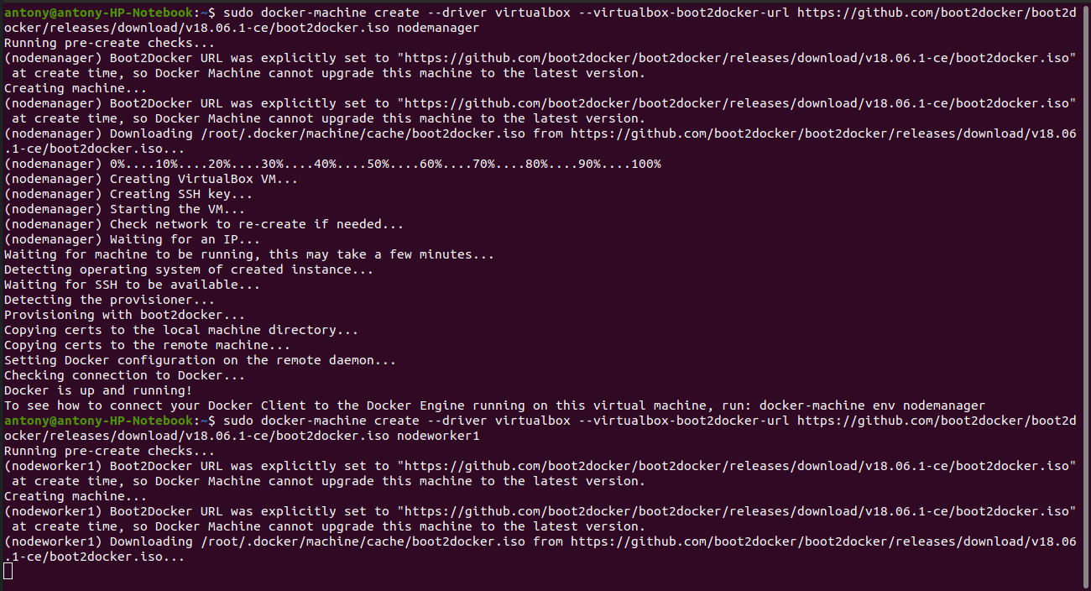

sudo docker-machine create --driver virtualbox --virtualbox-boot2docker-url https://github.com/boot2docker/boot2docker/releases/download/v18.06.1-ce/boot2docker.iso nodeworker2

sudo docker-machine ls

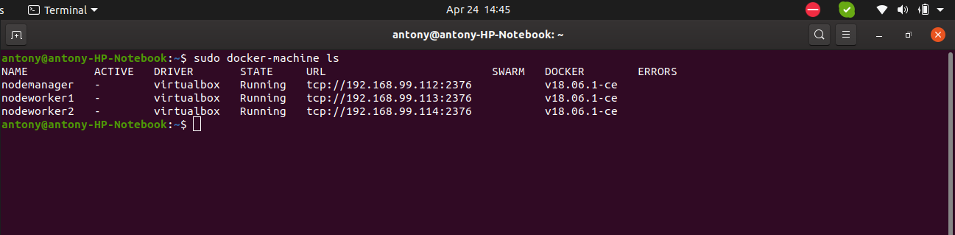

Step 3:

Now we are going to initialize the nodemanager node as the manager node.
sudo docker-machine ip nodemanager

sudo docker-machine ssh nodemanager

sudo docker swarm init --advertise-addr 192.168.99.112

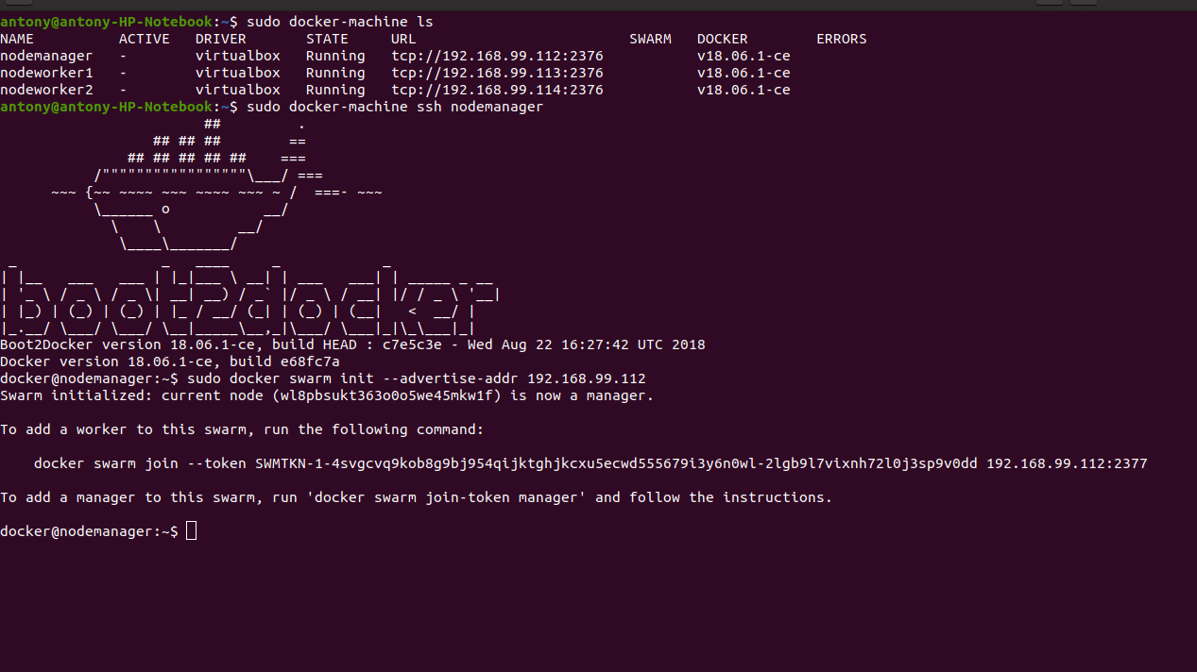

Now it became the leader node

Step 4:
Now we are going to add the nodeworker1 and nodeworker2 we craeted into this leader node nodemanager.

sudo docker-machine ssh nodeworker1

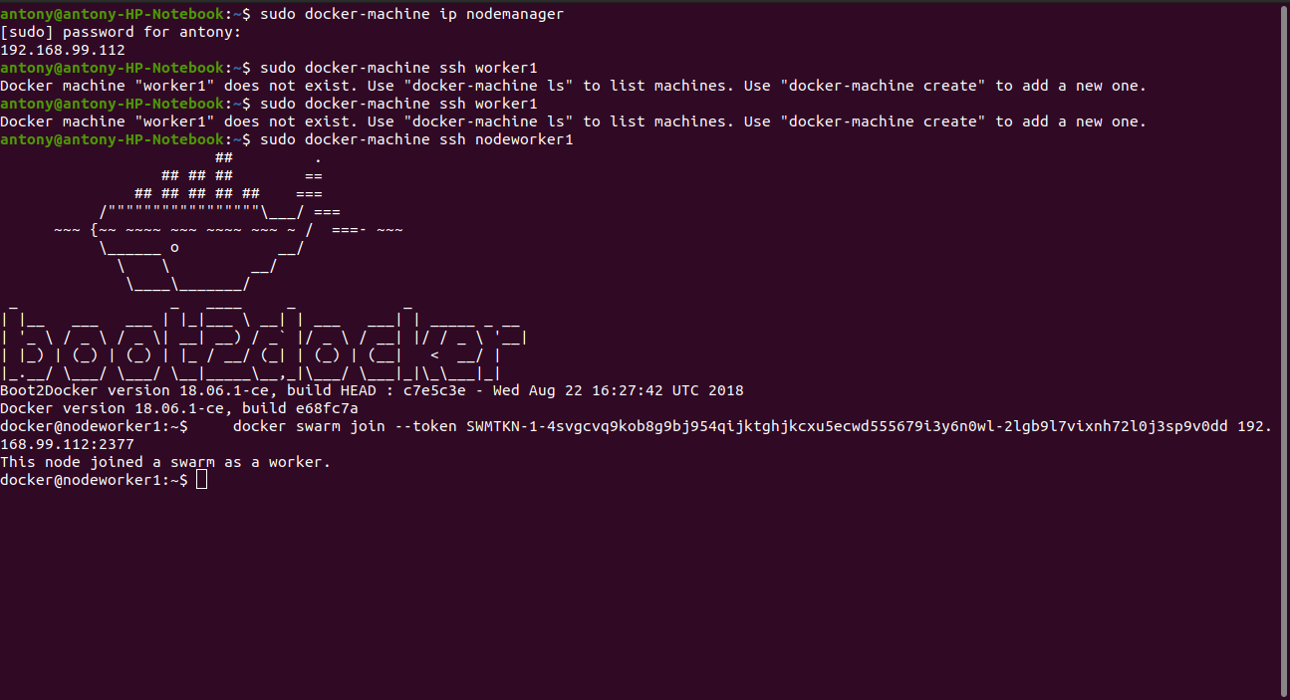
docker swarm join --token SWMTKN-1-4svgcvq9kob8g9bj954qijktghjkcxu5ecwd555679i3y6n0wl-2lgb9l7vixnh72l0j3sp9v0dd 192.168.99.112:2377

Similarly we do for the nodeworker2 too

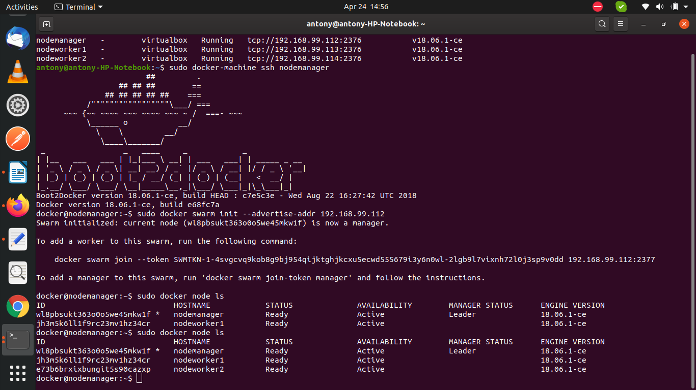

Step 5:
Now we are going to put our image into the sysytem
sudo docker service create --replicas 3 -p 80:80 --name ase antony12345/tony:tagname

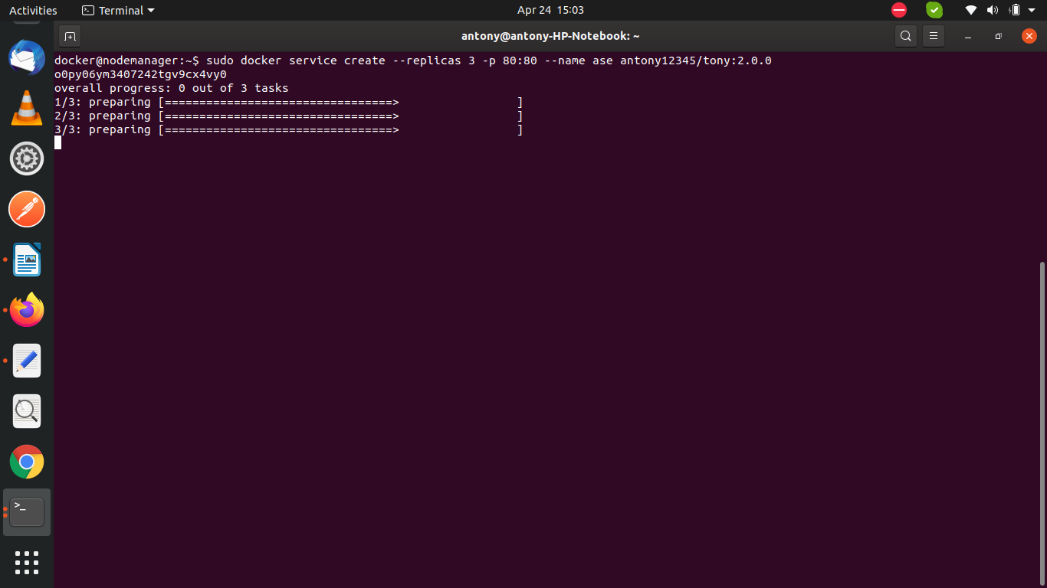
Here we are going to create 3 instances, later we will increse or decrese as we wish

