Assignment :how to install and uninstall using psadt

Name : Lalit Joshi ,Email : [Joshilalit2275@gmail.com](mailto:Joshilalit2275@gmail.com)

Topic 1: PSADT Folder Structure and Its Importance

he **PowerShell App Deployment Toolkit (PSADT)** uses a well-organized folder hierarchy to manage deployment packages and scripts efficiently. This structured approach helps in easy management, customization, and reuse of deployment components, making the application deployment process more streamlined and less error-prone.

**Key Folders:**

* **Toolkit/**: Contains core PSADT module files including scripts, manifests, and language resources; essentially the engine of PSADT.
* **Examples/**: Holds example deployment scripts serving as templates for new deployments.
* **Files/**: Stores the application installation files such as .msi, .exe, or .appx.
* **SupportFiles/**: Contains supporting files like configuration files, certificates, or helper scripts required during deployment.
* **Deploy-Application.ps1**: The main PowerShell script orchestrating the deployment process, customized per application.
* **Deploy-Application.exe**: A wrapper to run the PowerShell script with the correct execution policy.

**Additional Highlights:**

* PSADT supports customization for branding (banners, icons), UI, and scripts.
* Version control (e.g., Git) is recommended to track changes and maintain deployment scripts.
* The modular and flexible structure introduced in PSADT v4 makes managing and customizing deployments easier.

Understanding and using this folder structure effectively allows IT professionals to create, deploy, and manage application deployments with greater ease and consistency.

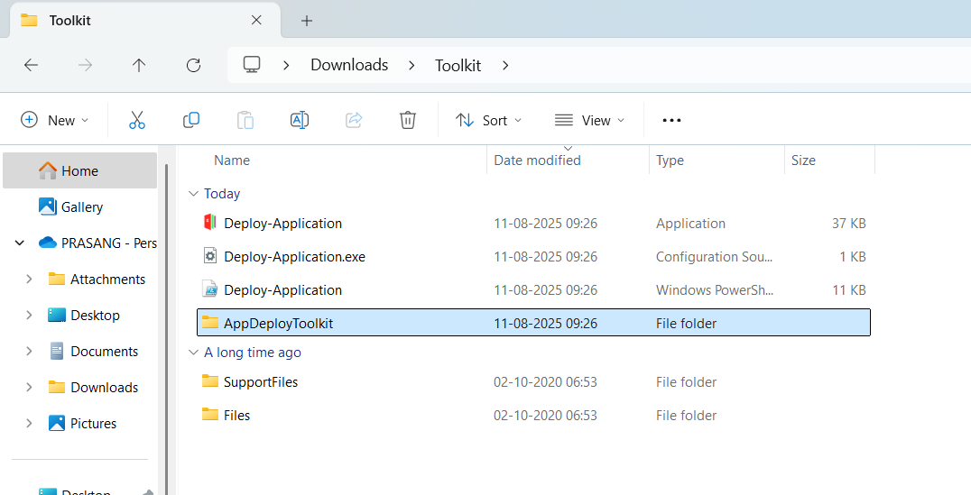

Topic 2:psadt .exe application deployment process

When you download PSADT, you’ll get a folder with:

Deploy-Application.ps1 ← Main script you edit

Deploy-Application.exe ← Wrapper to run the .ps1

Toolkit\ ← PSADT core functions

Files\ ← Place for your application installers

AppDeployToolkitConfig.xml

AppDeployToolkitMain.ps1

For deploying an .exe app, you’ll mainly work with:

* \**Files\** → put your .exe installer here.
* **Deploy-Application.ps1** → edit this to install/uninstall.

**2. Place Your .exe Installer**

Example:

CopyEdit

.\Files\7z2501-x64.exe

This keeps things organized and lets PSADT find the installer easily.

**3. Edit Deploy-Application.ps1**

Inside the script, find the **##*============================[ INSTALLATION ]============================*##** section and add:

powershell

CopyEdit

##*============================[ INSTALLATION ]============================*##

# Install 7-Zip silently

Show-InstallationWelcome -CloseApps '7zFM' -AllowDefer

Show-InstallationProgress -StatusMessage 'Installing 7-Zip, please wait...'

Execute-Process -Path "$dirFiles\7z2501-x64.exe" -Parameters "/S"

Show-InstallationPrompt -Message 'Installation complete!' -ButtonRightText 'OK'

For uninstall, in the **##*============================[ UNINSTALLATION ]============================*##** section:

powershell

CopyEdit

##*============================[ UNINSTALLATION ]============================*##

# Example uninstall (if your exe supports /uninstall or /S)

Execute-Process -Path "$dirFiles\7z2501-x64.exe" -Parameters "/S" # or actual uninstall command

**4. Run the Deployment**

You have **two ways**:

* **PowerShell directly:**

powershell

CopyEdit

.\Deploy-Application.ps1 -DeploymentType Install

