**Programs Part B Term Work**

1. Create a visual studio test project to demonstrate Automating Testing with Visual Studio.
2. User Master Page and Design pages with ASP.NET controls, Styling sites with ASP.NET themes:
3. 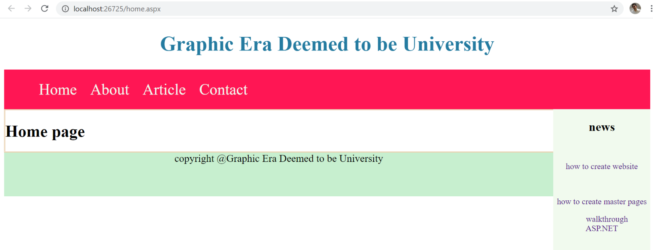**Single Master Page**
4. **Multiple Master Page**

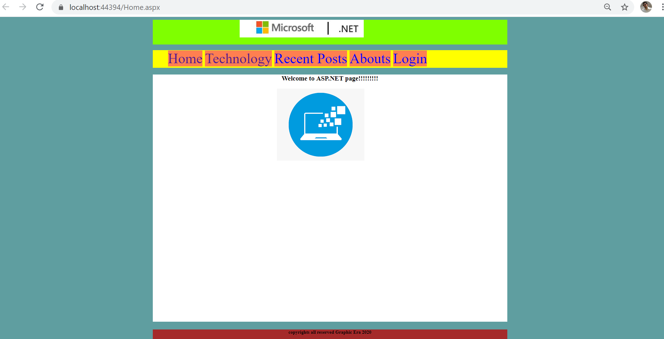

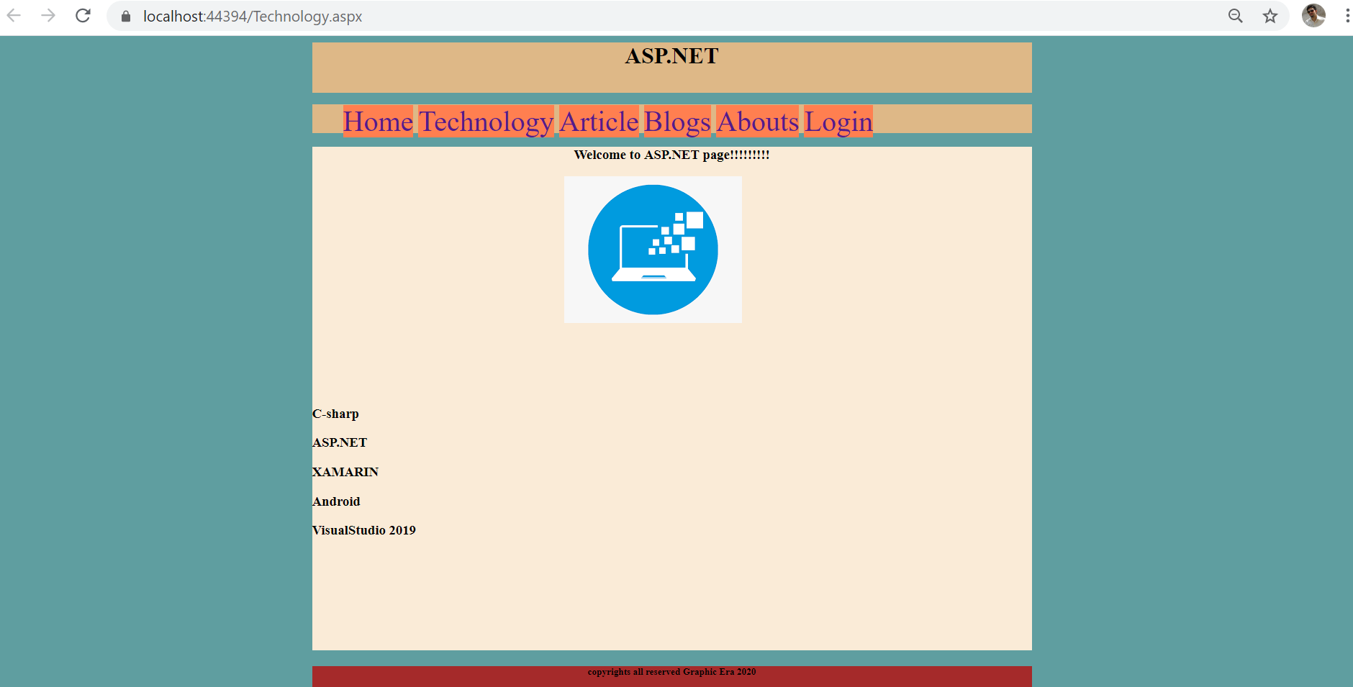

1. Create a registration form and show the working of all the validation controls used in it.
2. Demonstrate how to render user control in web form.