Name | Atul sharma
UID no. | 2021700060
Experiment No. | 5

AIM: | Implementation of Matrix Chain Multiplication
Program 1
PROBLEM STATEMENT : | Implementation of Matrix Chain Multiplication
ALGORITHM/  THEORY: | 1. n length[p]-1  2. for i ← 1 to n  3. do m [i, i] ← 0  4. for l ← 2 to n // l is the chain length  5. do for i ← 1 to n-l + 1  6. do j ← i+ l -1  7. m[i,j] ← ∞  8. for k ← i to j-1  9. do q ← m [i, k] + m [k + 1, j] + p_{i-1} p_{k} p_{j}  10. If q < m [i,j]  11. then m [i,j] ← q  12. s [i,j] ← k  13. return m and s.
PROGRAM: | #include <stdio.h>  #include<stdlib.h>  Bracketing(int* N, int a, int b, int n){  int m=*(N+a*n+b);  if(m-a<=1 && b-m-1>1){  if(m-a==0){  printf("M%d*(",a+1);  Bracketing(N,m+1,b,n);  printf(")");  }  else if(m-a==1){  printf("(M%d*M%d)(",a+1,m+1);  Bracketing(N,m+1,b,n);  printf(")");  }  }  else if(m-a>1 && b-m-1<=1){  if(b-m-1==0){  printf("(");  Bracketing(N,a,m,n);  printf(")*M%d",b+1);  }  else if(b-m-1==1){  printf("(",a,m);  Bracketing(N,a,m,n);  printf(")(M%d*M%d)",m+2,b+1);  }  }  else if(m-a<=1 && b-m-1<=1){  if(m-a==1 && b-m-1==0)  printf("(M%d*M%d)*M%d",a+1,m+1,m+2);  else if(m-a==0 && b-m-1==1)  printf("M%d*(M%d*M%d)",a+1,m+2,b+1);  else if(m-a==1 && b-m-1==1)  printf("(M%d*M%d)(M%d*M%d)",a+1,m+1,m+2,b+1);  }  else{  printf("(");  Bracketing(N,a,m,n);  printf(")(");  Bracketing(N,m+1,b,n);  printf(")");  }  }  Chain(int* A, int* M, int *N, int m, int n){  int i,l;  for(i=0;i<m;i++){  printf("\n }\n\nM[%d,%d]= min of\n {\n M[%d,%d] + M[%d,%d] + (d%d*d%d*d%d) = ",i+1,n-m+i+1,i+1,i+1,i+2,n-m+i+1,i+1,i+2,n-m+i+2);  printf("%d + %d + (%d*%d*%d) = ",*(M+i*n+i),*(M+(i+1)*n+n-m+i),*(A+i),*(A+i+1),*(A+n-m+i+1));  *(M+n*i+n-m+i)=*(M+i*n+i)+*(M+(i+1)*n+n-m+i)+(*(A+i))*(*(A+i+1))*(*(A+n-m+i+1));  *(N+n*i+n-m+i)=i;  printf("%d",*(M+n*i+n-m+i));  for(l=i+1;l<=n-m+i-1;l++){  if(*(M+n*i+n-m+i)>(*(M+i*n+l)+*(M+(l+1)*n+n-m+i)+(*(A+i))*(*(A+l+1))*(*(A+n-m+i+1)))){  printf("\n M[%d,%d] + M[%d,%d] + (d%d*d%d*d%d) = ",i+1,l+1,l+2,n-m+i+1,i+1,l+2,n-m+i+2);  printf("%d + %d + (%d*%d*%d) = ",*(M+i*n+l),*(M+(l+1)*n+n-m+i),*(A+i),*(A+l+1),*(A+n-m+i+1));  *(M+n*i+n-m+i)=(*(M+i*n+l)+*(M+(l+1)*n+n-m+i)+(*(A+i))*(*(A+l+1))*(*(A+n-m+i+1)));  *(N+n*i+n-m+i)=l;  printf("%d",*(M+n*i+n-m+i));  }  else{  printf("\n M[%d,%d] + M[%d,%d] + (d%d*d%d*d%d) = ",i+1,l+1,l+2,n-m+i+1,i+1,l+2,n-m+i+2);  printf("%d + %d + (%d*%d*%d) = %d",*(M+i*n+l),*(M+(l+1)*n+n-m+i),*(A+i),*(A+l+1),*(A+n-m+i+1),(*(M+i*n+l)+*(M+(l+1)*n+n-m+i)+(*(A+i))*(*(A+l+1))*(*(A+n-m+i+1))));  }  }  }  if(m>=2)  Chain(A,M,N,m-1,n);  }  main()  {  int i,j,k,l,n;  printf("Please enter the total number of matrix dimension sequence, you wanna multiply:");  scanf("%d",&n);  printf("\nNow enter all the order of matrices maintaining a proper sequence:");  int A[n],M[n-1][n-1],N[n-1][n-1];  for(i=0;i<n;i++)  {  // scanf("%d",&A[i]);  A[i] = (rand() % (46 - 15 + 1) + 15);  }  for(i=0;i<n-1;i++)  for(j=0;j<n-1;j++){  M[i][j]=0;  N[i][j]=0;  }  Chain(A,M,N,n-2,n-1);  printf("\n }\n\nThe matrix having minimum number of multiplication is:\n");  for(i=0;i<n-1;i++){  printf("\n\n");  for(j=0;j<n-1;j++){  if(i>j)  printf("\t-");  else  printf("\t%d",M[i][j]);  }  }  printf("\n\nSo the minimum number of multiplication required is: %d.",M[0][n-2]);  printf("\n\nThe parenthesization would be like:\t");  Bracketing(N,0,n-2,n-1);  printf("\n\n\n");  }
RESULT:
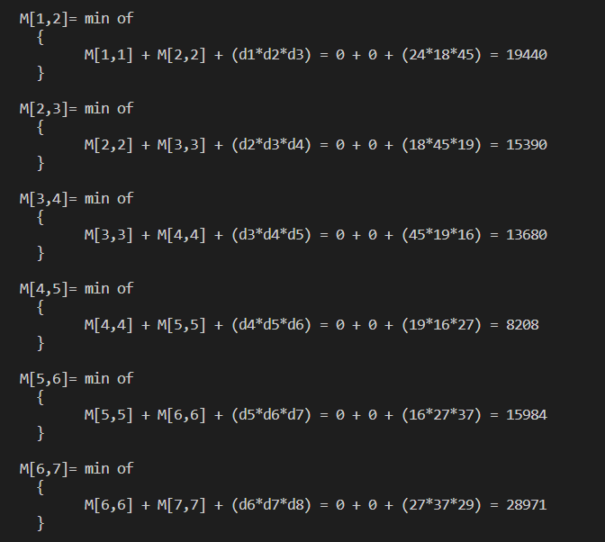

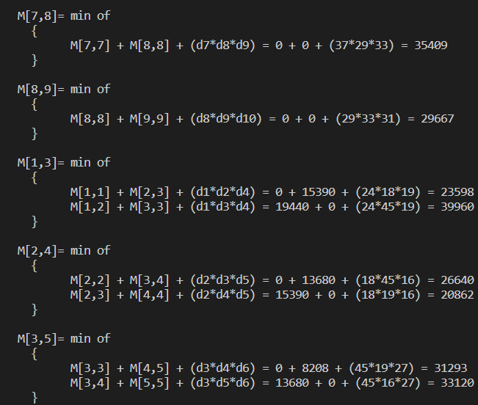

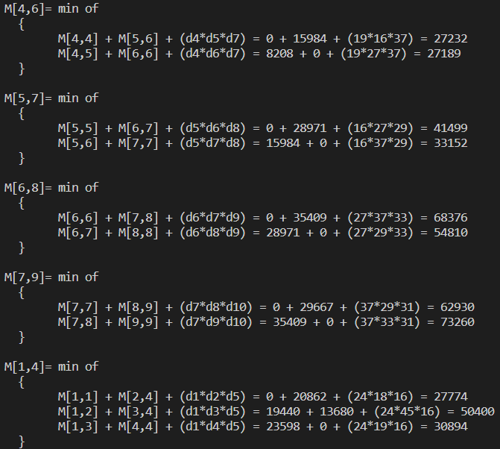

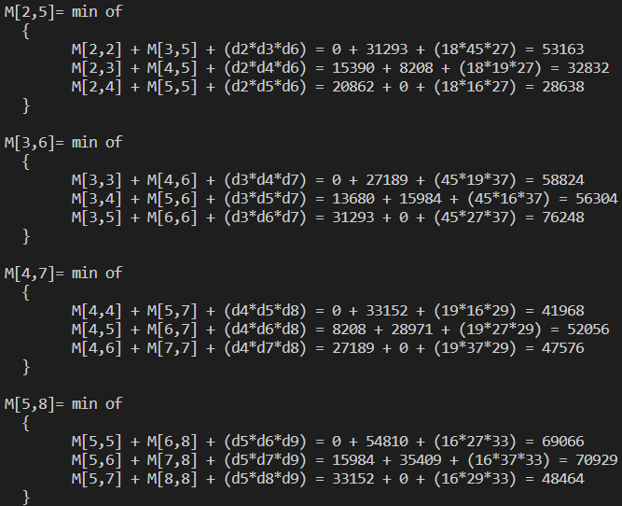

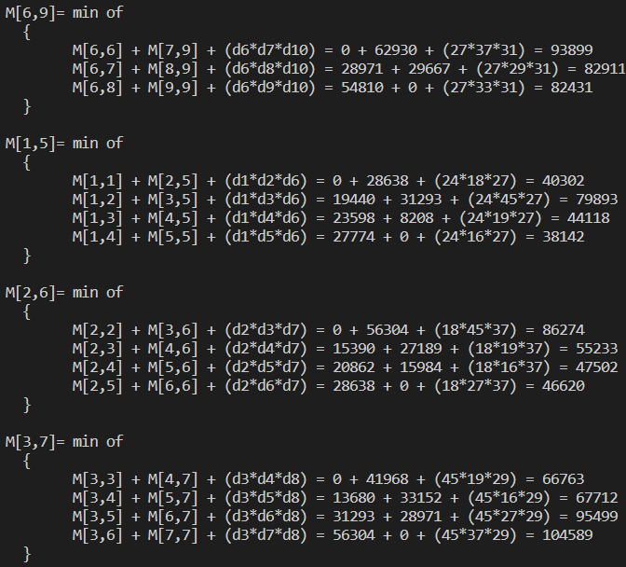
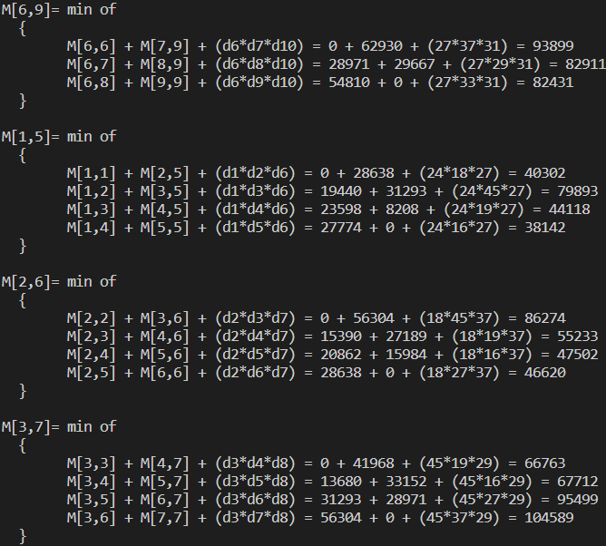

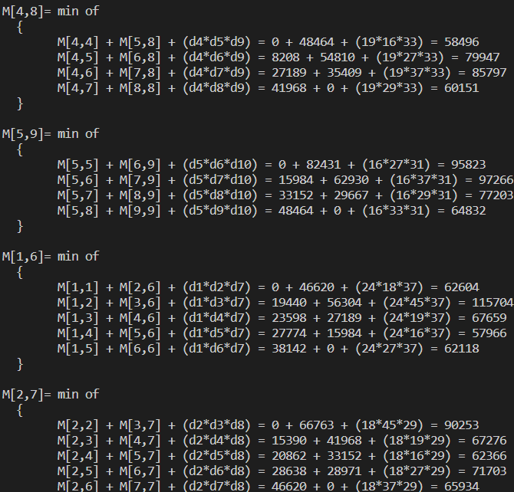

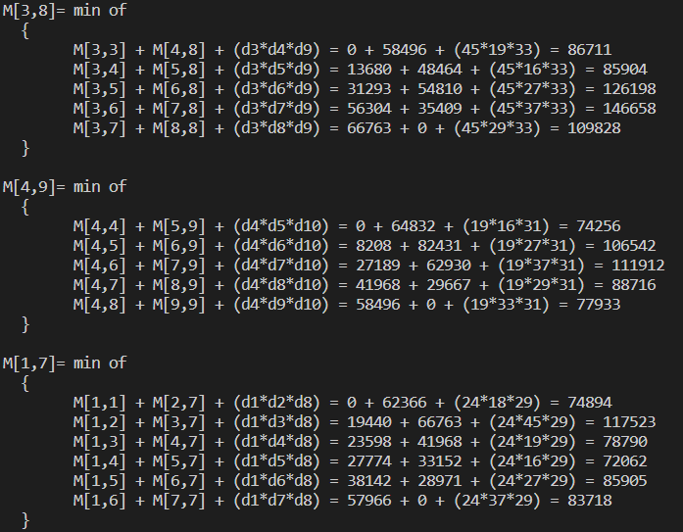

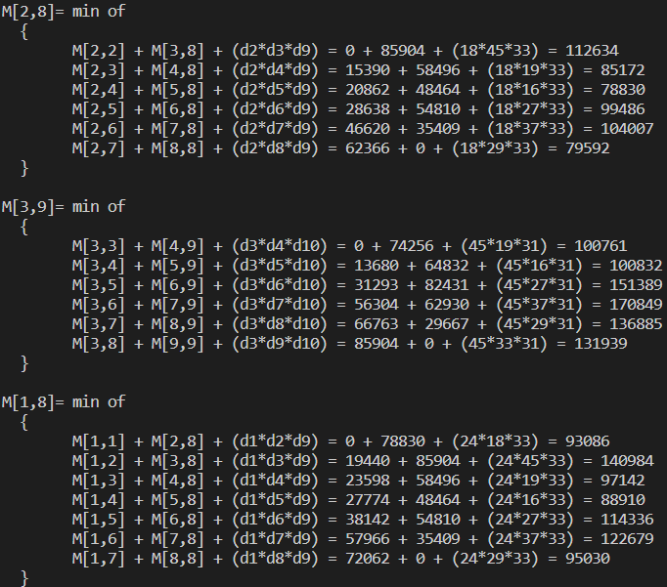

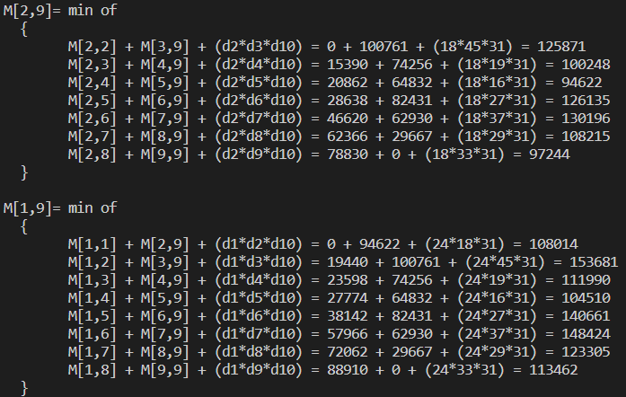

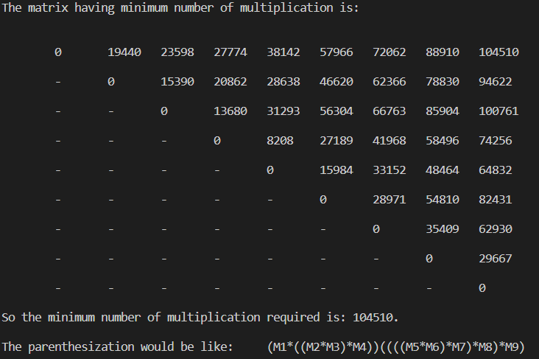

CONCLUSION: | Implemented and Learned the Matrix Chain Multiplication Algorithm.

