Name | Attul Sharma
UID no. | 20201700060
Experiment No. | 3

AIM: | Strassen’s Matrix Multiplication
Program 1
PROBLEM STATEMENT : | Given two square matrices A and B of size n x n each, find their multiplication matrix.
ALGORITHM/  THEORY: | Divide and Conquer :  Following is simple Divide and Conquer method to multiply two square matrices.  - Divide matrices A and B in 4 sub-matrices of size N/2 x N/2 as shown in the below diagram.  - Calculate following values recursively. ae + bg, af + bh, ce + dg and cf + dh.  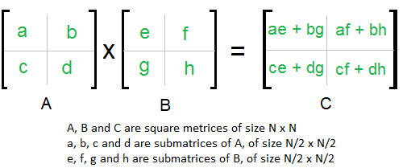
PROGRAM: | #include<stdio.h>  int main(){  int a[2][2],b[2][2],c[2][2];  int p1,p2,p3,p4,p5,p6,p7;  printf(" enter four elements of first matrix: ");  for(int i=0;i<2;i++)  for(int j=0;j<2;j++)  scanf("%d",&a[i][j]);  printf("enter the four elements of second matrix: ");  for( int i=0;i<2;i++)  for(int j=0;j<2;j++)  scanf("%d",&b[i][j]);  printf("\nThe first matrix is\n");  for(int i=0;i<2;i++){  printf("\n");  for(int j=0;j<2;j++)  printf("%d\t",a[i][j]);  }  printf("\nThe second matrix is\n");  for(int i=0;i<2;i++){  printf("\n");  for(int j=0;j<2;j++)  printf("%d\t",b[i][j]);  }  p1= (a[0][0] + a[1][1])*(b[0][0]+b[1][1]);  p2= (a[1][0]+a[1][1])*b[0][0];  p3= a[0][0]*(b[0][1]-b[1][1]);  p4= a[1][1]*(b[1][0]-b[0][0]);  p5= (a[0][0]+a[0][1])*b[1][1];  p6= (a[1][0]-a[0][0])*(b[0][0]+b[0][1]);  p7= (a[0][1]-a[1][1])*(b[1][0]+b[1][1]);  c[0][0]=p1+p4-p5+p7;  c[0][1]=p3+p5;  c[1][0]=p2+p4;  c[1][1]=p1-p2+p3+p6;  printf("\nAfter multiplication using \n");  for(int i=0;i<2;i++){  printf("\n");  for(int j=0;j<2;j++)  printf("%d\t",c[i][j]);  }  return 0;  }
RESULT:
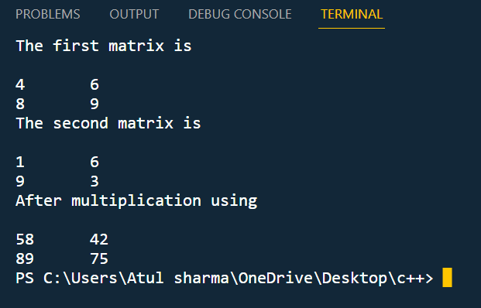
CONCLUSION: | I understand the concept of strassen matrix .

