Name: Atul Kumar
Email: atulk@usc.edu
USC ID: 3200 8001 08

Answer to Analysis Question 1:

Size of the stored file = 512 * 512 * 3 = 786432 bytes

File Size after quantization to 6 bits per channel:

In YUV 4:1:1 color space:
For every 4 pixels we have 4 samples of luminance and 1 sample each of chrominance with 6 bits per sample.
So we have 4*6 + 6 + 6 = 36 bits per 4 pixels.
On average we have 36/4 = 9 bits per pixel.
So, the size of the stored file = 512 * 512 * 9 bits = 294912 bytes

In YUV 4:2:2 color space:
For every 4 pixels we have 4 samples of luminance and 2 sample each of chrominance with 6 bits per sample.
So we have 4*6 + 2*6 + 2*6 = 48 bits per 4 pixels.
On average we have 48/4 = 12 bits per pixel.
So, the size of the stored file = 512 * 512 * 12 bits = 393216 bytes

Answer to Analysis Question 2:

Rotation and sub sampling are not commutative. Please see the example images below.

The aliasing caused by rotation is not same as caused by sub sampling. Rotation some times overwrite some of the pixels and some time leave blank some of the pixels. It happen because pixel are in integer co-ordinates and we calculate coordinates after rotation in floating point and convert them back into integer. But in sub sampling we remove every nth pixel uniformly. So the two operations are not commutative.

Even with our anti aliasing scheme we can’t make them commutative.

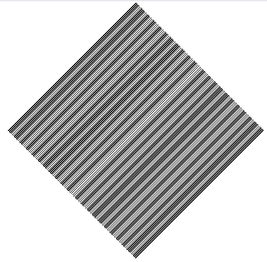
Image first sub sampled by 2 and then rotated by 45 degree with anti-aliasing turned off.

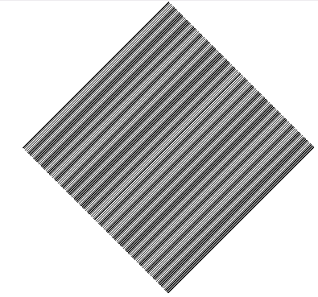
Image first rotated by 45 degree and then sub sampled by 2 with anti-aliasing turned off.

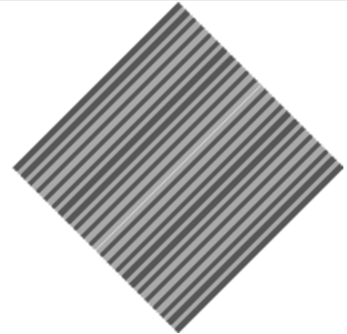
Image first sub sampled by 2 and then rotated by 45 degree with anti-aliasing turned on.

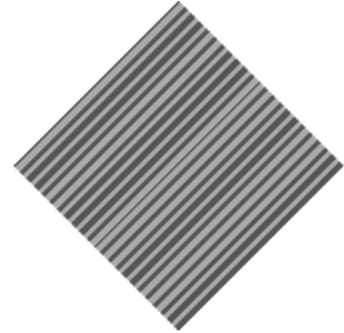
Image first rotated by 45 degree and then sub sampled by 2 with anti-aliasing turned on.

