|  |
| --- |
| **Experiment Title:**  Write a sample application to demonstrate AJAX |

# Objective: To learn and implement ASP AJAX

# Theory:

# ASP AJAX

AJAX is about updating parts of a web page, without reloading the whole page.

## **What is AJAX?**

AJAX = Asynchronous JavaScript and XML.AJAX is a technique for creating fast and dynamic web pages.

AJAX allows web pages to be updated asynchronously by exchanging small amounts of data with the server behind the scenes. This means that it is possible to update parts of a web page, without reloading the whole page.Classic web pages, (which do not use AJAX) must reload the entire page if the content should change.Examples of applications using AJAX: Google Maps, Gmail, Youtube, and Facebook tabs.

## **How AJAX Works**

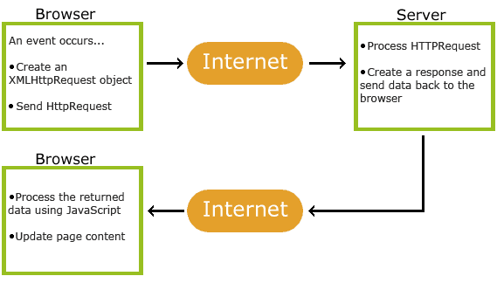

## AJAX is Based on Internet Standards.AJAX is based on internet standards, and uses a combination of:

* XMLHttpRequest object (to exchange data asynchronously with a server)
* JavaScript/DOM (to display/interact with the information)
* CSS (to style the data)
* XML (often used as the format for transferring data)

AJAX applications are browser- and platform-independent!

## The ASP File - "gethint.asp"

The ASP file checks an array of names, and returns the corresponding name(s) to the browser:

<%  
response.expires=-1  
dim a(30)  
'Fill up array with names  
a(1)="Anna"  
a(2)="Brittany"  
a(3)="Cinderella"  
a(4)="Diana"  
a(5)="Eva"  
a(6)="Fiona"  
a(7)="Gunda"  
a(8)="Hege"  
a(9)="Inga"  
a(10)="Johanna"  
a(11)="Kitty"  
a(12)="Linda"  
a(13)="Nina"  
a(14)="Ophelia"  
a(15)="Petunia"  
a(16)="Amanda"  
a(17)="Raquel"  
a(18)="Cindy"  
a(19)="Doris"  
a(20)="Eve"  
a(21)="Evita"  
a(22)="Sunniva"  
a(23)="Tove"  
a(24)="Unni"  
a(25)="Violet"  
a(26)="Liza"  
a(27)="Elizabeth"  
a(28)="Ellen"  
a(29)="Wenche"  
a(30)="Vicky"  
  
'get the q parameter from URL  
q=ucase(request.querystring("q"))  
  
'lookup all hints from array if length of q>0  
if len(q)>0 then  
  hint=""  
  for i=1 to 30  
    if q=ucase(mid(a(i),1,len(q))) then  
      if hint="" then  
        hint=a(i)  
      else  
        hint=hint & " , " & a(i)  
      end if  
    end if  
  next  
end if  
  
'Output "no suggestion" if no hint were found  
'or output the correct values  
if hint="" then  
  response.write("no suggestion")  
else  
  response.write(hint)  
end if  
%>

# Procedure :

Write web application implementing above codes.

# Conclusion: