**Experiment Title:** Form validation using PHP using regular expressions

# Objective:

To learn and implement Form validation using PHP using regular expressions

# Theory & Procedure :

## **What is Validation ?**

Validation means check the input submitted by the user. There are two types of validation are available in PHP. They are as follows −

* Client-Side Validation − Validation is performed on the client machine web browsers.
* Server Side Validation − After submitted by data, The data has sent to a server and perform validation checks in server machine.

## Some of Validation rules for field

|  |  |
| --- | --- |
| Field | Validation Rules |
| Name | Should required letters and white-spaces |
| Email | Should required @ and . |
| Website | Should required a valid URL |
| Radio | Must be selectable at least once |
| Check Box | Must be checkable at least once |
| Drop Down menu | Must be selectable at least once |

## **Valid URL**

Below code shows validation of URL

$website = input($_POST["site"]);

if (!preg_match("/\b(?:(?:https?|ftp):\/\/|www\.)[-a-z0-9+&@#\/%?=~_|!:,.;]*[-a-z0-9+&@#\/%=~_|]/i",$website)) {

$websiteErr = "Invalid URL";

}

Above syntax will verify whether a given URL is valid or not. It should allow some keywords as https, ftp, www, a-z, 0-9,..etc..

## **Valid Email**

Below code shows validation of Email address

$email = input($_POST["email"]);

if (!filter_var($email, FILTER_VALIDATE_EMAIL)) {

$emailErr = "Invalid format and please re-enter valid email";

}

Above syntax will verify whether given Email address is well-formed or not.if it is not, it will show an error message.

### **Example**

Example below shows the form with required field validation

<html>

<head>

<style>

.error {color: #FF0000;}

</style>

</head>

<body>

<?php

// define variables and set to empty values

$nameErr = $emailErr = $genderErr = $websiteErr = "";

$name = $email = $gender = $comment = $website = "";

if ($_SERVER["REQUEST_METHOD"] == "POST") {

if (empty($_POST["name"])) {

$nameErr = "Name is required";

}else {

$name = test_input($_POST["name"]);

}

if (empty($_POST["email"])) {

$emailErr = "Email is required";

}else {

$email = test_input($_POST["email"]);

// check if e-mail address is well-formed

if (!filter_var($email, FILTER_VALIDATE_EMAIL)) {

$emailErr = "Invalid email format";

}

}

if (empty($_POST["website"])) {

$website = "";

}else {

$website = test_input($_POST["website"]);

}

if (empty($_POST["comment"])) {

$comment = "";

}else {

$comment = test_input($_POST["comment"]);

}

if (empty($_POST["gender"])) {

$genderErr = "Gender is required";

}else {

$gender = test_input($_POST["gender"]);

}

}

function test_input($data) {

$data = trim($data);

$data = stripslashes($data);

$data = htmlspecialchars($data);

return $data;

}

?>

<h2>Absolute classes registration</h2>

<p><span class = "error">* required field.</span></p>

<form method = "post" action = "<?php

echo htmlspecialchars($_SERVER["PHP_SELF"]);?>">

<table>

<tr>

<td>Name:</td>

<td><input type = "text" name = "name">

<span class = "error">* <?php echo $nameErr;?></span>

</td>

</tr>

<tr>

<td>E-mail: </td>

<td><input type = "text" name = "email">

<span class = "error">* <?php echo $emailErr;?></span>

</td>

</tr>

<tr>

<td>Time:</td>

<td> <input type = "text" name = "website">

<span class = "error"><?php echo $websiteErr;?></span>

</td>

</tr>

<tr>

<td>Classes:</td>

<td> <textarea name = "comment" rows = "5" cols = "40"></textarea></td>

</tr>

<tr>

<td>Gender:</td>

<td>

<input type = "radio" name = "gender" value = "female">Female

<input type = "radio" name = "gender" value = "male">Male

<span class = "error">* <?php echo $genderErr;?></span>

</td>

</tr>

<td>

<input type = "submit" name = "submit" value = "Submit">

</td>

</table>

</form>

<?php

echo "<h2>Your given values are as:</h2>";

echo $name;

echo "<br>";

echo $email;

echo "<br>";

echo $website;

echo "<br>";

echo $comment;

echo "<br>";

echo $gender;

?>

</body>

</html>

It will produce the following result −

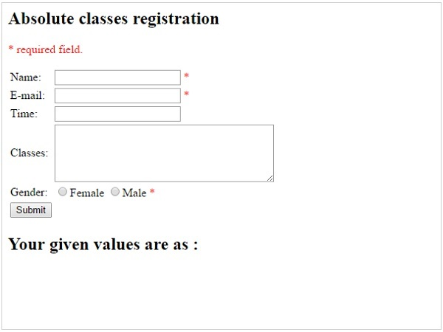

# Conclusion: