National College of Computer Studies Tribhuvan University

**IOST**



**Project Report On**

**“Curefy”**

**Submitted To:**

### National College of Computer Studies Department of Bachelor of Science in Computer Science and Information Technology (BSc.CSIT)

### Paknajol, Kathmandu

**In partial fulfillment of the requirement for the degree of Bachelor of Science in Computer Science and Information Technology (BSc. CSIT)**

**Submitted By:** Atullya Maharjan CSIT 5th Semester Roll No: 5

### Sec: B

# Abstract

Curefy is an innovative platform designed to revolutionize the way users interact with healthcare services. Unlike traditional methods where booking appointments and accessing hospital information requires physical visits or phone calls, Curefy leverages modern technology to provide a seamless online experience. This not only eliminates the need for in-person visits but also enhances convenience and accessibility for users.

The primary objective of Curefy is to offer a user-friendly and efficient platform where patients can easily book appointments with doctors, explore health packages, and access detailed hospital information. The development of Curefy highlights the potential of digital solutions in transforming healthcare interactions and improving overall user satisfaction.

One of the standout features of Curefy is its real-time appointment booking system, which allows users to schedule consultations with doctors quickly and effortlessly. This instant booking capability, combined with detailed information on available health packages, makes Curefy a comprehensive solution for managing healthcare needs online.

In summary, Curefy successfully meets its goal of delivering a simple, efficient, and user-centered platform, significantly enhancing the healthcare experience for users.

# Acknowledgement

I am sincerely grateful to **NCCS College** for providing me with the resources and support to undertake this project. I extend my heartfelt thanks to **Mr.Aashish Chapagain**, our esteemed lecturer for their invaluable guidance and expertise. Their continuous support has shaped the direction and quality of our work.

I also want to express my appreciation to my family, friends, and all the participants for their unwavering encouragement and contributions, which have been a constant source of motivation throughout this endeavor.

In conclusion, I am deeply thankful to NCCS College, Mr.Aashish Chapagain, and everyone involved for making this project a reality. Your support has been instrumental in its success.

Thanking You, Atullya Maharjan

CSIT 5th SEM (11th Batch)

**Table of Contents**

Abstract ii

Acknowledgement iii

Chapter 1: Introduction 1

1.1 Introduction to the project 1

1.2 Problem Statement 1

1.3 Objectives 2

1.4 Scope of Work 2

Chapter 2: User Research 3

2.1 Methodologies 3

2.2 Key Insights and Findings 4

2.3. Empathy Map 5

Chapter 3: User Persona 6

Chapter 4: Wireframes and Prototypes 7

4.1 Design Process: 7

4.2 Key Wireframes and Prototype Images: 7

Chapter 5: Usability Testing 10

Chapter 6: Final Product 11

Chapter 7: Learning 16

References 17

# Chapter 1: Introduction

## Introduction to the project

Curefy is a healthcare platform designed to make it easier for users to find hospital information, book appointments with doctors, and explore health packages. With a secure login system for patients and doctors, Curefy provides a simple and user-friendly experience, helping users manage their healthcare needs efficiently.

In addition to appointment booking, Curefy offers detailed profiles of healthcare professionals and hospitals, allowing users to make informed decisions about their healthcare options. The platform is designed with a focus on accessibility and convenience, ensuring that users can easily navigate through the services offered.

Curefy also integrates personalized health package recommendations, tailored to individual needs, helping users select the most suitable options for their health. The platform’s intuitive design ensures that even those with minimal tech experience can seamlessly manage their healthcare activities online.

Overall, Curefy is a comprehensive solution aimed at simplifying healthcare management, making it more accessible and user-centered for patients and healthcare providers alike.

## Problem Statement

People often face difficulties in finding accurate hospital information and booking appointments with doctors. The process can be confusing, time-consuming, and frustrating, especially when dealing with multiple healthcare providers. Long wait times, lack of transparency in available health services, and difficulty in comparing options are common issues that patients encounter.

Additionally, managing multiple healthcare needs, such as finding the right specialist, understanding available health packages, and securing timely appointments, can be overwhelming. Curefy was created to address these challenges by offering a straightforward platform where users can easily access hospital details, book appointments, and explore health packages, all in one place.

## Objectives

* To simplify the process of finding accurate hospital information and booking doctor appointments by providing an all-in-one online platform.
* To offer a user-friendly interface that allows patients and doctors to easily manage appointments, access health packages, and navigate healthcare services.
* To ensure the security and privacy of patient and doctor data by implementing robust access controls and encryption methods.
* To enhance user experience by providing instant confirmations and notifications for appointments and health package bookings.
* To provide detailed and up-to-date profiles of healthcare professionals and facilities, enabling users to make informed healthcare decisions.

## Scope of Work

The scope of Curefy includes:

* Designing a user-friendly interface.
* Providing access to hospital details.
* Implementing an easy appointment booking system.
* Offering various health packages.

# Chapter 2: User Research

## Methodologies

User research was conducted to understand the needs, preferences, and pain points of potential users for the Curefy platform. The research included:

* **Surveys and Questionnaires**: Used to gather broad, quantitative data about user preferences and expectations for a healthcare platform.
* **Interviews**: Conducted with patients and healthcare professionals to gain deeper insights into their requirements and challenges.
* **Competitor Analysis**: Reviewed similar healthcare platforms like HamroDoctor to see what they do well and where they could improve. The results are shown in a Google Sheet and helped guide the design of the Curefy platform.

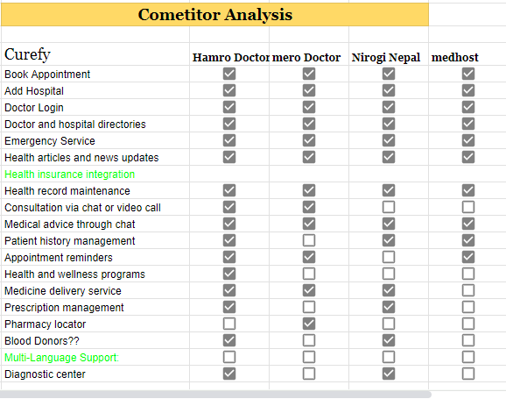

## Key Insights and Findings

* **User Preferences:** Surveys revealed that users prefer a streamlined, user-friendly interface for booking appointments and accessing hospital information. They value clear, detailed profiles of healthcare providers and easy navigation.
* **Challenges Identified:** Interviews with users highlighted difficulties in finding accurate hospital information and managing multiple healthcare appointments. Many expressed frustration with traditional methods that involve phone calls or physical paperwork.
* **Competitor Insights:** Competitor analysis showed that while some platforms offer basic appointment booking and hospital information, there is a lack of comprehensive health package options and real-time updates. Curefy can differentiate itself by providing detailed health package recommendations and instant appointment confirmations.
* **Security Concerns:** Both users and healthcare providers emphasized the need for strong data security measures. Ensuring privacy and implementing robust access controls were highlighted as essential features for building trust and user confidence.
* **User Feedback:** Users appreciate receiving immediate feedback and confirmations for their actions. Quick responses enhance user satisfaction and encourage more frequent use of the platform.
* **Design Preferences:** Participants in usability testing preferred designs that are visually clean and intuitive. They favored platforms with minimal clutter and straightforward navigation, making it easier to complete tasks efficiently.

## Empathy Map

To gain a deeper understanding of our users' experiences and emotions, an empathy map was developed. This tool helps to visualize and organize key insights into what users say, do, think, and feel. By mapping these elements, we can better empathize with their needs and challenges, leading to more informed design decisions.

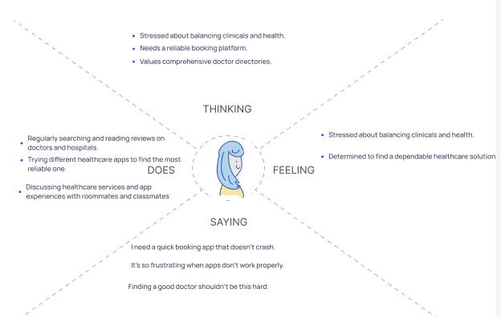

# Chapter 3: User Persona

To better understand our target users, we developed detailed personas representing different segments of the audience. Below is a visual representation of one of our key personas, showcasing their characteristics, pain points, and goals.

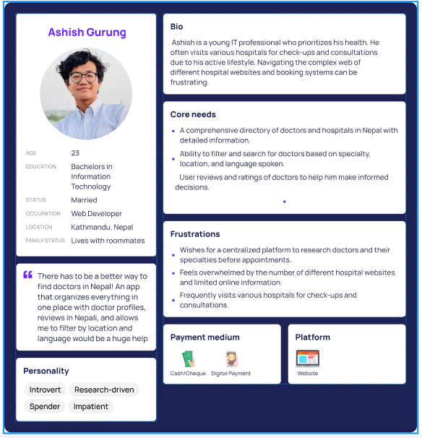

# Chapter 4: Wireframes and Prototypes

## ****4.1 Design Process:****

The design process for Curefy began with a thorough exploration of initial concepts, leading to the creation of wireframes and prototypes. This process was informed by user research, including surveys and interviews, as well as the insights gained from our empathy map. The goal was to translate these insights into functional and user-friendly designs.

## 4.2 Key Wireframes and Prototype Images:

1. **Moodboard:** The moodboard captures the visual style and thematic direction of the Curefy platform, including color schemes, typography, and design elements. It served as a reference for maintaining a consistent design language throughout the project.

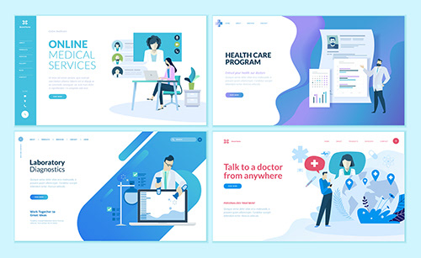

1. **Information Architecture:** To ensure a logical and intuitive user experience, the information architecture of Curefy was carefully planned.

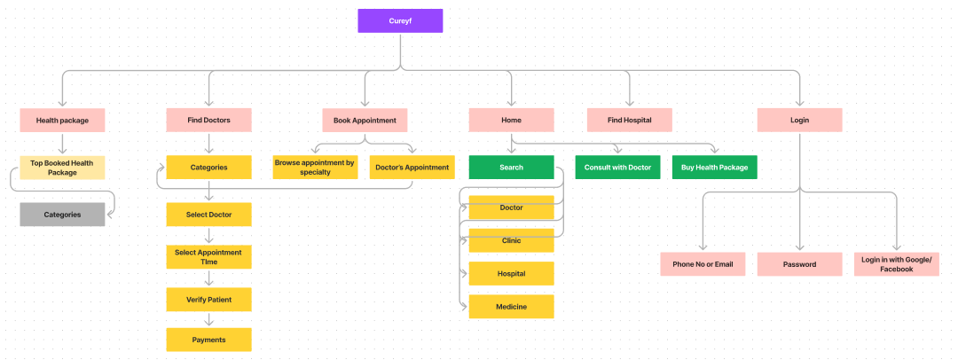

1. **Crazy 8’s :**

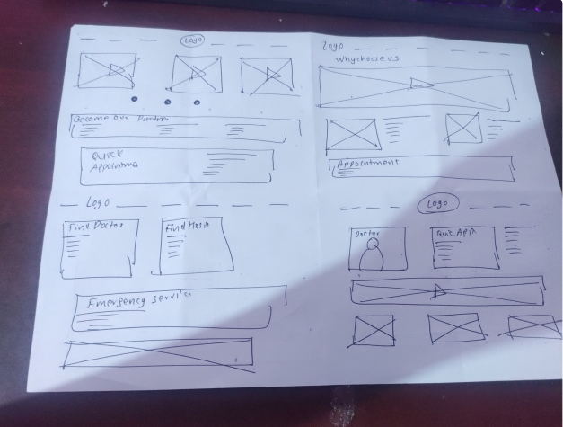

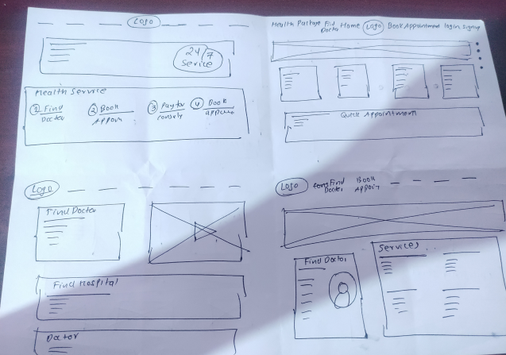

1. **Wireframes**

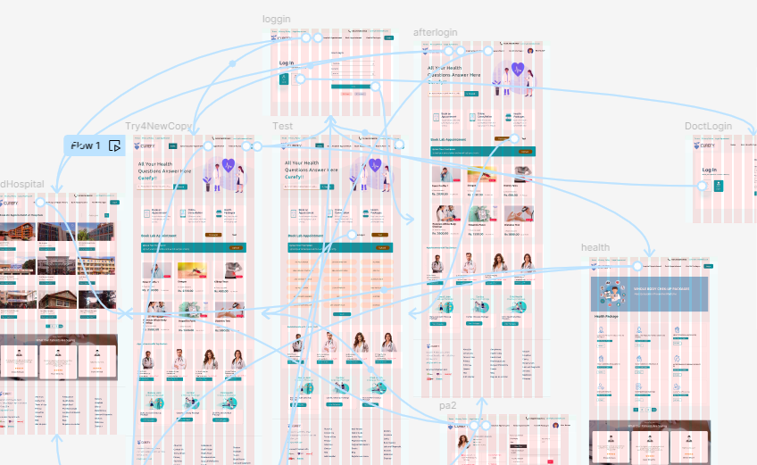

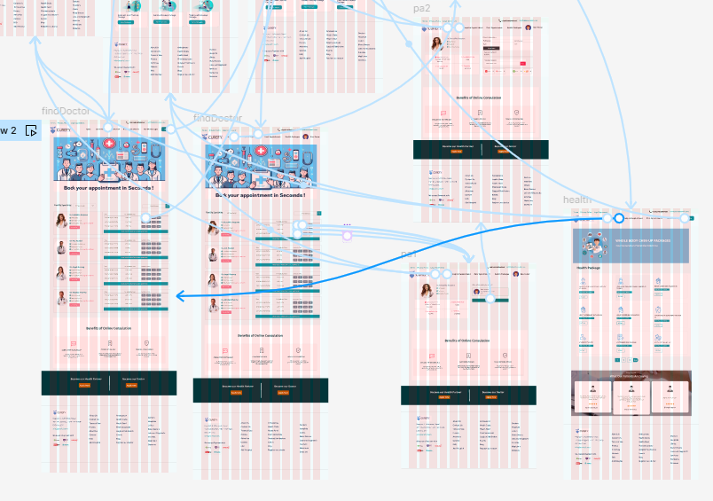

# Chapter 5: Usability Testing

Conducted usability testing to evaluate the effectiveness and user-friendliness of the Curefy platform. The goal was to identify any issues and ensure the design met user needs.

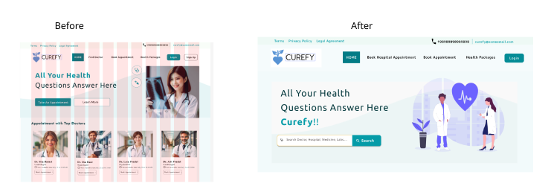

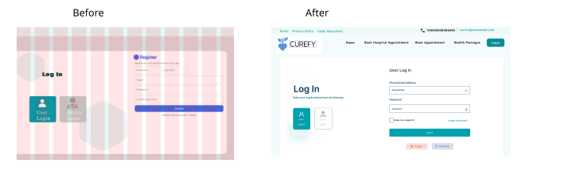  
  
**User Feedback Summary**: The Key feedback included difficulties in locating the appointment booking feature and confusion with the navigation menu. Users also suggested improvements for clarity in health package information.

# Chapter 6: Final Product

The final version of the Curefy platform presents a user-friendly and comprehensive healthcare solution. It integrates features for accessing hospital information, booking appointments with doctors, and exploring health packages, all within a secure and easy-to-navigate interface.

**Key Features:**

* **Hospital Information:** Users can view detailed profiles of hospitals, including contact details and services offered.
* **Appointment Booking:** An intuitive system for scheduling appointments with doctors, complete with availability and confirmation options.
* **Health Packages:** A section for exploring various health packages and their details.
* **Login:** A login system for patients and doctors, ensuring data privacy and security.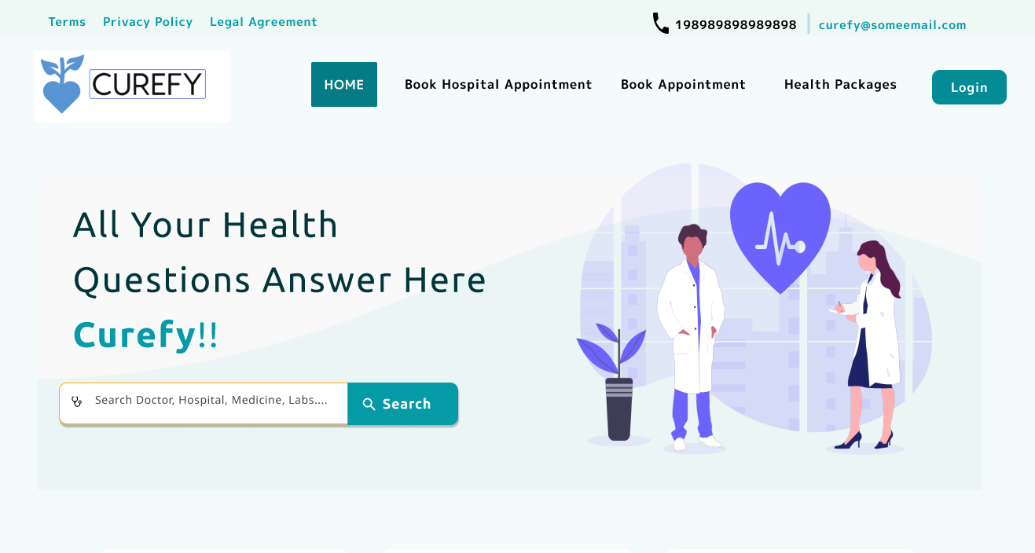 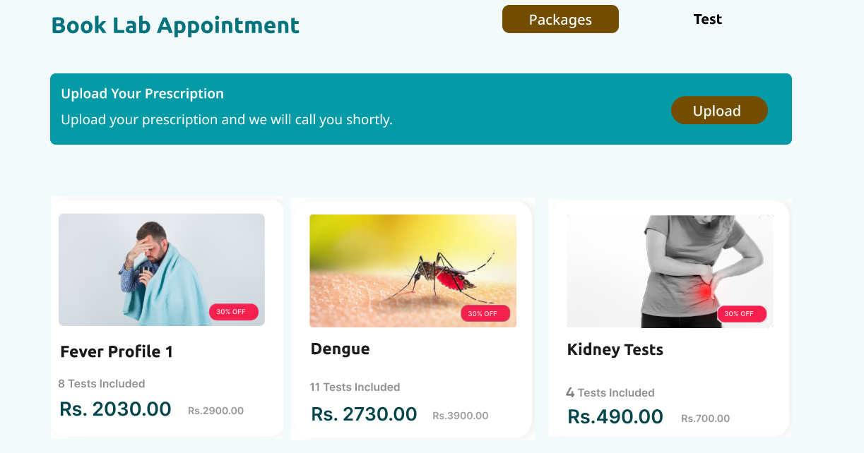 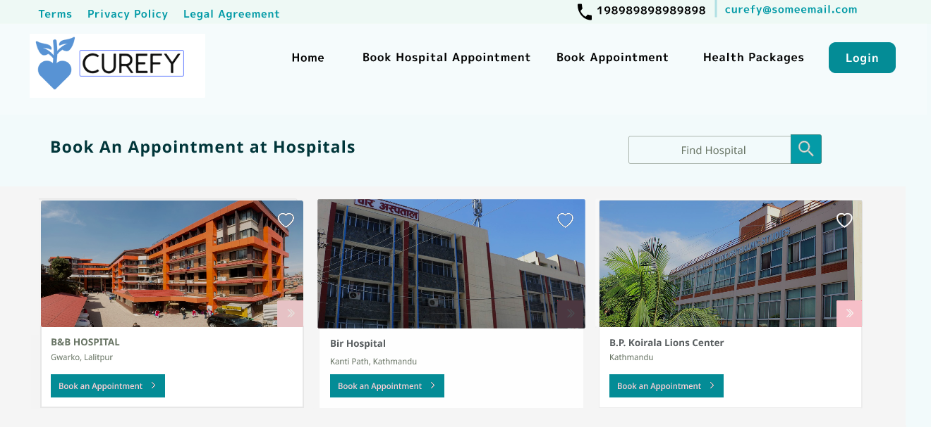 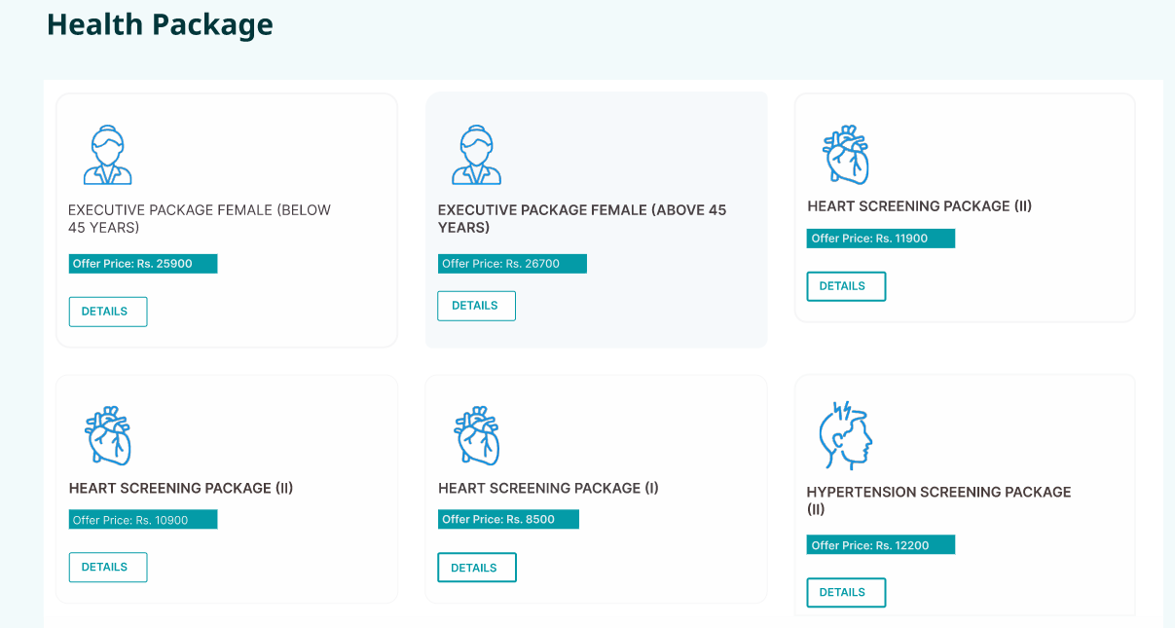 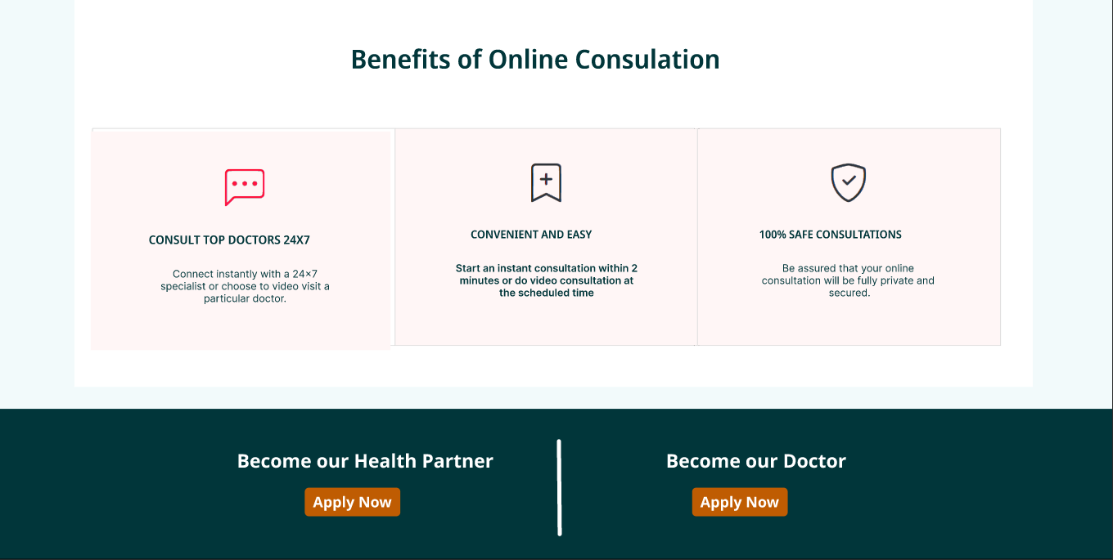 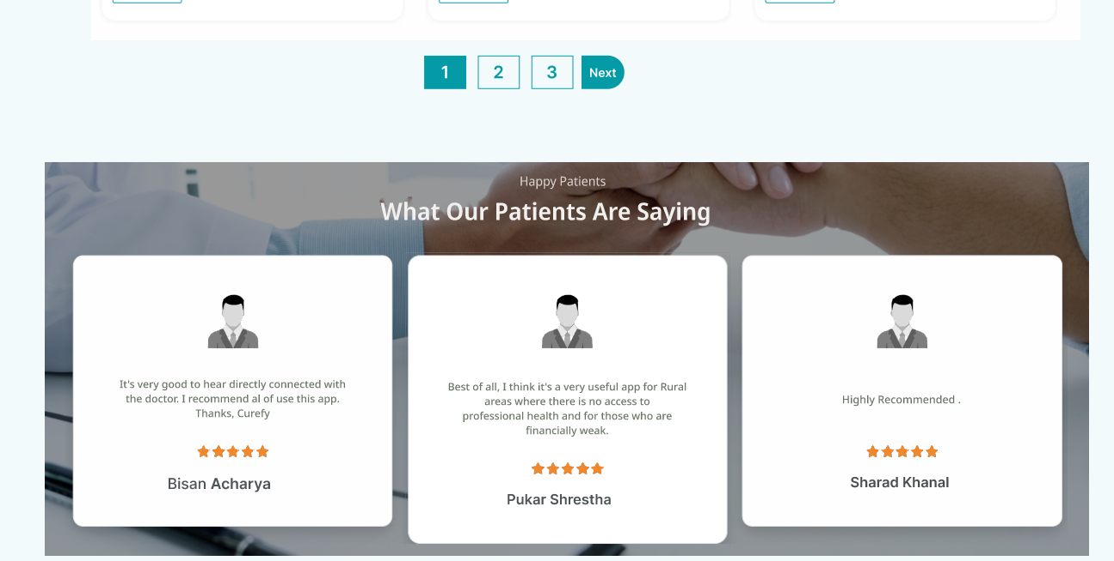 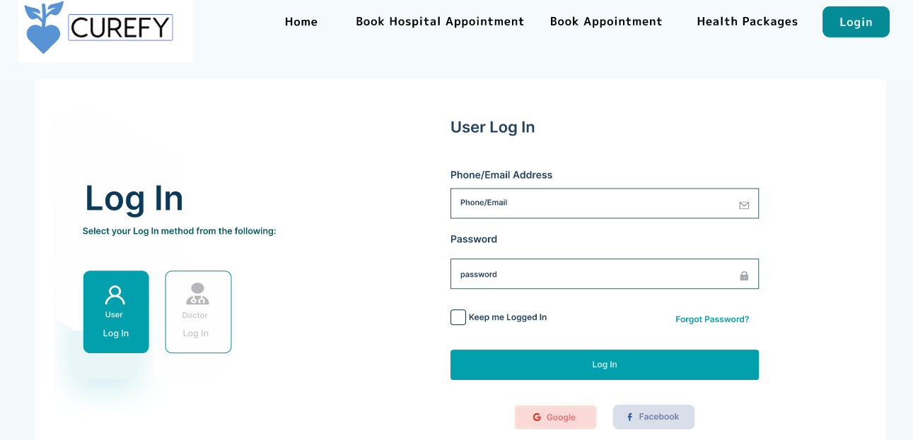 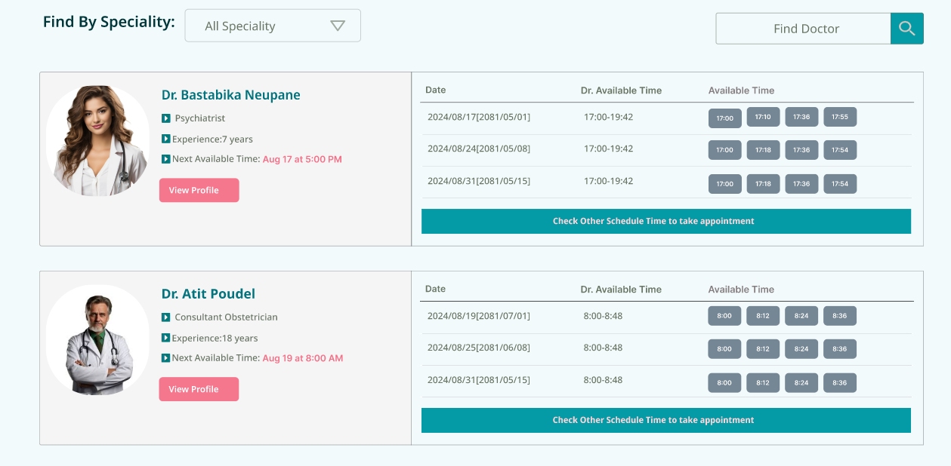 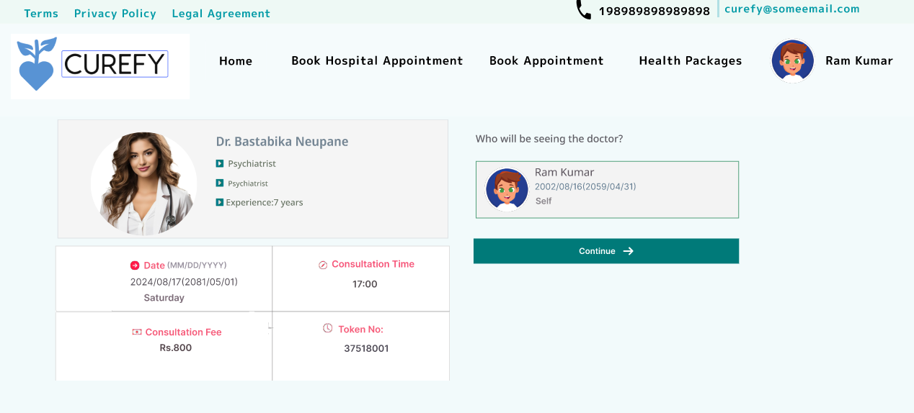 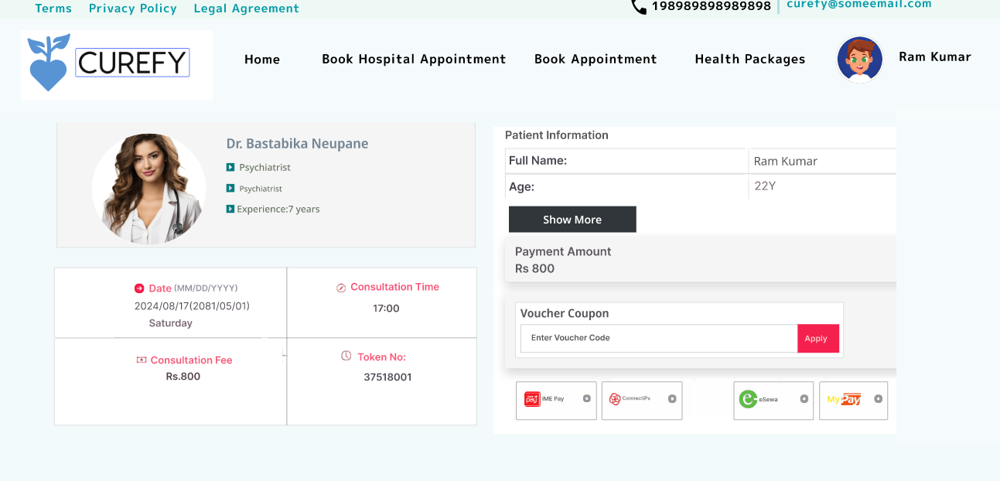

# Chapter 7: Learning

**Design and Development Insights:**

* **Enhanced Design Skills:** Gained a deeper understanding of creating user-centered designs through practical application of UI/UX principles.
* **Improved Wireframing Techniques:** Learned effective methods for developing wireframes and prototypes that accurately represent user needs and functionality.

**Usability Testing Experience:**

* **Feedback Integration:** Developed skills in gathering and analyzing user feedback, and using it to make informed design decisions.
* **Iterative Design:** Learned the importance of iterative design and continuous improvement based on real user interactions.

**User-Centered Design:**

* Gained a deeper understanding of the importance of designing with the user in mind.
* Learned how to incorporate user feedback effectively.

# References

* <https://www.hamrodoctor.com/>
* <https://merodoctor.com/>
* http://niroginepal.com/en/