MEDIPREDICT
Disease Prediction System

Project Technical Report
A Machine Learning Web Application

Group Project
Technology: Python, Flask, scikit-learn
Algorithm: Random Forest Classifier
Year: 2026

Submitted by Abacus UCP Coders:

Atul Patanayak

Himani Panigrahy

Kanhu Charan Sethi

Manas Ranjan Sahu

Beda Prakash Padhi

FOR EDUCATIONAL USE ONLY

Table of Contents

1. Introduction 1
1.1 Purpose of the System 1
1.2 Scope 1
2. Project Structure 2
2.1 File Summary 2
3. Technologies Used 3
3.1 Backend Technologies 3
3.2 Frontend Technologies 3
4. Dataset 4
4.1 Dataset Structure 4
4.2 Label Encoding 4
5. Machine Learning Model 5
5.1 Algorithm - Random Forest Classifier 5
5.2 Training Process 5
5.3 Model Configuration 5
5.4 Model Training Code 5
6. Flask Backend (app.py) 7
6.1 Application Routes 7
6.2 Prediction Function 7
6.3 API Request and Response 7
7. Frontend Website (index.html) 9
7.1 Page Sections 9
7.2 Screenshot - Home Page 9
7.3 Screenshot - Diagnosis Section 10
8. JavaScript Interaction Logic 11
8.1 Key Functions 11
8.2 API Call Code 11
9. How to Run the Project 12
9.1 Prerequisites 12
9.2 Step-by-Step Instructions 12
10. Limitations 13
10.1 Dataset Limitations 13
10.2 Model Limitations 13
10.3 Technical Limitations 13
11. Future Improvements 14
12. Conclusion 15
13. References 16

1. Introduction
The MediPredict Disease Prediction System is a machine learning-based web application designed to help users identify possible diseases based on symptoms they are experiencing. The system uses a Random Forest Classifier algorithm trained on a set of symptom-disease data to make predictions and provide health suggestions.
This project was developed as a group assignment to demonstrate the real-world application of machine learning concepts in the field of healthcare technology. The system combines a Python backend with a responsive web-based frontend, making it easy for any user to interact with the model through a browser without any technical knowledge.

1.1 Purpose of the System
The main purpose of this system is to:
- Allow users to input symptoms using a simple and visual interface.
- Predict the most likely disease using a trained machine learning model.
- Provide health suggestions and recommendations based on the predicted condition.
- Demonstrate the integration of machine learning with a live web application.

1.2 Scope
The system covers five health conditions — COVID-19, Flu, Migraine, Cold, and Healthy — based on five input symptoms: Fever, Cough, Headache, Fatigue, and Body Pain. It is designed for educational purposes and is not intended for real clinical use.

2. Project Structure
The project is organized as a standard Flask web application. Below is the full folder structure of the project as extracted from the ZIP archive:

disease_prediction/
├── app.py ← Flask backend + ML model
├── requirements.txt ← Python library dependencies
├── README.md ← Setup and run instructions
└── templates/
└── index.html ← Frontend HTML webpage

2.1 File Summary
File | Description
app.py | The main Python file. Contains the dataset, ML model training, Flask routes, and prediction logic.
templates/index.html | The frontend webpage. Built with HTML, CSS, and JavaScript. Sends symptom data to Flask and shows results.
requirements.txt | Lists the four Python libraries required to run the project: Flask, pandas, numpy, and scikit-learn.
README.md | A short guide explaining how to install and run the project.

3. Technologies Used
The project uses a combination of well-established Python libraries for machine learning and web development. Each technology was chosen for its reliability, ease of use, and availability.

3.1 Backend Technologies
Library / Tool | Purpose
Python 3.x | The primary programming language. Used for data handling, model training, and server logic.
Flask 3.0.0 | A lightweight web framework for Python. Used to serve the HTML page and handle the /predict API route.
scikit-learn 1.3.0 | The machine learning library. Provides RandomForestClassifier, LabelEncoder, train_test_split, and accuracy_score.
pandas 2.1.0 | Used to create and manage the symptom-disease dataset as a structured DataFrame.
numpy 1.26.0 | Used to format the user input as a numerical array before passing it to the model for prediction.

3.2 Frontend Technologies
Technology | Role
HTML5 | Provides the structure and layout of the web page.
CSS3 | Handles the visual styling — including colors, fonts, layout, and card components.
JavaScript (ES6+) | Handles user interactions, toggles symptom selection, and sends data to the Flask API using fetch().
Google Fonts | Loads the DM Serif Display and DM Sans fonts for a professional typographic appearance.
Jinja2 | Flask's built-in templating engine. Used to pass the model accuracy value from Python into the HTML page.

4. Dataset
The system uses a small, hand-crafted synthetic dataset built directly inside app.py as a Python dictionary. This approach was chosen because the project is for educational purposes and does not require a large external dataset.

4.1 Dataset Structure
The dataset contains 8 records with 5 binary features (0 = No, 1 = Yes) and one target label (Disease):

Record | Fever | Cough | Headache | Fatigue | BodyPain | Disease
1 | 1 | 1 | 1 | 1 | 1 | Flu
2 | 1 | 1 | 0 | 1 | 1 | COVID-19
3 | 0 | 1 | 1 | 1 | 0 | Migraine
4 | 1 | 0 | 1 | 0 | 1 | Flu
5 | 0 | 0 | 0 | 0 | 0 | Healthy
6 | 1 | 1 | 1 | 1 | 1 | COVID-19
7 | 0 | 0 | 0 | 0 | 0 | Healthy
8 | 0 | 1 | 0 | 1 | 0 | Cold

4.2 Label Encoding
Since the machine learning model requires numerical values, the disease names (strings) are converted to numbers using scikit-learn's LabelEncoder. This process assigns a unique integer to each disease class alphabetically:

Disease Name | Encoded Value
Cold | 0
COVID-19 | 1
Flu | 2
Healthy | 3
Migraine | 4

5. Machine Learning Model

5.1 Algorithm — Random Forest Classifier
The system uses a Random Forest Classifier, which is an ensemble learning method that builds multiple decision trees during training and combines their outputs to make a final prediction. It is well-suited for small tabular datasets and provides good accuracy without requiring complex tuning.

Why Random Forest?
Random Forest works by building many decision trees on different random subsets of the data and averaging their results. This reduces overfitting and produces more reliable predictions than a single decision tree — especially useful when the dataset is small.

5.2 Training Process
The model is trained with the following steps:

- The dataset is loaded into a pandas DataFrame.
- Disease labels are encoded as integers using LabelEncoder.
- Features (X) and target (y) are separated.
- The data is split into 80% training and 20% testing using train_test_split.
- A RandomForestClassifier with 100 trees is created and fitted on the training data.
- Accuracy is calculated on the test data and printed to the console.

5.3 Model Configuration
Parameter | Value
Algorithm | RandomForestClassifier
n_estimators | 100 decision trees
test_size | 0.2 (20% test, 80% train)
random_state | 42 (for reproducibility)
Input Features | Fever, Cough, Headache, Fatigue, BodyPain
Output Classes | COVID-19, Flu, Migraine, Cold, Healthy

5.4 Model Training Code
model = RandomForestClassifier(n_estimators=100)
model.fit(X_train, y_train)

y_pred = model.predict(X_test)
accuracy = accuracy_score(y_test, y_pred)
model_accuracy = round(accuracy * 100, 2)
print("Model Accuracy:", model_accuracy, "%")

6. Flask Backend (app.py)
The backend is built using Flask, a lightweight Python web framework. It serves the HTML frontend and exposes an API endpoint that the frontend can call to get predictions.

6.1 Application Routes
Route | Description
GET / | Serves the main index.html page. Passes the model_accuracy value to the template so it can be displayed in the header.
POST /predict | Accepts symptom data as a JSON object. Runs the prediction and returns the disease name and health suggestion as a JSON response.

6.2 Prediction Function
The predict_disease() function takes five binary symptom inputs, builds a numpy array, runs the model prediction, decodes the label, and returns the disease name along with a pre-written health suggestion:

def predict_disease(fever, cough, headache, fatigue, bodypain):
user_input = np.array([[fever, cough, headache, fatigue, bodypain]])
prediction = model.predict(user_input)
disease_name = label_encoder.inverse_transform(prediction)[0]

suggestions = {
"COVID-19": "Please consult a doctor immediately...",
"Flu": "Take rest and drink plenty of fluids...",
"Migraine": "Avoid stress, rest in a dark room...",
"Cold": "Drink warm water and take proper rest.",
"Healthy": "You seem healthy! Maintain a good diet."
}
suggestion = suggestions.get(disease_name, ...)
return disease_name, suggestion

6.3 API Request and Response
The /predict route accepts a POST request with a JSON body and returns a JSON response:

Request (sent from browser):
{
"fever": 1,
"cough": 1,
"headache": 0,
"fatigue": 1,
"bodypain": 1
}

Response (returned by Flask):
{
"disease": "COVID-19",
"suggestion": "Please consult a doctor immediately and isolate yourself."
}

7. Frontend Website (index.html)
The frontend is a single HTML file located in the templates/ folder. It is rendered by Flask using the Jinja2 templating engine and includes embedded CSS for styling and JavaScript for interactivity.

7.1 Page Sections
Section | Description
Header | Displays the MediPredict logo and the model accuracy badge in the top navigation bar.
Hero Banner | A large green banner with the app title and a short description of how the system works.
Step 1 — Symptoms | A card with 5 clickable symptom toggle buttons. Each button can be activated or deactivated by clicking.
Step 2 — Predict | A card with the Predict Disease button. When clicked, it sends the selected symptoms to the Flask API.
Step 3 — Result | A hidden card that appears after prediction. Shows the disease name, severity color, suggestion, and a reset button.
Info Strip | Three small cards explaining Random Forest, model accuracy, and the educational disclaimer.
Footer | A simple text footer with project information.

7.2 Screenshot — Home Page
The following screenshot shows the MediPredict website home page with the symptom selection interface:

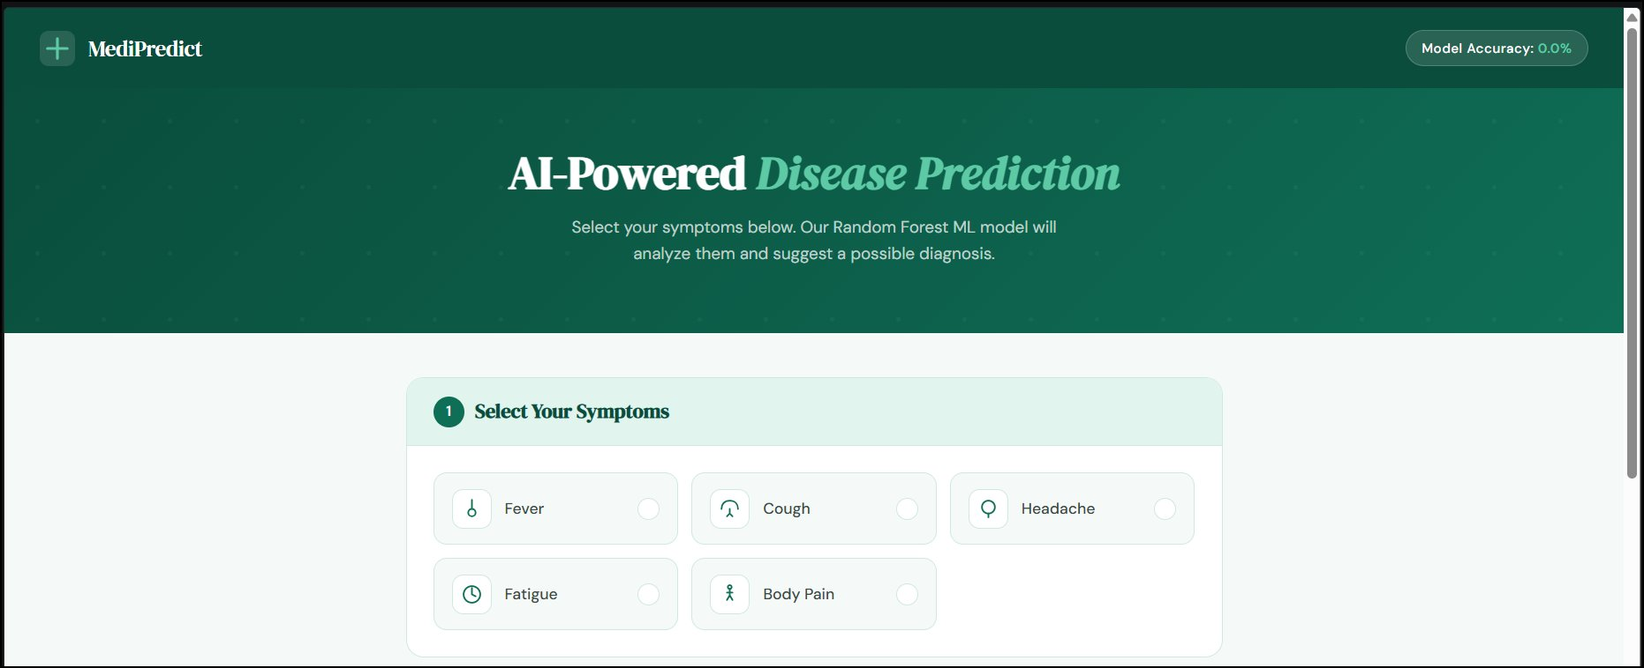
Figure 1: MediPredict Homepage — Symptom Selection Interface

7.3 Screenshot — Diagnosis Section
The second screenshot shows the lower half of the page with the Predict Disease button, model info cards, and the disclaimer:

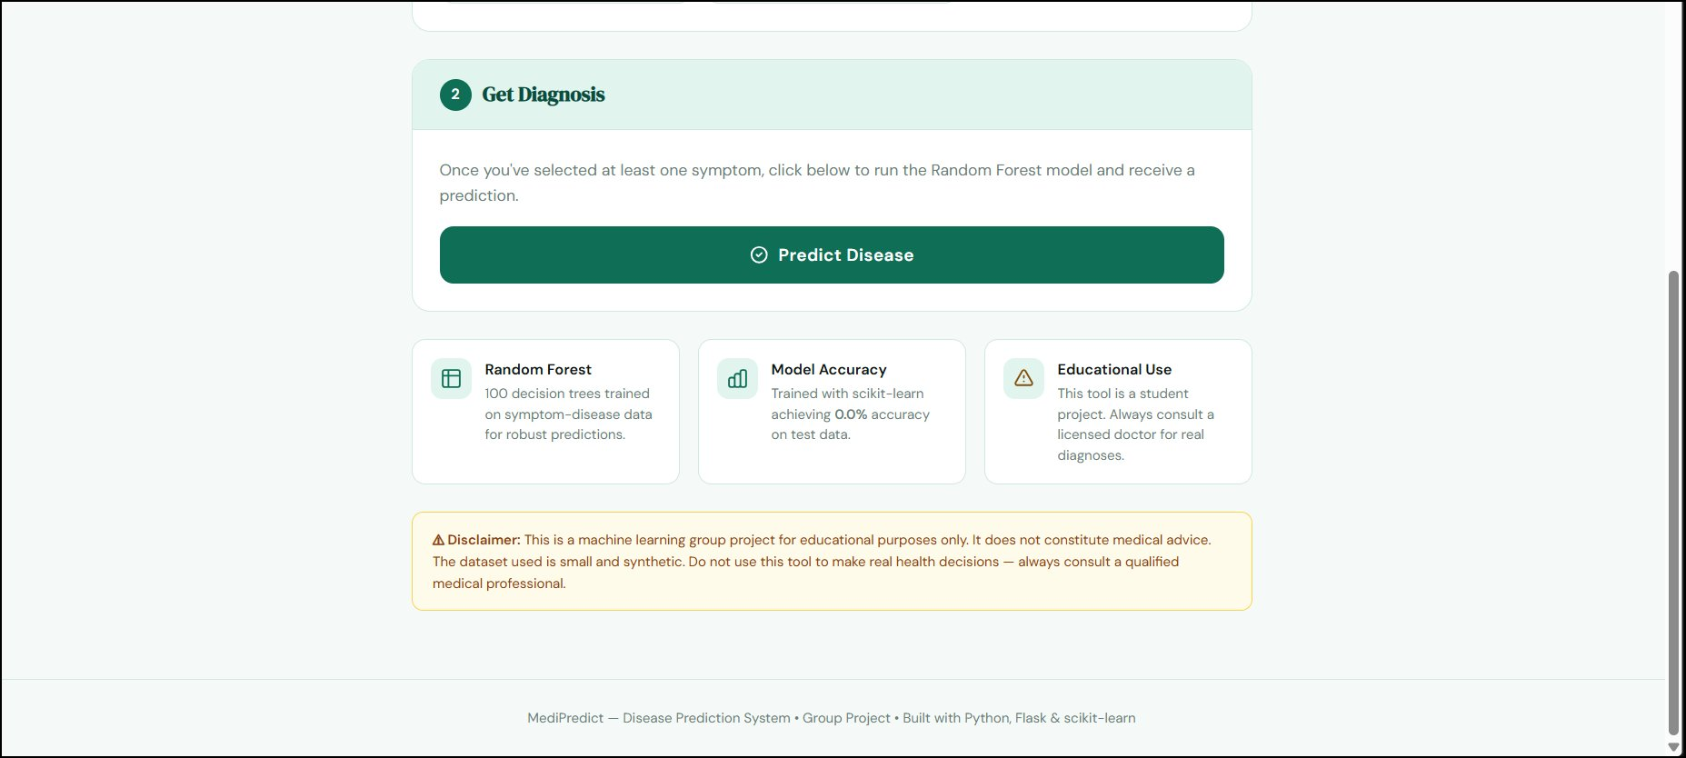
Figure 2: Diagnosis Section — Predict Button and Model Info Cards

8. JavaScript Interaction Logic
The frontend includes embedded JavaScript that manages all user interactions without requiring a page reload. It uses modern async/await syntax and the Fetch API to communicate with the Flask backend.

8.1 Key Functions
Function | Purpose
toggle(el) | Adds or removes the 'active' CSS class on a symptom button when the user clicks it.
getSymptoms() | Reads all symptom toggles and returns a dictionary of symptom names mapped to 0 or 1.
predict() | Async function that collects symptoms, sends a POST request to /predict, and calls showResult() with the response.
showResult() | Renders the result card with the disease name, color theme, suggestion text, and active symptom pills.
resetForm() | Clears all symptom selections and hides the result card, ready for a new prediction.

8.2 API Call Code
async function predict() {
const symptoms = getSymptoms();
const res = await fetch('/predict', {
method: 'POST',
headers: { 'Content-Type': 'application/json' },
body: JSON.stringify(symptoms)
});
const data = await res.json();
showResult(data, symptoms);
}

9. How to Run the Project
Follow these simple steps to set up and run the MediPredict Disease Prediction System on your computer.

9.1 Prerequisites
- Python 3.8 or higher must be installed on your computer.
- pip (Python package manager) must be available. It comes with Python by default.
- A web browser (Chrome, Firefox, or Edge) to view the website.

9.2 Step-by-Step Instructions
- Step 1 — Download: Download and unzip the project folder.
- Step 2 — Open Terminal: Open a terminal (Command Prompt on Windows, Terminal on Mac/Linux).
- Step 3 — Navigate: Navigate into the project folder using: cd disease_prediction
- Step 4 — Install Libraries: Run the following command to install all required libraries: pip install -r requirements.txt
- Step 5 — Run the App: Start the Flask server by running: python app.py
- Step 6 — Open Browser: Open your browser and go to: http://127.0.0.1:5000
- Step 7 — Use the App: Select symptoms and click Predict Disease to get a result.

To stop the server
Press Ctrl + C in the terminal window where the server is running. This will shut down the Flask application.

10. Limitations
As an educational project, the system has several known limitations that would need to be addressed before it could be used in a real-world medical context.

10.1 Dataset Limitations
- The dataset contains only 8 rows, which is far too small for a reliable medical prediction model.
- The data is synthetic and hand-crafted — it does not come from real patient records or clinical studies.
- Only 5 symptoms and 5 disease classes are covered. Real-world conditions involve hundreds of symptoms and thousands of diseases.

10.2 Model Limitations
- With a tiny dataset, the model may show high accuracy on test data due to overfitting rather than genuine learning.
- The model does not account for patient age, gender, medical history, or symptom severity.
- No probability threshold is set — the model always returns a prediction even if it is uncertain.

10.3 Technical Limitations
- The model is retrained every time the server starts. For production, the model should be saved to a file using joblib or pickle.
- No input validation is performed on the /predict endpoint. Malformed requests could cause errors.
- The application runs in debug mode (debug=True), which is not safe for production deployment.
- There is no database, user login system, or prediction history stored.

11. Future Improvements
The following improvements would significantly increase the quality and usefulness of the system if the project were to be developed further.

Improvement | Description
Larger Real Dataset | Replace the synthetic data with a real medical dataset such as the UCI Disease Symptom dataset or Kaggle datasets with thousands of records.
More Symptoms & Diseases | Expand the feature set to include 50+ symptoms and 20+ diseases for more useful and accurate predictions.
Model Saving | Use joblib to save the trained model to a .pkl file so it does not need to be retrained on every server startup.
Input Validation | Add server-side validation on all inputs and return proper error messages for invalid or missing data.
Confidence Score | Return the model's prediction probability alongside the disease name so users can see how confident the model is.
Cross-Validation | Use k-fold cross-validation to measure model performance more reliably on small datasets.
User History | Add a database (e.g. SQLite) to store past predictions and allow users to view their prediction history.
Mobile Responsive Design | Make the frontend fully responsive so it works well on smartphones and tablets.
Production Deployment | Deploy the app using Gunicorn and a cloud platform such as Heroku, Railway, or AWS for public access.
Dark Mode Support | Add a dark/light mode toggle to the UI for improved accessibility.

12. Conclusion
The MediPredict Disease Prediction System successfully demonstrates how machine learning can be integrated with a web application to create an interactive and user-friendly tool. The project brings together several key concepts from software development and data science, including data preprocessing, supervised learning with Random Forest, RESTful API design using Flask, and modern frontend development with HTML, CSS, and JavaScript.

Despite its limitations as an educational project, the system provides a solid foundation that can be extended into a more capable tool with a larger dataset, additional symptoms, and improved model tuning. The clean separation between the Python backend and the HTML frontend makes it straightforward to upgrade either part independently.

This project serves as a practical example of how students can apply classroom knowledge of machine learning and web development to build a complete, end-to-end application — from raw data to a working website that runs in any browser.

Disclaimer
This system is an educational group project and is not intended for real medical use. It does not replace the advice of a qualified medical professional. Always consult a licensed doctor for any health concerns.

13. References
The following tools, libraries, and resources were used in the development of this project:

Resource | Reference / URL
Python | https://www.python.org
Flask | https://flask.palletsprojects.com
scikit-learn | https://scikit-learn.org
pandas | https://pandas.pydata.org
NumPy | https://numpy.org
Google Fonts | https://fonts.google.com
Random Forest Paper | Breiman, L. (2001). Random Forests. Machine Learning, 45, 5-32.
Jinja2 Templates | https://jinja.palletsprojects.com

