

# FERGUSSON COLLEGE (Autonomous), PUNE 2019 - 2020

A Project

Report

On

***“Lead Generation Automation Tool”***

# Submitted to

# Fergusson College, Pune 411004

In the partial fulfillment of

**The Paper-V (Paper Code – MTS6509) Lab Course of M.Sc. (IMCA) Semester:-V**

*Developed By*

# Mr. Atul Rajaram Punde

**Roll NO: 1655**

# Mr. ….

**Roll NO: 1655**

# Mr. …

**Roll NO: 1655**

**Under the Guidance of**

**Prof. Hrishikesh Khaladakar.**

## Assistant professor

**C E R T I F I C A T E**

This is to certify that Mr. /Ms. _______________________________________

(Exam. Seat No. ____________________) is a student of M.Sc. (Industrial

Mathematics with Computer Applications), Part III has successfully completed

Semester V Project as Paper-V (Paper Code – MTS6509) Lab Course of M.Sc. (IMCA).

(Dr. V.V. Acharya)

HOD, Department of Mathematics

## Fergusson College (Autonomous), Pune- 411 004.

**ACCEPTANCE**

This is to certify that the undersigned have assessed and evaluated the project **Lead Generation Automaton Tool** submitted by **Atul Rajaram Punde and ….** The project report has been accepted for the partial fulfilment of the **Semester V Project as Paper-V (Paper Code – MTS6509) Lab Course of M.Sc. (IMCA)-III** from **Fergusson College, Pune**.

**External Examiner: Name: _______________________________________________**

Date: _______________________________________________

**Industrial Expert: Name: _______________________________________________**

Date: _______________________________________________

**Internal Examiner: Name: ________________________________________________**

Date: _______________________________________________

**PLACE:** FERGUSSON COLLEGE,PUNE.

## DATE: _____________ACKNOWLEDGEMENT

This report is presented at the end of Semester-V which is part of Lab Course of M.Sc. (IMCA) Semester-V. This Lab Course has been beneficial for me, as it gave me opportunity to utilize my skills and abilities.

This project has taken a considerable amount of time and resources and I would like to acknowledge the help of all of those who have made the project possible. I would take this opportunity to express my deep sense of gratitude towards my project guide **Mr. Hrishikesh Khaladkar Sir** for his encouragement, guidance and supervision of my project work during the semester.

I would also like to thank Head of Department Dr.V.V.Aacharya Sir.

ABSTRACT

The documentation tends to explain the invention and use of project ‘Lead Generation Automation Tool’ along with the brief description of the project, issues associated with it and its design details. However, it does not contain any implementation details. The report aims to benefit developer in the future who wishes to understand the project and perhaps extend its scope in the future. It also means of gaining better understanding of the developer themselves, of the work done by them. The project follows well-defined standards for design coding, implementation and documentation.

CONTENTS

**Acknowledgements** 04

**Abstract** 05

**Contents** 06

**1. Introduction** 07

1.1 Introduction 07

1.2 Project Overview 07

1.3 Existing System 08

1.4 Hardware and Software Specification 08

**2. System Development Lifecycle** 09

2.1 User Requirements 09

2.2 Feasibility Study 09

2.2.1 Technical Feasibility 09

2.2.2 Operational Feasibility 10

2.3 Analysis and Design 11

2.3.1 Use Case Diagram 11

2.3.2 Sequence Diagram 12

2.3.3 Activity Diagram 13

2.4 Concepts from Technologies 14

2.5 Testing 15

**3. Limitations of Tool** 16

**4. Future Scope** 17

**5. Conclusion** 18

**6. Bibliography** 19

1. INTRODUCTION

1.1 Introduction

This document is a report for the individual project implementation of an Automation Tool for Web Application. The project is an attempt to design and create a Web Application for Lead Generation so that users can be used by different services without Manual Process. Examples of these services include several steps like Finding Lead Information available on Up lead, Finding Mail-Id’s for those leads, Storing this Information at our database as well as CSV files and Shooting the Mail for Promotions or for any Marketing Purpose with given template. The main difficulty with the creation of such a Automation tool is the fact that the Manual Process is too Long, Time Consuming and Man Power Consuming. The need for such a Tool is justifiable. The use of this tool is a common part of everyday life for the Marketing, Promotions, and is considerably for collection of Data. It is likely that the usage of these tool will increase in the future. For the Clients it gives a simple, easy way of reaching to find their clients and to maintain Data.

1.2 Project Overview

The aim of this project is to create an Automation Tool in form of Web Application for Lead Generation. In other words the goal of this project is to provide such a tool where user can find the information of the Leads and able to shoot mail for marketing or promotion purpose. A significant part of this project is to look at how the Automation process can be implemented so as to be flexible enough for use with many varied users being powerful enough to allow to get data through application. Steps of Project are as follows:

* + - Finding Profiles of Lead on LinkedIn, Uplead or various websites.
    - Finding Emails for those lead on Google or by trying possible combinations from Name and Domain.
    - Storing this information
    - Shooting the Mail to those whose Mail Id’s are found successfully.

1.3 Existing System

In today’s life the whole work is done manually by humans copying Lead information from Websites, finding valid mail for same name and domain name from online tools for testing mail like Mail Tester or Mail Validator and the Sending mail of same templates to on those mail id’s, some of gives direct information of leads but these are very expensive to buy and again the drawback using them is they are not integrated with proper requirement and functionality. There is no such a system which handle all kind of requirement.

Also for the existing systems requires human resource. So it is time consuming and cost effectives for the user.

To solve such things this Automation Tool is invented.

1.4 Hardware and Software Specification

**Hardware Specification:**

**Processor:** Intel core I3 and above

**Processor speed:** 2.1 GHz Onwards

**RAM:** 1 GB (Minimum)

**Hard disk**: 300GB

**Software Specifications:**

**Front End Technologies:** HTML, CSS, Bootstrap.

**Server Side Technology:** Django.

**Backend:** Python.

**Database:** MongoDB.

**Operating system:** Windows10.

**Compatible browsers:** Google Chrome, Firefox.

**Microsoft VS Code:** It is an integrated development environment from Microsoft. Used for UI and its functionality to work in Python.

**Jupyter Notebook:**

2. SYSTEM DEVELOPMENT LIFECYCLE

2.1 User Requirements

**Introduction**: The proposed tool must be capable of handling all types of manual work which is currently done by user using human resources.

**Program Requirements:** The proposed tool must have a proper functional in all aspect, like input, output and process should be closely similar to manual.

**Life Cycle Requirements:** Requirement was clear earlier and at time passed some requirement were getting added, it can be a complicated process. The nature of the process depends on the methodology you choose for your software development like Agile, Waterfall, Incremental, etc. It also deals with the project documents like a project proposal, project management plan, project scope, and the business case.

2.2 Feasibility Study

2.2.1 Technical Feasibility

Evaluating the technical feasibility is the trickiest part of a feasibility study. This is because, at this point in time, not too many detailed things was known, making it difficult to access issues scraping data, finding mail etc. A number of issues have to be considered weather things are possible to achieve in specific tasks.

Understand the different technologies involved in the proposed system:

Before commencing the project, we have to be very clear about what are the technologies that are to be required for the development of the new system.

.

**Technical feasibilities of Tool:**

1. **Frontend Technologies** :

HTML 5: HTML 5 is a software solution stack that defines the properties and behaviors of web page content by implementing a markup based pattern to it.

CSS: To add the look and feel to the web site.

Bootstrap: To add readily available Look and effects.

1. **Backend Technologies :**

Python: Is the programing language used for various kind of algorithm functionalities.

Selenium: Selenium is a library in python used for Automation purpose.

2.2.2 Operational Feasibility

Proposed projects would beneficial only if they can be turned into proper usable tool that will meet the clients operating requirements. Simply stated, this test of feasibility asks if the tool will work properly as user friendly and with all functionality. Are there major barriers to Implementation? Here are questions that will help test the operational feasibility of a project:

• Is there sufficient support for the project from users? As there is not any current system which gives this functionality and all steps integration as one tool.

• Are the current business methods acceptable to the user? If they are not, Users may welcome a tool with all functionality and all step integration that will bring about a more operational and useful tool.

• Early involvement reduces the chances of resistance to the tool.

• General and increases the likelihood of successful project.

Since the proposed tool was to help reduce the hardships encountered. In the existing manual system, this new tools considered to be operational feasible.

2.3 Analysis and Design

2.3.1 Use Case Diagram

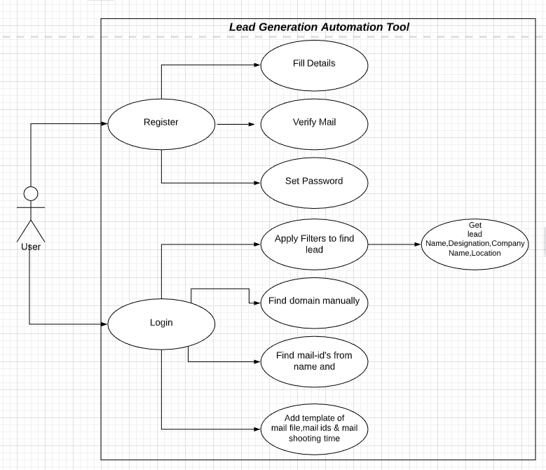

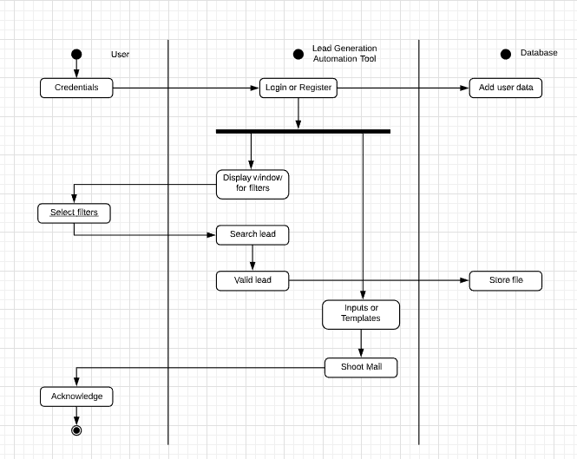.3.2 Activity Diagram

2.3.3 Sequence Diagram

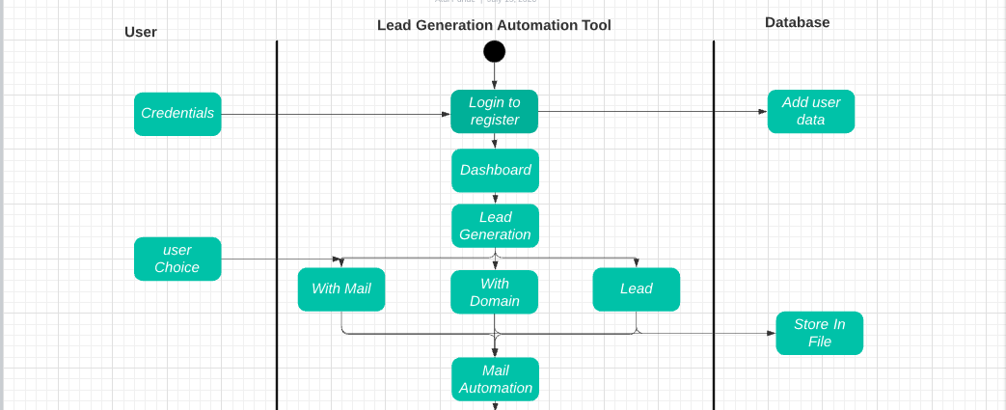

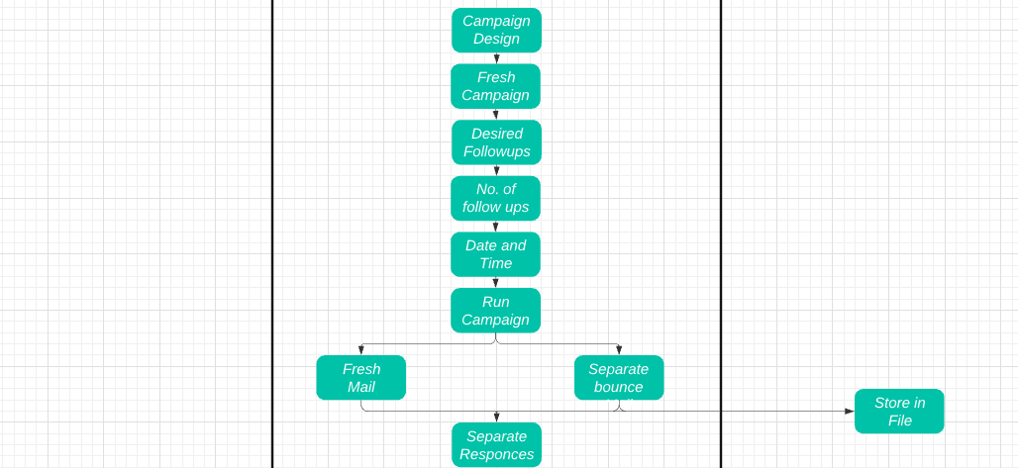







2.6 Screen Shots

This is a screen shot of original dashboard, which contains-

Vertical navbar including-

1) Register- If user is first time seeing this website, he/she can register.

2) Login- If user already register he/she can login using previous credentials.

3) Chat- This is not implemented yet, but this option is important from company perspective.

4) Profile- User profile which contains statistical information about leads generated by user and other details.

5) About Us- About the Exponential-x, terms and conditions and services.

Horizontal navbar including-

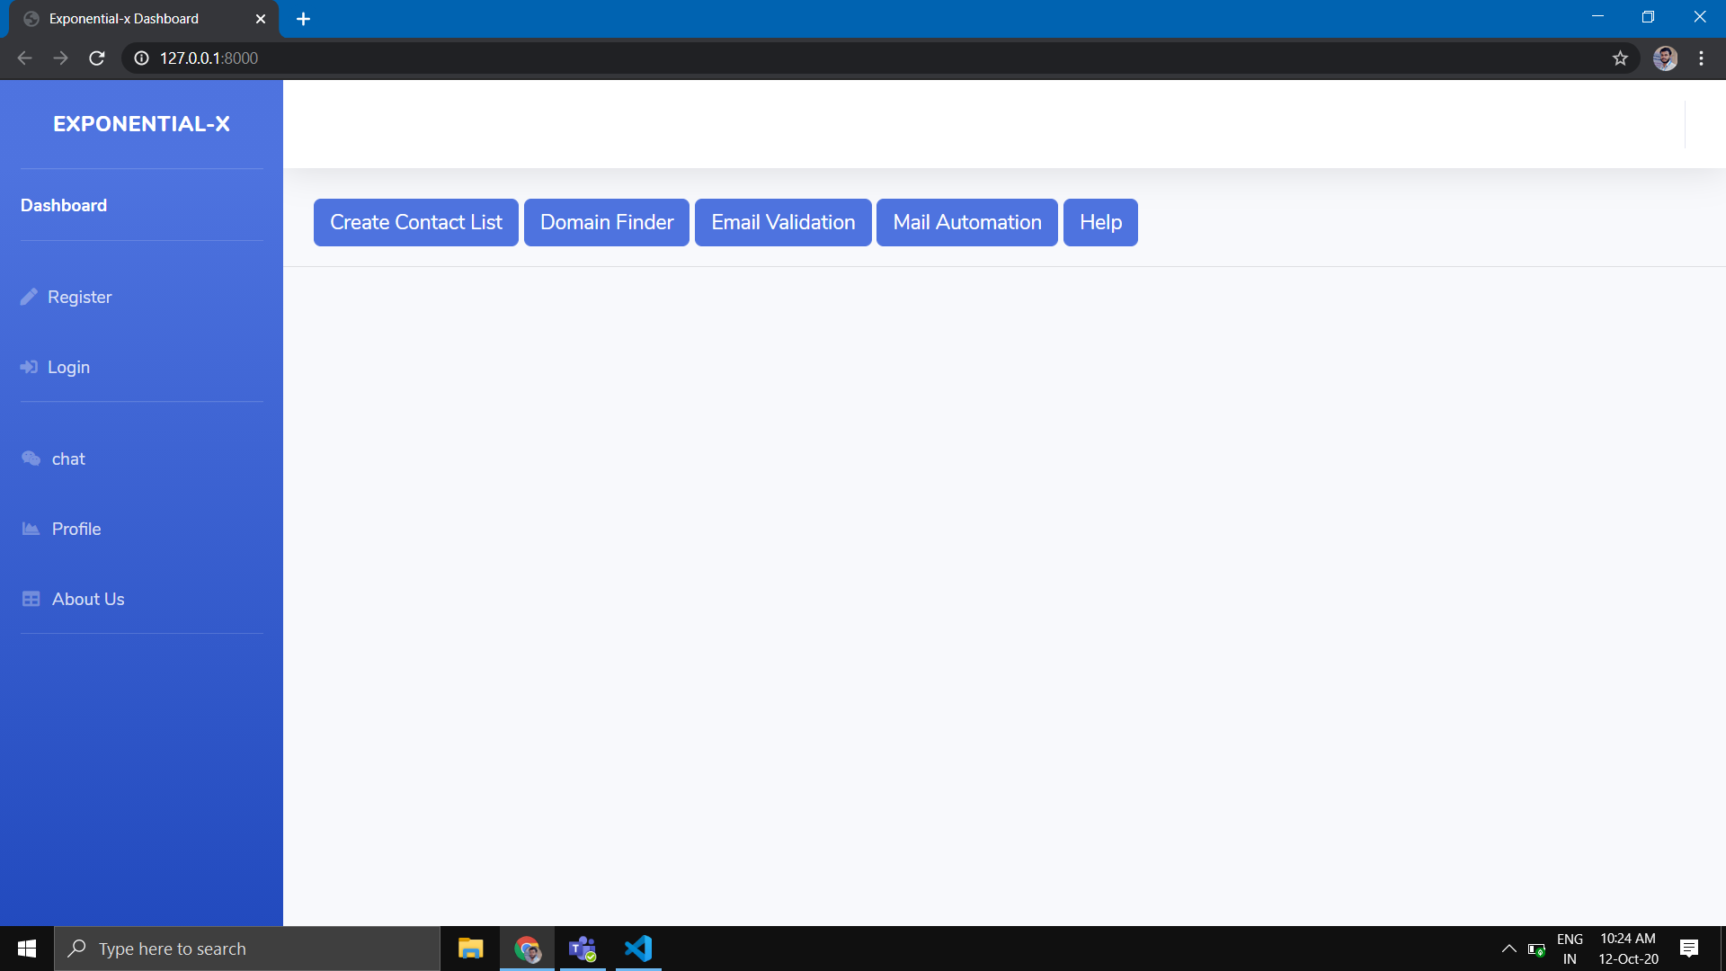

1) Create Contact List- If user is logged-in with LinkedIn he/she can apply filters according to his/her need. By using Scrap data button user can scrap the data from LinkedIn of above specified filters. While scraping itself data is passed to mongodb (To save users time). Download button is to save CSV file into user’s local machine. Now user is ready with CSV file of First Name, Last Name, Company Name, Designation, and Location.

This is the options in Create contact list module.

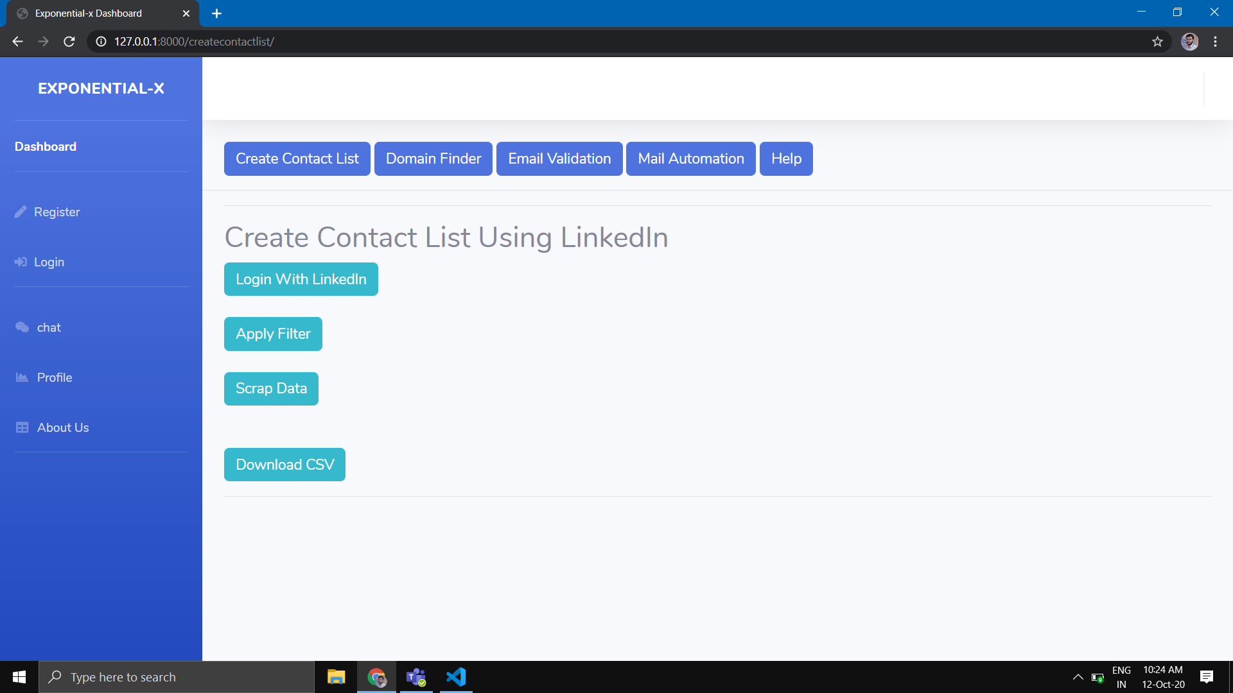

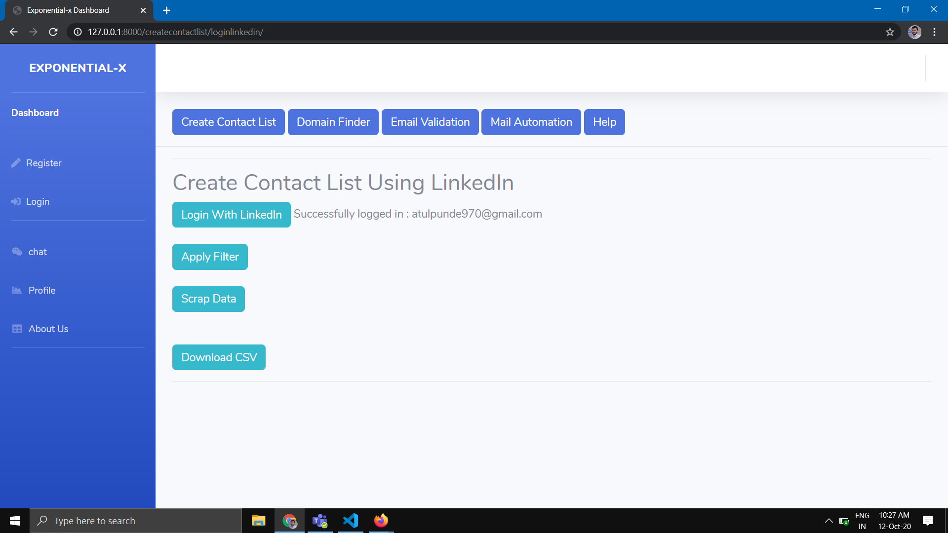

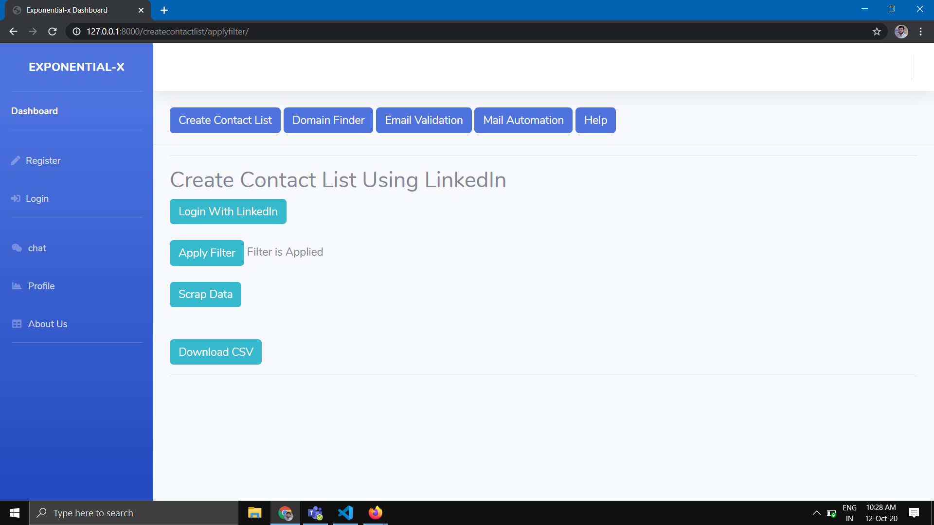

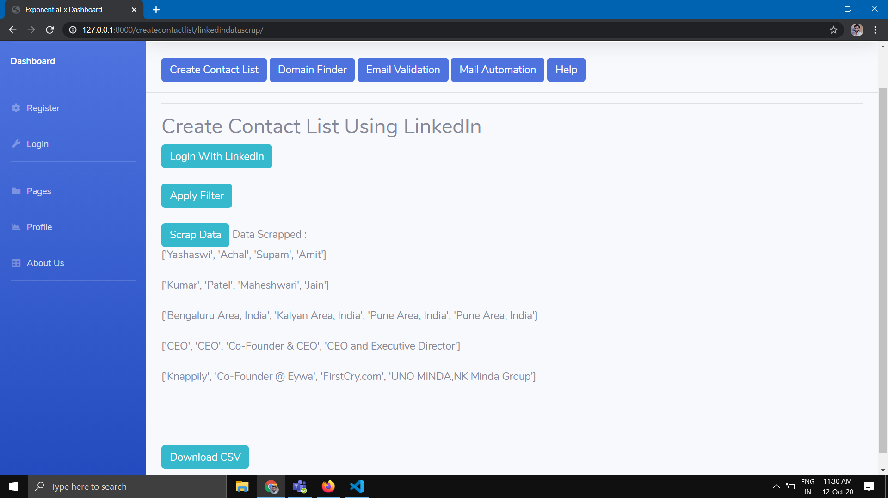

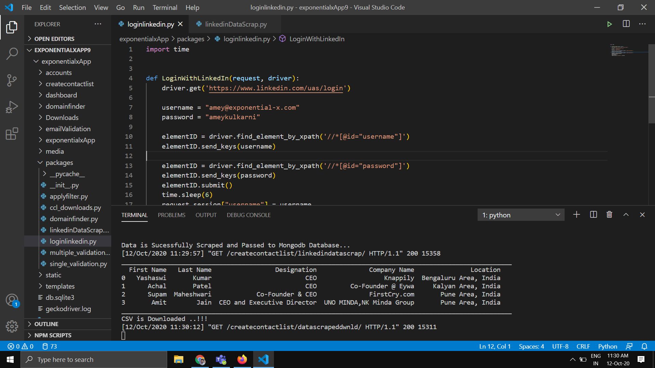

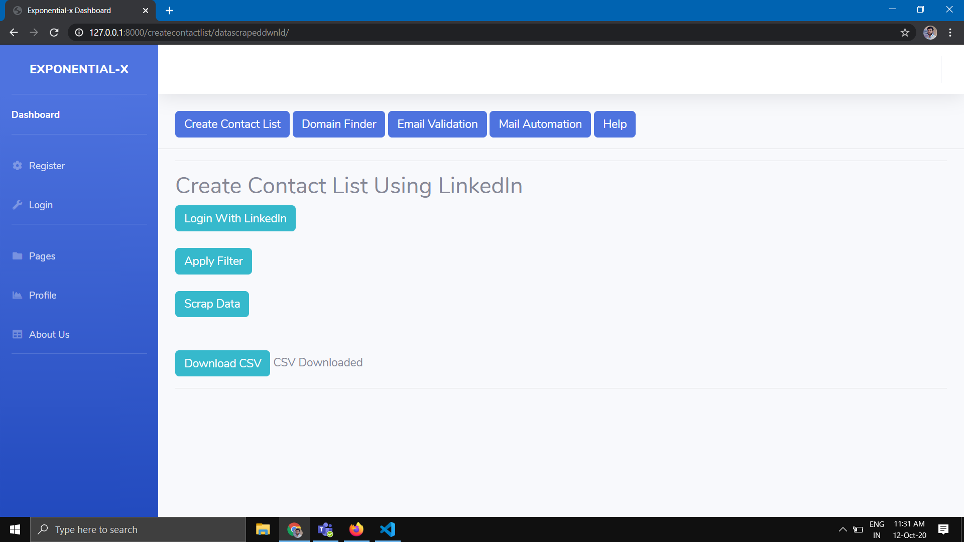

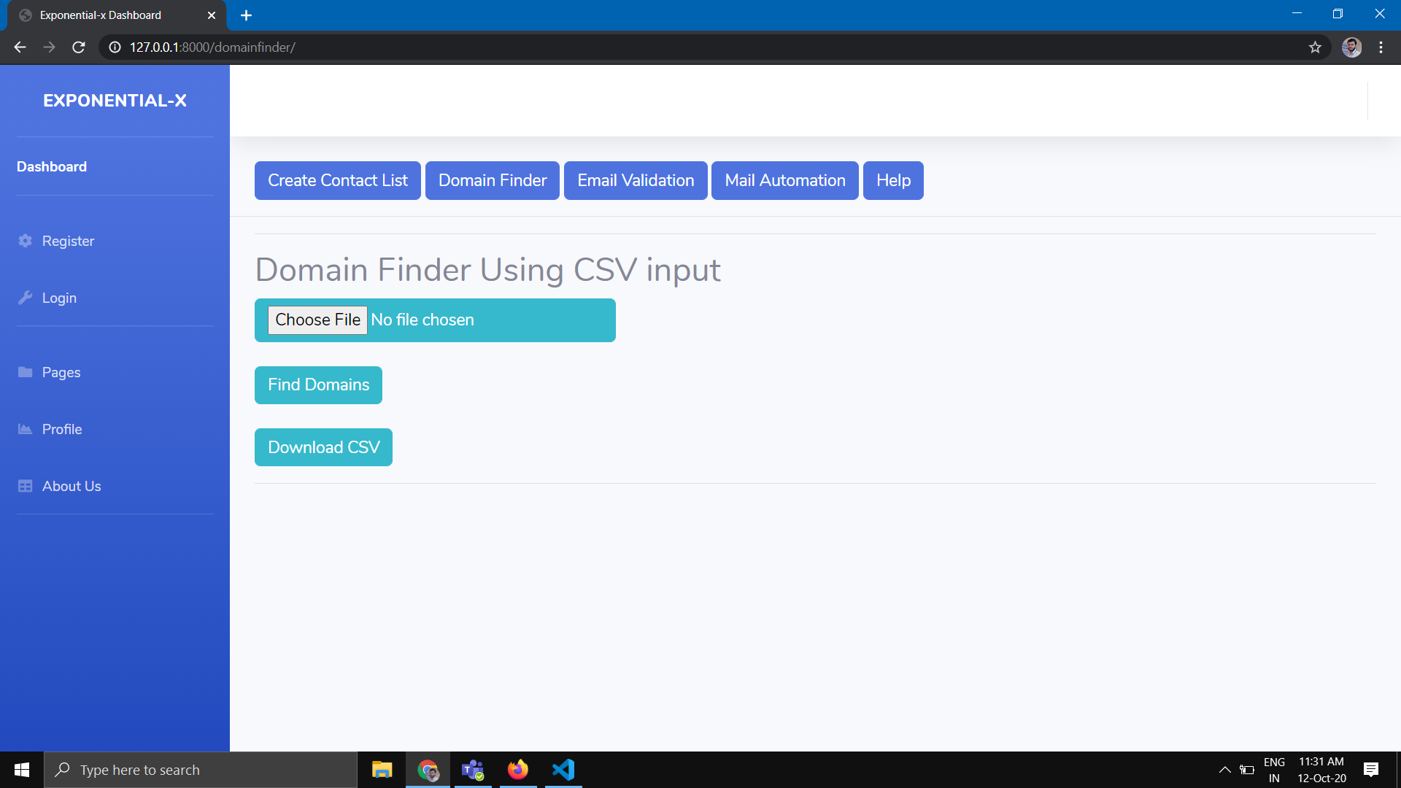

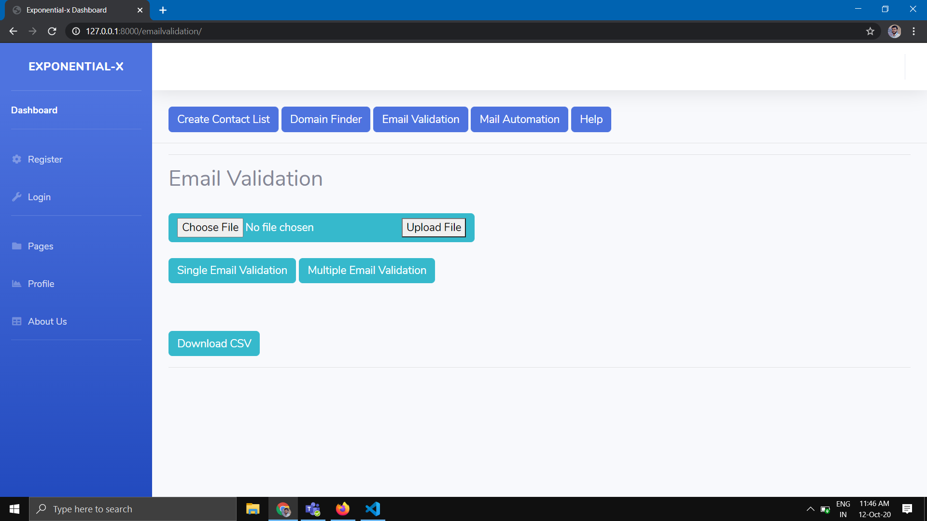

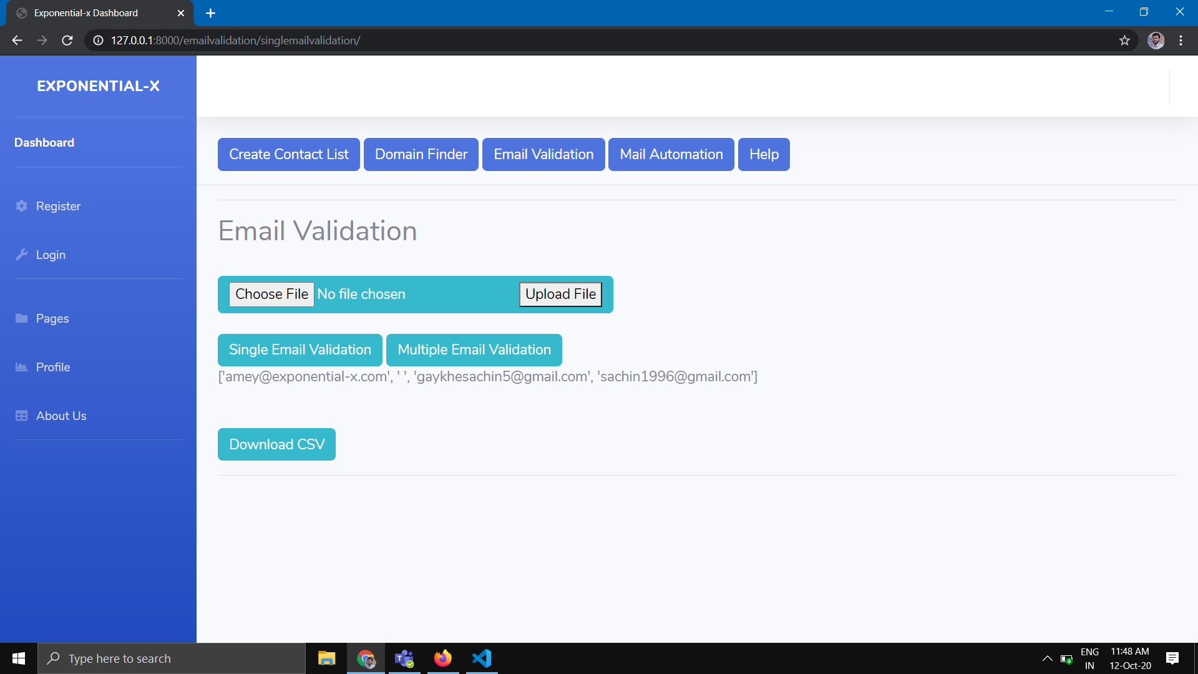

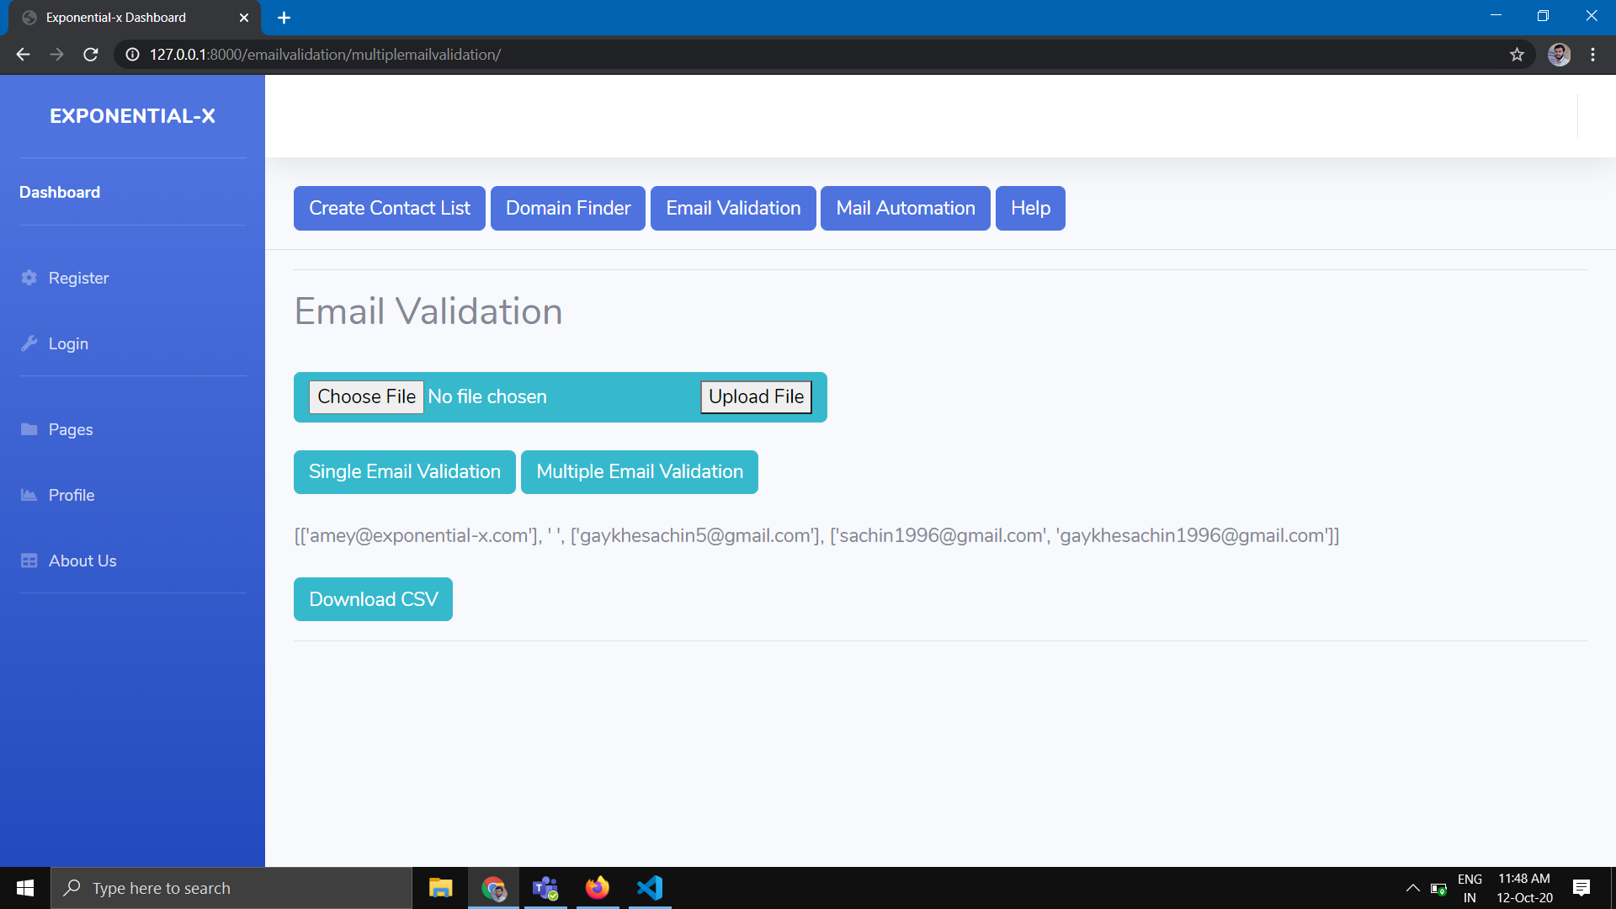

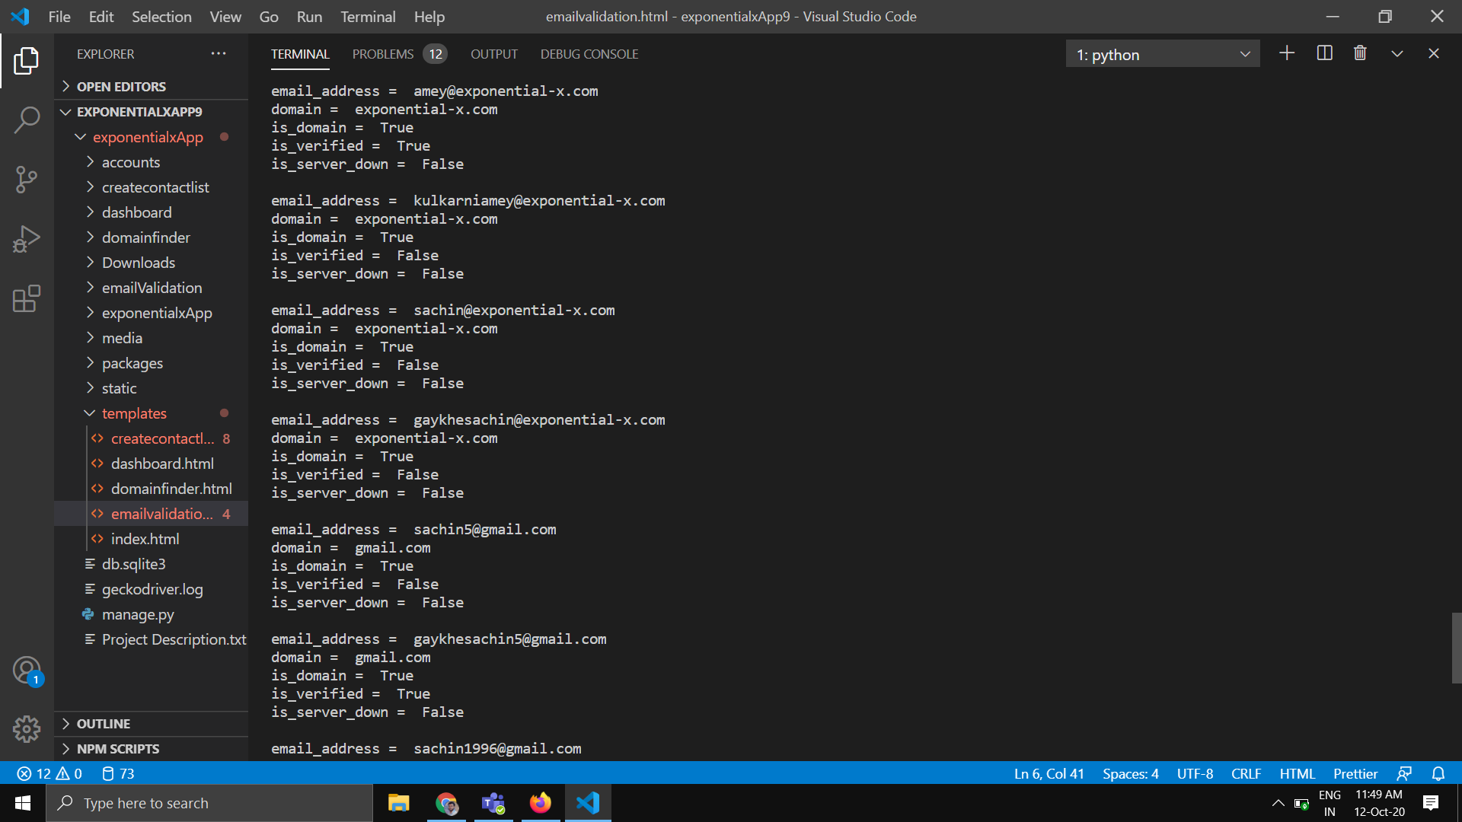

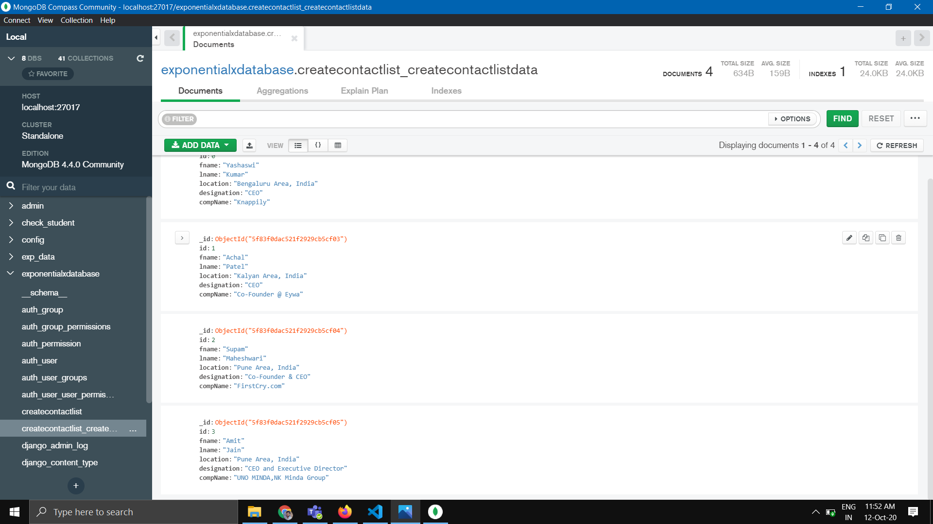

2.4 Concepts from Technologies

• **Python :** Python is an [interpreted](https://en.wikipedia.org/wiki/Interpreted_language), [high-level](https://en.wikipedia.org/wiki/High-level_programming_language), [general-purpose](https://en.wikipedia.org/wiki/General-purpose_programming_language) [programming language](https://en.wikipedia.org/wiki/Programming_language). Created by [Guido Van Rossum](https://en.wikipedia.org/wiki/Guido_van_Rossum) and first released in 1991, Python's design philosophy emphasizes [code readability](https://en.wikipedia.org/wiki/Code_readability) with its notable use of [significant whitespace](https://en.wikipedia.org/wiki/Off-side_rule). Its language constructs and [object-oriented](https://en.wikipedia.org/wiki/Object-oriented_programming) approach aim to help programmers write clear, logical code for small and large-scale projects.

• **Selenium:** Selenium is a free (open source) automated testing suite for web applications across different browsers and platforms. It is quite similar to HP Quick Test Pro (QTP now UFT) only that Selenium focuses on automating web-based applications. Testing done using Selenium tool is usually referred as Selenium Testing.

**• Pandas:** Pandas is an open source, BSD-licensed library providing high-performance, easy-to-use data structures and data analysis tools for the [Python](https://www.python.org/) programming language.

**• smtplib:** Python provides smtplib module, which defines an SMTP client session object that can be used to send mail to any Internet machine with an SMTP listener daemon.

**• HTML:** HTML is a computer language devised to allow website creation. These websites can then be viewed by anyone else connected to the Internet. It is relatively easy to learn, with the basics being accessible to most people in one sitting; and quite powerful in what it allows you to create.

**•Bootstrap:** Bootstrap is a [free and open-source](https://en.wikipedia.org/wiki/Free_and_open-source) [CSS framework](https://en.wikipedia.org/wiki/CSS_framework) directed at responsive, mobile-first [front-end web development](https://en.wikipedia.org/wiki/Front-end_web_development). It contains [CSS](https://en.wikipedia.org/wiki/CSS)- and (optionally) [JavaScript](https://en.wikipedia.org/wiki/JavaScript)-based design templates for [typography](https://en.wikipedia.org/wiki/Web_design#Typography), [forms](https://en.wikipedia.org/wiki/Form_(HTML)), [buttons](https://en.wikipedia.org/wiki/Button_(computing)#HTML), [navigation](https://en.wikipedia.org/wiki/Web_navigation#Local_website_navigation) and other interface components.

**• CSS:** Cascading Style Sheets (CSS) is a [style sheet language](https://en.wikipedia.org/wiki/Style_sheet_language) used for describing the [presentation](https://en.wikipedia.org/wiki/Presentation_semantics) of a document written in a [markup language](https://en.wikipedia.org/wiki/Markup_language) like [HTML](https://en.wikipedia.org/wiki/HTML).CSS is a cornerstone technology of the [World Wide Web](https://en.wikipedia.org/wiki/World_Wide_Web), alongside HTML and [JavaScript](https://en.wikipedia.org/wiki/JavaScript).

**•SQL:** Structured Query Language  is a [domain-specific language](https://en.wikipedia.org/wiki/Domain-specific_language) used in programming and designed for managing data held in a [relational database management system](https://en.wikipedia.org/wiki/Relational_database_management_system) (RDBMS), or for stream processing in a [relational data stream management system](https://en.wikipedia.org/wiki/Relational_data_stream_management_system) (RDSMS). It is particularly useful in handling [structured data](https://en.wikipedia.org/wiki/Data_model), i.e. data incorporating relations among entities and variables.

2.5 Testing

2.5.1 Testing Introduction

Testing is the method of checking whether the software is performing the given task successfully as expected or not. The expected speed, performance, accuracy and expected time should be taken into consideration while testing.

2.5.2 Manual Testing

* First Using Manual Process All Process have done manually and Results of all steps recorded in Files.
* Same process and same input is given to Tool in Steps.
* Data from the files are compared and tested how similar it is.
* Only the problem occurred is some of Leads are missing because of their emails are not in combinations in which we have implemented in Tool.

3. Limitations of Tool

* If domain is not found then we have to check it manually.
* If no any valid mail Id found then we need to check that, is there any other combinations of first name and last name.
* High Time Complexity.

4. Future Scope

* Next Step could be Report Generation of Sent mail and not sent mail, and Report data can be used for future process.
* Reply of the Mails can be Categorize.
* Tool should not be used by unauthorized User for that Registration Process could be change by asking business email for registration.
* Mail shooting functionality.

5. Conclusion

* Lead Generation Automation Tool is developed to provide an overall integrated automated tool for lead generation process which is done manually before.
* The benefits of tool is to find large amount lead information without any manual processing.
* Lead Generation Automation Tool is useful for data gathering of Leads in Marketing.

6. Bibliography

**Books Referred:**

1. Selenium WebDriver Recipes in Python by Zhimin Zhan
2. Learning Python, O’Reilly by Mark Lutz

**Web Sites and links Referred:**

1. https://www.tutorialspoint.com/flask/
2. <https://www.techbeamers.com/selenium-webdriver-python-tutorial/>
3. https://www.tutorialspoint.com/html/
4. https://www.tutorialspoint.com/css/