**ELL887 Cloud Computing**

**Assignment 2 – Azure**

**Name: Atul Kumar Rana**

**Entry No: 2023EET2195**

**Create a database to store information about products**

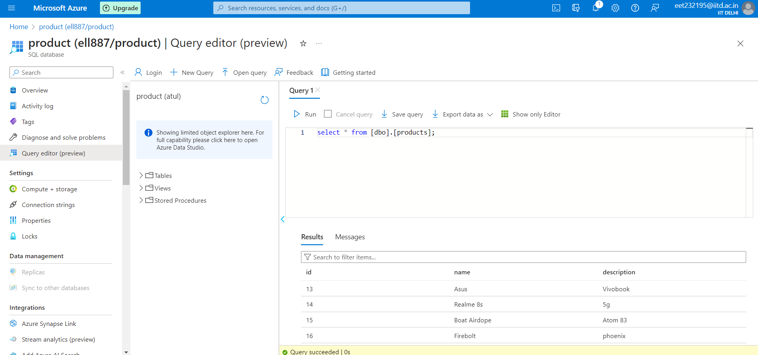

**Create a Web app that does the following:**

**• Add new products**

**• List all products**

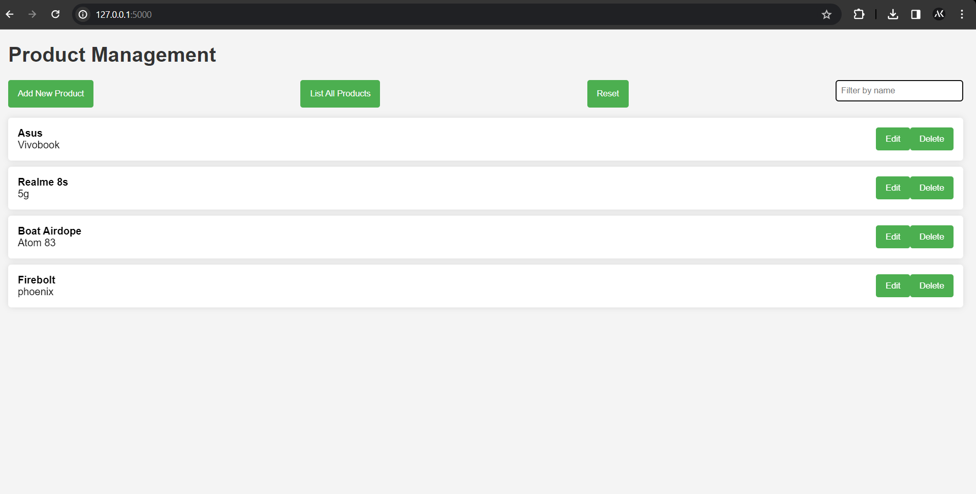

**Architecture diagram of the system**

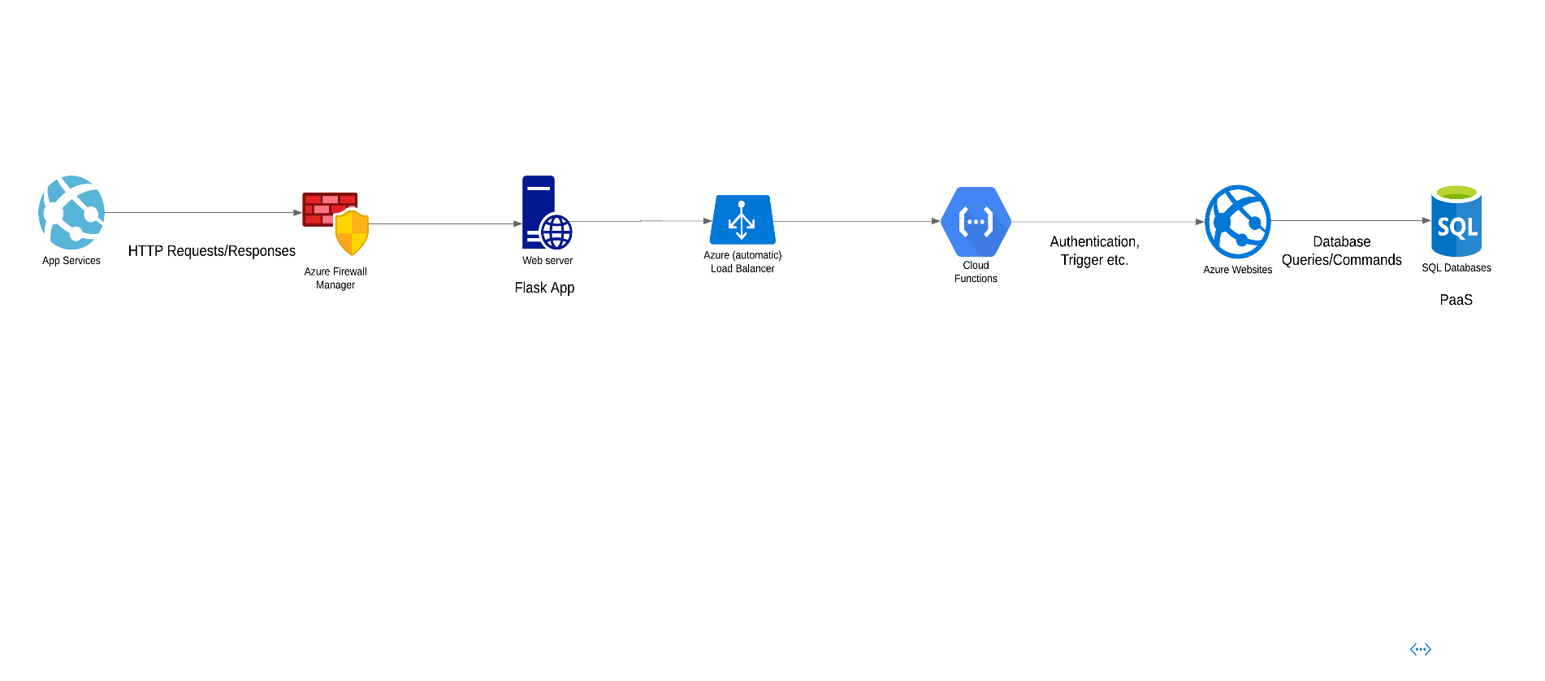

**The architecture decisions**

|  |  |  |
| --- | --- | --- |
| **Architecture** | **Decision** | **Rationale** |
| **Cloud Deployment (Azure)** | Choosing a cloud provider, in this case, Azure, allows for scalable and flexible infrastructure management. | Azure provides a wide range of services, including database solutions, load balancing, and security services, making it suitable for hosting and managing web applications |
| **Azure Load Balancer** | Implementing Azure Load Balancer distributes incoming network traffic across multiple web server instances | Load balancing enhances the availability and fault tolerance of the application by ensuring that no single server bears too much load |
| **Web Server (Flask App)** | Using a farm of web servers running the Flask application behind the load balancer | Distributing the application across multiple servers allows for horizontal scalability, ensuring efficient handling of increased user traffic |
| **Azure Firewall** | Implementing Azure Firewall as a network-level security service | Azure Firewall protects the application and database from unauthorized access, ensuring secure communication and preventing malicious activity |

|  |  |  |
| --- | --- | --- |
| **Azure Functions** | Utilize Azure Functions | Leverage Azure Active Directory for secure authentication, utilize various triggers based on workload requirements, adopt a serverless design for scalability, manage dependencies efficiently, integrate with Azure Application Insights for robust logging and monitoring, implement retry mechanisms for resilience, and secure environment configurations using Azure Key Vault for a comprehensive and resilient serverless architecture. |
| **Azure SQL Database** | Storing application data in Azure SQL Database | Azure SQL Database is a managed relational database service, providing high availability, security, and scalability. It's suitable for storing structured data used by the Flask application |

**URL to access application:**

[**http://eet232195.azurewebsites.net/**](http://eet232195.azurewebsites.net/)

This link may not be working sometimes because Azure app service is needed to deployed and database needed to be active before using the link.