BITS Pilani - Goa

Feb 11, 2017

Systematic Approach to Solving Machine Learning Problems

Workshop Prerequisite

Table of Contents

INSTALLING PYTHON & JUPYTER 3

INSTALLING SEABORN 4

Steps in MAC 4

Steps in Windows 7

## INSTALLING PYTHON & JUPYTER

It is HIGHLY suggested you use the Anaconda distribution for this course and installing packages. You can install the Anaconda distribution here: <http://continuum.io/downloads>

Pick the correct OS and install Python 2.7 from the above link.

**IMPORTANT NOTE:** This workshop uses **Python 2** and ***not Python 3.***

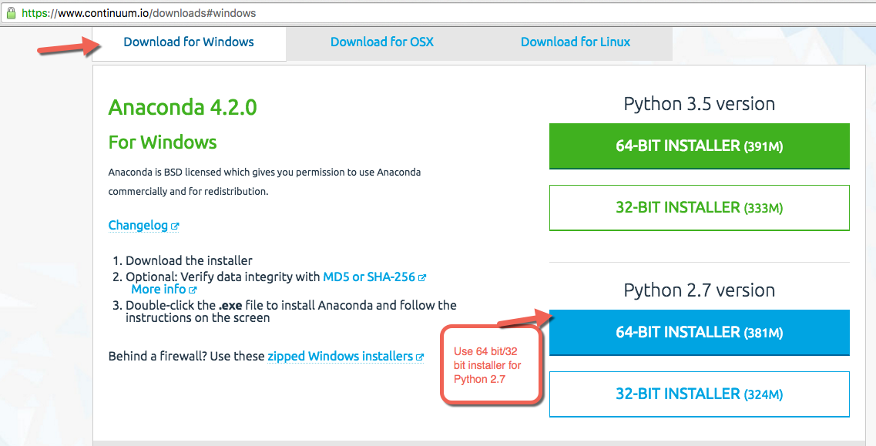

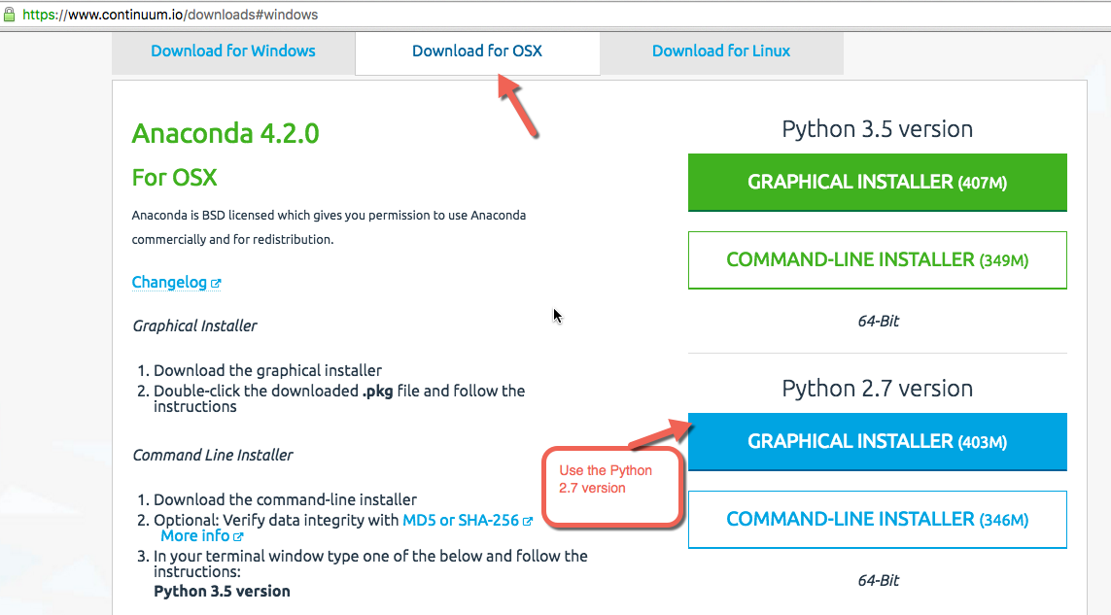

## INSTALLING SEABORN

Launch the Anaconda App, use the environment option to install any new packages. Seaborn is an additional package. The following steps describe how to install seaborn.

### **Steps in MAC**

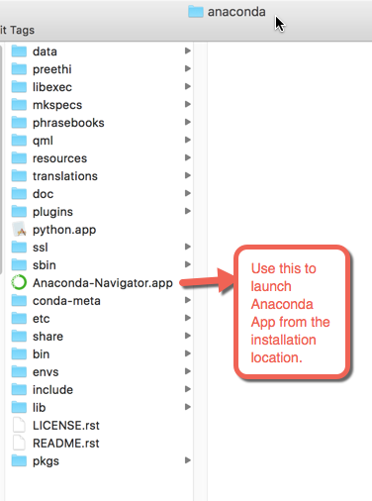

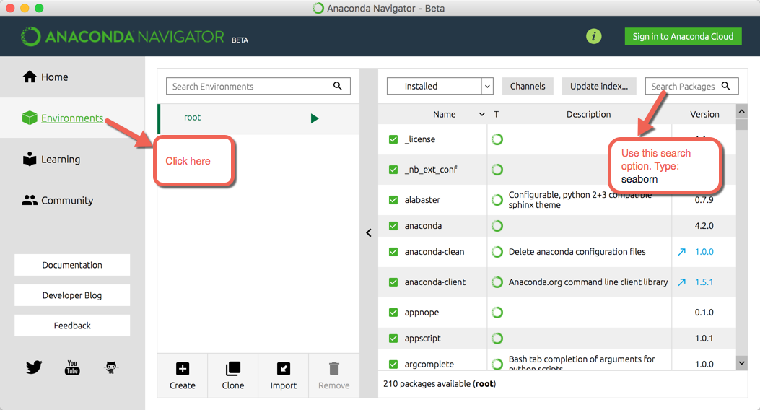

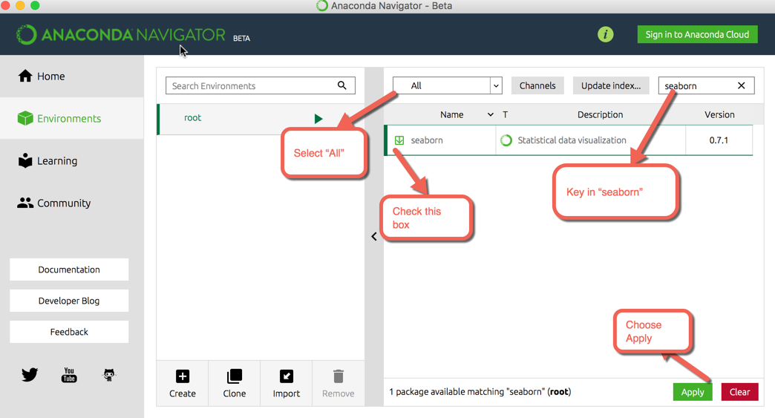

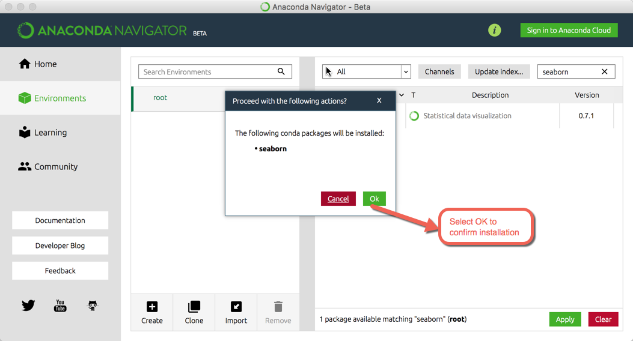

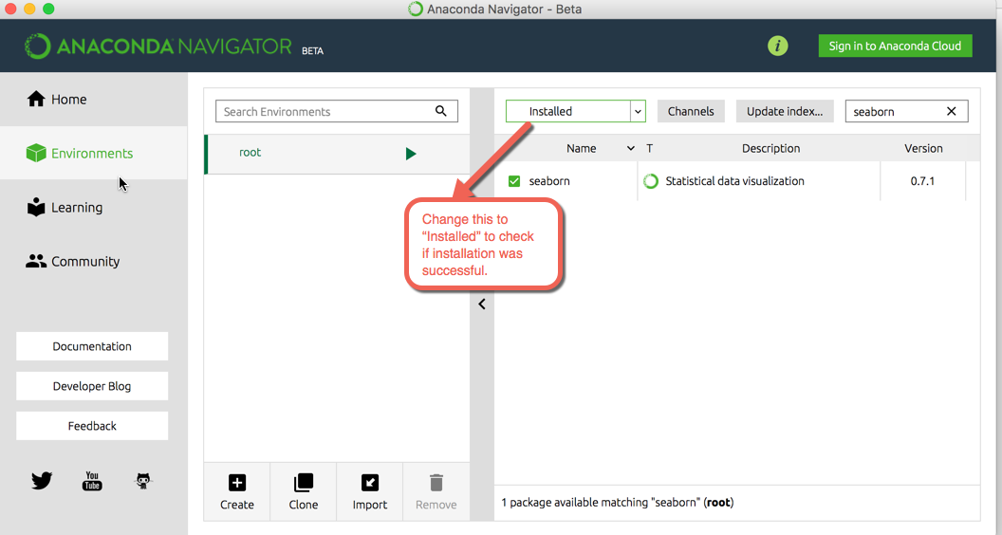

The seaborn package appears in the installed list of packages.

### **Steps in Windows**

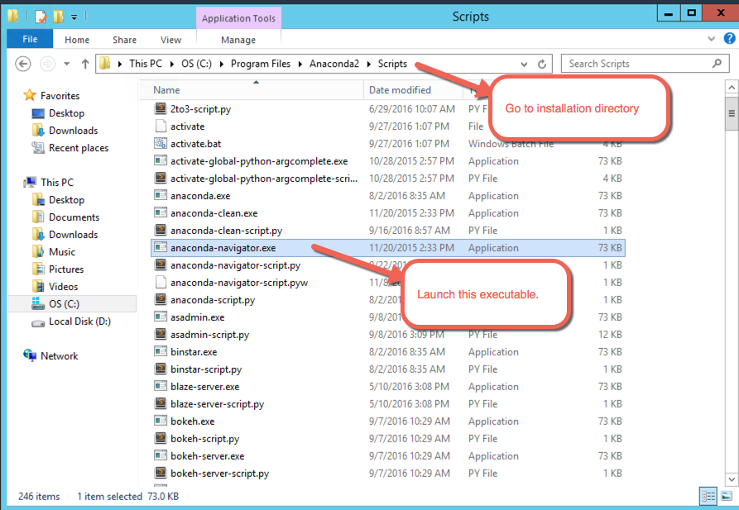

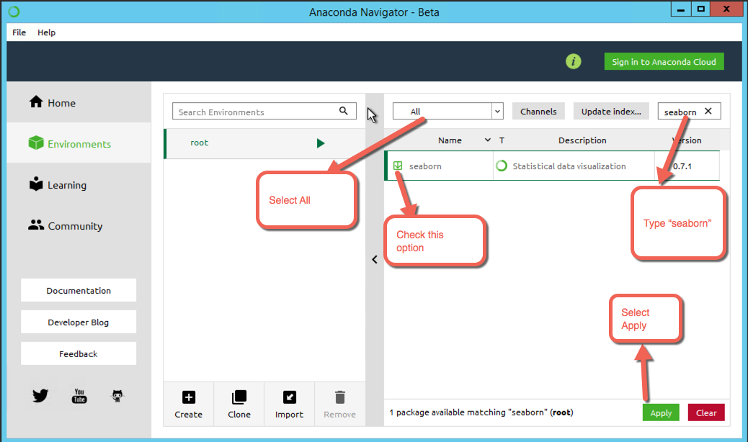

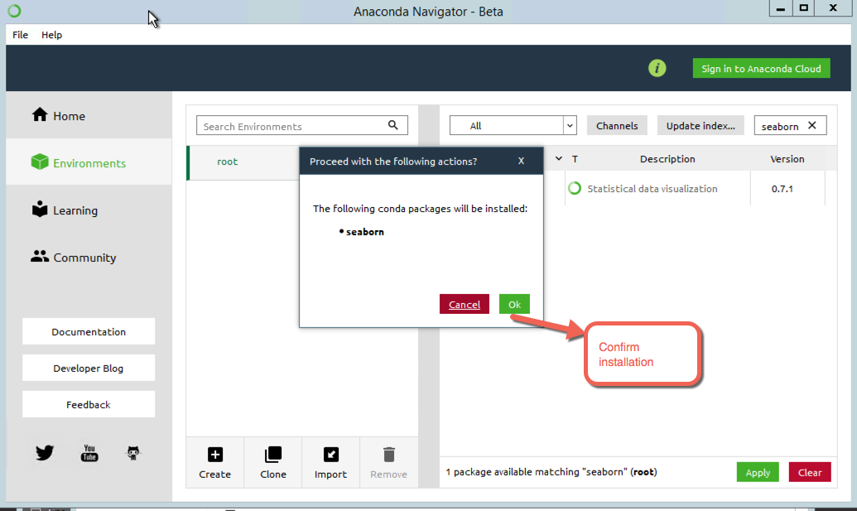

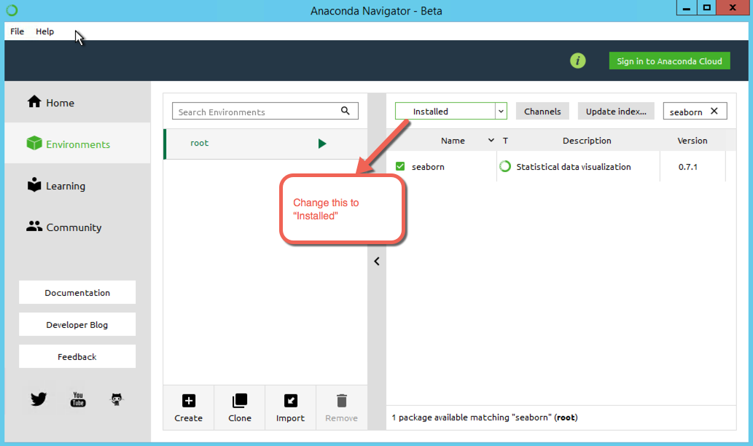

The seaborn package appears in the inst­­alled list of packages.

**Note:** If you have any doubts please reach out to:

Anoop Makwana (anoop_makwana@intuit.com)

Shashi Roshan (shashi_roshan@intuit.com)