**To run the application**

Cd nodeapp

nodeapp > npm start

**Enter in the search bar of browser to enter data**

<http://localhost:3000/users/form>

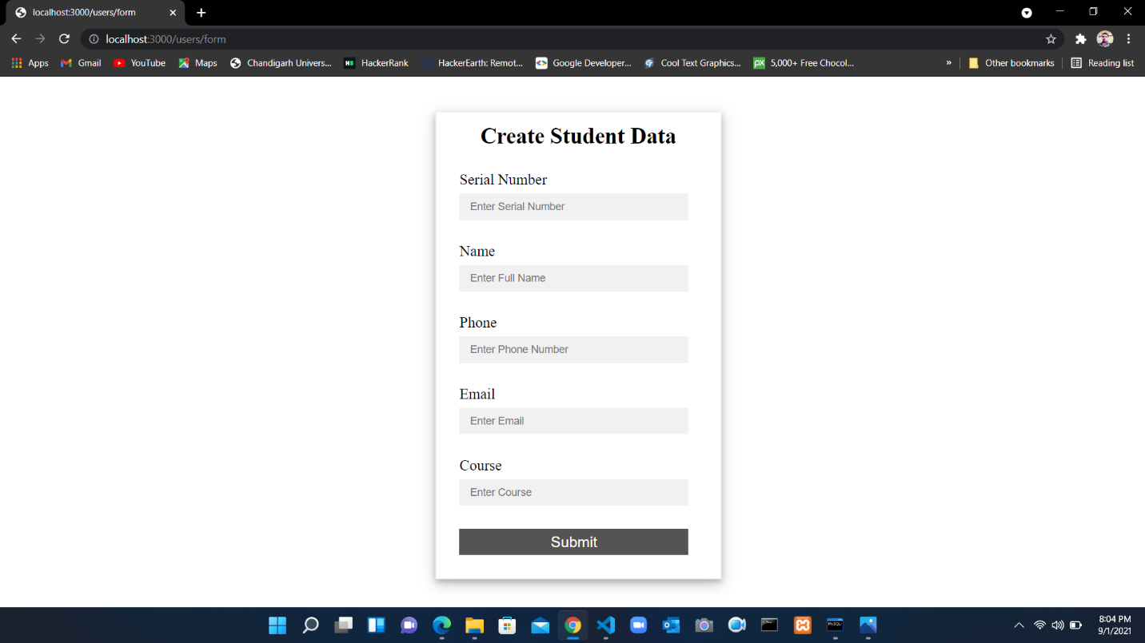

**To display the entered data**

<http://localhost:3000/users/user-list>

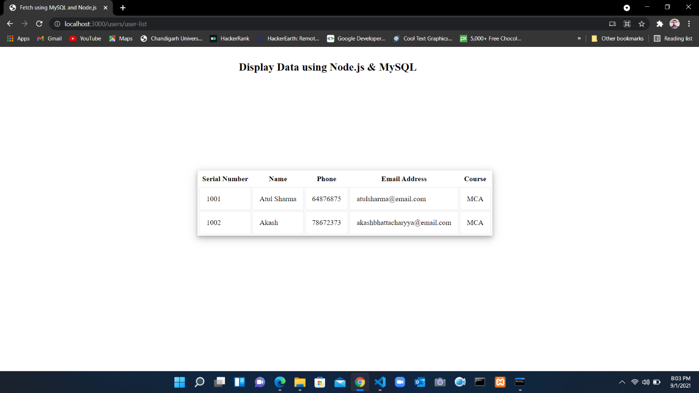

**Database**

**mysql>** create database verzeo;

**mysql>** use verzeo;

**mysql>** create table students (sno int, Name varchar(255), Phone int, email varchar(255), course varchar(255));

**mysql>** show tables;