AUTOBOXING

public class wrapper

{

public static void main(String args[])

{

int a=20;

Integer i=Integer.valueOf(a);

Integer j=a;

System.out.println(a+""+i+""+j);

}

}

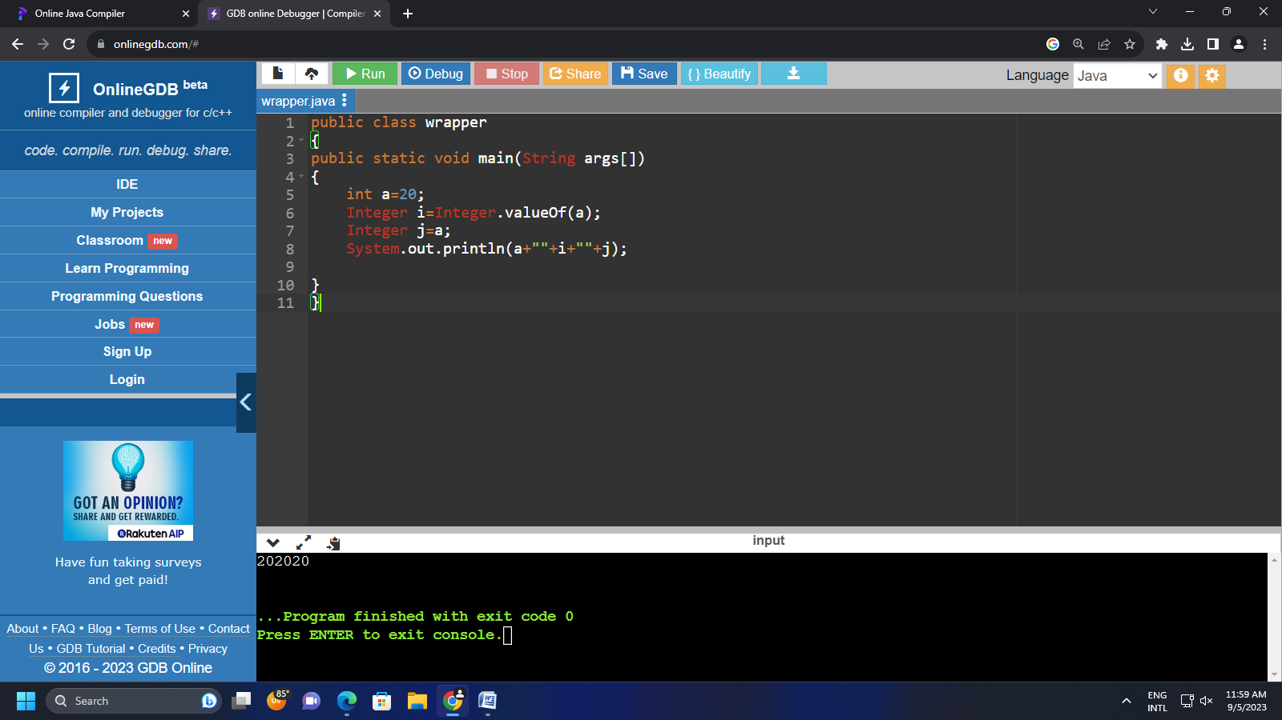

UNBOXING.

public class wrapper

{

public static void main(String args[])

{

Integer a = new Integer(3);

int i=a.intValue();

int j=a;

System.out.println(a+""+i+""+j);

}

}

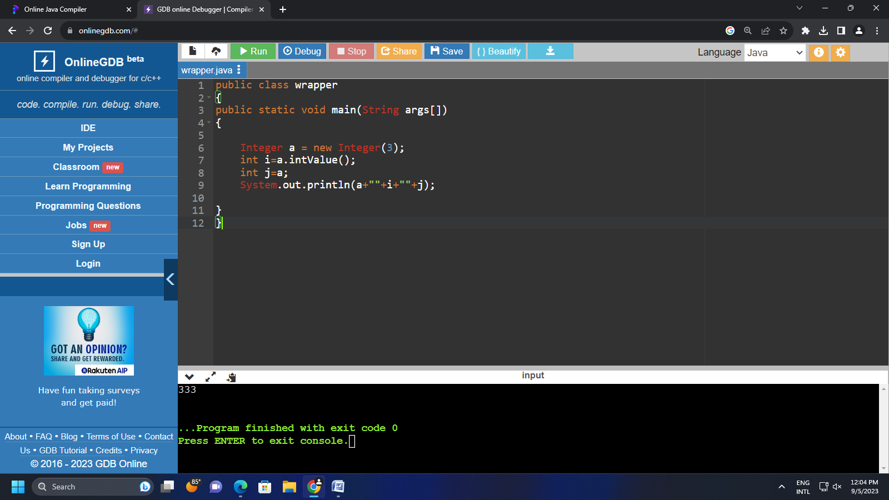

Declare primitive data type with some value convert it into object using wrapper class?

public class Wrapper

{

public static void main(String args[])

{

int i=16;

Integer I=i;

char c='a';

Character C=c;

short s=8;

Short S=s;

long l=135;

Long L=l;

float f=3.55F;

Float F=f;

double d=3.5675;

Double D=d;

System.out.println(I+" "+C+" "+S+" "+L+" "+F+" "+D+" ");}}

