Q1
A Dictionary stores keywords & its meanings. Provide facility for adding new keywords, deleting keywords, updating values of any entry. Provide facility to display whole data sorted in ascending/ Descending order. Also find how many maximum comparisons may require for finding any keyword. Use Binary Search Tree for implementation.
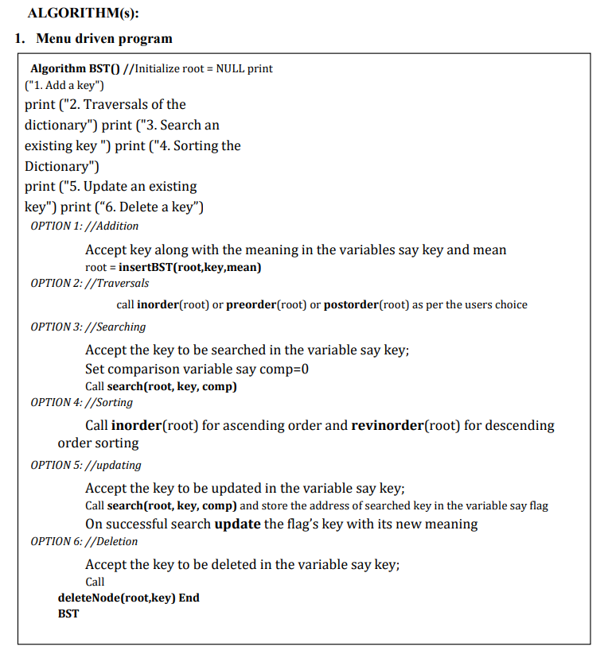
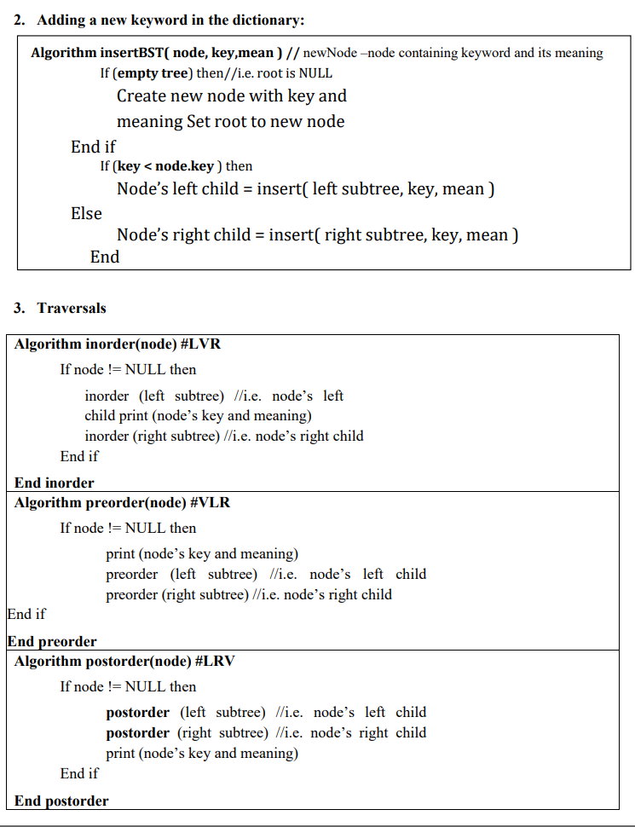
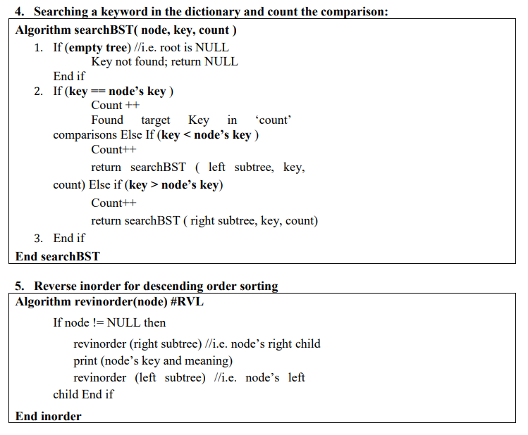
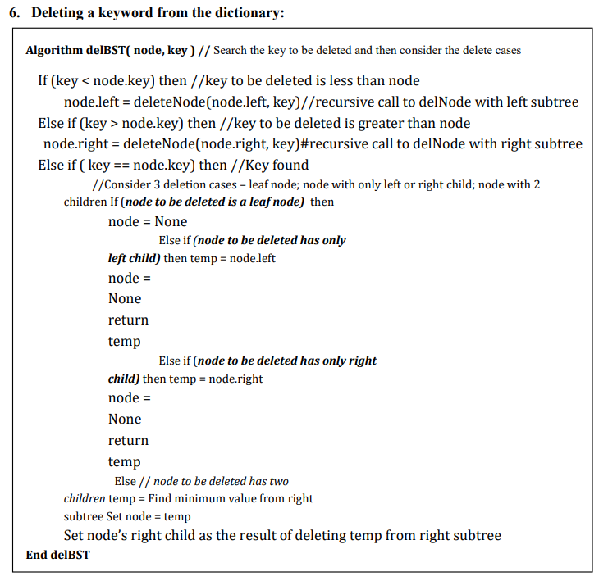

Q2
Accept prefix expression, and construct a binary tree and perform recursive and non-recursive traversals.
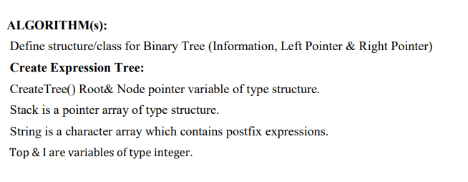
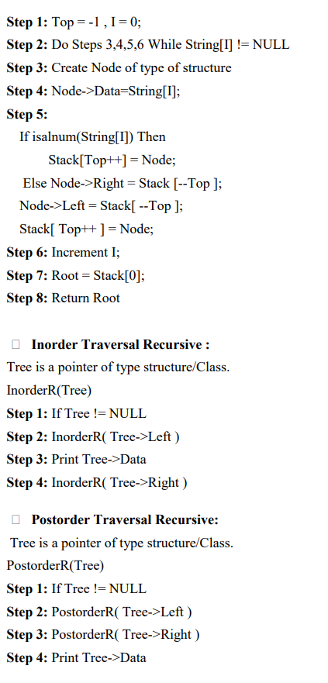
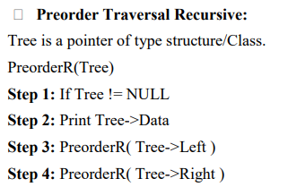

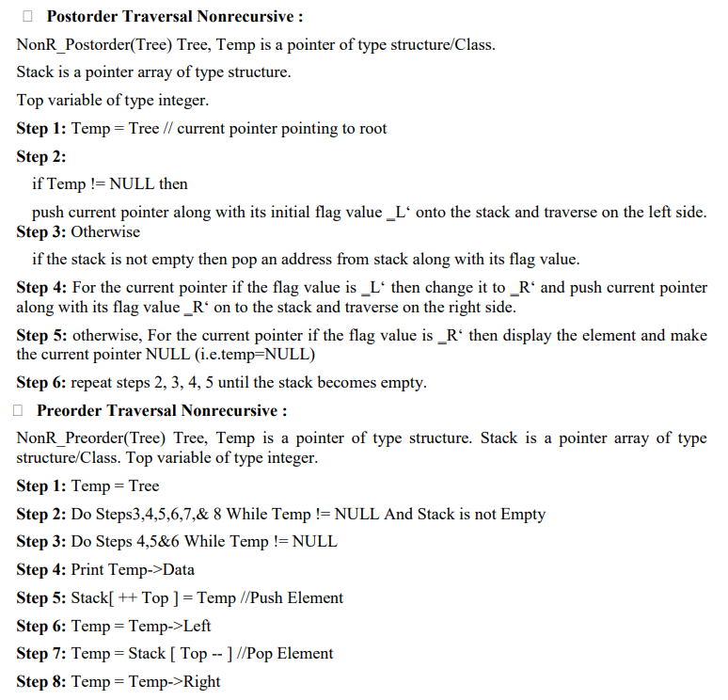
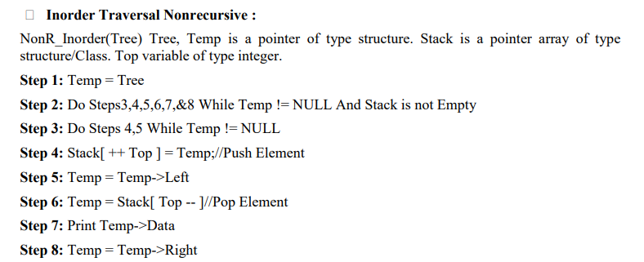

Q3
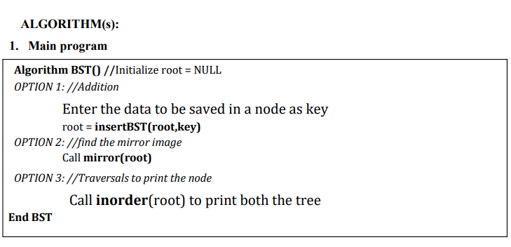
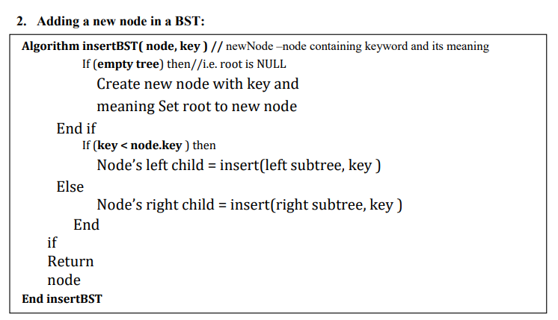
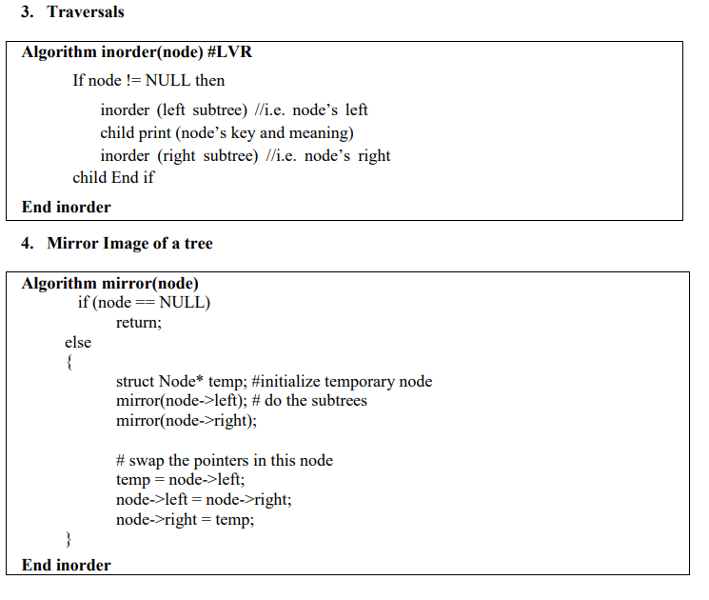

Q4
Create inorder threaded binary search tree and perform the traversals Objective(s):
Implement threaded binary search tree.
Perform traversal and print the tree.
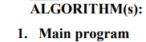
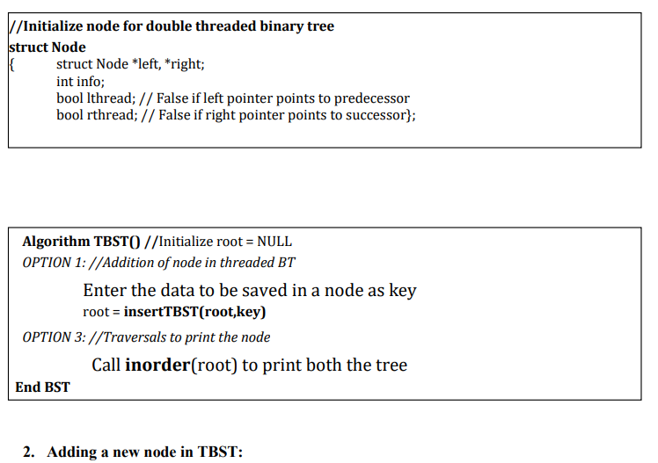
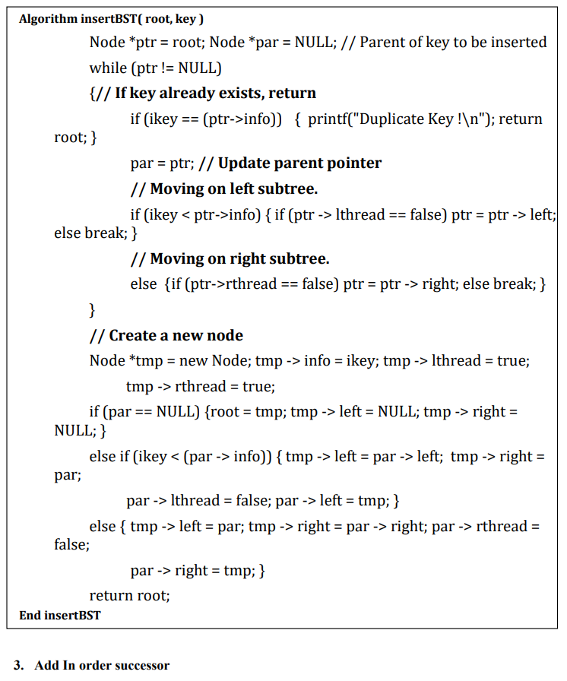

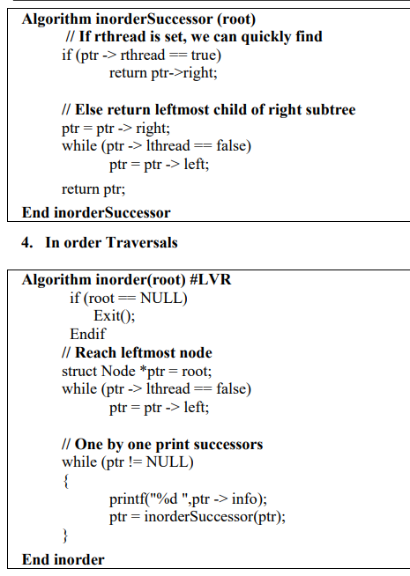

Q5
Represent a given graph using adjacency list and perform DFS and BFS.
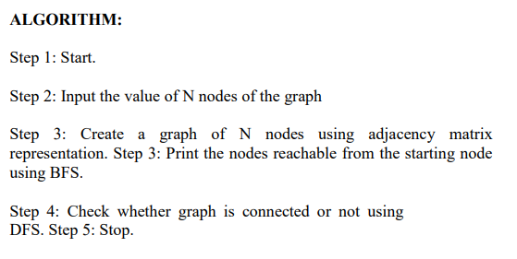

Q6
Represent a given graph using an adjacency list or array and find the shortest path using Dijkstra algorithm
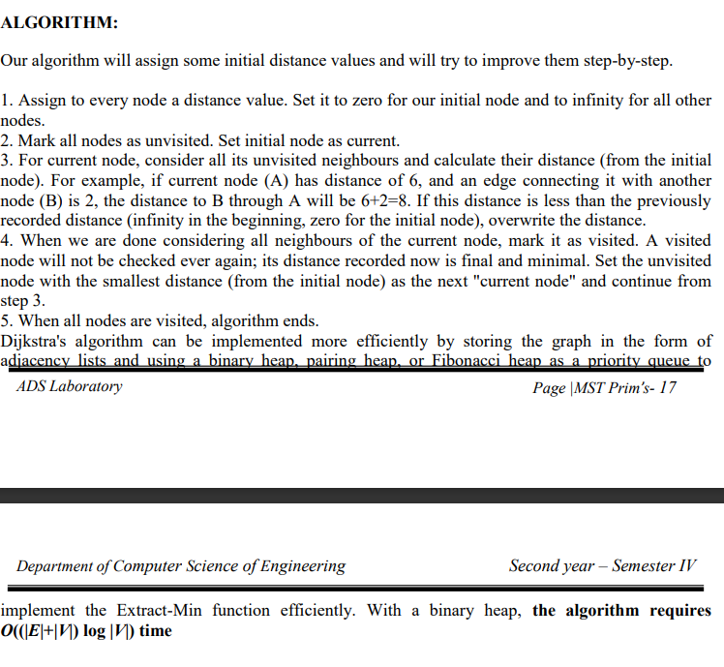

Q7
Represent a given graph using an adjacency list or array and generate a minimum spanning tree using Kruskal's or Prim’s algorithm
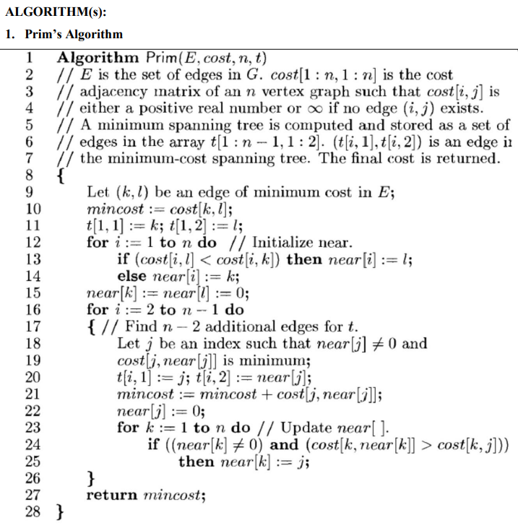
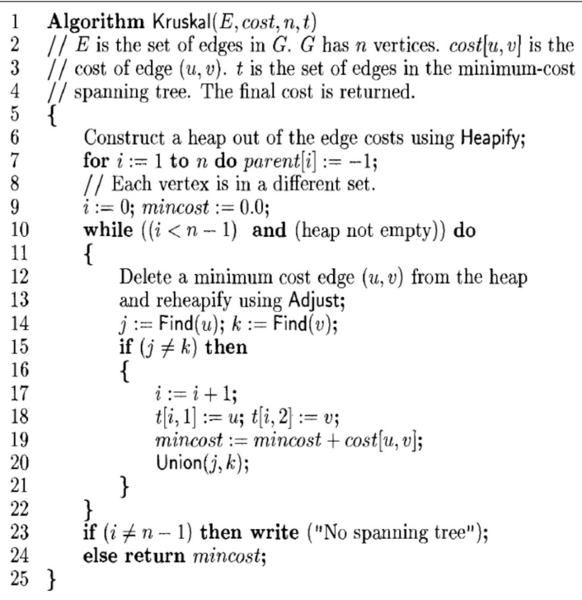
Q8
Create a hash table and handle the collisions using linear probing with or without replacement.

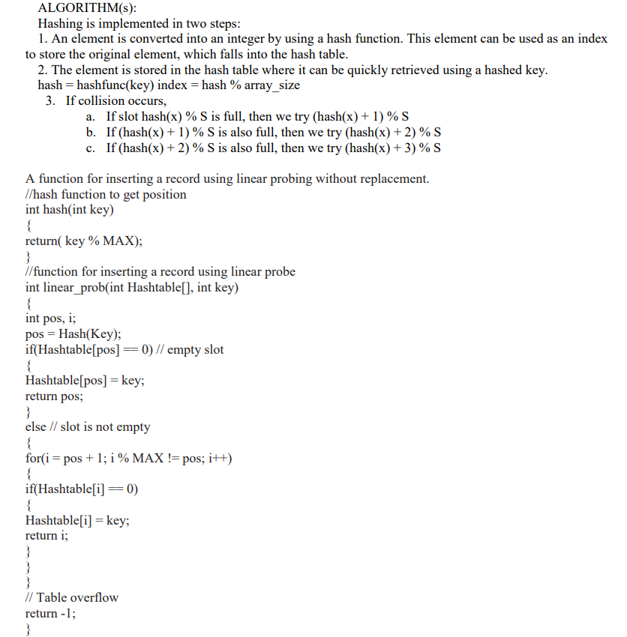

Q9
Company maintains employee information as employee ID, name, designation and salary. Allow user to add, delete information of employee. Display information of particular employee. If employee does not exist an appropriate message is displayed. If it is, then the system displays the employee details. Use sequential file to maintain the data
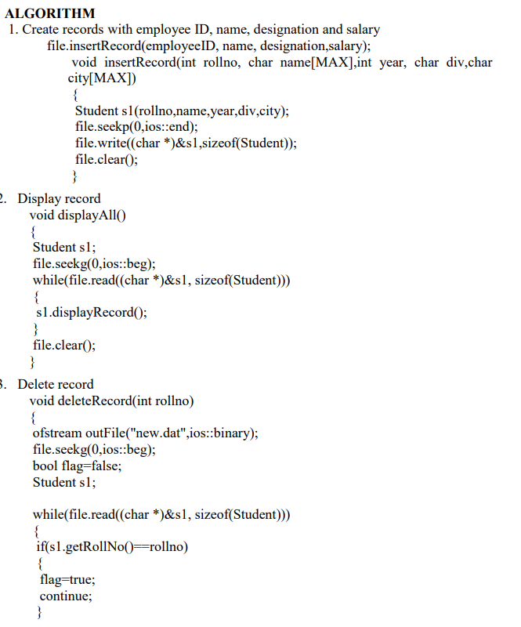
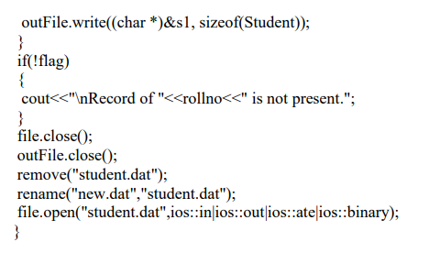

Q10
Implementation of direct access file - Insertion and deletion of a record from a direct access file using chaining with or without replacement.
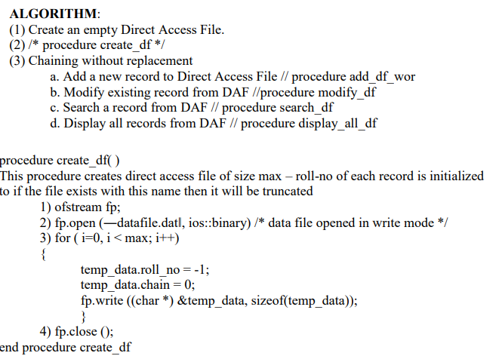
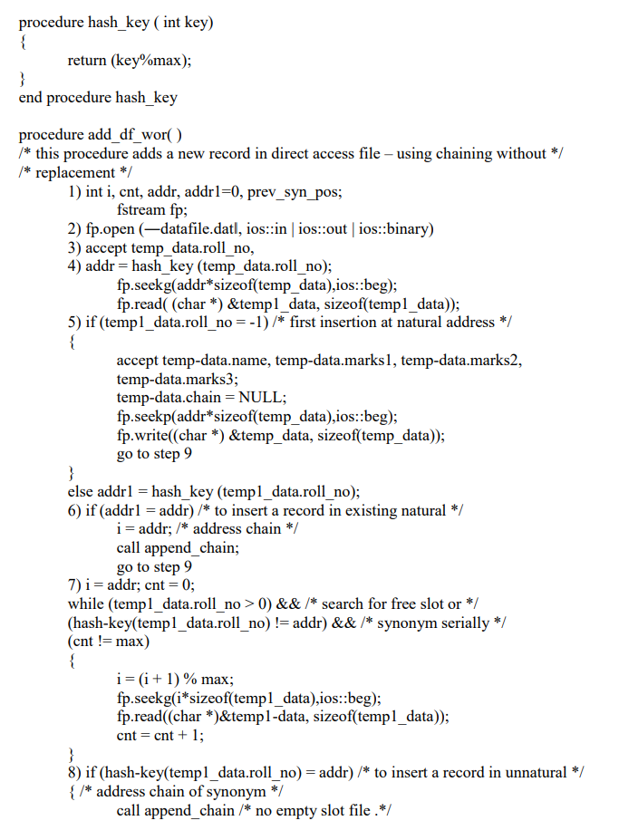
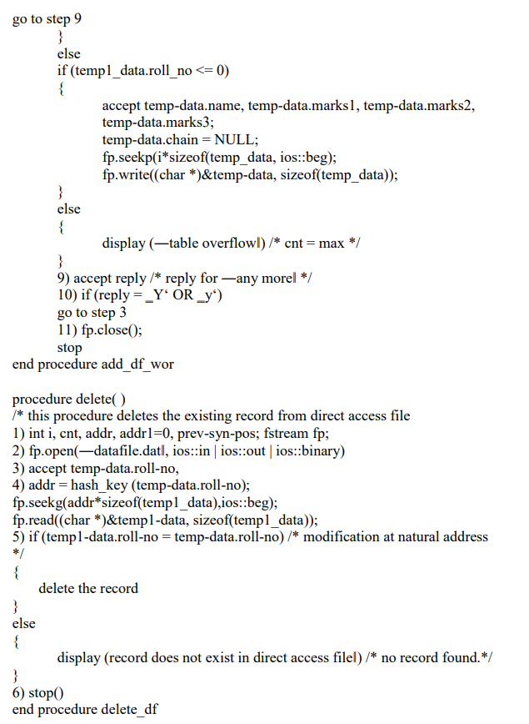

Q11
A Dictionary stores keywords & its meanings. Provide facility for adding new keywords, deleting keywords, updating values of any entry. Provide facility to display whole data sorted in ascending/ Descending order. Also find how many maximum comparisons may require for finding any keyword. Use Height balance tree and find the complexity for finding a keyword.
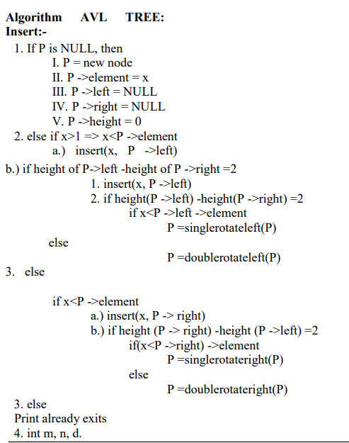
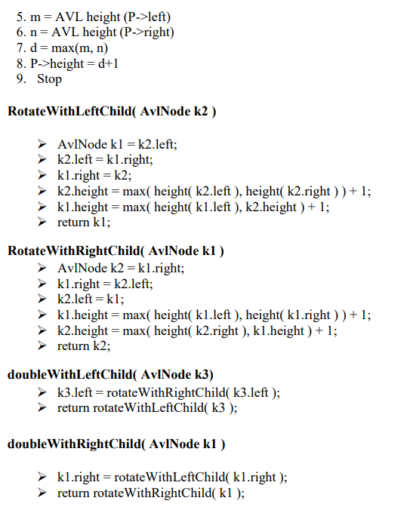

Q12
Consider telephone book database of N clients. Make use of a hash table implementation to quickly look up client’s telephone number
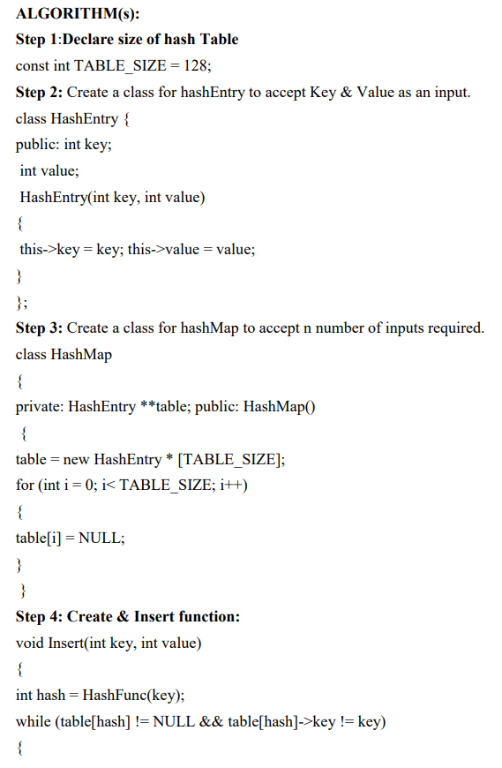
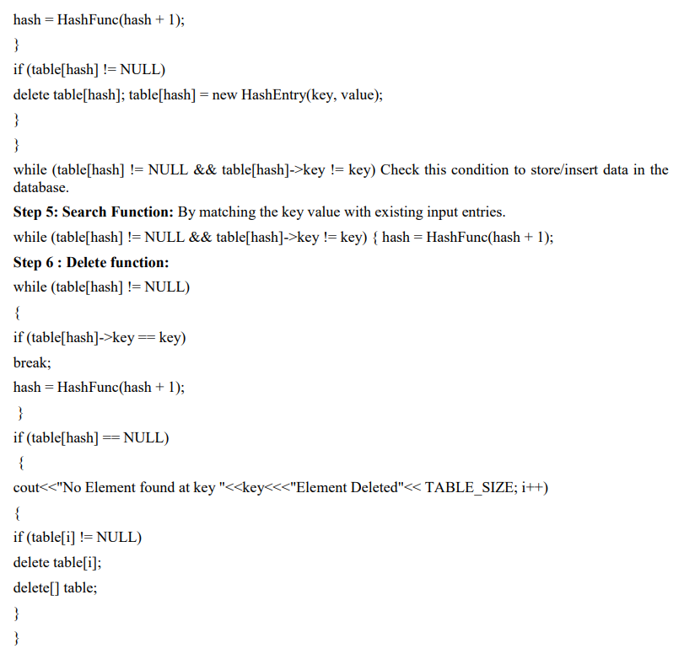

Q13
Implement Heap sort.
