Comments for TuraGrammar
- To be integrated with TuraResearchAssistant
- Not checking grammar accurately
- This tool does not require any summary generation. Please remove
- Rewrite, shorten, expand, etc. These features are not working
- AI suggest is not working or explain what to expect from this feature
- We should highlight the suggestions or changes should appear in track mode
- Provide a function to upload document instead of just copy pasting
- Provide a tab for selecting language (UK/US English), currently it’s by default US English
- No significance of this score. Please remove
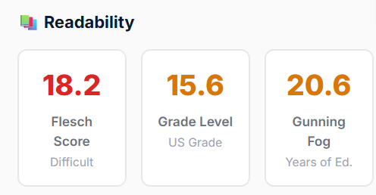
- There is tab below, which languages?
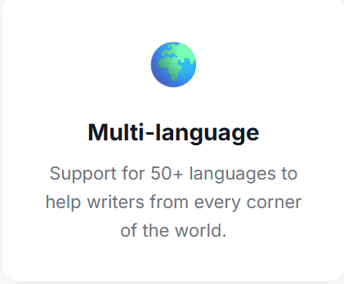

We checked the paragraph below, which contains grammar mistakes, but the tool was not able to detect all the errors and showed the result as 100% accurate.
Gastroesophageal reflux disease were
defined as reflux of gastric content into
the esophagus, resulting in significant
symptoms and/or complications
Voting percentage: A 91.6, D 8.3
Level of evidence: 3
Grade of recommendation: III
The term gastroesophageal reflux
denotes retrograde movement of gastric
content into the esophagus. Although
mild occasional reflux of gastric
content into esophagus is common, it is
considered a disease if it is significant
enough to causes symptoms and/or
complications. Sour regurgitation and
heartburn is the cardinal symptoms
of GERD. Accordingly, the reflux
of gastric content into esophagus,
resulting in significant symptoms
(heartburn/regurgitation for at least
once a week for at least one month) and/
or complications was considered
appropriate definition of GERD by the
task force.
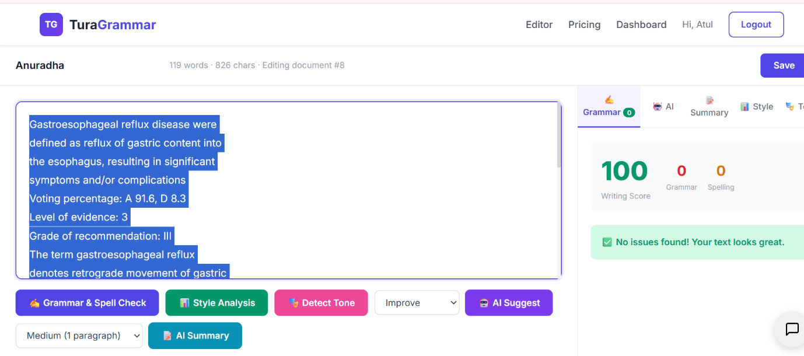

Comments for TuraBot
- It is taking a lot of time to upload the PDF
- After uploading the PDF, the tool is unable to identify it and asking again to upload upon asking to summarize
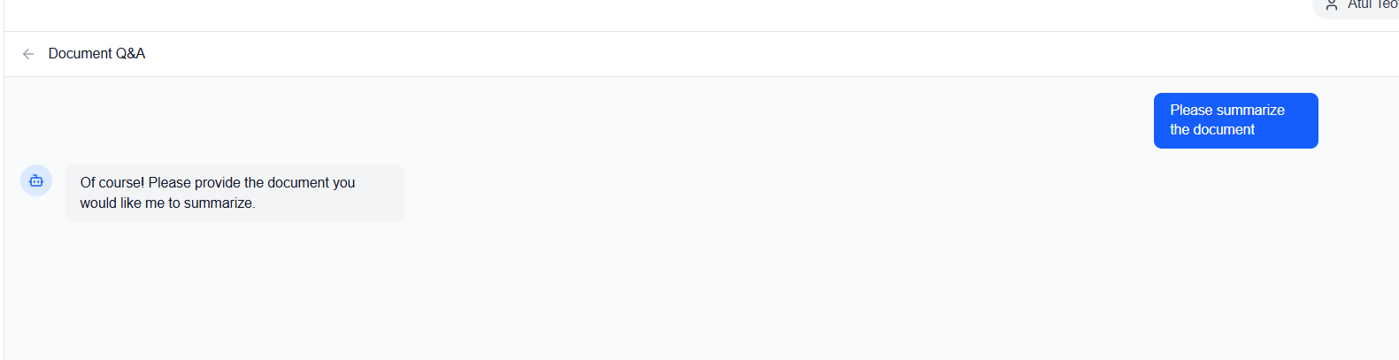
- How to work as a team after creating it and what features it provides. After accepting the team request, the status is showing as “PENDING”
- Explain more about live chats
- TuraNewbot: Functionality is not clear.
- Remove PDF Reader from this tool, it’s not required here.
- Please make this tool only for communication with client or internal team. It’s quite confusing.

Comments for TuraResearchAssistant
TuraResearch Assistant should be expanded so it can support researchers with more than just PDF-based Q&A. Right now, it mainly takes a PDF and answers questions from it, but we want it to become a more complete research assistant.
Please add the following features to the platform:
- PDF Reader
Users should be able to upload, read, search, summarize, and ask questions from PDFs.
- TuraGrammar
Grammar correction tool that helps improve spelling, grammar, punctuation, sentence structure, clarity, and academic tone.
- AI Writer
Add an AI writing feature where researchers or students can enter a prompt and get help writing content such as abstracts, introductions, research summaries, proposals, essays, reports, or other academic content.
- Paraphraser
Add a paraphrasing tool that rewrites text while keeping the meaning the same. After paraphrasing, it should also check that the output is not repeating the same 3–4 words from the original text in the same line or sentence.
- Literature Search
Add a literature search option where users can enter a prompt, keyword, or research question, and the system can search and extract relevant articles from sources like PubMed and Google Scholar (atleast 50 from both the databases).
- Data Extraction
Add a feature where users can upload a PDF or Word document and extract data into a specific template provided by the user, such as a table, form, or custom research extraction sheet.
- Find Novel Ideas
Add a feature that helps users find new research ideas, research gaps, concepts, and possible study topics based on their prompt, uploaded documents, or existing literature.
- Workspace, Projects, and History
The workspace, projects, and history tabs are already there, and they should stay because they are useful for organizing work and keeping track of previous tasks.
The main goal is to make TuraResearch Assistant a complete research support platform where users can read, write, search literature, paraphrase, extract data, generate new ideas, and manage their research work in one place.

