**“Matches App”**

**Index**

* 1. Hardware Requirement
  2. Software Requirement
  3. Synopsis
  4. Service Requirements
  5. Features
  6. Use Case Diagram

**1.1 Hardware Requirement**

Processor - 2 GHz and above

Hard Disk - 500 GB

RAM - 4 GB

**1.2 Software Requirement**

Operating System - Windows

Software (IDE / Frameworks)-

1. Spring (STS)
2. MongoDB
3. Git bash
4. Postman
5. Chrome Browser
6. JDK 11
7. Mockito
8. Junit

**1.3 Synopsis:**

The Matches App application gives the more information about matches. It gives better and smooth schedule of all the matches. Using this can add and fetch the match details. User can easily access the match details by upcoming match schedule and old matches done, also recommendations. In this application it lists the match details.

It also provides details about

1. Upcoming Matches
2. Old Matches
3. Recommended Matches

The user wants to register first and login to access the system. Once registered user can login through username and password provided by him. After logging in the user should select the kind of activity he would like to perform. User can search match details by giving specific details.

**1.4 Service Requirement:**

1. Login
2. Eureka
3. API Gateway
4. Adding Matches (Admin)
5. Upcoming matches
6. Old Matches
7. Recommendations for user

**1.5 Features:**

1. Registration and Login Authentication.
2. Smooth schedule of matches
3. Gives the detailed schedule of upcoming, old matches and recommendations for users

**1.6 Use Case Diagram:**

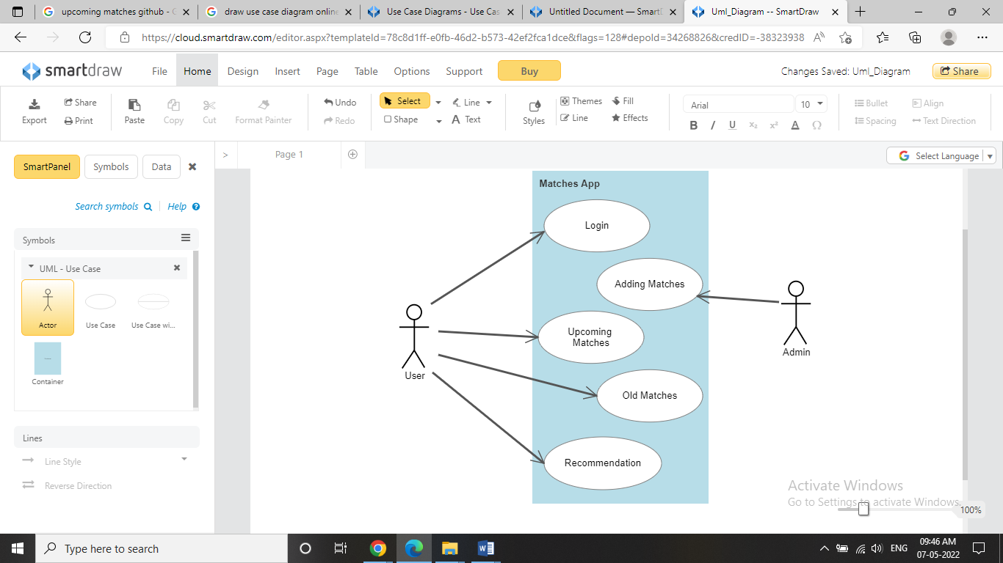

**Code Coverage:**

**EurekaServerService**

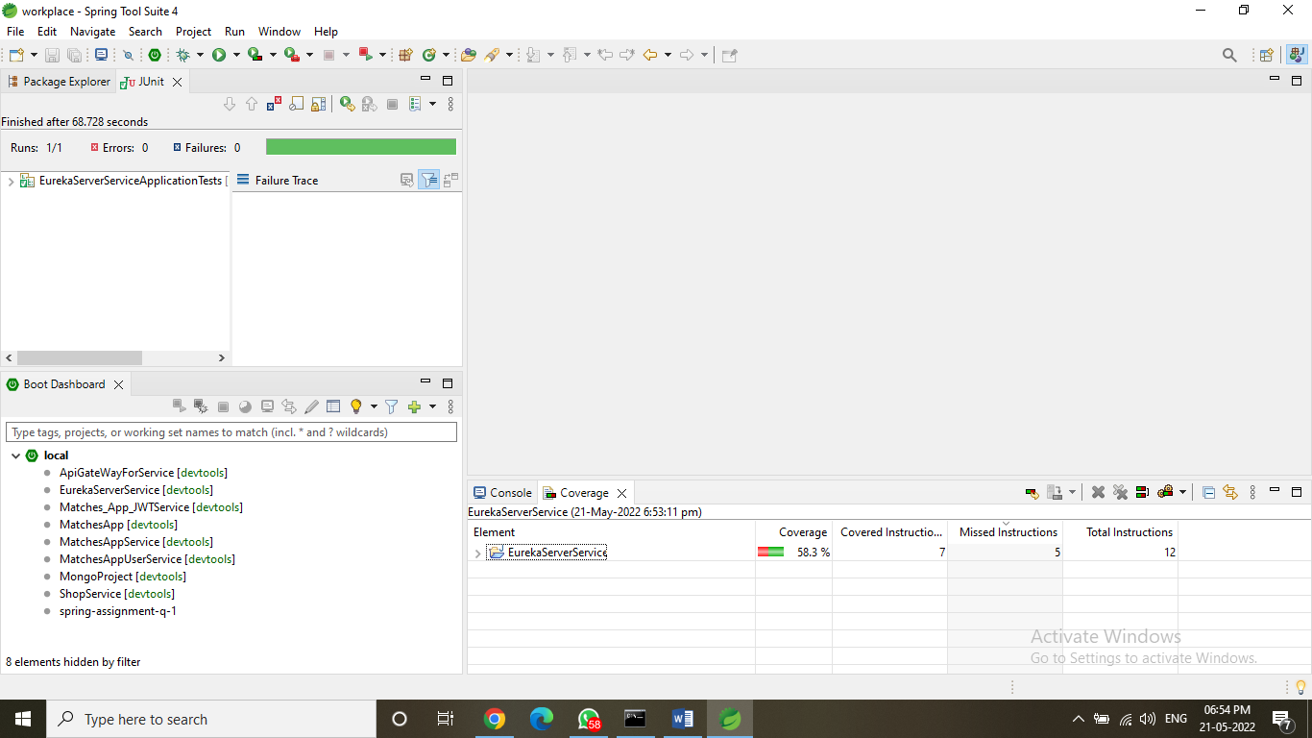

**ApiGateWayForService**

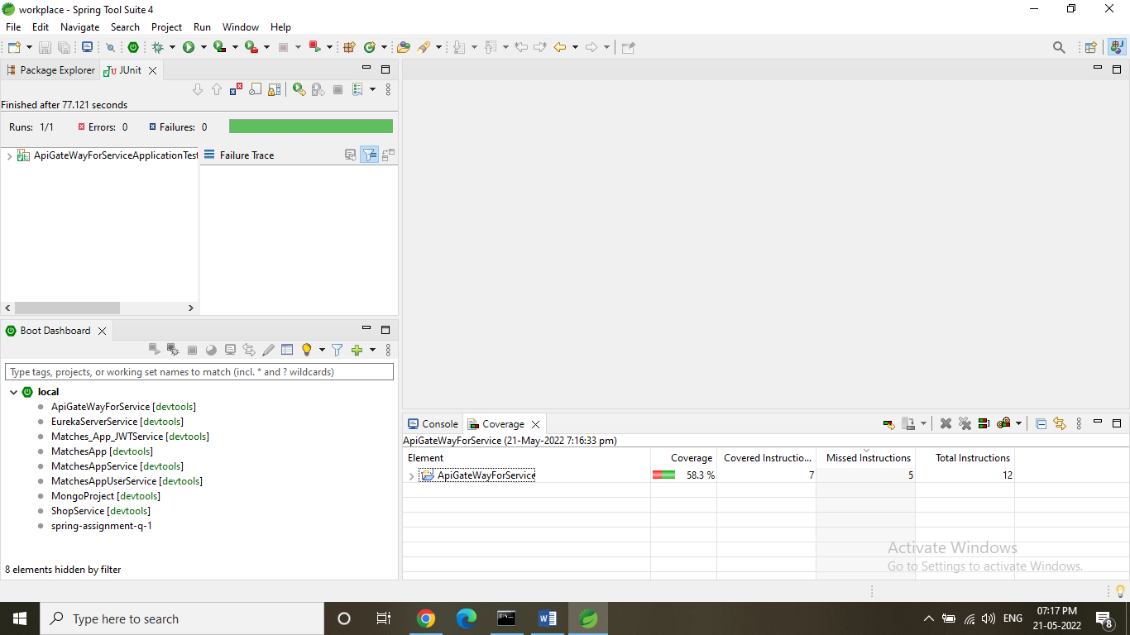

**Matches_App_JWTService**

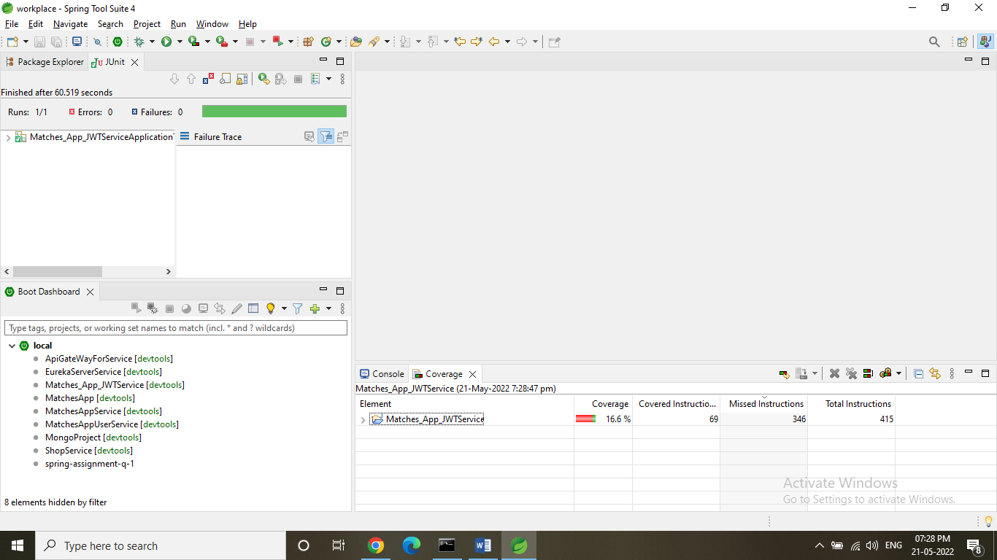

**MatchesAppService (Admin)**

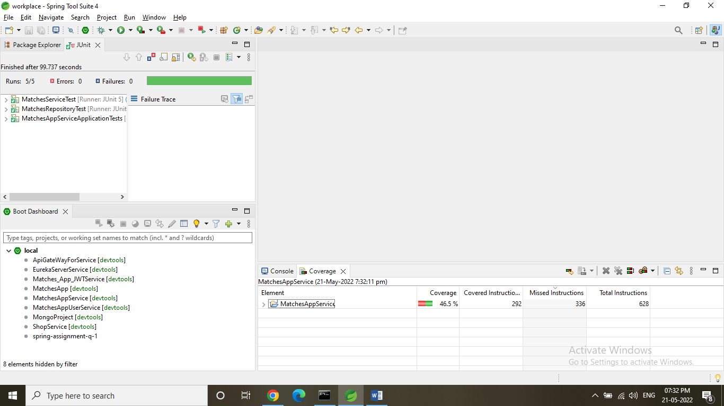

**MacthesAppUserService**

