Rock Island News
‘Don’t cook tonight, call Chicken Delight!’
Roald Tweet | (4) comments
Al Tunick was not the kind of young man to sit back and wait for the American Dream to knock. He went looking. In 1936, the Canadian immigrant married Ethel Harris of Rock Island and joined her father’s company, A.D. Harris Scrap Metal. At the same time, he pursued his own schemes, like selling old box cars to farmers for storage. 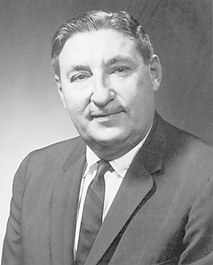In 1950, Tunick found himself the successful bidder for a defunct company and a warehouse full of low-pressure cookers and fryers. In order to demonstrate the cooker’s potential to buyers, he and his entire family opened a chicken restaurant at 2920 18th Ave. in Rock Island. Here, he decided to push a new concept — take-out meals. Customers could buy an entire meal in a box, take it home and eat it there. He called his restaurant Chicken Delight. It was such a success that he soon opened a second restaurant on 16th Street in Moline’s Uptown. For a brief time, Tunick even delivered boxes of his chicken by parachute to area farm families. By the following year, the young entrepreneur was crossing the United States selling franchises for Chicken Delight. New restaurants increased so rapidly that Tunick had to open a factory and warehouse at 2211 3rd Ave. for the manufacture and distribution of new cookers. By 1965, there were 750 Chicken Delight restaurants around the country. Through advertising in national media and mentions by entertainers such as Bob Hope, “Don’t cook tonight, call Chicken Delight!” became a household phrase. In spite of his success, Al Tunick kept looking. He sold his company to Consolidated Foods and went on to develop several other franchises, most notably the Karmelkorn shops, whose enticing aromas became a feature of every new mall in the country. By the time he died in 1987, Al Tunick had changed the way America eats.
Dr. Roald Tweet is a historian, folklorist and professor emeritus of the Augustana College English department. Contact him at rinews@qctimes.com. Listen to “Rock Island Lines” on WVIK, Augustana Public Radio, 90.3 FM at 11 a.m. and 5:27 p.m. Monday through Friday.

