Bisphere Problem Summary

Let a bisphere segment be defined as two circles connected by a line segment. Call one endpoint circle B, and one endpoint circle S. The goal is, given some number of bisphere segments N and a 2D grid of dimensions Y by X, place the bispheres on the grid in a way that maximizes the number of contacts between the S circles (maximize how many are adjacent to one another). We define a contact as an instance where an S circle is next to another S circle on the grid. Each segment can be placed vertically or horizontally.

An example of this problem is below (B circle is green; S circle is red):

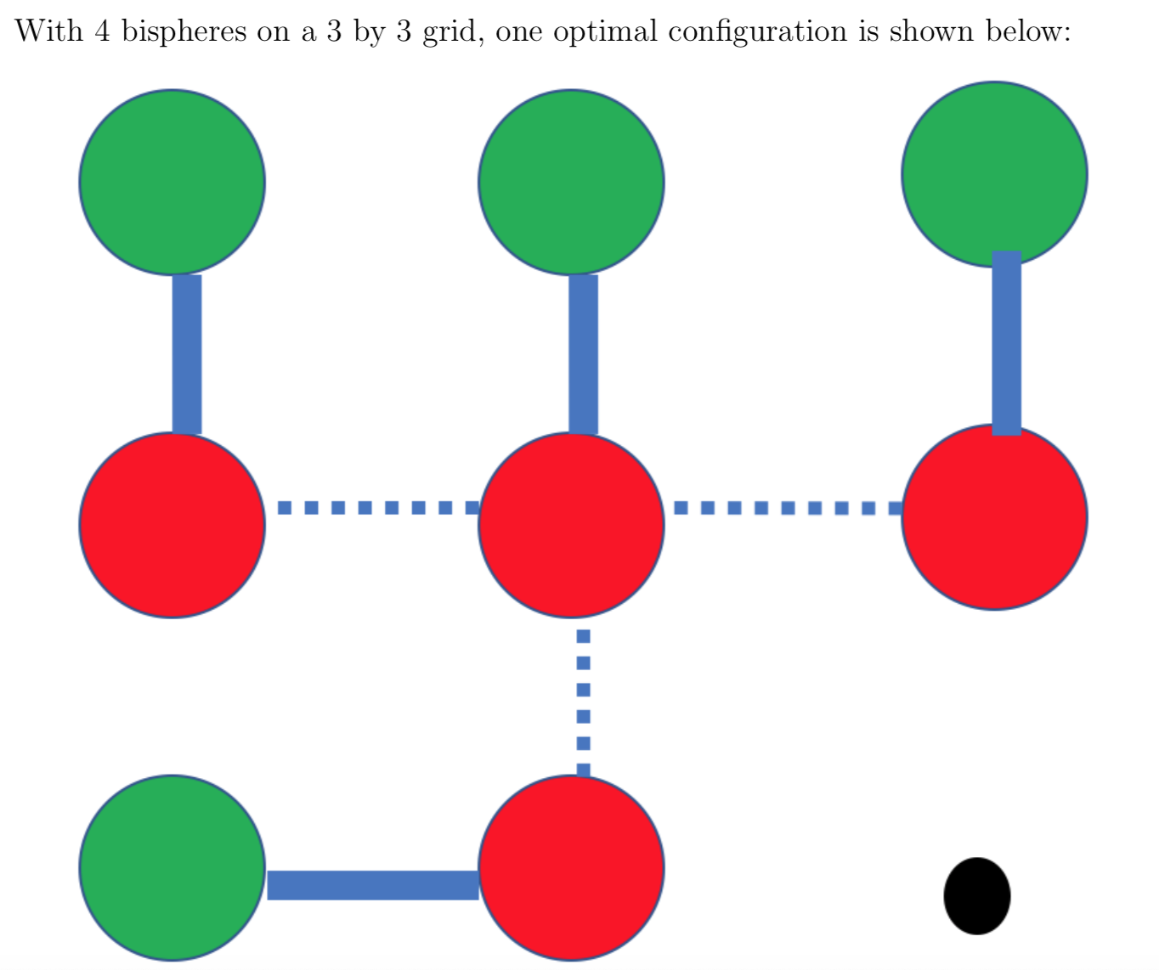

In the above example, the maximum contact number is 3 (contacts shown by dotted lines).