#### Thermal-Hydraulic performance analysis of chip cooling in electronic devices using Machine Learning

Project-I (ME47603) report submitted to Indian Institute of Technology Kharagpur

in partial fulfillment for the award of the degree of Bachelor of Technology

in

Manufacturing Science and Engineering

**by**

**Tushar Mishra (18MF3IM35)**

**Under the supervision of Professor Chirodeep Bakli**



**Department of Mechanical Engineering Indian Institute of Technology Kharagpur Autumn Semester, 2021-22**

**November 24, 2021**

#### DECLARATION

I certify that

1. The work contained in this report has been done by me under the guidance of my supervisor.
2. The work has not been submitted to any other Institute for any degree or diploma.
3. I have conformed to the norms and guidelines given in the Ethical Code of Conduct of the Institute.
4. Whenever I have used materials (data, theoretical analysis, figures, and text) from other sources, I have given due credit to them by citing them in the text of the thesis and giving their details in the references. Further, I have taken permission from the copyright owners of the sources, whenever necessary.

Date: November 24, 2021 (Tushar Mishra) Place: Kharagpur (18MF3IM35)

#### [DEPARTMENT OF MECHANICAL ENGINEERING](http://www.iitkgp.ac.in/department/CE) [INDIAN INSTITUTE OF TECHNOLOGY KHARAGPUR](http://www.iitkgp.ac.in/) KHARAGPUR - 721302, INDIA



##### CERTIFICATE

This is to certify that the project report entitled “**Thermal-Hydraulic performance analysis of chip cooling in electronic devices using Machine Learning**” submitted by **Tushar Mishra** (Roll No. 18MF3IM35) to the Indian Institute of Technology Kharagpur towards partial fulfillment of requirements for the award of the degree of Bachelor of Technology in Manufacturing Science and Engineering is a record of bonafide work carried out by him under my supervision and guidance during Autumn Semester, 2021-22.

Professor Chirodeep Bakli

Date: November 24, 2021 School of Energy Science and Engineering Place: Kharagpur Indian Institute of Technology Kharagpur

Kharagpur - 721302, India

## Abstract



Name of the student: **Tushar Mishra** Roll No: **18MF3IM35**

Degree for which submitted: **Bachelor of Technology**

Department: **Department of Mechanical Engineering**

Thesis title: **Thermal-Hydraulic performance analysis of chip cooling in electronic devices using Machine Learning**

Thesis supervisor: **Professor Chirodeep Bakli**

Month and year of thesis submission: **November 24, 2021**



With growing demands and the trend to manufacture ever-smaller electronic devices, power production, and heat flux has increased tremendously over the past decades. Hence, an efficient thermal management system is indispensable to obtain extraordinary performance indicators. The conventional air cooling system has remained inept in removing excess heat. This has sparked the development of numerous innovative chip cooling techniques. An effective thermal management technique for chip cooling in electronic devices is a liquid-cooled microchannel heat sink (MCHS). This technique reduces thermal resistance at chip junctions and keeps the chip surface temperature as low as possible.

We have done extensive analysis and Optimization studies using Machine Learning to obtain maximum heat transfer parameters.

## Acknowledgments

I am greatly indebted to my project supervisor Prof. **Chirodeep Bakli** and my mentor Mr. **Avinash Kumar** for their invaluable guidance and encouragement throughout this project. I am thankful for their aspiring guidance, invaluably constructive criticism, and friendly advice during the project work. I would like to take this opportunity to express my sincere and profound gratitude to them.

I would also like to gratefully acknowledge the suggestions and discussions received from my fellow project members and students at IIT Kharagpur whenever I had any doubt.

I sincerely thank all the faculty of the Mechanical Engineering Department for their kind cooperation in all phases of my project work.

Last but not the least, I thank my parents and all my family members for the support and motivation they have provided throughout my project.

**Tushar Mishra 18MF3IM35**

# Contents

**Declaration**

**Certificate**

**Abstract**

**Acknowledgements**

**Introduction**

**Literature Review**

**Theory, Modeling, and Methodology**

**Machine Learning Theory and Problem Formulation**

**Dataset**

**ML Methodology and Process Flow**

**Results**

**Conclusion**

**Future Scope**

**Bibliography**

**1. Introduction**

In our ever-growing quest for a truly smart future, we have created a communication and computer revolution. The electronics industry has aided us at every step of the way in ensuring industrial automation, high-performance, and intense data processing power.

We have achieved consistent miniaturization of these devices for decades, and now we have almost pushed them to their absolute physical limits. As a result, there has been a tremendous increase in power production and consumption, and heat flux through these devices, and we need an effective and efficient thermal management system to obtain optimum performances.

Air cooling disperses the heat in and around the device, and hence it often increases the ambient temperature of the overall system. An air cooler involves more power consumption, is not suitable for sustained cooling for longer durations and the cooling effect is not that high. Hence we need better technology to cool chips in electronic devices.

One of the most effective cooling techniques is using a liquid-cooled microchannel heat sink (MCHS). This method reduces the thermal resistances of the chip junctions and keeps the chip temperature as low as possible. We will explore and analyze the various geometric and physical properties of such a system and obtain critical values from optimization study using extensive Machine Learning techniques.

**1.1 Problem Statement**

We are interested in the Thermal-Hydraulic performance analysis of chip cooling in electronic devices using Machine Learning. We will study the effect of various geometric and physical parameters of a double-layer tapered microchannel heat sink (DL-MCHS) with a counter flow arrangement. We will obtain the critical Tapering Factor at which maximum heat transfer takes place using various Regression models.

**1.2 Objectives Of The Study**

The primary objectives of the study are

* Establishing and modeling the critical geometric and fluid flow parameters
* Exploratory data analysis of the Model dataset
* Formulation of the problem into a Machine Learning use case
* Obtaining critical parameters for the regression problem
* Creating an Empirical Formula for Nusselt number

**2. Literature Review**

Energy conversion and utilization are continuous but ever-increasing processes for sustainability and economic development. Environmental concerns, such as thermal and air pollution, have dictated the practices of energy conservation and recovery, as well as the implementation of clean energy sources. Efficient heat exchangers are an important component for processes where energy conservation is achieved through enhanced heat transfer. Such issues as increased energy demands, space limitations and material savings have highlighted the necessity for miniaturized light-weight micro-channel heat sinks (MCHS), which provide high heat transfer when compared to traditional air cooling in electronic devices. The traditional heat exchangers employ ineffective techniques and subpar geometric parameters, cross-sections, orientations, and surface textures. With the current boom in the electronics industry, this technology is nearing its limits and will become obsolete. Microchannels are a particular target of research due to their higher heat transfer and reduced weight as well as their space, energy, and materials savings potential over regular tube counterparts.

The first MCHS was proposed by Tukerman and Pease [1] and they manufactured MCHS by etching micro-channel on a silicon substrate which was 50 µm wide and 300 µm deep to remove heat flux of 790 W cm−2 from very large scale integration (VLSI) chip by passing water through micro-channels.

Qu and Mazumdar [2, 3] concluded that the Navier–Stokes equation and energy equation can satisfactorily predict the fluid flow and heat transfer characteristics of MCHS.

**2.1 Gap Identification**

In contrast to traditional heat exchangers, the heat transfer and fluid flow correlations, and the systematic design procedures are not yet well established for microchannels. It remains to be established whether the classical fluid flow and heat transfer theories and correlations are valid for microchannels. Numerous investigations are underway with researchers consolidating evidence on both sides of this question.

Most of the established research can be classified as experimental and numerical study.

In this paper, we will employ various Regression models to obtain the results in a novel attempt to tackle this problem.

**3. Theory, Modeling, and Methodology**

A tapered double-layered MCHS (DL-MCHS) is composed of two layers separated by a solid rib where both the lower and upper microchannels are converging in nature due to tapered in the middle rib with a counter-flow heat arrangement.

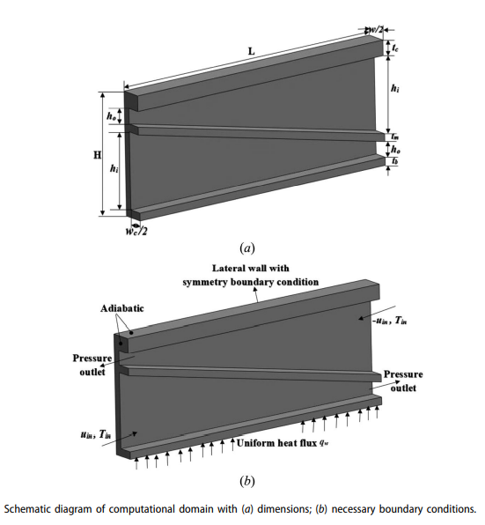

| **Material** | **Density**  **(kg/m3)** | **Specific heat**  **(J/kg-K)** | **Thermal conductivity**  **(W/m-K)** | **Viscosity**  **(kg/m-s)** |
| --- | --- | --- | --- | --- |
| Water | 998.2 | 4182 | 0.6 | 0.001003 |
| Silicon | 2330 | 703 | 149 | - |

Fluid used: **Water**

Substrate material: **Silicon**

| **Parameters** | **Values (µm)** |
| --- | --- |
| Channel length, L | 10,000 |
| Channel width, wc | 100 |
| Channel height at inlet, hi | Vary with TF |
| Channel height at outlet, ho | Vary with TF |
| Total channel height, Hc = hi + ho | 1050 |
| Width of computational domain, w | 200 |
| Thickness of base, tb | 50 |
| Thickness of middle rib, tm | 50 |
| Thickness of cover, tc | 50 |

**3.1 Numerical Model**

Using Navier–Stokes equations with Boundary conditions and Energy equations: (Mass, Momentum, and Energy), we obtain the following results

Tapering Factor : 

Reynolds number : 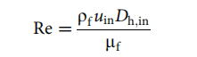

Inlet hydraulic diameter: 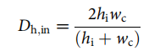

Overall thermal resistance : 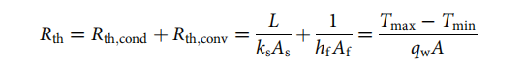

(* Assumptions: We can neglect RThermal  of solid and hence, we obtain TChip ~ TWall

Now, to determine the overall convective heat transfer in the channel having a non-uniform cross-section, the average Nusselt number is calculated as

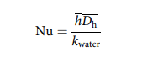

where the average heat transfer coefficient : 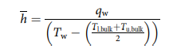

and the mean hydraulic diameter : 

With an increase in tapering, the convective heat transfer coefficient increases, and hence the Nusselt number increases.

Nusselt number is a measure of the ratio between heat transfer by convection and heat transfer by conduction alone. The larger the Nusselt number, the more effective the convection

**4. Machine Learning Theory and Problem Formulation**

We formulate the given problem as a Multivariate Regression Problem. We will try to quantify the effect of various numerical features like Tapering Factor, Reynolds Number, Temperature, and Heat Flux on Nusselt Number.

We will try to incorporate the following three types of features

* Variables that are already proven in the literature to be related to the outcome.
* Variables that can either be considered the cause of the exposure, the outcome, or both.
* Interaction terms of variables that have large main effects.

**4.1 Linear Regression**

Linear regression is a supervised learning machine learning algorithm. It carries out a regression task. Based on independent variables, regression models a targeted prediction value. It is mostly employed in forecasting and determining the link between variables. Different regression models differ in terms of the evaluated type of relationship between dependent and independent variables and the number of independent variables they utilize.

By achieving the best-fit regression line, the model aims to predict y value such that the error difference between the predicted value and true value is minimum.

**4.2 Lazy Predict Regressor**

Selecting the best model for your Machine Learning problem statement is a very tedious task. We have to import all the libraries then tune the parameters, then compare all the models, then check the model performance using different objectives. This process takes a lot of time.

To avoid this problem, we have exploited the Lazy Predict library. With the help of the lazy predict python library, we can train all the baseline ML models available in **scikit** learn without hyperparameter tuning. We can then select the top-performing models and tune the models to best fit our dataset.

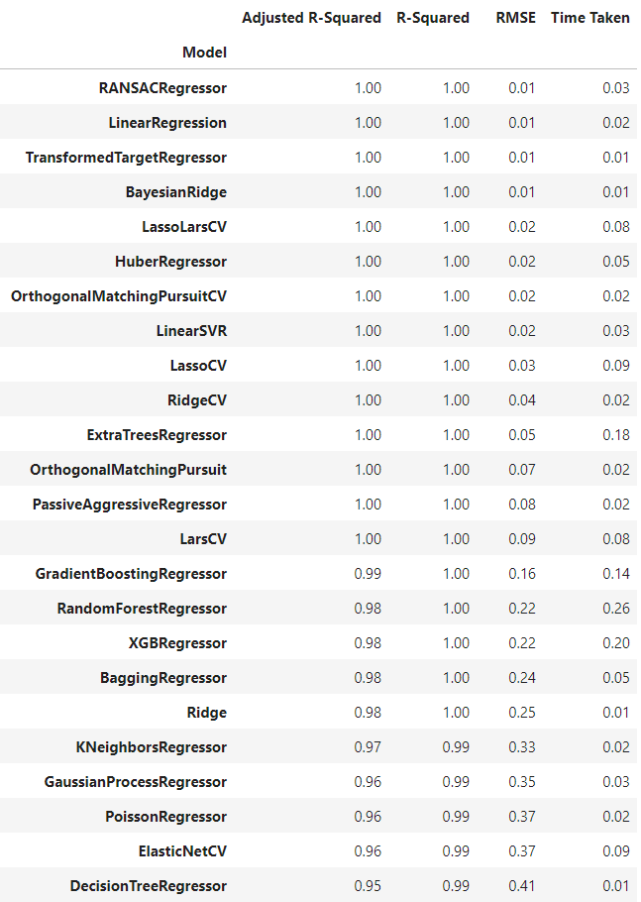

**4.3 Decision Trees**

Decision trees answer sequential questions which send us down a certain route of the tree given the answer. The model behaves with “if this then that” conditions ultimately yielding a specific result. A Decision Tree is a Supervised learning technique that is tree-structured, where internal nodes represent the features of a dataset, branches represent the decision rules and each leaf node represents the outcome. The decisions or the test are performed on the basis of features of the given dataset. For predicting the class of the given dataset, the algorithm starts from the root node of the tree.

This algorithm compares the values of the root attribute with the record (real dataset) attribute and, based on the comparison, follows the branch and jumps to the next node. For the next node, the algorithm again compares the attribute value with the other sub-nodes and moves further. It continues the process until it reaches the leaf node of the tree. However, building decision trees require algorithms capable of determining an optimal choice at each node.

**4.4 Random Forest**

The random forest algorithm utilizes both bagging and feature randomness to create an uncorrelated forest of decision trees. Feature randomness, also known as feature bagging or the random subspace method generates a random subset of features, which ensures low correlation among decision trees. This is a key difference between decision trees and random forests. While decision trees consider all the possible feature splits, random forests only select a subset of those features. It creates an uncorrelated forest of trees when building each individual tree whose prediction by committee is more accurate than that of any individual tree. The greater number of trees in the forest leads to higher accuracy and prevents the problem of overfitting.

**4.5 XGBoost Regressor and Feature Importance using Information Gain**

A benefit of using ensembles of decision tree methods like gradient boosting is that they can automatically provide estimates of feature importance from a trained predictive model. Importance provides a score that indicates how useful or valuable each feature was in the construction of the boosted decision trees within the model.

The more an attribute is used to make key decisions with decision trees, the higher its relative importance. This importance is calculated explicitly for each attribute in the dataset, allowing attributes to be ranked and compared to each other.

'Gain' is the improvement in accuracy brought by a feature to the branches it is on.

**5. Dataset**

The dataset consisted of 24 independent and dependent features obtained from the numerical model. The value(column) to be predicted is Nu- Nusselt Number.

We had 191 data points with varying TF, Re, and temperature.

The Tapering Factor(TF) varies from 0.25 to 1

The Reynolds Number(Re) takes on the following values:

10, 50, 100, 200, 300, 400, 500, 600

DataSet Head:

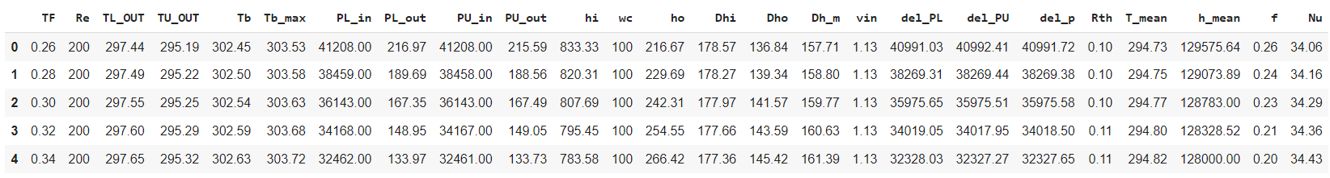

Descriptive Statistics:

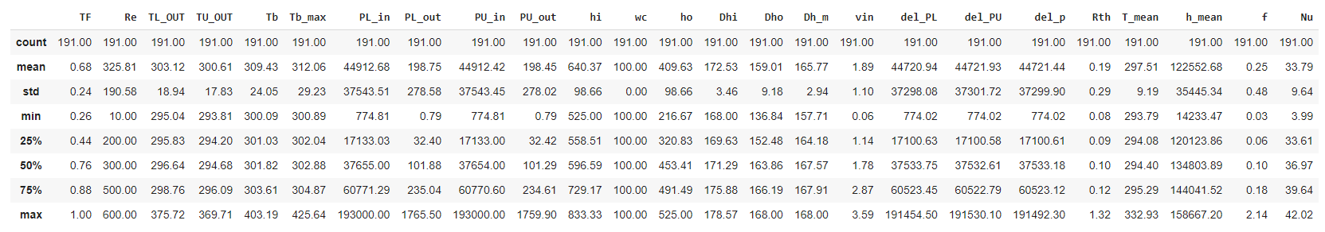

**6. ML Methodology and Process Flow**

In this section, we will describe the Process Flow of the project, the Pearson correlations between the independent and dependent features available in our dataset, and analyze the feature importance plot obtained from the XGBoost regressor.

**6.1 Process Flow**

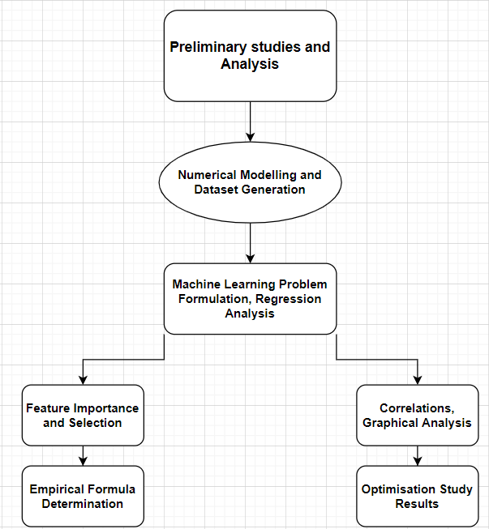

**6.2 Correlations**

The Pearson Correlation Heatmap and matrix for the given dataset is as shown below:

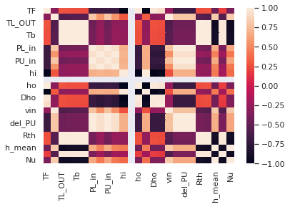

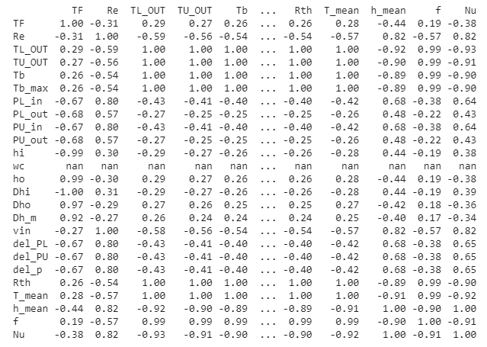

**6.3 Feature Importance and Selection**

Calculating feature importance on this predictive modeling problem using a trained XGBoost model, we obtain the following results:

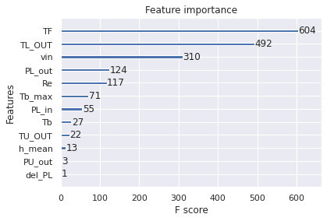

**7. Results**

We have chosen the top performing models as well as two ensemble methods from the list of top performing Regression models in the Lazy Regressor table.

| Model | Adjusted R Squared | RMSE | Time |
| --- | --- | --- | --- |
| Linear Regression | 1.00 | 0.01 | 0.04 |
| Linear Support Vector Regression | 1.00 | 0.02 | 0.06 |
| Decision Tree Regressor | 0.95 | 0.38 | 0.02 |
| Random Forest Regressor | 0.97 | 0.20 | 0.52 |
| XGBRegressor | 0.98 | 0.18 | 0.40 |

Here, R² = Explained variation / Total Variation **(SSres)**- Squares of residuals **(SStot)**- Total sum of squares

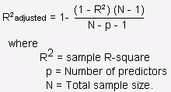

RMSE- Root Mean Squared Error- 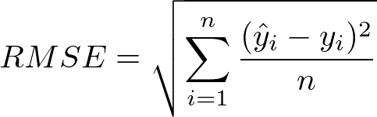

**Optimum Value of Nusselt Number:**

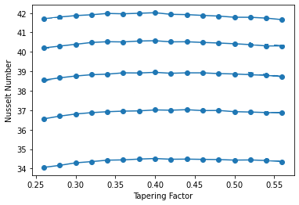

Variation of Nusselt Number with Tapering Factor at different Reynolds number

**Maximum Nusselt Number: 41.99 at TF=0.39 with Reynolds number, Re=600**

**Empirical Formula Determination:**

Employing Linear Regression techniques and making suitable assumptions, we obtain the following Empirical formula for the variation of Nusselt Number with TF, Tbulk and Re.

**Nu = -2.93235987*TF - -0.25346334* Tb + 0.02287909* Re**

**Conclusions**

Nusselt number varies with Tapering Factor, Bulk Fluid Temperature, Tout,l and Tout,u

Experimental simulations within the computational domain suggest that the optimum Nusselt number value corresponds to a Tapering Factor between 0.3 and 0.4. After extensive exploration and regression analysis, we have obtained the optimum Nusselt number value of 41.99 at TF=0.39, and then obtained an empirical formula for Nu.

**Future Scope**

The eventual aim of this project is to create a comprehensive and well researched ML model that will provide the values of Nu with variations in conduction, pumping power, friction, fluid properties, geometry and material properties of the channels etc.

# Bibliography

1) Tuckerman, D.B. and Pease, R.F.W., 1981. High-performance heat sinking for VLSI. *IEEE Electron device letters*, *2*(5), pp.126-129.

2) Qu, W. and Mudawar, I., 2002. Analysis of three-dimensional heat transfer in micro-channel heat sinks. *International Journal of heat and mass transfer*, *45*(19), pp.3973-3985.

3) Qu, W. and Mudawar, I., 2002. Experimental and numerical study of pressure drop and heat transfer in a single-phase micro-channel heat sink. *International journal of heat and mass transfer*, *45*(12), pp.2549-2565.

4) Morshed, A.K.M.M. and Khan, J.A., 2010, January. Numerical analysis of single phase multi layered micro-channel heat sink with inter-connects between vertical channels. In *International Heat Transfer Conference* (Vol. 49415, pp. 133-140).

5) Chen, T. and Guestrin, C., 2016, August. Xgboost: A scalable tree boosting system. In *Proceedings of the 22nd acm sigkdd international conference on knowledge discovery and data mining* (pp. 785-794).

6) Breiman, L., 2004. STATISTICS DEPARTMENT UNIVERSITY OF CALIFORNIA AT BERKELEY September 9, 2004.

7) Vafai, K. and Zhu, L., 1999. Analysis of two-layered micro-channel heat sink concept in electronic cooling. *International Journal of Heat and Mass Transfer*, *42*(12), pp.2287-2297.