#### Thermal-Hydraulic performance analysis of chip cooling in electronic devices using Machine Learning

Project-I (ME47603) report submitted to Indian Institute of Technology Kharagpur

in partial fulfillment for the award of the degree of Bachelor of Technology

in

Manufacturing Science and Engineering

**by**

**Tushar Mishra (18MF3IM35)**

**Under the supervision of Professor Chirodeep Bakli**



**Department of Mechanical Engineering Indian Institute of Technology Kharagpur Autumn Semester, 2021-22**

**November 24, 2021**

#### DECLARATION

I certify that

1. The work contained in this report has been done by me under the guidance of my supervisor.
2. The work has not been submitted to any other Institute for any degree or diploma.
3. I have conformed to the norms and guidelines given in the Ethical Code of Conduct of the Institute.
4. Whenever I have used materials (data, theoretical analysis, figures, and text) from other sources, I have given due credit to them by citing them in the text of the thesis and giving their details in the references. Further, I have taken permission from the copyright owners of the sources, whenever necessary.

Date: November 24, 2021 (Tushar Mishra) Place: Kharagpur (18MF3IM35)

#### [DEPARTMENT OF MECHANICAL ENGINEERING](http://www.iitkgp.ac.in/department/CE) [INDIAN INSTITUTE OF TECHNOLOGY KHARAGPUR](http://www.iitkgp.ac.in/) KHARAGPUR - 721302, INDIA



##### CERTIFICATE

This is to certify that the project report entitled “**Thermal-Hydraulic performance analysis of chip cooling in electronic devices using Machine Learning**” submitted by **Tushar Mishra** (Roll No. 18MF3IM35) to the Indian Institute of Technology Kharagpur towards partial fulfillment of requirements for the award of the degree of Bachelor of Technology in Manufacturing Science and Engineering is a record of bonafide work carried out by him under my supervision and guidance during Autumn Semester, 2021-22.

Professor Chirodeep Bakli

Date: November 24, 2021 School of Energy Science and Engineering Place: Kharagpur Indian Institute of Technology Kharagpur

Kharagpur - 721302, India

## Abstract



Name of the student: **Tushar Mishra** Roll No: **18MF3IM35**

Degree for which submitted: **Bachelor of Technology**

Department: **Department of Mechanical Engineering**

Thesis title: **Thermal-Hydraulic performance analysis of chip cooling in electronic devices using Machine Learning**

Thesis supervisor: **Professor Chirodeep Bakli**

Month and year of thesis submission: **November 24, 2021**



With growing demands and the trend to manufacture ever-smaller electronic devices, power production, and heat flux has increased tremendously over the past decades. Hence, an efficient thermal management system is indispensable to obtain extraordinary performance indicators. The conventional air cooling system has remained inept in removing excess heat. This has sparked the development of numerous innovative chip cooling techniques. An effective thermal management technique for chip cooling in electronic devices is a liquid-cooled microchannel heat sink (MCHS). This technique reduces thermal resistance at chip junctions and keeps the chip surface temperature as low as possible.

We have done extensive analysis and Optimization studies using Machine Learning to obtain maximum heat transfer parameters.

## Acknowledgments

I am greatly indebted to my project supervisor Prof. **Chirodeep Bakli** and my mentor Mr. **Avinash Kumar** for their invaluable guidance and encouragement throughout this project. I am thankful for their aspiring guidance, invaluably constructive criticism, and friendly advice during the project work. I would like to take this opportunity to express my sincere and profound gratitude to them.

I would also like to gratefully acknowledge the suggestions and discussions received from my fellow project members and students at IIT Kharagpur whenever I had any doubt.

I sincerely thank all the faculty of the Mechanical Engineering Department for their kind cooperation in all phases of my project work.

Last but not the least, I thank my parents and all my family members for the support and motivation they have provided throughout my project.

**Tushar Mishra 18MF3IM35**

# Contents

**Declaration** **i**

**Certificate** **ii**

**Abstract** **iii**

**Acknowledgements** **iv**

**Contents** **v**

**List of Figures** **vi**

**List of Tables** **vii**

**Abbreviations** **viii**

**Symbols** **ix**

1. **Sample** **1**
   1. Introduction 1

Literature Survey 1

Research gaps 1

Objective 1

Scope 1

An algorithm 2

* 1. Adding another section 2

**A Appendix A** **4**

**Bibliography** **5**

# List of Figures

1.1 Splitting of the input space (X1 x X2) by M5’ model tree algorithm . 2 1.2 Figures sample 2

# List of Tables

1.1 Sample table 3

# Abbreviations

**FEA F**inite **E**lement **A**nalysis **FEM F**inite **E**lement **M**ethod

**LVDT L**inear **V**ariable **D**ifferential **T**ransformer **RC R**einforced **C**oncrete

# Symbols

*Del* elasticity tensor

*σ* stress tensor

*ε* strain tensor

# Chapter 1 Sample

### Introduction

Give a brief of the chapter and introduce what you will talk about.

**Literature Survey** This is a sample. Write about referred papers. Cite like this (Nip et al., 2010b). Another example would be this (Nip et al., 2010a). More cita- tions like this (Bird and Bommer, 2004), (Tremblay et al., 2003) and (AlHamaydeh et al., 2016).

**Research gaps** Typically include research gaps for your study.

**Objective** Similarly objectives of study.

**Scope** Define scope of study.

Chapter 1. *Sample* 2



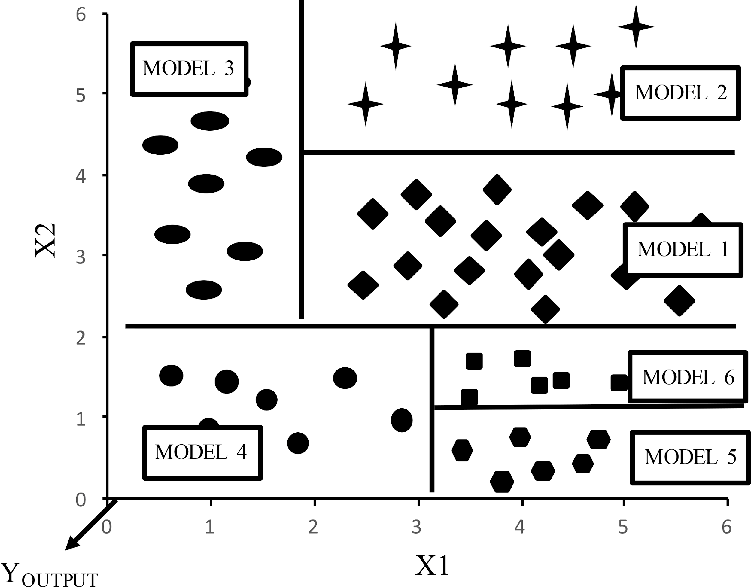

Figure 1.1: Splitting of the input space (X1 x X2) by M5’ model tree algorithm

**An algorithm** How you could refer to figures: This is an example. (Refer 1.1). You can add equations like this Eq. (1.1)

*SDR* = *sd*(*T* ) *−* Σ *Ti × sd*(*T* ) (1.1)

*i*

*i |T |*

### Adding another section

You can show a lot of figures together like these Figures 1.2(a), 1.2(b), 1.2(c) below. You can add lists into the text like this.

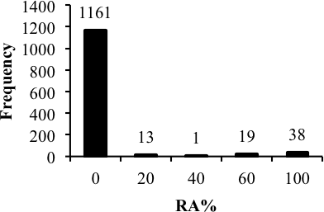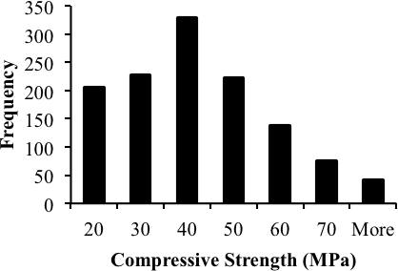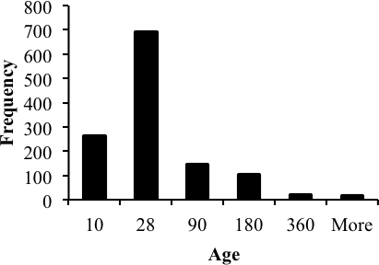

* + 1. Caption1 (b) Caption2 (c) Caption3

Figure 1.2: Figures sample

Chapter 1. *Sample* 3



* Some sample text item 1.
* You may refer to tables 1.1
* Or figures 1.2(a)

Tables can be added like this

Table 1.1: Sample table



Column 1 Column 2 Column 3

1 Data1 13.41179 0.9492839

2 Data2 13.39824 0.9492952

# Appendix A Appendix A

Write your Appendix content here.

# Bibliography

AlHamaydeh, M., Abed, F., and Mustapha, A. (2016). Key parameters influencing performance and failure modes for brbs using nonlinear fea. *Journal of Construc- tional Steel Research*, 116:1–18.

Bird, J. F. and Bommer, J. J. (2004). Evaluating earthquake losses due to ground failure and identifying their relative contribution. In *13 WCEE: 13 th World Conference on Earthquake Engineering Conference Proceedings*.

Nip, K., Gardner, L., Davies, C., and Elghazouli, A. (2010a). Extremely low cycle fa- tigue tests on structural carbon steel and stainless steel. *Journal of constructional steel research*, 66(1):96–110.

Nip, K. H., Gardner, L., and Elghazouli, A. (2010b). Cyclic testing and numerical modelling of carbon steel and stainless steel tubular bracing members. *Engineering Structures*, 32(2):424–441.

Tremblay, R., Archambault, M.-H., and Filiatrault, A. (2003). Seismic response of concentrically braced steel frames made with rectangular hollow bracing members. *Journal of Structural Engineering*, 129(12):1626–1636.