**Introduction**

In our ever-growing quest for a truly smart future, we have created a communication and computer revolution. The electronics industry has aided us at every step of the way in ensuring industrial automation, high-performance, and intense data processing power.

We have achieved consistent miniaturization of these devices for decades, and now we have almost pushed them to their absolute physical limits. As a result, there has been a tremendous increase in power production and consumption, and heat flux through these devices, and we need an effective and efficient thermal management system to obtain optimum performances.

Air cooling disperses the heat in and around the device, and hence it often increases the ambient temperature of the overall system. An air cooler involves more power consumption, is not suitable for sustained cooling for longer durations and the cooling effect is not that high. Hence we need better technology to cool chips in electronic devices.

One of the most effective cooling techniques is using a liquid-cooled microchannel heat sink (MCHS). This method reduces the thermal resistances of the chip junctions and keeps the chip temperature as low as possible. We will explore and analyze the various geometric and physical properties of such a system and obtain critical values from optimization study using extensive Machine Learning techniques.

**Problem Statement**

We are interested in the Thermal-Hydraulic performance analysis of chip cooling in electronic devices using Machine Learning. We will study the effect of various geometric and physical parameters of a double-layer tapered microchannel heat sink (DL-MCHS) with a counter flow arrangement. We will obtain the critical Tapering Factor at which maximum heat transfer takes place using various Regression models.

**Objectives Of The Study**

The primary objectives of the study are

* Establishing and modeling the critical geometric and fluid flow parameters
* Exploratory data analysis of the Model dataset
* Formulation of the problem into a Machine Learning use case
* Obtaining critical parameters for the regression problem
* Creating an Empirical Formula for Nusselt number

**Literature Review**

Energy conversion and utilization are continuous but ever-increasing processes for sustainability and economic development. Environmental concerns, such as thermal and air pollution, have dictated the practices of energy conservation and recovery, as well as the implementation of clean energy sources. Efficient heat exchangers are an important component for processes where energy conservation is achieved through enhanced heat transfer. Such issues as increased energy demands, space limitations and material savings have highlighted the necessity for miniaturized light-weight micro-channel heat sinks (MCHS), which provide high heat transfer when compared to traditional air cooling in electronic devices. The traditional heat exchangers employ ineffective techniques and subpar geometric parameters, cross-sections, orientations, and surface textures. With the current boom in the electronics industry, this technology is nearing its limits and will become obsolete. Microchannels are a particular target of research due to their higher heat transfer and reduced weight as well as their space, energy, and materials savings potential over regular tube counterparts.

The first MCHS was proposed by Tukerman and Pease [1] and they manufactured MCHS by etching micro-channel on a silicon substrate which was 50 µm wide and 300 µm deep to remove heat flux of 790 W cm−2 from very large scale integration (VLSI) chip by passing water through micro-channels.

Qu and Mazumdar [6,7] concluded that the Navier–Stokes equation and energy equation can satisfactorily predict the fluid flow and heat transfer characteristics of MCHS.

**Gap Identification**

In contrast to traditional heat exchangers, the heat transfer and fluid flow correlations, and the systematic design procedures are not yet well established for microchannels. It remains to be established whether the classical fluid flow and heat transfer theories and correlations are valid for microchannels. Numerous investigations are underway with researchers consolidating evidence on both sides of this question.

Most of the established research can be classified as experimental and numerical study.

In this paper, we will employ various Regression models to obtain the results in a novel attempt to tackle this problem.

**Theory, Modeling, and Methodology**

A tapered double-layered MCHS (DL-MCHS) is composed of two layers separated by a solid rib where both the lower and upper microchannels are converging in nature due to tapered in the middle rib with a counter-flow heat arrangement.

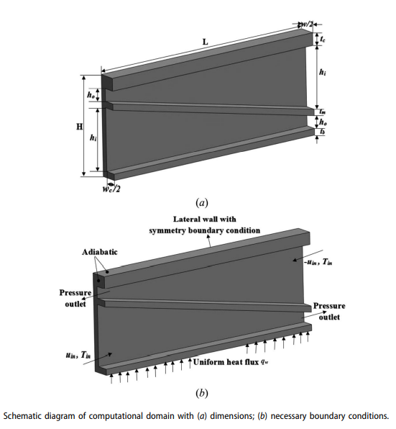

| **Material** | **Density**  **(kg/m3)** | **Specific heat**  **(J/kg-K)** | **Thermal conductivity**  **(W/m-K)** | **Viscosity**  **(kg/m-s)** |
| --- | --- | --- | --- | --- |
| Water | 998.2 | 4182 | 0.6 | 0.001003 |
| Silicon | 2330 | 703 | 149 | - |

Fluid used: **Water**

Substrate material: **Silicon**

| **Parameters** | **Values (µm)** |
| --- | --- |
| Channel length, L | 10,000 |
| Channel width, wc | 100 |
| Channel height at inlet, hi | Vary with TF |
| Channel height at outlet, ho | Vary with TF |
| Total channel height, Hc = hi + ho | 1050 |
| Width of computational domain, w | 200 |
| Thickness of base, tb | 50 |
| Thickness of middle rib, tm | 50 |
| Thickness of cover, tc | 50 |

**Numerical Model**

Using Navier–Stokes equations with Boundary conditions and Energy equations: (Mass, Momentum, and Energy), we obtain the following results

Tapering Factor : 

Reynolds number : 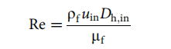

Inlet hydraulic diameter: 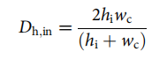

Overall thermal resistance : 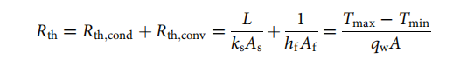

(* Assumptions: We can neglect RThermal  of solid and hence, we obtain TChip ~ TWall

Now, to determine the overall convective heat transfer in the channel having a non-uniform cross-section, the average Nusselt number is calculated as

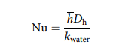

where the average heat transfer coefficient : 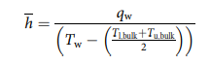

and the mean hydraulic diameter : 

With an increase in tapering, the convective heat transfer coefficient increases, and hence the Nusselt number increases.

Nusselt number is a measure of the ratio between heat transfer by convection and heat transfer by conduction alone. The larger the Nusselt number, the more effective the convection

**Machine Learning Theory and Problem Formulation**

We formulate the given problem as a Multivariate Regression Problem. We will try to quantify the effect of various numerical features like Tapering Factor, Reynolds Number, Temperature, and Heat Flux on Nusselt Number.

We will try to incorporate the following three types of features

* Variables that are already proven in the literature to be related to the outcome.
* Variables that can either be considered the cause of the exposure, the outcome, or both.
* Interaction terms of variables that have large main effects.

**Linear Regression**

Linear regression is a supervised learning machine learning algorithm. It carries out a regression task. Based on independent variables, regression models a targeted prediction value. It is mostly employed in forecasting and determining the link between variables. Different regression models differ in terms of the evaluated type of relationship between dependent and independent variables and the number of independent variables they utilize.

By achieving the best-fit regression line, the model aims to predict y value such that the error difference between the predicted value and true value is minimum.

**Lazy Predict Regressor**

Selecting the best model for your Machine Learning problem statement is a very tedious task. We have to import all the libraries then tune the parameters, then compare all the models, then check the model performance using different objectives. This process takes a lot of time.

To avoid this problem, we have exploited the Lazy Predict library. With the help of the lazy predict python library, we can train all the baseline ML models available in **scikit** learn without hyperparameter tuning. We can then select the top-performing models and tune the models to best fit our dataset.

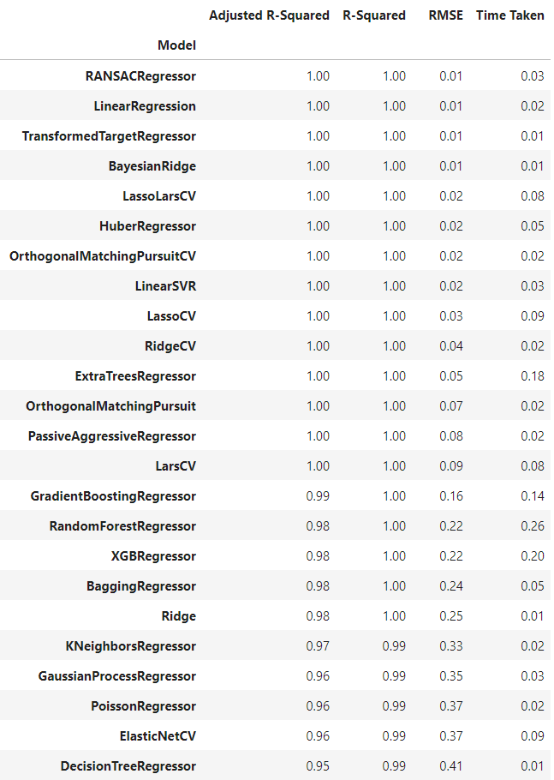

**Decision Trees**

Decision trees answer sequential questions which send us down a certain route of the tree given the answer. The model behaves with “if this then that” conditions ultimately yielding a specific result. A Decision Tree is a Supervised learning technique that is tree-structured, where internal nodes represent the features of a dataset, branches represent the decision rules and each leaf node represents the outcome. The decisions or the test are performed on the basis of features of the given dataset. For predicting the class of the given dataset, the algorithm starts from the root node of the tree.

This algorithm compares the values of the root attribute with the record (real dataset) attribute and, based on the comparison, follows the branch and jumps to the next node. For the next node, the algorithm again compares the attribute value with the other sub-nodes and moves further. It continues the process until it reaches the leaf node of the tree. However, building decision trees require algorithms capable of determining an optimal choice at each node.

**Random Forest**

The random forest algorithm utilizes both bagging and feature randomness to create an uncorrelated forest of decision trees. Feature randomness, also known as feature bagging or the random subspace method generates a random subset of features, which ensures low correlation among decision trees. This is a key difference between decision trees and random forests. While decision trees consider all the possible feature splits, random forests only select a subset of those features. It creates an uncorrelated forest of trees when building each individual tree whose prediction by committee is more accurate than that of any individual tree. The greater number of trees in the forest leads to higher accuracy and prevents the problem of overfitting.

**XGBoost Regressor and Feature Importance using Information Gain**

A benefit of using ensembles of decision tree methods like gradient boosting is that they can automatically provide estimates of feature importance from a trained predictive model. Importance provides a score that indicates how useful or valuable each feature was in the construction of the boosted decision trees within the model.

The more an attribute is used to make key decisions with decision trees, the higher its relative importance. This importance is calculated explicitly for each attribute in the dataset, allowing attributes to be ranked and compared to each other.

'Gain' is the improvement in accuracy brought by a feature to the branches it is on.

**Dataset**

The dataset consisted of 24 independent and dependent features obtained from the numerical model. The value(column) to be predicted is Nu- Nusselt Number.

We had 191 data points with varying TF, Re, and temperature.

The Tapering Factor(TF) varies from 0.25 to 1

The Reynolds Number(Re) takes on the following values:

10, 50, 100, 200, 300, 400, 500, 600

DataSet Head:

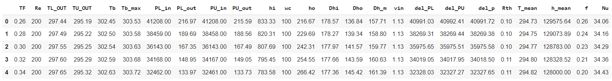

Descriptive Statistics:

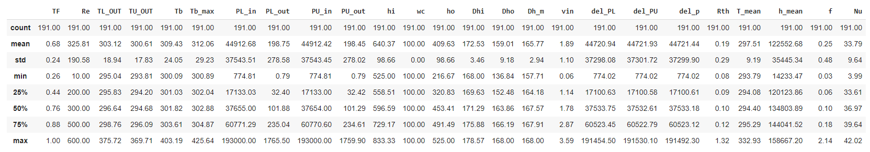

**Methodology and Process Flow**

In this section, we will describe the Process Flow of the project, the Pearson correlations between the independent and dependent features available in our dataset, and analyze the feature importance plot obtained from the XGBoost regressor.

**Process Flow**

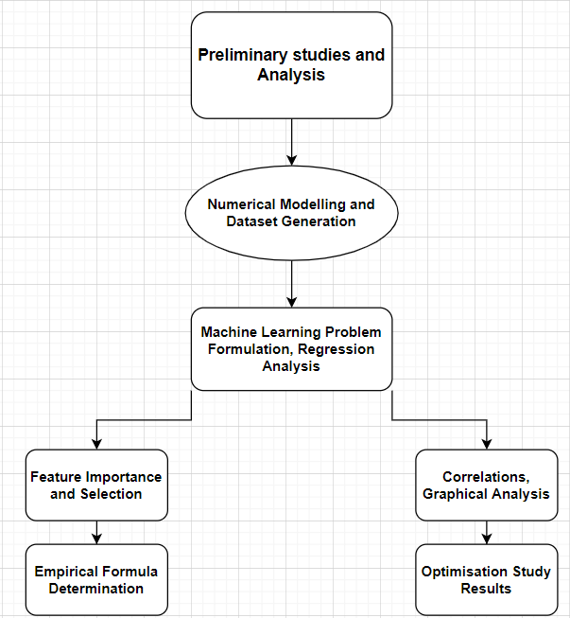

**Correlations**

The Pearson Correlation Heatmap and matrix for the given dataset is as shown below:

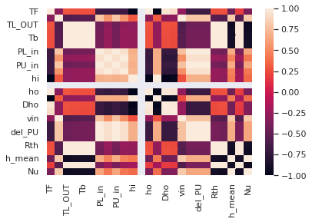

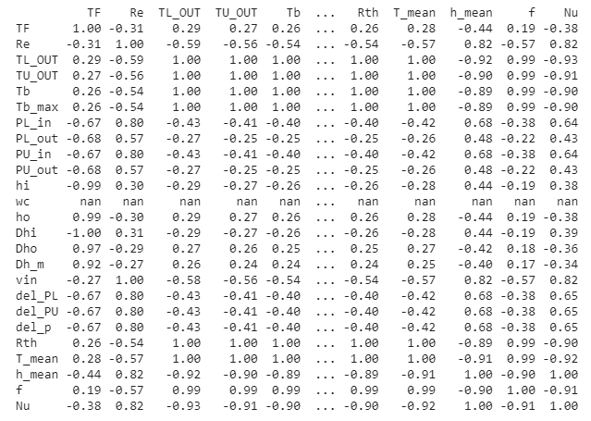

**Feature Importance and Selection**

Calculating feature importance on this predictive modeling problem using a trained XGBoost model, we obtain the following results:

