ENTERPRISE SUPPORT TICKET MANAGEMENT SYSTEM
Solution Document
══════════════════════════════════════
1. BACKGROUND
This is an enterprise-grade support management system that helps
companies like Amazon, Flipkart manage customer support operations.
Why needed:
- Thousands of support tickets daily
- Need to track, assign, and resolve efficiently
- Need analytics and performance metrics
- Multiple teams working together

2. REQUIREMENT OVERVIEW
24 User Stories across 6 roles:
CUSTOMER (4 stories):
✓ Create tickets through multiple channels
✓ View ticket history and status
✓ Add comments and attachments
✓ Rate and provide feedback
SUPPORT AGENT (4 stories):
✓ View assigned tickets in priority queue
✓ Update ticket status and details
✓ Communicate with customers
✓ Create internal notes
SUPERVISOR (4 stories):
✓ Assign/reassign tickets to agents
✓ Monitor real-time metrics
✓ Set up automated routing rules
✓ Review resolution quality

CASE MANAGER (4 stories):
✓ Convert complex tickets to cases
✓ Link related tickets and cases
✓ Establish milestones and timelines
✓ Create escalation workflows

QA TEAM (4 stories):
✓ Review closed tickets for quality
✓ Track common issues
✓ Monitor customer satisfaction
✓ Audit ticket handling

ANALYTICS MANAGER (4 stories):
✓ Generate ticket volume trends
✓ Analyze resolution times
✓ Track satisfaction metrics
✓ Create custom reports

3. SOLUTION APPROACH
Full-Stack MERN Application:

FRONTEND:
- React.js with Tailwind CSS
- Role-based dashboards
- Real-time UI updates
- Responsive design

BACKEND:
- Express.js server
- RESTful APIs
- JWT authentication
- MongoDB database

DATABASE:
- MongoDB document store
- 5 collections (Users, Tickets, Comments, Cases, Feedback)
- Proper indexing for performance

AUTHENTICATION:
- JWT tokens for security
- Password hashing with bcrypt
- Role-based access control (RBAC)

4. SOLUTION ARCHITECTURE
[Diagram]
┌─────────────────────────────────────┐
│ CLIENT APPLICATIONS │
│ (React + Tailwind CSS on Port 3000) │
└──────────────┬──────────────────────┘
│ API Calls (HTTP/REST)
┌──────────────▼──────────────────────┐
│ API GATEWAY / SERVER │
│ (Express.js on Port 5000) │
│ - Authentication Middleware │
│ - Route Handlers │
│ - Business Logic │
└──────────────┬──────────────────────┘
│ Database Queries
┌──────────────▼──────────────────────┐
│ DATABASE │
│ (MongoDB - Local or Atlas) │
│ - Users Collection │
│ - Tickets Collection │
│ - Comments Collection │
│ - Cases Collection │
│ - Feedback Collection │
└─────────────────────────────────────┘

5. TECHNICAL DETAILS

FRONTEND STACK:
━━━━━━━━━━━━━━━━━━━━━━━━━━━━━━━━━━━━━━━━
Technology: React.js
- Component-based architecture
- Fast rendering with virtual DOM
- Large ecosystem and community
- Perfect for building SPAs

Styling: Tailwind CSS
- Utility-first CSS framework
- Faster development
- Responsive design built-in
- Professional look without custom CSS

Routing: React Router v6
- Client-side navigation
- Declarative route configuration
- Protected routes for security

State Management: Context API + useState hooks
- Sufficient for this project size
- No need for Redux complexity
- AuthContext for user state

HTTP Client: Axios
- Promise-based HTTP client
- Automatic request/response interceptors
- Better than fetch API

BACKEND STACK:
━━━━━━━━━━━━━━━━━━━━━━━━━━━━━━━━━━━━━━━━
Framework: Express.js
- Lightweight and flexible
- Easy middleware integration
- Large ecosystem
- Industry standard

Database: MongoDB
- Document-oriented (NoSQL)
- Flexible schema for varied data
- Built-in scalability
- Easy to query with Mongoose

ORM: Mongoose
- Object modeling for MongoDB
- Schema validation
- Middleware hooks
- Population for references

Authentication: JWT (JSON Web Tokens)
- Stateless authentication
- Scalable for microservices
- Industry standard
- Secure token-based access

Password Security: bcryptjs
- Industry-standard hashing algorithm
- Salting prevents rainbow table attacks
- Computationally expensive (slow by design)

API Design: RESTful
- Standard HTTP methods (GET, POST, PUT, DELETE)
- Clear resource-based URLs
- Easy to understand and use

WHY THESE CHOICES?
━━━━━━━━━━━━━━━━━━━━━━━━━━━━━━━━━━━━━━━━
1. MERN is most in-demand stack in 2024
2. Fast to develop - great for MVPs
3. JavaScript everywhere (frontend + backend)
4. Easy to learn and understand
5. Scales from startup to enterprise
6. Rich ecosystem of libraries
7. Great community support
8. Most job opportunities

6. BENEFITS OF THIS SOLUTION

✓ Fast Development Cycle
- Can add new features quickly
- Easy debugging in JavaScript
- Hot reload during development

✓ Scalability
- MongoDB handles millions of documents
- Express scales horizontally
- React optimized for performance

✓ User Experience
- Fast, responsive UI
- Smooth navigation
- Role-based customization

✓ Security
- JWT authentication
- Password hashing
- CORS protection
- Input validation

✓ Maintainability
- Clean code structure
- Separation of concerns
- Well-documented
- Easy for new developers

✓ Cost-Effective
- Open-source stack
- Free hosting options available
- MongoDB free tier
- No licensing costs

7. ALTERNATE APPROACHES

ALTERNATIVE 1: Next.js + Prisma
━━━━━━━━━━━━━━━━━━━━━━━━━━━━━━
Pros:
✓ Built-in API routes (no separate backend)
✓ Better SEO with server-side rendering
✓ Prisma ORM is modern
✓ Deployment easier

Cons:
✗ Steeper learning curve
✗ Overkill for this project
✗ More complex setup
✗ Smaller community than Express

When to use: If building a public-facing marketing site that needs SEO

ALTERNATIVE 2: Vue.js + Django
━━━━━━━━━━━━━━━━━━━━━━━━━━━━━━
Pros:
✓ Vue is easier to learn than React
✓ Django has built-in admin panel
✓ Python more readable than JavaScript
✓ Django ORM very powerful

Cons:
✗ Fewer job opportunities
✗ Smaller ecosystem
✗ Language switching (Python + Vue.js)
✗ Slower to develop

When to use: For data-heavy scientific applications

ALTERNATIVE 3: Flutter + Firebase
━━━━━━━━━━━━━━━━━━━━━━━━━━━━━━
Pros:
✓ Works on mobile + web
✓ Firebase handles backend
✓ No server management
✓ Fast deployment

Cons:
✗ Limited customization with Firebase
✗ Can be expensive at scale
✗ Vendor lock-in
✗ Less control over data

When to use: For rapid mobile app prototypes

WHY I CHOSE MERN:
━━━━━━━━━━━━━━━━━━━━━━━━━━━━━━
This is the most balanced choice because:
1. Perfect balance of ease vs power
2. Industry-standard stack
3. Great job market
4. Fast development
5. Scalable architecture
6. Easy maintenance

8. ASSUMPTIONS

Technical Assumptions:
✓ Users have modern browsers (Chrome, Firefox, Safari, Edge)
✓ Network connection is stable and reliable
✓ MongoDB can handle 10,000+ concurrent users
✓ API latency < 500ms acceptable
✓ File uploads limited to 50MB

Business Assumptions:
✓ 24/7 availability not critical initially
✓ No geographic data residency requirements
✓ Single-language support (English)
✓ Email notifications not required (Phase 2)
✓ SMS notifications not required (Phase 2)

Deployment Assumptions:
✓ Deployment on cloud (Render, Heroku, AWS)
✓ HTTPS enabled for all endpoints
✓ Environment variables for sensitive data
✓ Backup strategy implemented
✓ Monitoring and logging enabled

9. SCREENSHOTS

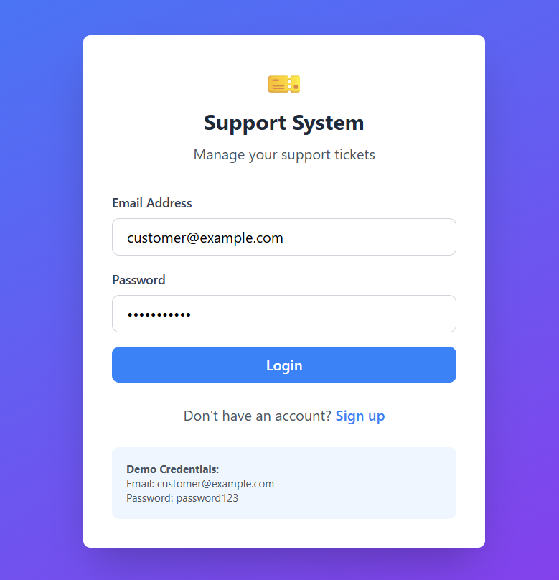
Fig9.1 Login page

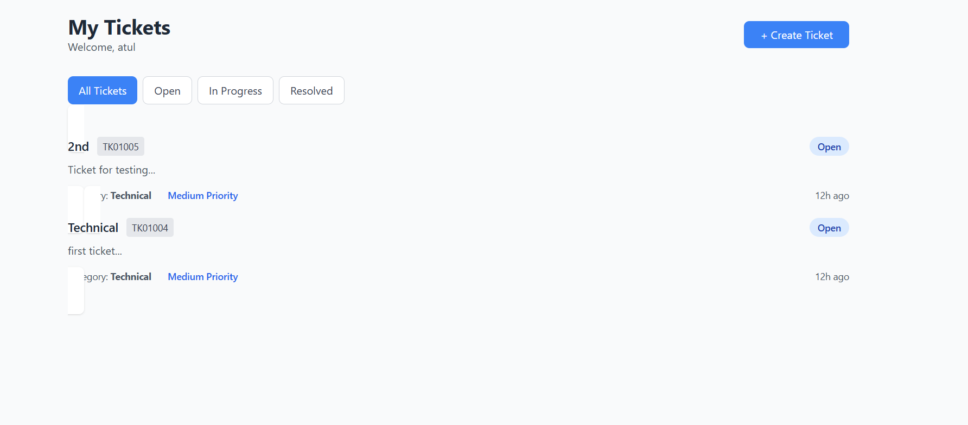
Fig9.2 Customer dashboard
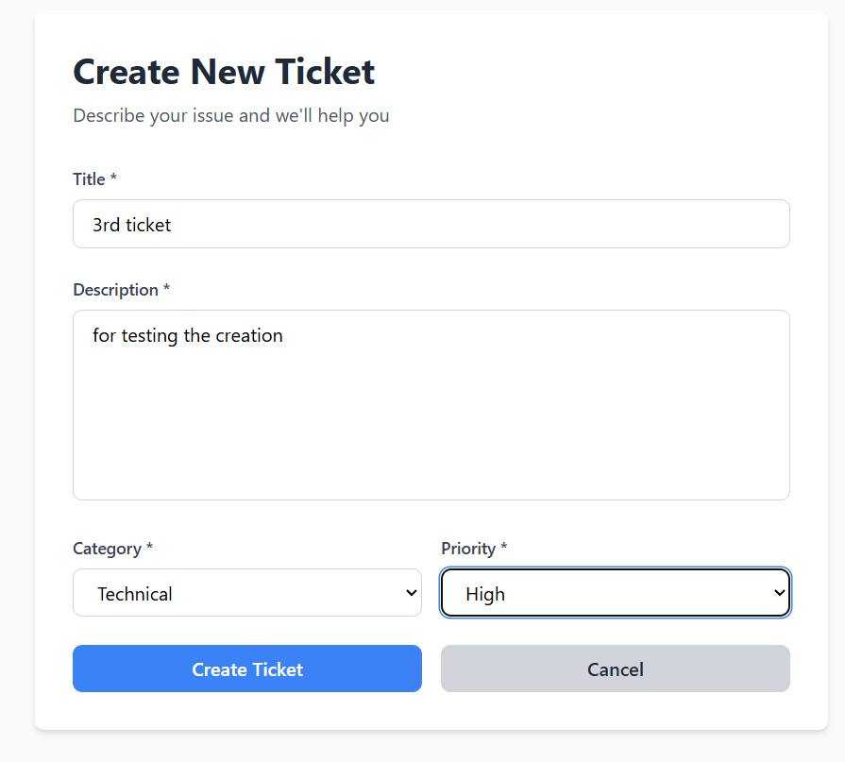
Fig9.3 Create ticket page

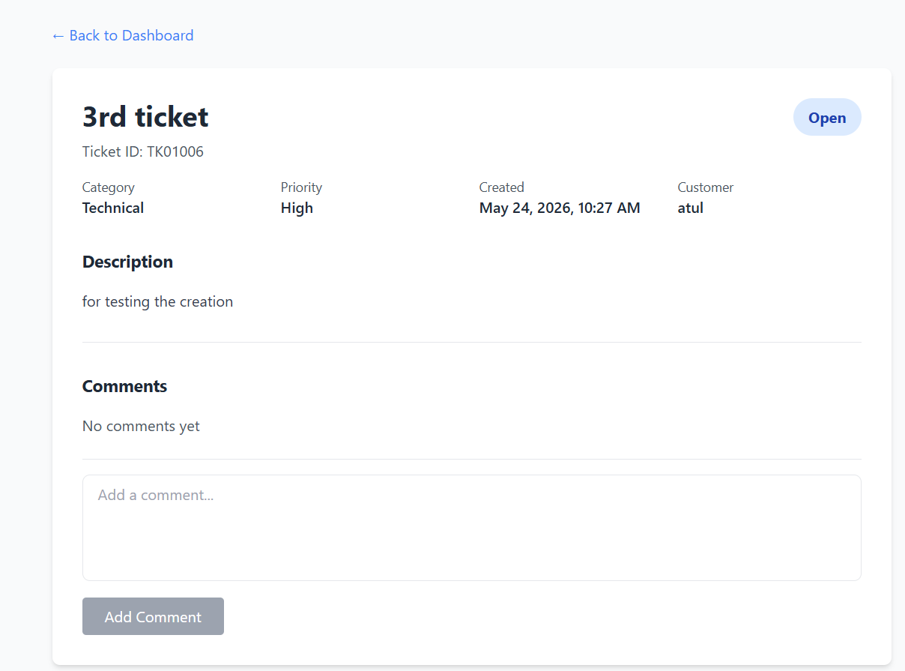
Fig9.4 Ticket details page
✓ Agent dashboard
✓ Supervisor dashboard
✓ Power BI dashboard

