Name____Joel Atwood____ Mark _____________________/50

[**Instructions**: Remove everything that is not a heading below and fill in with your own diagrams, etc.]

## Brief introduction __/3

The feature that I am designing is the user interface with the game itself. This would take given input from the player and interface with the game itself. It would then assist in displaying the results back to the player.

## Use case diagram with scenario __14

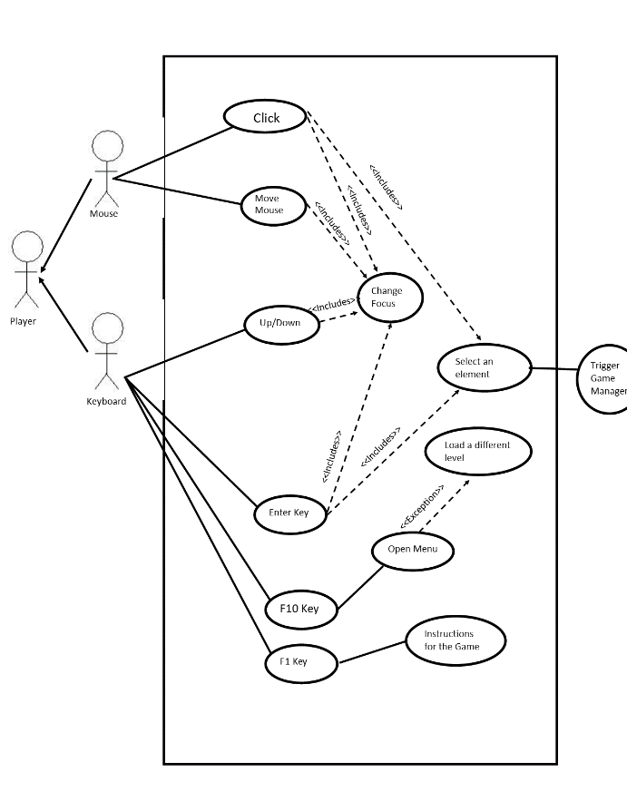

### Scenarios

**Name:** Open Menu

**Summary:** This allows players to change settings and move from the different parts of the games structure.

**Preconditions:** Game is running

**Basic sequence:**

**Step 1:** Player presses F10.

**Step 2:** Game pauses.

**Step 3:** Brings up a menu of options.

**Step 4:** One of the options is chosen.

**Step 5:** Run that option.

**Exceptions:**

**Step 1:** Player presses the escape key to close the menu: return to the game.

**Step 2:** Player provides unexcepted input: ignore that input.

**Post conditions:** Player either modifies settings desired and navigates to desired location

**Priority:** 1*

**ID:** M2

*The priorities are 1 = must have, 2 = essential, 3 = nice to have.

**Name:** Start Menu

**Summary:** Allows the player to begin the game as well as change settings initially

**Preconditions:** Player opens the .exe file

**Basic sequence:**

**Step 1:** Player opens the game

**Step 2:** Player manipulates any desired settings.

**Step 3:** Player chooses the begin game option

**Step 4:** Open the first level to be played.

**Exceptions:**

**Step 1:** Player exits the game: terminate the game

**Step 2:** Player provides unexcepted input: ignore that input.

**Post conditions:** Either the game will be running or the player will select a different option within the menu.

**Priority:** 2*

**ID:** M1

*The priorities are 1 = must have, 2 = essential, 3 = nice to have.

**Name:** Instructions

**Summary:** This will allow the player to learn the controls for the game so that they can be better able to play and enjoy

**Preconditions:** Game is running

**Basic sequence:**

**Step 1:** Player presses F1 or selects the help button in any of the menus.

**Step 2:** Game pauses.

**Step 3:** Brings up a window that will display all of the controls the player has and general information about the game.

**Step 4:** Player closes the window

**Post conditions:** Gameplay resumes

**Priority:** 1*

**ID:** F1

*The priorities are 1 = must have, 2 = essential, 3 = nice to have.

## Data Flow diagram(s) from Level 0 to process description for your feature _______14

### Data Flow Diagrams

### Process Descriptions

Draw UI

While the game is running display the

END WHILE

**\*Notes**: Yours should be much longer. You could use a decision tree or decision table instead if it is more appropriate.

## Acceptance Tests ________9

Run feature 1000 times sending output to a file using a random order of button inputs. This will be tested using several different settings.

The output file will have the following characteristics:

* Random input and its given output
* Any errors displaying the relevant data
* Conditions used for any given settings.

## Timeline _________/10

### Work items

|  |  |  |
| --- | --- | --- |
| Task | Duration (PWks) | Predecessor Task(s) |
| Software Analysis | 1 | - |
| Gantt timeline | 1 | 1 |
| Prototype | 2 | 1 |
| Coding Standards | 1 | 2, 3 |
| Setup Development Process | 1 | 4 |
| Core Features Finished | 5 | 4 |
| User manual | 1 | 6 |
| Game Complete | 3 | 5, 7 |

### Pert diagram

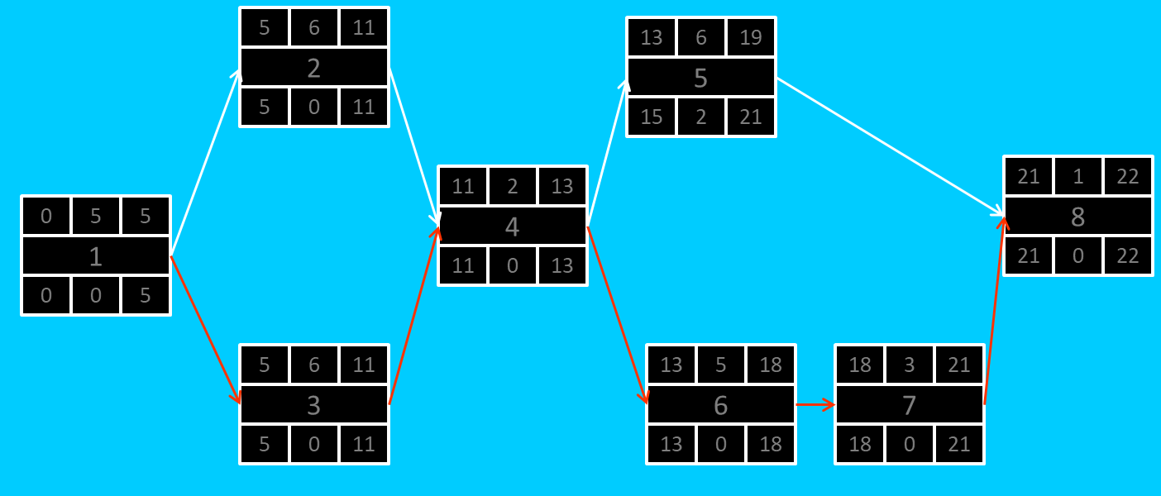

### Gantt timeline

