## Predestination

The Greek word for predestination in Romans 8:29-30 is προορίζω (proorizō) where *pro* means before (the world began) and *orizo* means to mark or to design. We get the English word horizon from this Greek word. Predestination means to design beforehand. Perfect God is omniscient and knew all that is knowable in eternity past and His design always existed from eternity past. God designed a plan before man ever existed. Jesus Christ is the focal point of that plan. He had a destiny. It was predesigned for Jesus Christ to be judged for the sins of the whole world and to purchase a kingdom. This predestination took place in eternity past. See categories on The Plan of God and Divine Decrees.

“For those whom He foreknew, He also predestined to become conformed to the image of His Son, so that He would be the firstborn among many brethren; and these whom He predestined, He also called; and these whom He called, He also justified; and these whom He justified, He also glorified.”  (Romans 8:29-30, NASB)

Predestination means that we are in the plan of God, a predesigned plan. We enter the plan through positive volition at Gospel hearing. Our predestination is based on our Union with Christ who is the predestined One, the elected One. 1 Peter 2:5; Isaiah 42:1.

"you also, as living stones, are being built up as a spiritual house for a holy priesthood, to offer up spiritual sacrifices acceptable to God through Jesus Christ." (1 Peter 2:5, NASB)

""Behold, My Servant, whom I uphold; My chosen one in whom My soul delights. I have put My Spirit upon Him; He will bring forth justice to the nations." (Isaiah 42:1, NASB)

Predestination applies to the believer only. The believer chooses Christ’s destiny by their free will and is therefore predestined. God has a plan for their life. It was predesigned that Romans 8:28 would be operative in the life of every believer while on earth.

“And we know that God causes all things to work together for good to those who love God, to those who are called according to His purpose.” (Romans 8:28, NASB)

The unbeliever is not predestined to hell. The unbeliever chooses their own destiny by their own free will. Christ died spiritually for the sins of everyone. Unbelievers go to hell because they reject Jesus Christ as Savior. They have a free will and they chose to operate independently of God’s grace provision.

The believer is predestined to be conformed to the image of God’s Son. At salvation, the believer has Positional Truth, is placed into union with Christ by the Holy Spirit, and as a result shares all that Jesus Christ has. In the Christian way of life, the intake and application of Bible doctrine through the filling of the Holy Spirit and the grace apparatus for perception, the believer builds the edification complex of the soul and produces the character of Christ in their souls. God the Father predesigned in eternity past that everything in His perfect plan would unfold exactly as He knew it would consistent with the free will of all His creatures. Rom. 8:29; Rev. 21:4.

"For those whom He foreknew, He also predestined to become conformed to the image of His Son, so that He would be the firstborn among many brethren;" (Romans 8:29, NASB)

"and He will wipe away every tear from their eyes; and there will no longer be any death; there will no longer be any mourning, or crying, or pain; the first things have passed away."" (Revelation 21:4, NASB)

Predestination results in believers becoming adult sons and heirs of God. Eph. 1:4. See categories on [Heirship (Inheritance)](#_Heirship_(Inheritance)) and Adoption.

"just as He chose us in Him before the foundation of the world, that we would be holy and blameless before Him. In love" (Ephesians 1:4, NASB)

**Predestination and the Will of God**

God is omniscient and in His foreknowledge He knew who would exercise their free will to become a believer. God’s predesigned plan for all believers is that all believers be “conformed to the image of His Son.” Election is our part in the plan when we choose for Christ. Every believer’s life has been predesigned on the basis of God’s knowledge of every free will decision that they will make. Rom. 8:29.

"For those whom He foreknew, He also predestined to become conformed to the image of His Son, so that He would be the firstborn among many brethren;" (Romans 8:29, NASB)

God has a directive will for the believer’s life. God directs the believer to operate in certain categories of His will. It is God’s operational will that every believer be filled with the Holy Spirit the maximum amount of time. It is God’s viewpoint will that every believer will think divine viewpoint. It is God’s geographical will that every believer be located geographically where they will grow spiritually and receive maximum blessing based on their spiritual growth.

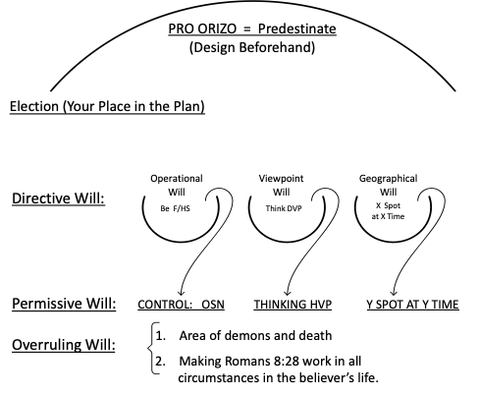

God has a permissive will for the believer’s life. God permits believers to operate in the power of their old sin nature. He permits believers to think human viewpoint. He permits believers to freely choose to be at a certain place at a certain time instead of some other place at some other time.

God has an overruling will for the believer’s life. God overrules in the area of demon activity as far as the believer is concerned. No demon or human can take the life of a believer unless or until God permits it. God takes every good or bad decision in the believer’s life and makes it work together for the good of that believer. Job 1-2; Rom. 8:28.

"And we know that God causes all things to work together for good to those who love God, to those who are called according to His purpose." (Romans 8:28, NASB)

Because God is omniscient and omnipotent, He has taken every decision that we will ever make and has predesign a plan for our lives, making it all work together for our good. Only the believer shares the destiny of Christ and therefore has a predesigned life. This does not mean that the believer does not have free will. God has predesigned that Romans 8:28 will work. The unbeliever is not predestined to hell. He goes there because of their own choice to reject the salvation work of Jesus Christ on the Cross. John 3:18.

" "He who believes in Him is not judged; he who does not believe has been judged already, because he has not believed in the name of the only begotten Son of God. " (John 3:18, NASB)