EXPLORATORY DATA ANALYSIS
AND VISUALIZATION OF LOGISTICS DATA
Week 3 Task Report

Dataset | 300 hypothetical shipment records
Time period | 1–30 July 2026
Variables | Zone, distance, volume, traffic, delivery time, transport cost, on-time status
Tools | Python, pandas, NumPy, Matplotlib
Important: the dataset is synthetic and generated for educational demonstration. Findings describe this simulation, not a real logistics company.

Executive Summary
This report demonstrates exploratory data analysis (EDA) for a hypothetical last-mile logistics operation using 300 simulated shipment records over 30 days. The dataset includes delivery zone, distance, shipment volume, traffic level, delivery duration, transportation cost, and on-time status. Python is used to calculate descriptive statistics, examine relationships between variables, and create visualisations. The analysis focuses on identifying potential cost drivers, delivery-time bottlenecks, zone-level differences, and day-to-day demand variation.
In this simulation, average delivery time is about 89.2 minutes, average transport cost is about ₹306 per shipment, and the overall on-time rate is 82.3%. Traffic level and travel distance are useful operational dimensions to investigate, while shipment volume can influence handling time and cost. The findings should be treated as illustrative because the data are generated using assumed relationships rather than collected from actual operations. The report explains each visualisation, gives Python code examples, and recommends how a logistics team could validate the findings using real records.

1. Introduction and Objectives
Logistics operations generate data about orders, delivery distances, shipment sizes, travel conditions, delivery duration, and transportation costs. Exploratory Data Analysis helps analysts understand the structure and quality of data before building forecasts or optimisation models. It also allows managers to see patterns that may be hidden in raw tables. This task uses a hypothetical dataset to demonstrate how Python can turn operational data into useful evidence.
- Define a realistic hypothetical logistics dataset and explain its variables.
- Calculate central tendency and dispersion measures for numeric variables.
- Study distributions, time trends, group differences, and correlations.
- Create visualisations and justify why each chart is appropriate.
- Interpret findings and recommend practical next steps for logistics decision-making.

2. Dataset Design and Simulation
The simulated dataset represents 300 shipments handled over 30 days, from 1 July to 30 July 2026. Each row represents one shipment. The delivery zones are Central, North, South, East, and West. Distance is measured in kilometres, delivery time in minutes, and transportation cost in Indian rupees (INR). Traffic is classified as Low, Medium, or High. On-time status is a Boolean variable indicating whether a shipment met its assumed delivery commitment.
Variable | Type / unit | Description
shipment_id | Categorical ID | Unique shipment reference
order_date | Date | Date the shipment entered the simulated system
delivery_zone | Categorical | Area served by the delivery operation
distance_km | Numeric, km | Estimated travel distance
shipment_volume | Integer, parcels | Number of parcel units in the shipment
traffic_level | Categorical | Low, Medium, or High traffic
delivery_time_min | Numeric, minutes | Simulated time to complete delivery
transport_cost_inr | Numeric, INR | Simulated transport cost per shipment
on_time | Boolean | Whether delivery met the simulated commitment

3. Methodology
Data generation: A fixed random seed was used so the same hypothetical dataset can be regenerated for reproducibility.
Data inspection: The dataset was checked for row counts, data types, missing values, and the range of numeric variables.
Descriptive statistics: Mean, median, standard deviation, minimum, maximum, and quartiles were calculated to summarise typical values and variability.
Group comparisons: Delivery time, cost, and on-time performance were compared by zone and traffic category.
Relationship analysis: A correlation matrix and scatter plots were used to inspect associations between distance, shipment volume, delivery time, and cost.
Interpretation: Findings were translated into hypotheses for operational improvement, while noting that synthetic patterns are not causal evidence.

4. Descriptive Statistics
The table below summarises the numeric variables. The mean gives the arithmetic average, while the median is the middle observation and is less affected by extreme values. The standard deviation describes variation around the mean. The minimum, maximum, and quartiles help identify the spread and possible outliers.
Variable | Mean | Median | Std. dev. | Minimum | Maximum
distance_km | 15.99 | 16.35 | 7.15 | 2.00 | 33.90
shipment_volume | 7.74 | 8.00 | 4.39 | 1.00 | 15.00
delivery_time_min | 89.18 | 88.65 | 23.64 | 17.60 | 155.50
transport_cost_inr | 306.23 | 309.88 | 78.98 | 115.95 | 494.43
Interpretation: a mean noticeably above the median can indicate a right-skewed distribution, where a small number of long or expensive shipments raise the average. The standard deviation should be considered alongside the mean because two variables with similar averages may have very different variability.

5. Visualizations and Interpretation

Figure 1. Distribution of delivery times
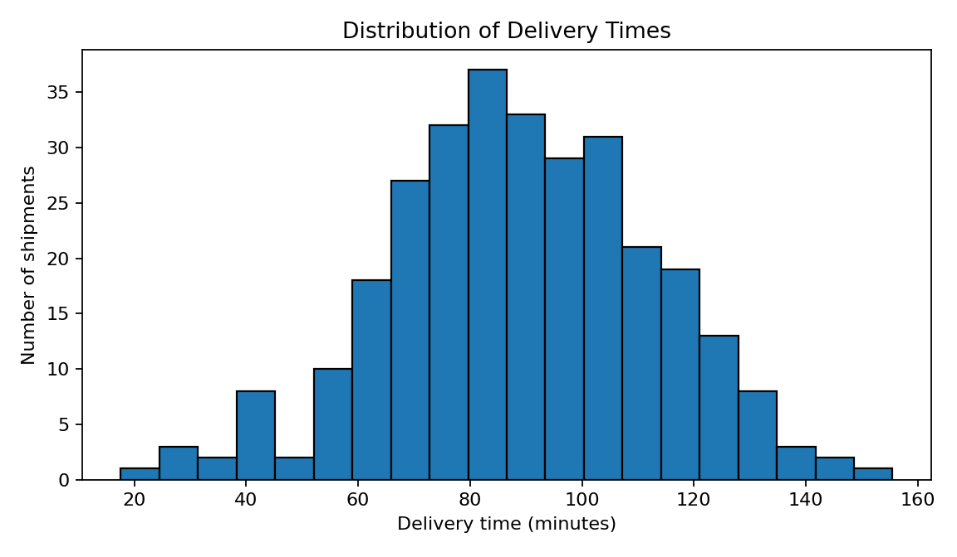
A histogram shows how frequently delivery durations occur within intervals. It is useful for identifying the typical duration, spread, skewness, and unusually long deliveries. If the right tail is long, managers should inspect the longest deliveries to determine whether they are caused by distant destinations, traffic, failed attempts, or data errors.

Figure 2. Transportation cost versus distance
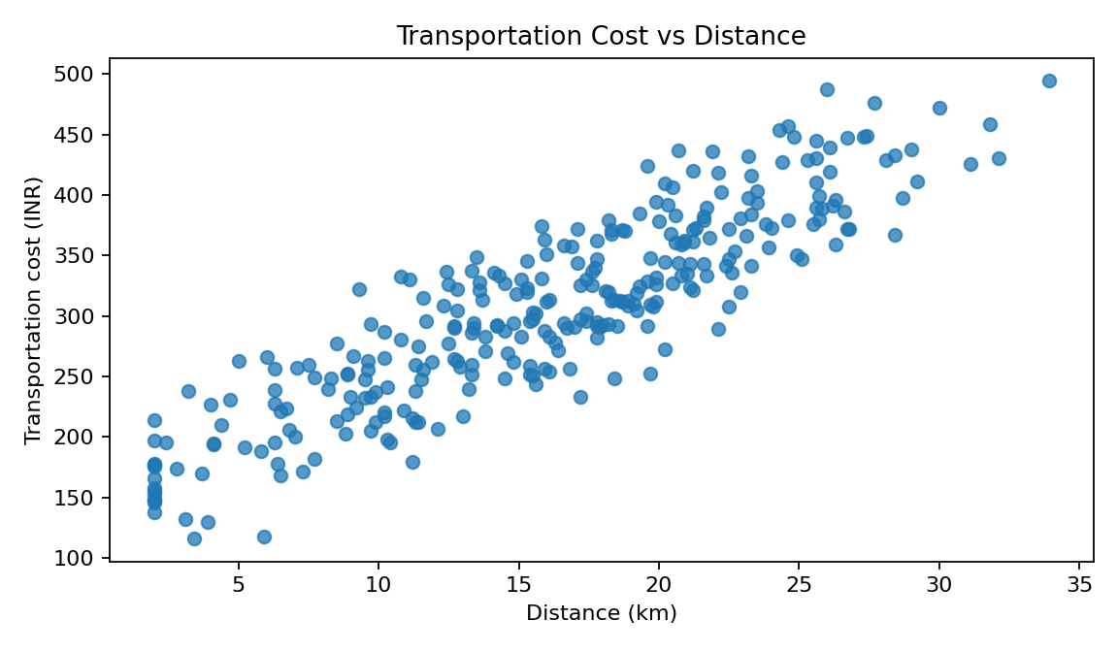
A scatter plot is appropriate for two numeric variables. An upward pattern suggests that longer trips tend to cost more. Points far from the overall pattern may represent special handling, unusual route conditions, or errors. Distance is not the only cost driver; shipment volume, time, tolls, and vehicle type may also matter.

Figure 3. Average delivery time by zone
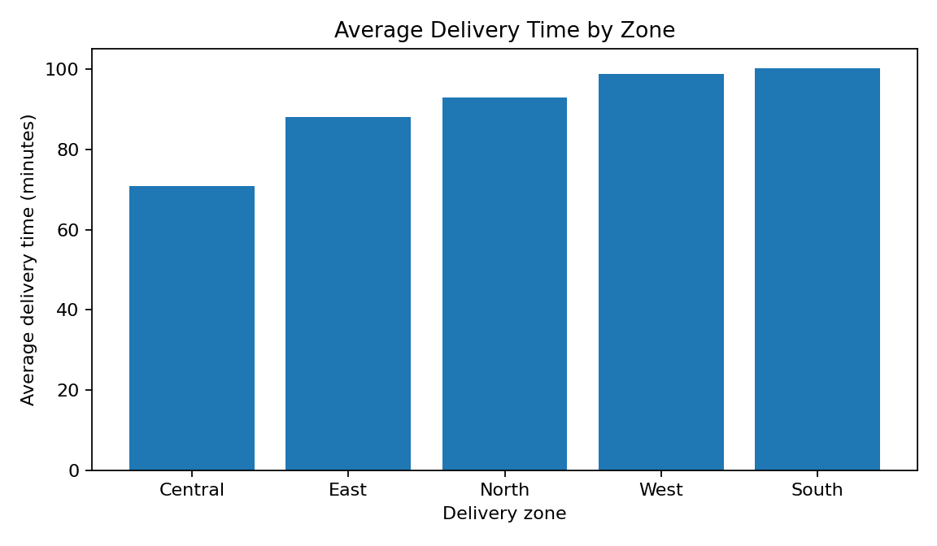
A bar chart makes category comparisons straightforward. Zones with higher average times may need route redesign, different dispatch times, or additional capacity. Before changing operations, compare the number of shipments, distance, traffic mix, and service commitments across zones.

Figure 4. Delivery time versus distance by traffic level
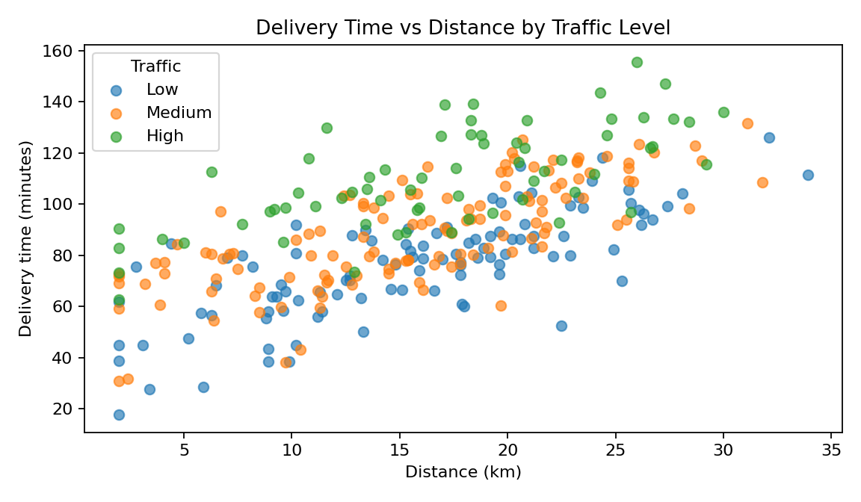
The grouped scatter plot shows whether the relationship between distance and delivery time changes under different traffic conditions. If high-traffic points sit higher for similar distances, traffic may be an important contributor to delay. The chart supports investigation but cannot establish causality by itself.

Figure 5. Daily shipment volume
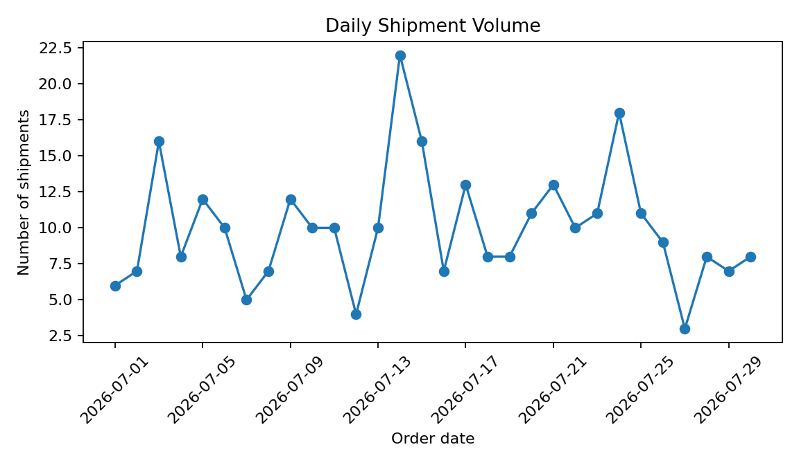
A line chart is suited to data ordered over time. Peaks and troughs show variation in workload and may help with staffing and vehicle planning. The simulated series covers only 30 days, so it is not enough to establish yearly seasonality.

Figure 6. Delivery-time spread by traffic level
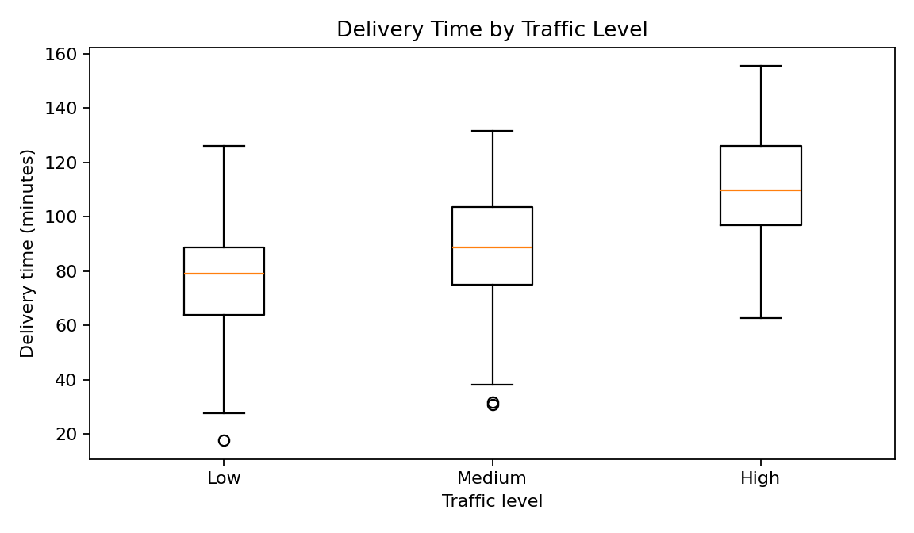
A box plot compares medians, quartiles, spread, and potential extreme values across traffic categories. A higher median or wider spread for high traffic would suggest less predictable delivery times. Investigate whether traffic category was measured consistently and whether zones are comparable.

6. Zone-Level Performance Summary
This table compares shipment counts, average delivery time, average cost, on-time rate, and average distance by delivery zone. It helps identify zones that may warrant further investigation.
Zone | Shipments | Avg. time (min) | Avg. cost (₹) | On-time (%) | Avg. distance (km)
Central | 73 | 70.8 | 223 | 89.0 | 7.6
East | 58 | 88.1 | 298 | 77.6 | 14.9
North | 49 | 93.0 | 323 | 75.5 | 17.8
South | 49 | 100.1 | 366 | 73.5 | 21.4
West | 71 | 98.7 | 346 | 90.1 | 20.5

7. Correlation and Relationships
Correlation measures the strength and direction of a linear association between numeric variables. Values closer to +1 indicate a stronger positive linear association, values closer to -1 a stronger negative association, and values near 0 a weak linear association. Correlation does not prove causation.
Variable | distance_km | shipment_volume | delivery_time_min | transport_cost_inr
distance_km | 1.00 | 0.04 | 0.66 | 0.89
shipment_volume | 0.04 | 1.00 | 0.25 | 0.24
delivery_time_min | 0.66 | 0.25 | 1.00 | 0.77
transport_cost_inr | 0.89 | 0.24 | 0.77 | 1.00
Interpret the matrix alongside the scatter plots. Distance and transport cost are expected to move together in this simulated dataset because distance is included in the cost-generation rule. Delivery time and cost may also be positively associated because delivery time contributes to the simulated cost. These relationships are partly built into the synthetic data and should be tested independently on real operational records.

8. Key Analytical Insights
1. Average delivery time is 89.2 minutes, with a median of 88.7 minutes. The difference between the two measures helps describe the distribution and the influence of longer deliveries.
2. Average transportation cost is ₹306 per shipment. Cost comparisons should account for distance, shipment volume, and traffic so that a zone is not judged unfairly just because it serves farther destinations.
3. Overall on-time performance in the simulation is 82.3%. Review late shipments by zone and traffic category to identify whether delays cluster in specific conditions.
4. The dataset includes 300 shipments over 30 days. Daily volume changes show why dispatch planning should be based on workload patterns rather than a fixed daily average alone.
5. The visualisations should be used to form operational hypotheses: investigate high-duration routes, compare cost per kilometre or per parcel, and check whether high-traffic periods align with more delays. A larger real dataset and multivariable analysis would be needed to quantify the independent contribution of each factor.

9. Recommendations
- Review the longest delivery-time records and classify causes such as distance, traffic, failed delivery, waiting time, and data errors.
- Compare zones using normalised measures such as cost per kilometre, cost per parcel, and on-time rate, not only raw averages.
- Use daily shipment counts to plan vehicle and staffing capacity, and validate patterns over several months before claiming seasonality.
- Collect actual timestamps for dispatch, arrival, service start, and proof of delivery so driving time can be separated from handling and waiting time.
- For future analysis, use a regression model with distance, traffic, volume, zone, and time-of-day features to estimate delivery duration, while checking for confounding factors.
- Repeat KPI monitoring on real data and compare before-and-after results during a controlled pilot.

10. Python Code Examples
The complete runnable script is supplied separately. The following excerpts demonstrate the main analysis steps.

10.1 Descriptive statistics and group analysis
import pandas as pd
df = pd.read_csv("hypothetical_logistics_dataset.csv")
print(df[["distance_km", "shipment_volume",
"delivery_time_min", "transport_cost_inr"]].describe())
zone_summary = df.groupby("delivery_zone").agg(
shipments=("shipment_id", "count"),
avg_time=("delivery_time_min", "mean"),
avg_cost=("transport_cost_inr", "mean"),
on_time_rate=("on_time", "mean")
)
print(zone_summary)

10.2 Create a scatter plot
import matplotlib.pyplot as plt
plt.figure(figsize=(7, 4))
plt.scatter(df["distance_km"], df["transport_cost_inr"], alpha=0.7)
plt.title("Transportation Cost vs Distance")
plt.xlabel("Distance (km)")
plt.ylabel("Cost (INR)")
plt.tight_layout()
plt.show()

10.3 Correlation analysis
numeric = df[["distance_km", "shipment_volume",
"delivery_time_min", "transport_cost_inr"]]
print(numeric.corr())

11. Limitations
The dataset is simulated, relatively small, and limited to 30 days. The formulas used to generate the data introduce relationships by design, so the charts demonstrate analytical techniques rather than prove real-world effects. The data do not include driver shifts, actual road-network routes, fuel logs, delivery attempts, service-time components, vehicle types, or customer time windows. Before applying the recommendations, a logistics team should repeat the analysis using validated operational data and check whether the conclusions remain consistent.

12. Conclusion
This report demonstrates how exploratory data analysis and visualisation can help understand logistics performance. Descriptive statistics summarise typical values and variability; histograms and box plots show distributions; scatter plots reveal relationships; bar charts compare delivery zones; and line charts expose daily workload changes. The analysis points to distance, traffic, shipment volume, and zone characteristics as useful dimensions for investigating delivery time and transport cost. Because the dataset is hypothetical, the results should be treated as a learning exercise and validated against real records before operational decisions are made.

Appendix: Files Produced
- hypothetical_logistics_dataset.csv — simulated shipment-level data for reuse.
- week3_logistics_eda.py — Python script that regenerates the dataset and visualisations.
- Embedded figures in this report — six charts generated from the simulated data.

