**User Guide: Compare Tab**

Use the compare tab to create a change diff when comparing a proposed change against the existing database.

Proposed folder location: “/path/to/your/folder/aciTerraformServer/proposed”

*Note: change /path/to/your/folder so it matches your environment.*

*Enter* ***example*** *to compare .tf files from the example folder.*

*Enter* ***proposed*** *to compare.tf files form the proposed folder.*

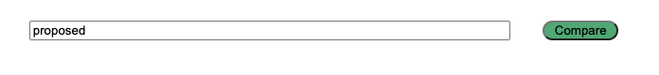

*Note: diff output is not saved to the diff database.*